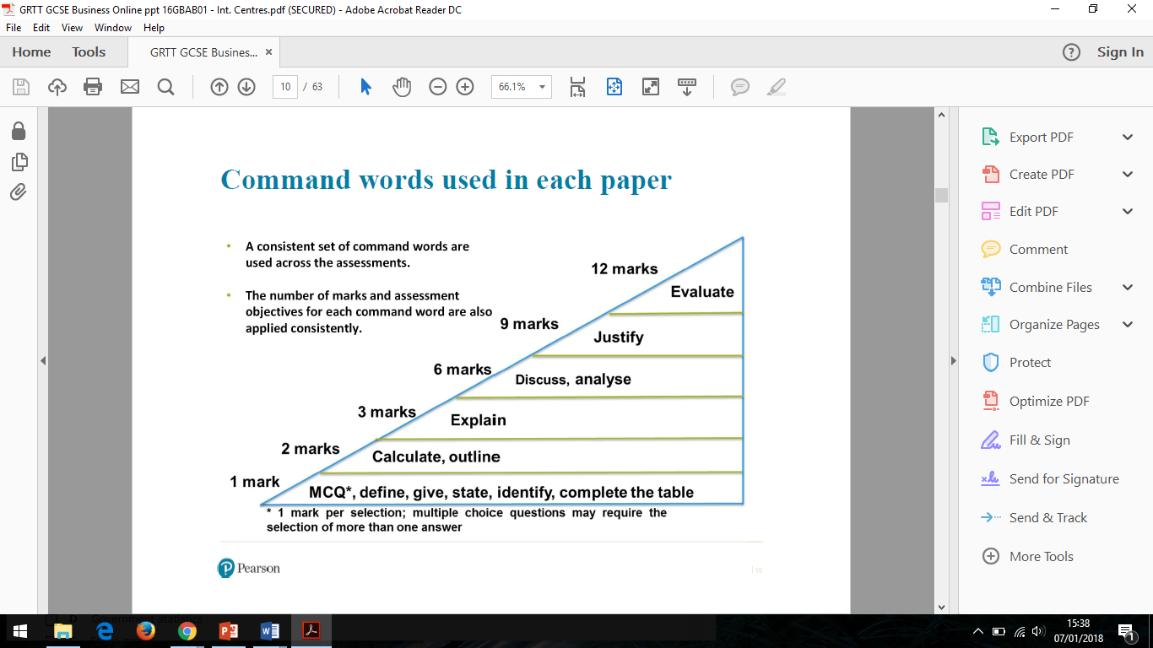

**Assessment Objectives**

|  |  |  |
| --- | --- | --- |
| AO | Skill Tested | % on Paper |
| AO1a | Recall | 15% |
| AO1b | Understanding | 20% |
| AO2 | Context / Calculate | 35% |
| AO3a | Analysis | 20% |
| AO3b | Evaluation | 10% |

**Business Studies**

**Exam Technique Mat (GCSE)**

***1, 2 and 3 Mark Questions***

**\*\*Keep looking back at the question when answering\*\***

**1 Mark Questions**

**(AO1a and AO2)**

**MCQ (Multi Choice Questions)**

**Section A**

Read through how many answers are required, 1 or 2. Ensure you cross the box. **DO NOT TICK**

**Define / Give / State**

**Section B and C**

No context required, do not waste time copying out the question. Only 1 short sentence needed, with no further detail.

**Identify**

**Section B and C**

You will need to use data (chart or graph) to calculate an answer. Ensure you understand the scale if a graph.

**Complete the table**

**Section A**

Check your work carefully, ensure you use the correct data from the table for your calculation.

**2 Mark Questions**

**Calculate**

**(AO2) Section A B & C**

1. Write out your formula (no marks for just this)

2. Get data from information given and write down working out (1 mark for method)

3. Answer on dotted line, units given (2 marks for just correct answer) 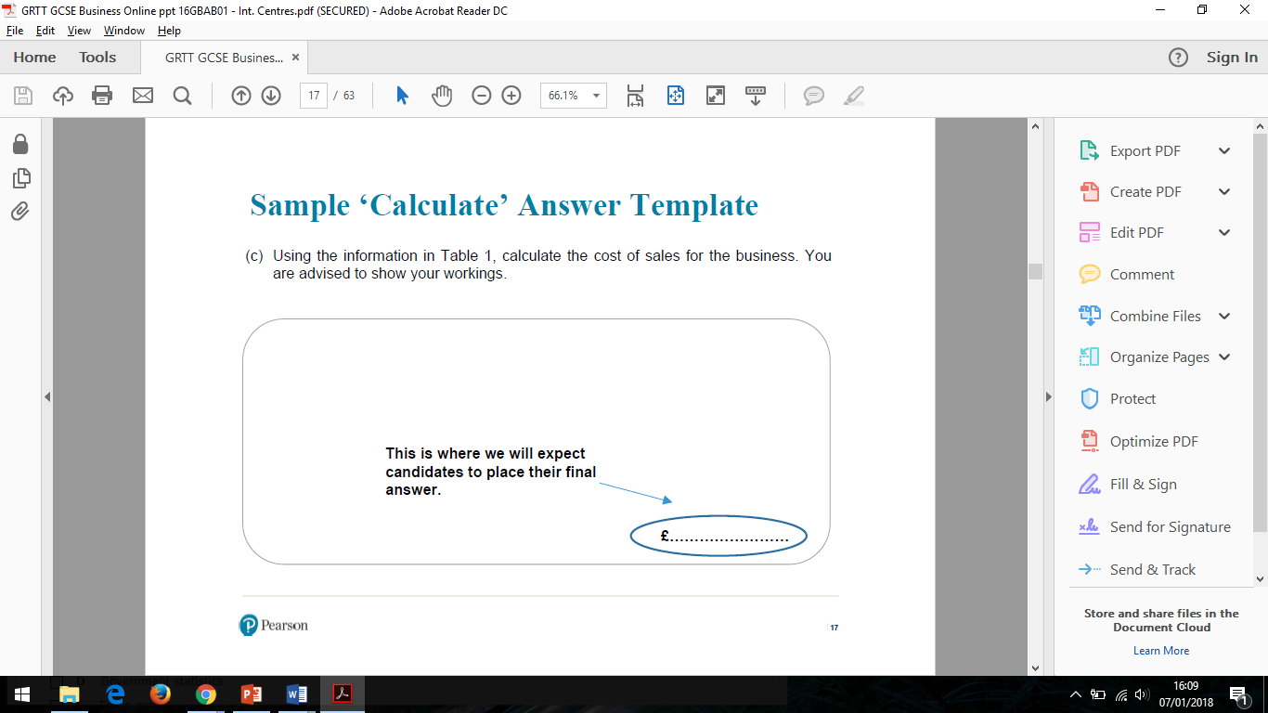Give answer to 2 decimal place

**Outline**

**(AO2) Section B & C**

*Outline one drawback*

*Outline one benefit*

*Outline one method*

*Outline one impact*

Write **one** drawback /benefit/ method/ impact etc

Then **develop** your answer with **context**

_______ this means _______

________ therefore _______

_________ such as________

*(context could include competitor name, product name, location but* ***can’t*** *be anything given in question)*

**3 Mark Questions**

**Explain**

**(AO1a and AO1b) Section A**

There will be 6 of these in each paper

*Explain one impact*

*Explain one method*

*Explain one advantage*

*Explain one disadvantage*

Point -> Explanation -> Impact

**NO CONTEXT NEEDED**

__ therefore ___ this leads to_____

___ this will ___ as a result_______

___ this means___ consequently ___

___ so_______ this may impact_ ___

___for example___this means that__

Make sure you have 3 strands of development in your answer

