Year 12
A Level PE
Learner Booklet
Anatomy & Physiology
Exercise Physiology
Biomechanics

Name………………………..
Tutor…………………………
School……………………….

Anatomy and Physiology

Section 1.1.a | Skeletal and muscular systems
Joints, movements and muscles | Shoulder:  - Flexion, extension, abduction, adduction, horizontal flexion/extension, medial and lateral rotation, circumduction  - Deltoid, latissimus dorsi, pectoralis major, trapezius, teres minor  Elbow:  - Flexion, extension  - Biceps brachii, triceps brachii  Wrist:  - Flexion, extension  - Wrist flexors, wrist extensors  Hip:  - Flexion, extension, abduction, adduction, medial and lateral rotation  - Iliopsoas, gluteus maximus, medius and minimus, adductor longus, brevis and magnus  Knee:  - Flexion, extension  - Hamstring group: biceps femoris, semi-membranosus, semi-tendinosus  - Quadriceps group: rectus femoris, vastus lateralis, vastus intermedius and vastus medialis  Ankle:  - Dorsi flexion, plantar flexion  - Tibialis anterior, soleus, gastrocnemius  Planes of movement:  - Frontal  - Transverse  - Sagittal
Functional roles of muscles and types of contraction | Roles of muscles:  - Agonist  - Antagonist  - Fixator  Types of contraction:  - Isotonic  - Concentric  - Eccentric  - Isometric
Analysis of movement | Analyse movement with reference to:  - Joint type  - Movement produced  - Agonist and antagonist muscles involved  - Type of muscle contraction taking place
Skeletal muscle contraction | Structure and role of motor units in skeletal muscle contraction;  Nervous stimulation of the motor unit:  - Motor neuron  - Action potential  - Neurotransmitter  - ‘All or none’ law
Muscle contraction during exercise of differing intensities and during recovery | Muscle fibre types:  - Slow oxidative  - Fast oxidative glycolytic  - Fast glycolytic  Recruitment of different fibre types during exercise of differing intensities and during recovery.

Glossary of key terms

Complete the definitions for the key terms.

Key Term | Definition
Abduction
Action Potential
Adduction
Agonist
All-or-none law
Antagonist
Antagonistic muscle action
Concentric contraction
Delayed onset muscle soreness
Dorsi-flexion
Eccentric contraction
Extension
Fast glycolytic muscle fibres
Fast oxidative glycolytic muscle fibres
Fixator
Flexion
Horizontal extension
Horizontal flexion
Isometric contraction
Isotonic contraction
Joint
Ligament
Movement analysis
Movement patterns
Muscle hypertrophy
Myoglobin
Neuromuscular system
Neurotransmitter
Plane of movement
Plantar flexion
Slow oxidative muscle fibres
Stretch reflex

Skeletal system
Label the skeleton below, identifying where each bone is located.

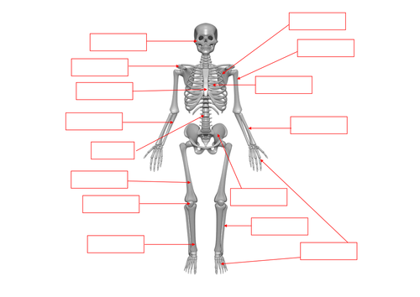

Planes of movement and movement patterns
Draw a diagram to help show the planes of movement and movement patterns.

Frontal Plane | Sagittal Plane | Transverse Plane
Flexion | Extension | Dorsi-flexion
Plantar-flexion | Abduction | Adduction
Horizontal extension | Horizontal flexion | Give a sporting example for a movement in;  Sagittal plane  Frontal plane  Transverse plane

Muscular system
Label the muscles on the body below. Choose from the following terms below;

Pectoralis major Rectus abdominis Gluteus medius
Biceps brachii Adductor longus Gluteus maximus
External obliques Rectus femoris Biceps femoris
Wrist flexors Posterior deltoid Gastrocnemius
Tibialis anterior Triceps brachii Soleus
Anterior deltoid Latissimus dorsi Trapezius
Teres major Wrist extensors Iliopsoas
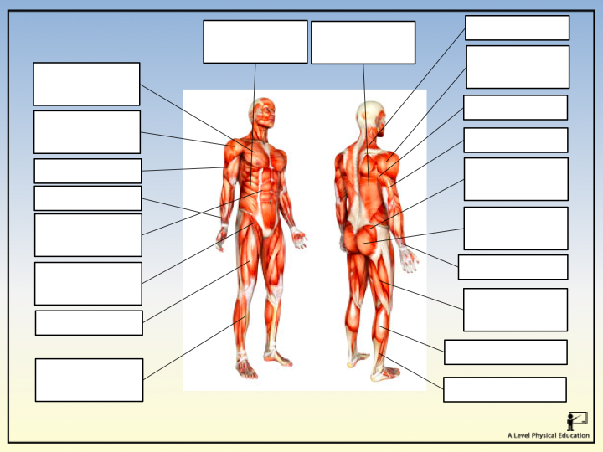

Movement analysis
Consider the picture below, apply your knowledge to perform a movement analysis of the javelin throwers’ right wrist, shoulder, hip, knee and ankle.
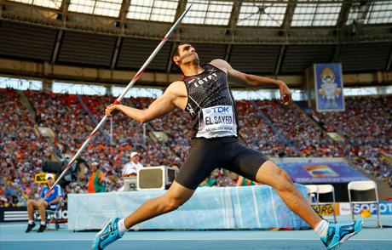
Remember to include;
- Joint type
- Articulating bones
- Movement pattern
- Agonist muscle
- Antagonist muscle
- Contraction types

Skeletal muscle contraction
Complete the flow diagram, summarising the role of a motor unit in skeletal muscle contraction;

Skeletal and Muscular System
Assessment Questions

- In order for a muscle to contract, one or more motor units will be stimulated and will follow the ‘all-or-none’ law.
- Describe the structure of a motor unit (1 mark)
- What is the ‘all-or-none’ law? (1 mark)
- What is the effect of stimulating more motor units? (1 mark)

- Name one agonist and one antagonist at the ankle joint at the point of take-off during a vertical jump. (2 marks)

- Fig 1. shows a performer doing a sit up.

Fig 1.
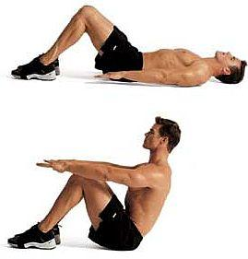
- Complete the table below to show the movements that take place at the hip joint during the upward and downward phases.
Phase | Agonist | Antagonist | Type of contraction
Upward
Downward
(6 marks)

- Fig 2 shows a performer in the upward and downward phases of a press-up.
Fig. 2
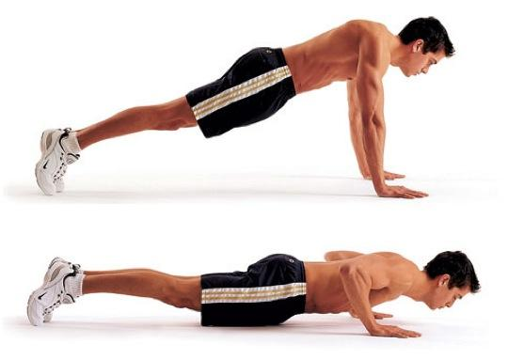
Analyse the movement for both the upward and downward phases of a press up, including;
- Joint types and movements produced at the elbow
- Muscle functions and types of contraction at the elbow
- The type of contraction of the muscles of the leg.
(10 marks)

Section 1.1.b | Cardiovascular and respiratory systems
Cardiovascular system at rest | The relationship between, and resting values for:  - Heart rate  - Stroke volume  - Cardiac output  - Methods of calculating the above  Cardiac cycle:  - Diastole  - Systole  Conduction system of the heart linked to the cardiac cycle
Cardiovascular system during exercise of differing intensities and during recovery | Effects of different exercise intensities and recovery on:  - Heart rate  - Stroke volume  - Cardiac output  - Methods of calculating the above  Redistribution of cardiac output during exercise of differing intensities and during recovery:  - Vascular shunt mechanism  - Role of the vasomotor centre  - Role of the arterioles  - Role of pre-capillary sphincters  Mechanisms of venous return during exercise of differing intensities and during recovery.  Regulation of heart rate during exercise:  - Neural factors  - Hormonal factors  - Intrinsic factors
Respiratory system at rest | Relationship between resting values for:  - Breathing frequency  - Tidal volume  - Minute ventilation  - Methods of calculating the above  Mechanics of breathing at rest and the muscles involved:  - Diaphragm  - External intercostals  - At the alveoli  - At the muscles
Respiratory system during exercise of differing intensities and during recovery | Effects of differing intensities of exercise and recovery on:  - Breathing frequency  - Tidal volume  - Minute ventilation  Mechanics of breathing during exercise of differing intensities and during recovery, including additional muscles involved:  - Inspiration – sternocleidomastoid, pectoralis minor  - Expiration – internal intercostals, rectus abdominis  Regulation of breathing during exercise of different intensities and during recovery:  - Neural control  - Chemical control  Effect of differing intensities of exercise and recovery on gas exchange at the alveoli and at the muscles:  - Changes in pressure gradient  - Changes in dissociation of oxyhaemoglobin

Glossary of key terms

Complete the definitions for the key terms

Key Term | Definition
Alveoli

Arterioles
Atherosclerosis
Blood pooling
Blood viscosity
Bohr shift
Bradycardia
Breathing rate
Capillarisation
Carbon dioxide
Cardiac control centre (CCC)
Cardiac output (Q)
Cardiovascular drift
Chronic Obstructive Pulmonary Disease (COPD)
Conduction system
Coronary heart disease (CHD)
Deoxygenated blood
Diastole
Diffusion
Diffusion gradient
Dissociation
Expiration
Expiratory centre (EC)
Frank-Starling mechanism (Starling’s law)
Gaseous exchange
Haemoglobin
Heart attack
Heart rate
Hypertension
Hyper-viscosity
Inspiration
Inspiratory centre (IC)
Minute Ventilation
Mitochondria
Myogenic
Oxygenated blood
Oxyhaemoglobin dissociation curve
Parasympathetic nervous system
Partial pressure
Pre-capillary sphincters
Pulmonary circuit
Respiratory control centre (RCC)
Stroke
Stroke volume
Sympathetic nervous system
Systemic circuit
Systole
Tidal Volume
Vascular shunt mechanism
Vasoconstrict
Vasodilate
Vasomotor control centre (VCC)
Vasomotor tone
Venous return

The structure of the heart
Label the diagram of the heart

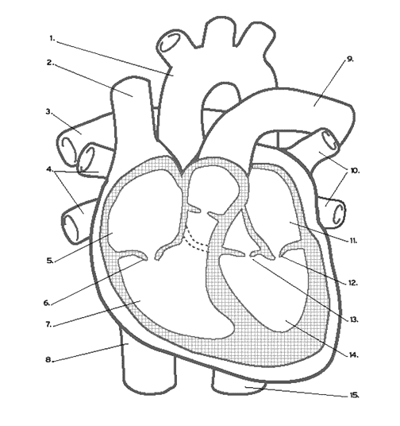

The cardiac cycle
Describe the pathway of blood through the heart alongside the cardiac cycle. Use the following key terms in your description;
Sino-atrial node (SA node), Atrio-ventricular node (AV node), bundle of His, bundle branches, purkinje fibres, diastole, atrial systole, ventricular systole.

Venous return mechanisms
Describe the five mechanisms of venous return.

1. | 2. | 3.
4. | 5. | Why is good venous return so important for a sports performer?

Vascular shunt mechanism
Describe the role of the vasomotor control centre in relation to the vascular shunt mechanism.

The structure of the respiratory system
Label the diagram of the respiratory system

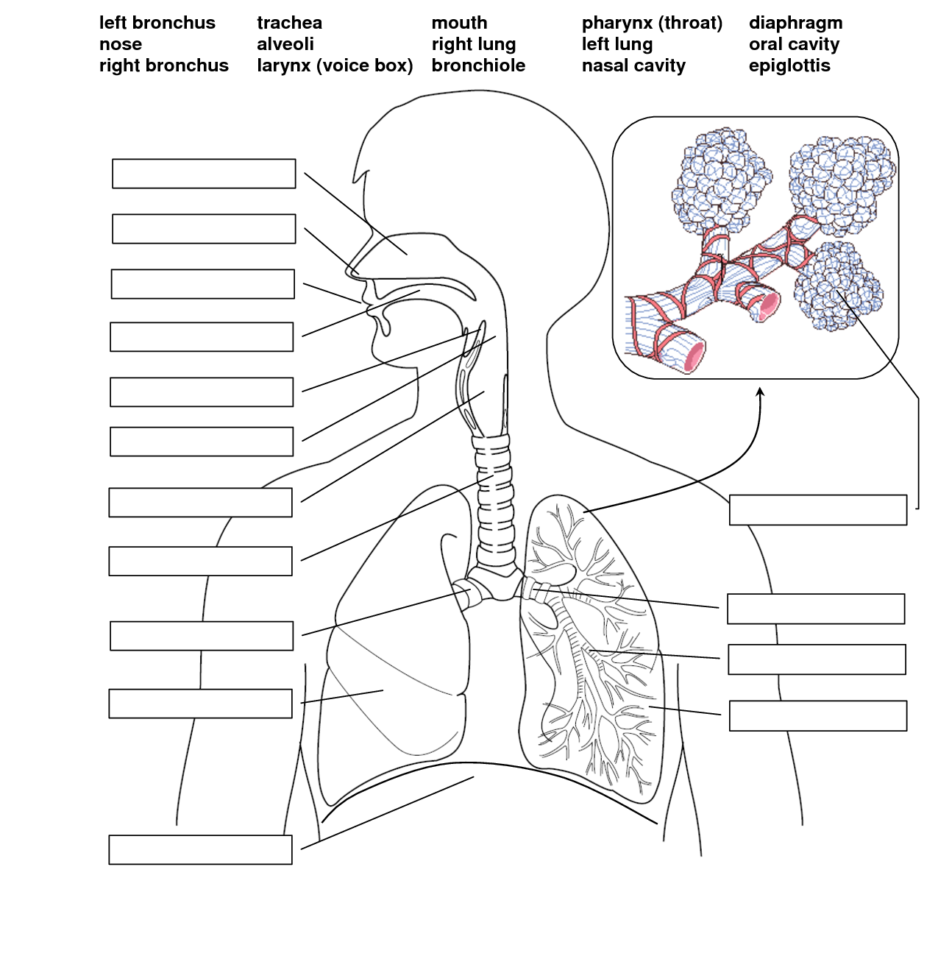

Mechanics of breathing
Describe the mechanics of breathing for each scenario.
Mechanics of inspiration at rest

Mechanics of expiration at rest

Mechanics of inspiration during exercise

Mechanics of expiration during exercise

Respiratory regulation
Breathing rates and minute ventilation remain elevated post exercise and gradually reduce, especially if an active recovery is used. Based on the information that the chemical and neural receptors send to the RCC post exercise, write a paragraph explaining why breathing rate and minute ventilation remain high, reducing gradually in recovery.

Bohr shift

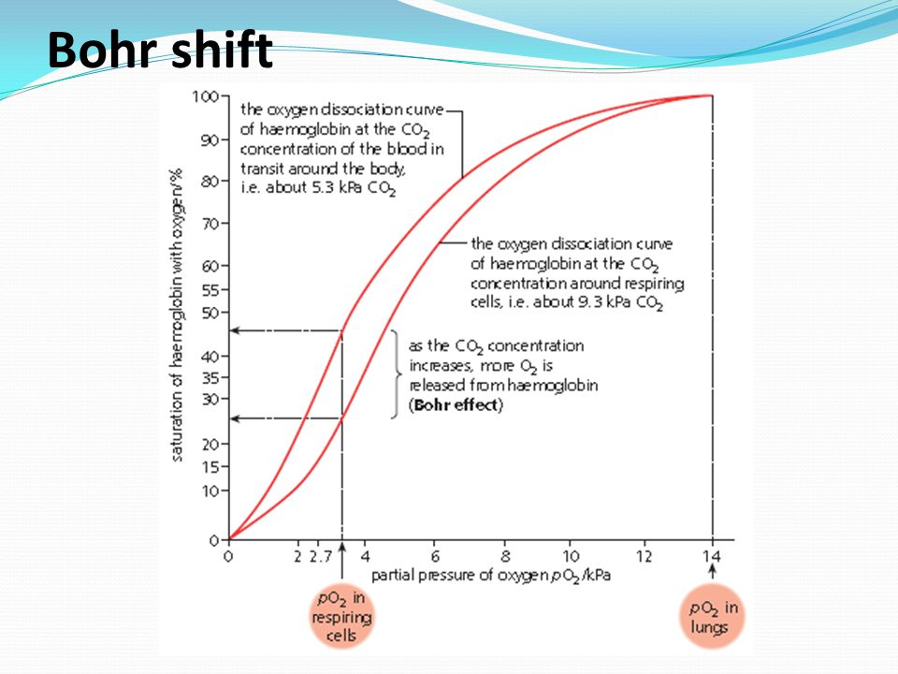

Write a paragraph explaining how the oxyhaemoglobin dissociation curve helps explain the transport and increased delivery of oxygen to the muscles during exercise.

Exercise Physiology

Section 1.2.a | Diet and nutrition and their effect on physical activity and performance
Diet and Nutrition | Function and importance of the components of a healthy, balanced diet:  - Carbohydrates  - Proteins  - Fats  - Minerals  - Vitamins  - Fibre  - Water  Energy intake and expenditure and energy balance in physical activity and performance.
Ergogenic aids | Use of ergogenic aids; potential benefits and risks:  Pharmacological aids:  - Anabolic steroids  - Erythropoietin (EPO)  - Human growth hormone (HGH)  Physiological aids:  - Blood doping  - Intermittent hypoxic training (IHT)  - Cooling aids  Nutritional aids:  - Amount of food  - Composition of meals  - Timing of meals  - Hydration  - Glycogen/carbohydrate loading  - Creatine  - Caffeine  - Bicarbonate  - Nitrate

Glossary of key terms

Complete the definitions for the key terms

Key Term | Definition
Anabolic steroids

Bicarbonate

Blood doping

Caffeine

Carbohydrate

Cooling aids

Creatine supplementation
Energy

Energy balance

Energy expenditure

Energy intake

Ergogenic aid

Fats

Glycaemic Index (GI)

Glycogen/carbohydrate loading
Human growth hormone (HGH)
Intermittent hypoxic training (IHT)
Metabolic equivalent (MET) value
Muscle hypertrophy

Nitrates

Pharmacological aids

Physiological aids

Protein

Recombinant erythropoietin (RhEPO)
Saturated fatty acids

Thermic effect of food (TEF)
Unsaturated fatty acids

Vitamins and minerals

Diet and Nutrition
Complete the table for each dietary component summarising the key function and importance of each component for a performer and foods where they can be found.

Dietary component | Functions and importance | Sources
Carbohydrates

Proteins

Fats

Minerals

Vitamins

Fibre

Water

Ergogenic aids
Complete the table for each ergogenic aid.

Ergogenic aid | What are they? | Who uses them? | Performance benefits | Risks
Anabolic steroids

Erythropoietin (EPO)

Human Growth Hormone (HGH)

Blood doping

Intermittent hypoxic training (IHT)

Cooling aids

Amount, composition and timing of meals
Glycogen loading

Hydration

Creatine

Caffeine

Bicarbonate

Nitrate

QUESTION
Using sporting examples, critically evaluate the use of pharmaceutical and physiological aids in a sport of your choice. (10 marks)

Section 1.2.b | Preparation and training methods in relation to improving and maintaining physical activity and performance
Aerobic training | Aerobic capacity and maximal oxygen uptake (VO₂max)  How VO₂max is affected by:  - Individual physiological make-up  - Training  - Age  - Gender  Methods of evaluating aerobic capacity:  - Laboratory test of VO₂max using direct gas analysis  - NCF multi-stage fitness test  - Queen’s college step test  - Cooper 12-minute run  Intensity and duration of training used to develop aerobic capacity:  - Continuous training  - High intensity interval training (HIIT)  The use of target heart rates as an intensity guide  Physiological adaptations from aerobic training:  - Cardiovascular  - Respiratory  - Muscular  - Metabolic  Activities and sports in which aerobic capacity is a key fitness component.
Strength training | Types of strength:  - Strength endurance  - Maximum strength  - Explosive/elastic strength  - Static and dynamic strength  Factors that affect strength:  - Fibre type  - Cross sectional area of the muscle  Methods of evaluating each type of strength:  - Grip strength dynamometer  - 1 repetition maximum (1RM)  - Press up or sit-up test  - Vertical jump test  Training to develop strength:  - Repetitions  - Sets  - Resistance guidelines used to improve each type of strength  - Multi-gym  - Weights  - Plyometrics  - Circuit/interval training  - Work intensity  - Work duration  - Relief interval  - Number of work/relief intervals  Physiological adaptations from strength training:  - Muscle and connective tissues  - Neural  - Metabolic  Activities and sports in which strength is a key fitness component.
Flexibility training | Types of flexibility  - Static flexibility (active and passive)  - Dynamic flexibility  Factors that affect flexibility  - Type of joint  - Length of surrounding connective tissue  - Age  - Gender  Methods of evaluating flexibility:  - Sit and reach test  - Goniometer  Training used to develop flexibility  - Passive stretching  - Proprioceptive neuromuscular facilitation (PNF)  - Static stretching  - Dynamic stretching  - Ballistic stretching  - Isometric stretching  Physiological adaptations from flexibility training:  - Muscle and connective tissues  Activities and sport which flexibility is a key fitness component
Periodisation of training | Periodisation cycles:  - Macrocycle  - Mesocycle  - Microcycle  Phases of training:  - Preparatory  - Competitive  - Transition  Tapering to optimise performance  How to plan personal health and fitness programmes for aerobic, strength and flexibility training.
Impact of training on lifestyle diseases | The effect of training of lifestyle diseases:  - Cardiovascular system  - Coronary heart disease (CHD)  - Stroke  - Atherosclerosis  - Heart attack  - Respiratory system  - Asthma  - Chronic obstructive pulmonary disease (COPD)

Glossary of key terms

Complete the definitions for the key terms

Term | Definition
Adaptation

Aerobic capacity

Aerobic work

Anaerobic work

Asthma

Atherosclerosis

Ballistic stretching
Basal metabolic rate (BMR)
Chronic Obstructive Pulmonary Disease (COPD)
Circuit training

Continuous training
Coronary heart disease (CHD)
Dynamic flexibility
Explosive strength
Fartlek training

FITT

Heart attack

High-intensity interval training (HIIT)
Isometric stretching
Maximal strength
Meso-cycle

Micro-cycle

Periodisation

Plyometrics

Principles of training
Proprioceptive neuromuscular facilitation (PNF)
Static active stretching
Static flexibility

Static passive stretching
Strength endurance
VO2 max

Work:relief ratio

Periodisation
Use the diagram to help you explain the six main components of a periodised training plan.

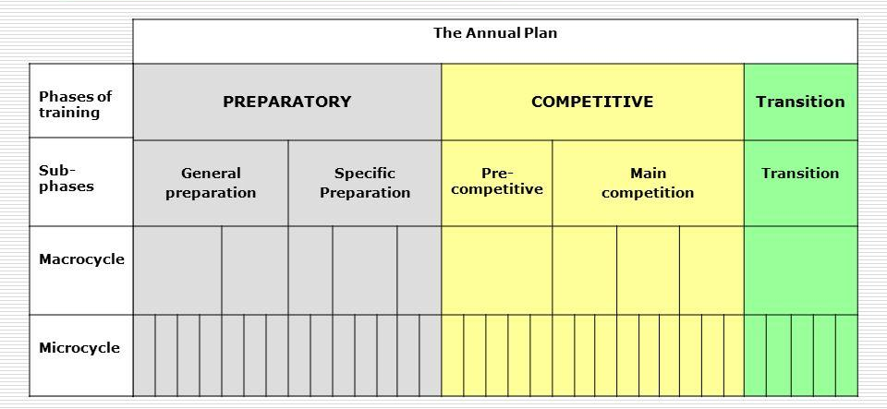

Preparation and training methods in relation to improving and maintaining physical activity and performance - Exam Questions

- Explain how a swimmer would use ‘periodisation’ to prepare for competitions. (4 marks)
- Some performers break the rules and use banned substances to enhance their
performance. Describe the physiological reasons why a performer may use anabolic steroids. (3 marks)
- The 1500 metres race for men at the 2004 Athens Olympics was won in 3min 34.18s,
while the same event for women was won in 3min 57.90s.
(a) Identify five structural or physiological characteristics that could account for these differences in times between males and females. (5 marks)
- Weight training is used by some performers as a method of training because of its effects on the body. Describe five physiological and/or structural changes that occur in the body as a result of a weight-training programme. (5 marks)

Biomechanics

Section 1.3.a | Biomechanical principles, levers and the use of technology
Biomechanical principles | Define and apply Newton’s laws of motion:  - Newton’s first law: Inertia  - Newton’s second law: Acceleration  - Newton’s third law: Reaction  Force:  - Net force  - Balanced and unbalanced force  - Weight  - Reaction  - Friction  - Air resistance  - Factors affecting friction and air resistance and their manipulation in sporting performance  - Free body diagrams showing vertical and horizontal forces acting on a body at an instant in time and the resulting motion  - Calculations of force, momentum, acceleration and weight  - Definition of centre of mass  - Factors affecting the position of centre of mass  - The relationship between centre of mass and stability
Levers | Components of a lever system:  - Load  - Effort  - Fulcrum  - Effort arm  - Load arm  1st class lever  2nd class lever  3rd class lever  Mechanical advantage of a 2nd class lever
Analysing movement through the use of technology | Definitions and uses of:  - Limb kinematics  - Force plates  - Wind tunnels  How each type of technology may be used to optimise performance in sport.

Glossary of key terms

Write the definitions for the key terms

Term | Definition
Air resistance

Balanced forces

Centre of mass

Force

Free body diagram
Friction

Inertia

Mechanical advantage
Mechanical disadvantage
Net force

Power output

Reaction

Stability

Streamlining

Unbalanced forces
Weight

Newton’s laws of motion
Apply all three of Newton’s laws of motion to a football penalty kick.

Apply all three Newton’s laws of motion to a basketball jump shot.

Apply all three Newton’s laws of motion to a situation in your sport.

Calculations

Term | Equation
Velocity

Momentum

Acceleration

Force

Weight

Friction
Describe the four factors that affect friction.

Roughness of the ground surface | Roughness of the contact surface
Temperature | Size of normal reaction
Air resistance
Describe the four factors that affect air resistance.

Velocity | Shape
Frontal cross-sectional area | Smoothness of surface

Free body diagram
Draw a free body diagram for a) marathon runner travelling at constant velocity b) long-jumper accelerating forwards and upwards at take-off.

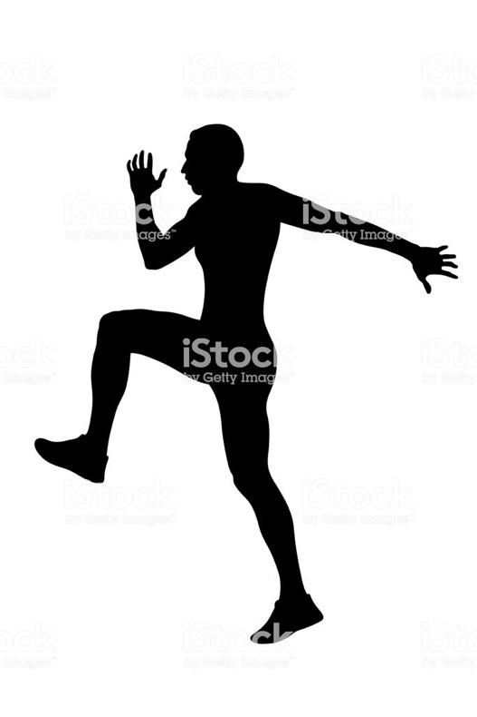

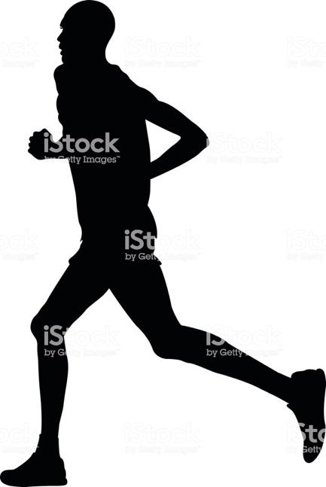

Lever Systems

Classification of lever system and a sporting example.

Class | Order of components | Sporting example
First

Second

Third

Mechanical advantage is…

Mechanical disadvantage is…

Biomechanical principles – Exam Questions

- Using ‘Newton’s First’ and ‘Second Laws of Motion’, explain how a swimmer dives off
the starting blocks. (4 marks)
- During a football game, a performer kicks a ball. Describe the effects of forces on the
flight of the ball. (4 marks)
- Elite golfers use their clubs to overcome the forces acting on the golf ball so that it travels long distances.
(a) Describe how the impact of the golf club, gravity and air resistance affect the velocity
and acceleration of a golf ball. (4 marks)
- Explain the term mechanical advantage and apply it to a sporting example of your choice. (3 marks)
- Using a sporting example of your choice, explain the factors that affect the position of the centre of mass. (4 marks)
- Draw a free body diagram, showing the forces acting upon a speed-skater accelerating forward. (4 marks)

