GCSE (9-1) PHYSICAL EDUCATION

Socio-cultural issues and Sports Psychology

Learning Booklet
Name:
Tutor:
Class teacher(s):
School:
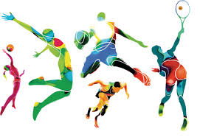

Glossary of Terms
Balanced Diet | A diet that contains the correct proportion of carbohydrates, proteins, fats, vitamins, minerals, fibre and water necessary to maintain good health.
Beta Blockers | A drug used to control heart rhythm and lower pressure.
Closed Skill | Skills that are performed in a predictable environment Eg. a player taking a lineout in rugby.
Commercialisation | Links business and commerce into sport with primary focus of profit which can lead to exploitation.
Complex Skill | A skill which requires a lot of focus and decision making to perform.
Confidence | The degree to which a performer believes they have the ability to perform and complete tasks with success.
Discrimination | The unfair treatment of individuals whereby opportunities are not available to all of the different social groups.
Deviance | Behaviour that is either immoral or seriously breaks the rules and norms of the sport.
Ethnicity | A state of belonging to a specific social group with common cultural or national traditions or beliefs.
Feedback | Information that is given to a performer either during or after their performance with the aim to improve performance.
Gamesmanship | Where the laws of the game are interpreted in ways, which whilst not illegal, are not in the spirit of the game. Pushing the limits to gain unfair advantage.
Gender | State of being male or female.
Golden Triangle | The links and relationship between sponsorship, sporting events and the media.
Guidance | Given to aid the learning of a skill. Visual, verbal, manual and mechanical.
Health | The state of emotional, physical and social well-being.
Hydration | Having the appropriate level of water in the body for it to function optimally.
Open skill | These are affected by the environment and are predominantly perceptual as they much be adapted to suit the environment. Eg. a pass in football.
Role models | Someone to be looked up to.
Simple Skill | Consists of basic movement actions that are not difficult to perform with few decisions to make. Eg. a chest pass in basketball.
Skilful movement | A fluent and coordinated movement which is efficient, technically accurate and aesthetically pleasing.
SMART | Specific – a target to achieve  Measurable – something quantitative you can see  Achievable – something that can be done by the performer  Recorded – a training programme record  Timed – to be achieved in a certain amount of time
Sponsorship | The giving of money or goods to performers in order to get good publicity and/or increased profit.
Sportsmanship | Ethical, appropriate, polite and fair behaviour while participating in a game or event.
Steroids | Anabolic steroids are synthetic hormones that enhance physical performance.
Stimulants | Drugs used to raise physiological arousal in the body.
Violence | Physical acts committed in sport that go beyond the accepted rules of play or expected levels of contact within a contact sport.

2.1.a
Engagement patterns of different social groups in physical activity and sports
Topic area: | Learners must:
Physical activity and sport in the UK | - Be familiar with current trends in participation in activity and sport:  - Using different sources (such as Sport England, National Governing Bodies and Department for Culture, Media and Sport.  - Of different social groups  - In different physical activities and sports
Participation in physical activity in sport | - Understand how different factors can affect participation, including:  - Age  - Gender  - Ethnicity  - Religion/culture  - Family  - Education  - Time/work commitments  - Cost/disposable income  - Disability  - Opportunity/access  - Discrimination  - Environment/climate  - Media coverage  - Role models  - Understand strategies which can be used to improve participation:  - Promotion  - Provision  - Access  - Be able to apply examples from physical activity/sport to participation issues.

2.1.a

- What is the effect of ethnicity on participation rates?
…………………………………………………………………………………………………………………………………………………………………………………………………………………………………………………………………………
- Which social group is most ‘at risk’ and should be targeted by physical activity interventions?
…………………………………………………………………………………………………………………………………………………………………………………………………………………………………………………………………………
- Why does socio-economic status have the observed effect on participation?
……………………………………………………………………………………………………………………………………………………………………………………………………………………………………………………………………………………………………………………………………………………………………………………………………………………………………………………………………………………………………………………………………………………
- How could the participation rates of disabled people be increased?
……………………………………………………………………………………………………………………………………………………………………………………………………………………………………………………………………………………………………………………………………………………………………………………………………………………………………………………………………………………………………………………………………………………
- Why do you think there are differences between male and female participation?
……………………………………………………………………………………………………………………………………………………………………………………………………………………………………………………………………………………………………………………………………………………………………………………………………………………………………………………………………………………………………………………………………………………

2.1.a

2.1.a

2.1.b
Commercialisation of physical activity and sport
Topic area: | Learners must:
Commercialisation of Sport | - Understanding the influence of the media on the commercialisation of physical activity and sport:  - Different types of social media  . Social  . Internet  . TV/visual  . Newspapers/magazines  - Know the meaning of commercialisation, including sport, sponsorship and the media (the golden triangle)  - Positive and negative effects of the media on commercialisation  - Be able to apply practical examples to these issues.  - Understand the influence of sponsorship on the commercialisation of physical activity and sport:  - Positive and negative effects of sponsorship on commercialisation  - Be able to apply practical examples to the issue of sponsorship.

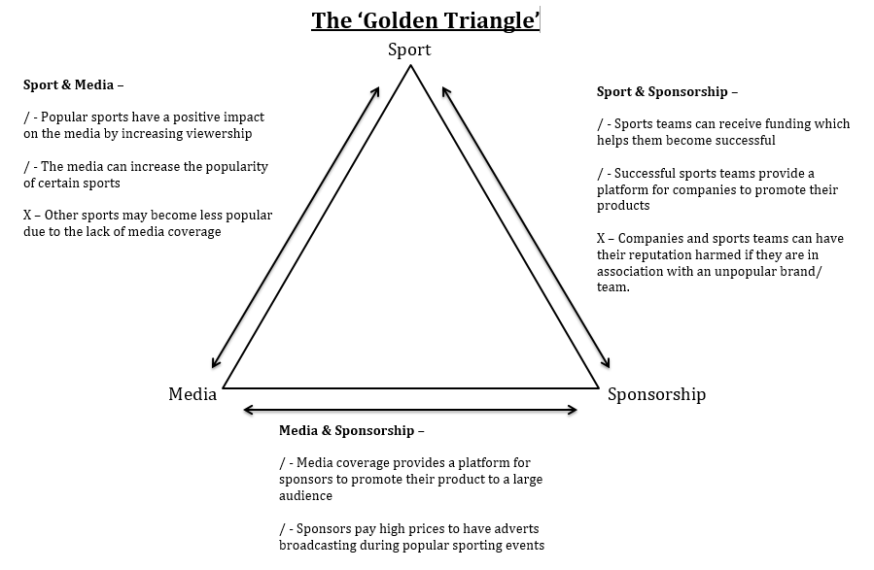
2.1.b
2.1.b
Commercialisation of sport - Produce a brief report to explain commercialisation in a sport of your choice, including the relationship between physical activity and sport, commercialisation, and the media.
……………………………………………………………………………………………………………………………………………………………………………………………………………………………………………………………………………………………………………………………………………………………………………………………………………………………………………………………………………………………………………………………………………………………………………………………………………………………………………………………………………………………………………………………………………………………………………………………………………………………………………………………………………………………………………………………………………………………………………………………………………………………………………………………………………………………………………………………………………………………………………………………………………………………………………………………………………………………………………………………………………………………………………………………………………………………………………………………………………………………………………………………………………………………………………………………………………………………………………………………………………………………………………………………………………………………………………………………………………………………………………………………………………………………………………………………………………………………………………………………………………………………………………………………………………………………………………………………………………………………………………………………………………………………………………………………………………………………………………………………………………………………………………………………………………………………………………………………………………………………………………………………………………………………………………………………………………………………………………………………………………………………………………………………………………………………………………………………………………………………………………………………………………………………………………………………………………………………………………………………………………………………………………………………………………………………………………………………………………………………………………………………………………………………………………………………………………………………………………………………………………………………………………………………………………………………………………………………………………………………………………………………………………………………………………………………………………………………………………………………………………………………………………………………………………………………………………………………………………………………………………………………………………………………………………………………………………………………………………………………………………………………………………………………………………………………………………………………………………………………………………………………….

2.1.b
2.1.b

Ethical and social-cultural issues in physical activity and sport
Topic area: | Learners must:
Ethics in Sport | - Know and understand:  - The value of sportsmanship  - The reasons for gamesmanship and deviance in sport  - Be able to apply practical examples to these concepts
Drugs in Sport | - Know and understand the reasons why sports performers use drugs  - Know the types of drugs and their effect on sports performance:  - Anabolic steroids  - Beta blockers  - Stimulants  - Give practical examples of the use of these drugs in sport  - Know and understand the impact of drug use in sport:  - On performers  - On sport itself
Violence in Sport | - Know and understand the reasons for player violence  - Give practical examples of violence in sport
2.1.c

2.1.c
Sportsmanship vs Gamesmanship

Sportsmanship:
Key Words:
Definitions:
Examples:

Sportsmanship
Gamesmanship

Gamesmanship:
Sportsmanship:

Gamesmanship:

Reasons for gamesmanship:
Consequences of gamesmanship:
2.1.c
Drugs in Sport - Identify which of the prohibited substances (stimulants, anabolic steroids and beta blockers) would be most beneficial for the following athletes of take. Suggest why and identify any potential side effects.
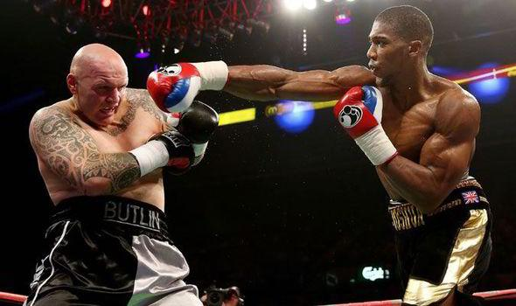
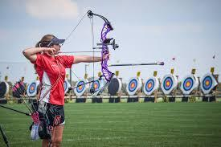

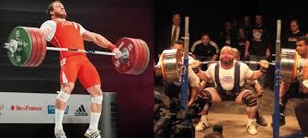

2.1.c

Drugs in Sport - Discuss the reasons why an athlete might take performance enhancing drugs when competing in competitive sport and write down the advantages and disadvantages below.

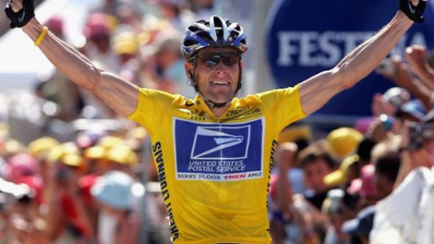

Discuss the reasons why sports people take performance enhancing drugs. (8)
…………………………………………………………………………………………………………………………………………………………………………………………………………………………………………………………………………………………………………………………………………………………………………………………………………………………………………………………………………………………………………………………………………………………………………………………………………………………………………………………………………………………………………………………………………………………………………………………………………………………………………………………………………………………………………………………………………………………………………………………………………………………………………………………………………………………………………………………………………………………………………………………………………………………………………………………………………………………………………………………………………………………………………………………………………………………………………………………………………………………………………………………………………………………………………………………………………………………………………………………………………………………………………………………………………………………………………………………………………………………………………………………………………………………………………………………………………………………………………………………………………………………………………………………………………………………………………………………………………………………………………………………………………………

2.1.c

2.2
Sports Psychology
Topic area: | Learners must:
Characteristics of a skilful movement | - Know the definition of motor skills  - Understand and be able to apply examples of the characteristics of a skilful movement:  - Efficiency  - Pre-determined  - Co-ordinated  - Fluent  - Aesthetic
Classification of skills | - Know continua used in the classification of skills, including:  - Simple to complex skills (difficulty continua)  - Open to closed skills (environmental continua)  - Be able to apply practical examples of skills for each continuum along with justification of their placement on both continua.
Goal setting | - Understand and be able to apply examples of the use of goal setting:  - For exercise adherence  - To motivate performers  - To improve and/or optimise performance  - Understand the SMART principle of goal setting with practical examples (specific, measurable, achievable, recorded, timed)  - Be able to apply the SMART principle to improve and/or optimise performance.
Mental preparation | - Know mental preparation techniques and be able to apply practical examples to their use:  - Imagery  - Mental rehearsal  - Selective attention  - Positive thinking
Types of Guidance | - Understand types of guidance, their advantages and disadvantages, and be able to apply practical examples to their use:  - Visual  - Verbal  - Manual  - Mechanical
Types of feedback | - Understand types of feedback and be able to apply practical examples to their use:  - Intrinsic  - Extrinsic  - Knowledge of performance  - Knowledge of results  - Positive  - Negative

2.2

2.2
Classification of skills
Classify the following sports examples given below by circling the appropriate classification for each. You must then justify why you chose each one of the two classifications for each.
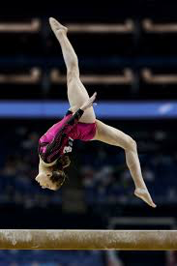
Example: Somersault
Simple / Complex
Why? –

Open / Closed
Why? –

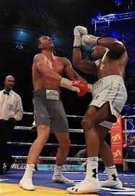
Example: Uppercut
Simple / Complex
Why? –

Open / Closed
Why? –

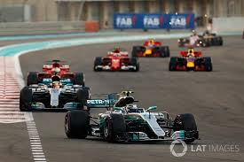
Example: Racing driver
Simple / Complex
Why? –

Open / Closed
Why? –

2.2

Identify what the data in the graph above shows and discuss the possible reasons for this trend in the athlete’s performance and how goal setting could have led to this improvement.

The data shows………………………………………………………………………………………………………………… ………………………………………………………………………………………………………………………………………………………………………………………………………………………………………………………………………………………………………………………………………………………………………………………………………………………………………………………………………………………………………………………………………………………………………………………………………………………………………………………………………………………………………………………………………………………………………………………………………………………………………………………………………………………………………………………………………………………………………………………………………………………………………………………………………………………………………………………………………………………………………………………………………………………………………………………………………………………………………………………………………………………………………………………………………………………………………………………………………………………………………………………………………………………………………………………………………………………………………………………………………………………………………………………………………………………………………………………………………………………………………………………………………………………………………………………………………………………………………………………………………………………………………………………………………………………………………………………………………………………………

2.2 GOAL SETTING

The athlete should be able to reach their goal.
S –

It is important that you have a means of tracking your progress towards your goal.
M –

Goals should contain a lot of detail in order to improve understanding of what you are trying to achieve.
A –

Goals need to be given a defined period in which they should be achieved.
R –

It is important that performance results are logged in order to inform decisions.
T –

2.2

2.2

2.2

2.2

Federer:
…………………………………………………………………………………………………………………………………………………………………………………………………………………………………………………………………………………………………………………………………………………………………………………………………………………………………………………………………………………………………………………………………………………………………………

Murray:
…………………………………………………………………………………………………………………………………………………………………………………………………………………………………………………………………………………………………………………………………………………………………………………………………………………………………………………………………………………………………………………………………………………………………………

Health, fitness and well-being
Topic area: | Learners must:
Health, fitness and well-being | - Know what is meant by health, fitness and well-being  - Understand the different health benefits of exercise and consequences of a sedentary lifestyle:  Physical  - Injury  - CHD  - Blood  - Bone density  - Obesity  - Type 2 diabetes  - Posture  - Fitness  Emotional  - Selfesteem/confidence  - Stress management  - Image  Social  - Friendship  - Belonging to a group  - Loneliness  - Be able to apply the above to different age groups
Diet and Nutrition | - Know the definition of a balanced diet  - Know the components of a balanced diet  - Carbohydrates  - Proteins  - Fats  - Vitamins  - Minerals  - Fibre  - Water  - Understand the effect of diet and hydration of energy use in physical activity  - Be able to apply practical examples for physical activity and sport to diet and nutrition.

2.3 Benefits of exercise and consequences of a sedentary lifestyle
Factor (Physical) | Benefit from Exercise | Consequence of a Sedentary Lifestyle | Age Dependent (notes)
Injury
Coronary Heart Disease (CHD)
Blood Pressure
Bone Density
Obesity
Type 2 Diabetes
Posture
Fitness
Factor (Emotional) | Benefit from exercise | Consequence of a sedentary lifestyle
Self-esteem / Confidence
Stress management
Image

Factor (Social) | Benefit from exercise | Consequence of a sedentary lifestyle
Friendship
Belonging to a group
Loneliness

2.3

2.3

2.3

2.3

2.3

2.3

