GCSE PE
Anatomy and Physiology
Learning Booklet
Name:
Tutor:
Class/teacher(s):
School:

1.1
  - Applied anatomy and physiology – An Overview
Learners will develop knowledge and understanding of the basic structures and functions of body systems that are particularly important to physical activities and sports. They will also study the short and long-term effects of exercise on these systems, and how these effects can impact on physical fitness and performance. Learners will develop the ability to collect and use data, analyse movement and apply their knowledge and understanding, using examples from physical activity and sport.

The sections:
1.1.a. The structure and function of the skeletal system
Learners will be able to name and locate the major bones of the body and be able to apply examples of how the skeletal system allows the functions such as posture and protection. Learners will be able to identify major joints along with the associated articulating bones in the knee, elbow, shoulder and hip. Knowledge will be developed of the types of movement at hinge joints and ball and socket joints, as well as being able to apply these movements to examples from physical activities and sports.
Topic area Learners must:

Glossary of terms for 1.1 a
Articulating bones | Bones that move relative to each other at a joint.
Cartilage | A tough, elastic, fibrous connective tissue
Ligament | A short band of tough and flexible tissue connecting bones together and stabilise the joint.
Synovial Joint | An area where two or more bones meet within a joint capsule and allows a wide range of movement to occur
Tendon | A tendon is a tough yet flexible band of fibrous tissue which joins muscle to bone

Tasks per section:

Location of major bones.
Task) Label the diagram of a skeleton with all 19 bones.
Why are there 20 arrows and not just 19?
………………………………………………………………………………………………………………………………….
………………………………………………………………………………………………………………………………….

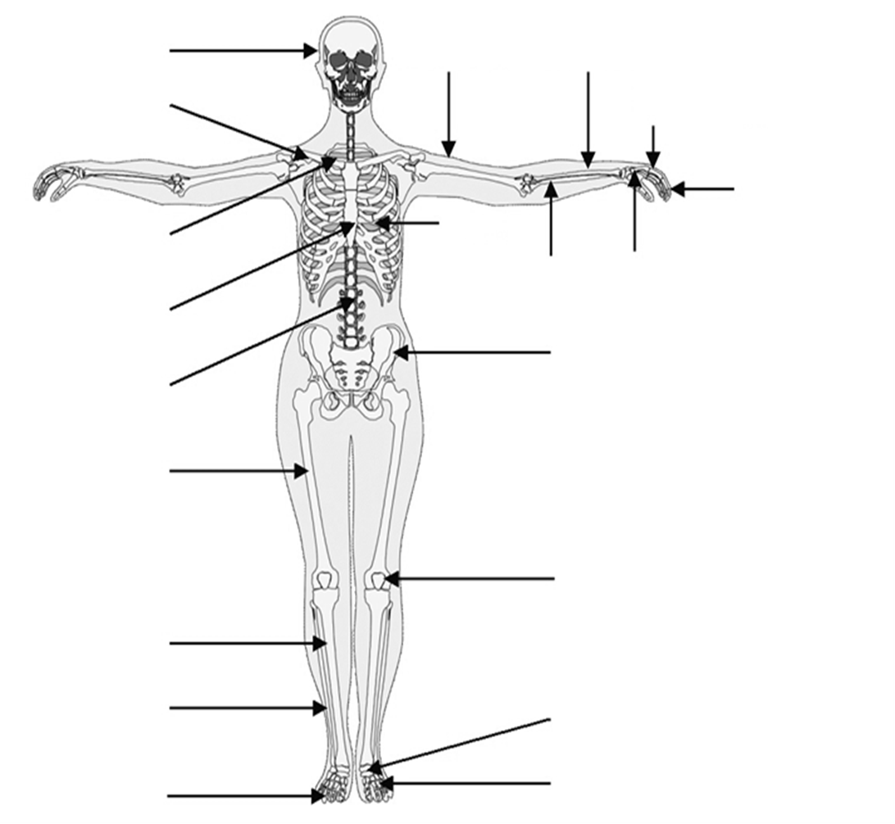

Functions of skeleton.
Task) Identify the functions of the skeleton
- To provide ________ and _________, giving the body its posture
- To allow movement by providing attachment sites for ___________
- To protect the internal ________
- To produce ___________, both red and white
- To store ___________ such as phosphorus, calcium, potassium and iron

Task) Identify the bone that is being described in each clue then fit it into the crossword.
Types of synovial joint
Task) Give the definition of a synovial joint
………………………………………………………………………………………………………………………………….
………………………………………………………………………………………………………………………………….

Types of movements at hinge and ball and socket joints
Task) Complete the table
Joint type | Movements created | Two examples on body | Example in sport
Hinge |  | 1.  2. | 1.  2.
Ball and socket |  | 1.  2. | 1.  2.

Task) Using a sporting example describe the anatomical action at a hinge joint
………………………………………………………………………………………………………………………………….
………………………………………………………………………………………………………………………………….
………………………………………………………………………………………………………………………………….
………………………………………………………………………………………………………………………………….

Other components of joints
Task) In the table, link the component of a joint to its role
Component of joint | Draw an arrow to link to the correct role | Roles
Tendon |  | a soft connective tissue. It acts as a shock absorber and reduces friction at the joint
Ligament |  | attach bone to bone. Function helps to stabilise joints during movement
Cartilage |  | attach muscles to bone. When muscles contract they pull on the tendons which pull on the bones and make them move

1.1.b. The structure and function of the muscular system
Learners will develop their knowledge of the location of the major muscle groups and be able to apply muscle use to examples from physical activities and sport. Learners will also develop their knowledge of the roles of muscles as agonists, antagonists, fixators and also how they operate as antagonistic pairs, again by applying to examples from physical activities and sports.

Glossary of terms for 1.1 b
Abduction | Movement away from the midline of the body
Adduction | Movement towards the midline of the body
Agonist | The muscle that works to create the movement
Antagonist | The muscle that works in the opposite way of the agonist
Antagonistic muscle action | A pair of muscles that work together to produce movement with one muscle contracting whilst the other muscle relaxes. E.g. the upper arm, as the arm flexes the bicep contracts and the triceps relaxes
Circumduction | The circular movement of a joint. It is a movement pattern that combines flexion, extension, adduction, and abduction
Fatigue | Muscle tiredness when the body has a lack of energy
Fixator | A muscle which acts as the stabilizer and helps the agonist work effectively of one part of the body during movement of another part
Flexion | A bending movement around a joint in a limb
Extension | A straightening movement around a joint.
Rotation | The turning of a body part about its long axis as if on a pivot
Tasks per section:

Location of major muscle groups
Task) Label both the front and back diagrams of the muscular system with all 11 muscles.
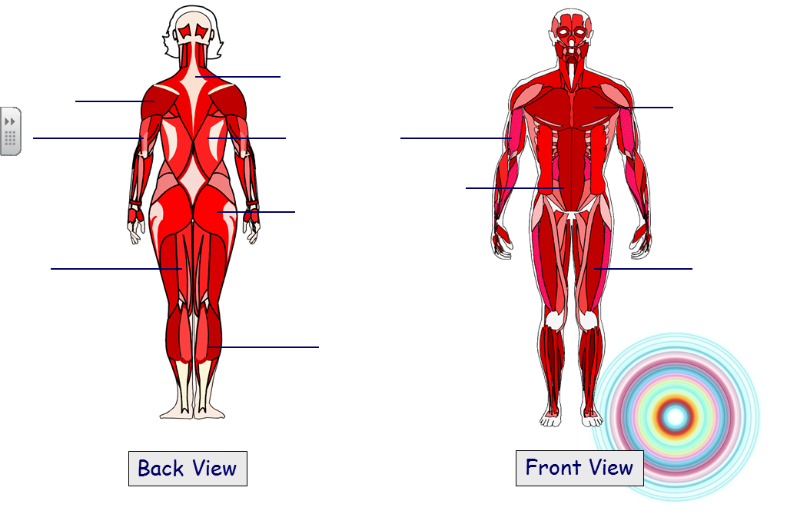
The roles of muscles in movement
Task) Explain the difference between origin and insertion using biceps as the example
………………………………………………………………………………………………………………………………….
………………………………………………………………………………………………………………………………….
………………………………………………………………………………………………………………………………….
………………………………………………………………………………………………………………………………….
………………………………………………………………………………………………………………………………….
………………………………………………………………………………………………………………………………….

Task) Choose a different muscle and identify the origin and insertion points
………………………………………………………………………………………………………………………………….
………………………………………………………………………………………………………………………………….
………………………………………………………………………………………………………………………………….
………………………………………………………………………………………………………………………………….

Task) Complete the table, identifying the agonist and antagonist muscles
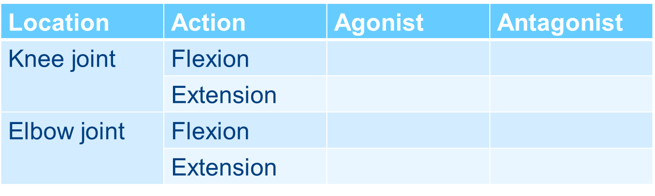
Task) Describe the role of a fixator muscle and provide an example
………………………………………………………………………………………………………………………………….
………………………………………………………………………………………………………………………………….
………………………………………………………………………………………………………………………………….
………………………………………………………………………………………………………………………………….

1.1.c. Movement analysis
Learners will develop their knowledge of the three classes of lever and will be able to use examples from physical activities and sport to show where these levers might operate to produce movement. Learners will become aware of the mechanical advantage provided by levers in movement. Learners will know the three planes of movement and be able to give examples of these levers from different physical activities and sports. Frontal, transverse and longitudinal axes of rotation will be recognised by learners who will be able to apply these to examples from physical activities and sports.

Glossary of terms for 1.1 c
Axis of rotation | A line around which the body can turn
Frontal axis of rotation | Runs horizontally from the front to back of your body. A gymnast performing a cartwheel moves through this axis
Longitudinal axis of rotation | Passes vertically from the top to the bottom of your body. A 360 degree turn rotates through this axis.
Transverse axis of rotation | Passes horizontally from left to right. A somersault passes through this plane
Frontal plane | An imaginary line which divides the body from front to back vertically
Sagittal plane | An imaginary line which divides the body vertically into left and right sides
Transverse plane | An imaginary line which divides the body horizontally from front to back
Levers | - 1st Class: A lever in which the fulcrum is positioned between the load and the effort.  - 2nd Class: A class 2 lever has the load and the effort on the same side of the fulcrum, with the load nearer the fulcrum.  - 3rd Class: The effort is placed between the load and the fulcrum, and the effort must travel a shorter distance and be greater than the load.
Mechanical advantage | 1st and 2nd class levers provide mechanical advantage, this means that a larger load can be moved with a smaller amount of effort.

Tasks per section:
Lever systems
Task) Which is the most common lever in the body
………………………………………………………………………………………………………………………………….
………………………………………………………………………………………………………………………………….

Task) Re-write the definition of mechanical advantage
………………………………………………………………………………………………………………………………….
………………………………………………………………………………………………………………………………….
………………………………………………………………………………………………………………………………….
………………………………………………………………………………………………………………………………….

Task) In the diagrams below, identify each lever then label where the effort and load are

Planes of movement and axes of rotation
Task) Provide a sporting example for each axis
- Frontal axis
………………………………………………………………………………………………………………………………….
………………………………………………………………………………………………………………………………….

- Longitudinal axis
………………………………………………………………………………………………………………………………….
………………………………………………………………………………………………………………………………….

- Transverse axis
………………………………………………………………………………………………………………………………….
………………………………………………………………………………………………………………………………….
Task) Describe the following planes of movement
- Frontal plane
………………………………………………………………………………………………………………………………….
………………………………………………………………………………………………………………………………….
………………………………………………………………………………………………………………………………….

- Sagittal plane
………………………………………………………………………………………………………………………………….
………………………………………………………………………………………………………………………………….
………………………………………………………………………………………………………………………………….

- Transverse plane
………………………………………………………………………………………………………………………………….
………………………………………………………………………………………………………………………………….
………………………………………………………………………………………………………………………………….
1.1.d. The cardiovascular and respiratory systems
Learners will develop their knowledge and understanding of the structure and function of the cardiovascular system. Blood vessels and blood cells with their pathway through the heart will be understood along with definitions of key cardiac terms. Learners will understand the pathway of air through the respiratory system and know the role of the respiratory muscles and alveoli during breathing, along with an understanding of key definitions. Learners will also be able to define aerobic and anaerobic exercise and be able to give practical examples of aerobic and anaerobic activities.
Glossary of terms for 1.1 d
Aerobic exercise | Use of oxygen for the duration of the exercise. Usually at moderate intensity at a continuous rate e.g. long distance running
Anaerobic exercise | Exercise which does not allow for the predominant usage of oxygen. Usually high or very high intensity for a short period of time. E.g. sprinting up a hill
Blood vessels | Tubular structures that carry blood around our bodies
Breathing rate | The number of breaths taken in a minute
Capilliarisation | The development of blood capillaries in the body which increases through long term effects of exercise
Cardiac output | The volume of blood pumped per minute by each ventricle of the heart.  Cardiac output = stroke volume x heart rate
Double circulatory system | The human body has two circulatory loops in which blood circulates. One is oxygenated, and the other is deoxygenated.  Systemic – the circulatory loop that controls blood flow from the heart to the rest of the working muscles and organs.  Pulmonary - the circulatory loop that controls blood flow from the heart to the lungs
Gaseous exchange | The movement of gases taking place at the alveoli and capillaries
Heart rate | Number of heart beats per minute
Lactic acid | A waste product produced in the muscle tissues during strenuous exercise where the anaerobic energy system is in use
Minute ventilation | The volume of gas inhaled or exhaled from the lungs per minute
Red blood cells | Oxygen carrying cells containing haemoglobin
Stroke volume | The amount of blood pumped out of the heart (left ventricle - to the body) during each contraction
Tidal volume | The amount of air which enters the lungs during normal inhalation at rest

Tasks per section:

Structure of cardiovascular system
Task) Label the diagram below with the following structures:
Atria (there is a left and right), Ventricles (there is a right and left), Septum, Triscuspid valve, Bicuspid valve, Semi-lunar valves (pulmonary and aortic), Aorta, Vena cava, Pulmonary vein, Pulmonary artery.
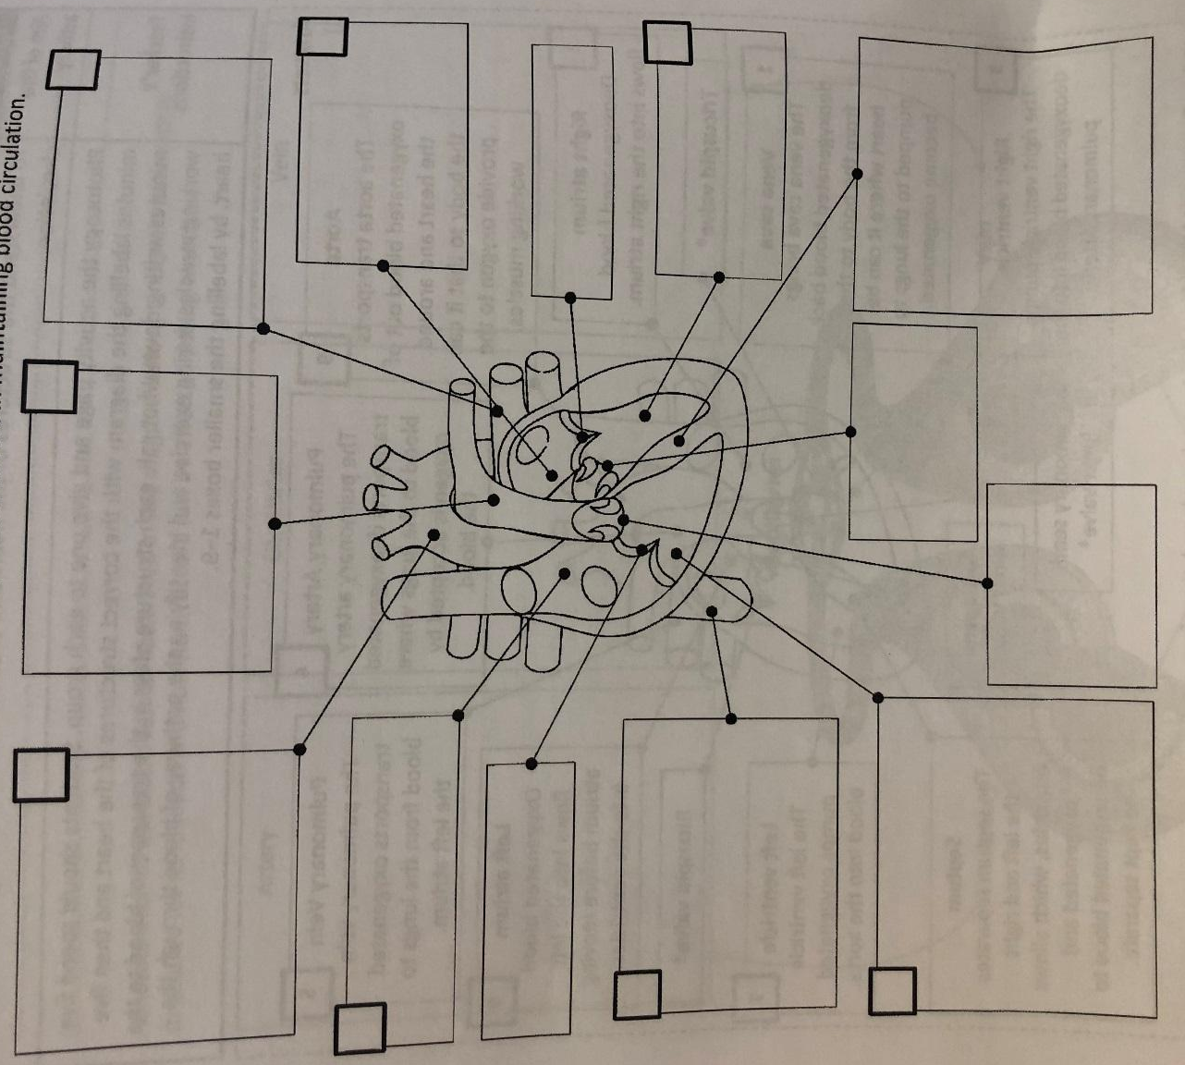

Task) Explain what is meant by the Double Circulatory System
………………………………………………………………………………………………………………………………….
………………………………………………………………………………………………………………………………….
………………………………………………………………………………………………………………………………….
………………………………………………………………………………………………………………………………….

Task) Below is the order of blood through the Pulmonary system and circulatory system. Fill in the blanks

Task) Fill in the boxes with information about each blood vessels. You must include: size of lumen, valves, wall thickness, vasodilation/vasoconstriction, blood pressure
Arteries | Capillaries | Veins

Function of cardiovascular system
Task) Match the following term to the definition
Heart rate |  | The amount of blood ejected from the heart in one minute
Stroke volume |  | The number of times the heart beats in one minute
Cardiac output |  | The amount of blood ejected from the heart with each beat
What is the important equation for cardiac output that uses all the terms above?
___________________ X __________________ = ______________________

Task) Describe the role of each part of the circulatory system
- Atrium
………………………………………………………………………………………………………………………………….
………………………………………………………………………………………………………………………………….
- Ventricles
………………………………………………………………………………………………………………………………….
………………………………………………………………………………………………………………………………….
- Septum
………………………………………………………………………………………………………………………………….
………………………………………………………………………………………………………………………………….

- Aorta
………………………………………………………………………………………………………………………………….
………………………………………………………………………………………………………………………………….
- Vena cava
………………………………………………………………………………………………………………………………….
………………………………………………………………………………………………………………………………….
- Pulmonary artery
………………………………………………………………………………………………………………………………….
………………………………………………………………………………………………………………………………….
- Pulmonary vein
………………………………………………………………………………………………………………………………….
………………………………………………………………………………………………………………………………….
- Bicuspid valve
………………………………………………………………………………………………………………………………….
………………………………………………………………………………………………………………………………….
- Tricuspid valve
………………………………………………………………………………………………………………………………….
………………………………………………………………………………………………………………………………….
- Semilunar valve
………………………………………………………………………………………………………………………………….
………………………………………………………………………………………………………………………………….

Structure of respiratory system
Task) label the diagram of the respiratory system
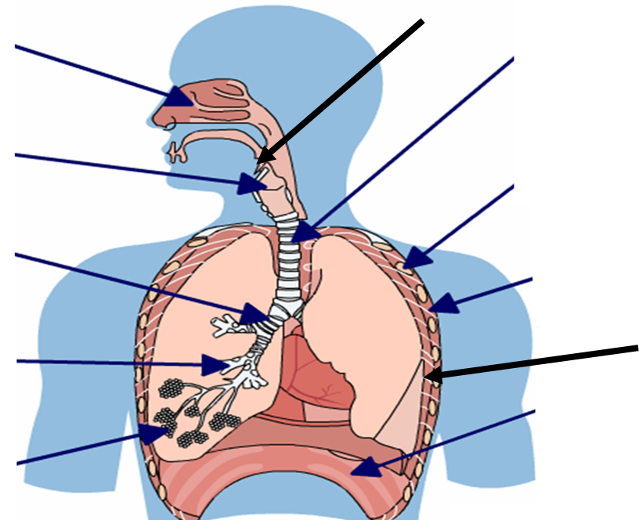
Function of respiratory system
Task) Define the following terms:
- Breathing rate
………………………………………………………………………………………………………………………………….
………………………………………………………………………………………………………………………………….
………………………………………………………………………………………………………………………………….

- Tidal volume
………………………………………………………………………………………………………………………………….
………………………………………………………………………………………………………………………………….
………………………………………………………………………………………………………………………………….

- Minute ventilation
………………………………………………………………………………………………………………………………….
………………………………………………………………………………………………………………………………….
………………………………………………………………………………………………………………………………….
Now use the tree terms above to complete the equation
___________________ = __________________ X ____________________
Task) Circle the correct answer
- when the intercostal (respiratory muscles) contract the thoracic cavity increases/decreases in size
- when the intercostal (respiratory muscles) contract the rib cage moves upwards and outwards/downwards and inwards
- when the diaphragm contracts it flattens which increases/decreases the thoracic cavity, lowering/raising the air pressure and draws air into/out of the lungs

Task) Answer the following questions
What does inspiration mean?
………………………………………………………………………………………………………………………………….
………………………………………………………………………………………………………………………………….
What does exhalation mean?
………………………………………………………………………………………………………………………………….
………………………………………………………………………………………………………………………………….

Task) The journey of air through the respiratory system. Beside each phase explain what each section is and what happens at each section
- Nose

- Mouth

- Trachea

- Bronchi

- Bronchioles

- Alveoli

- Into the blood

Gaseous exchange
Task) Use this diagram to explain how oxygen enters the blood stream and also how the body gets rid of carbon dioxide.
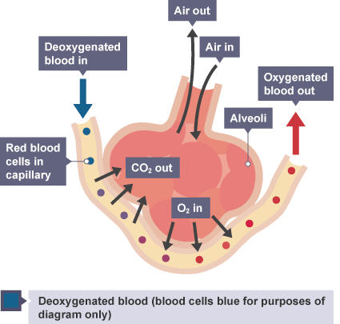

Aerobic and anaerobic exercise
Task) Sort the words below to create definitions of aerobic and anaerobic exercise using all of the words provided and your own words.
OXYGEN ENERGY RESPIRATION ENDURANCE HIGH
LACTIC FAT SPRINTING INTENSITY JOGGING
CARBOHYDRATE GLYCOGEN MODERATE SPRINTING

Aerobic:
………………………………………………………………………………………………………………………………….
………………………………………………………………………………………………………………………………….
………………………………………………………………………………………………………………………………….
………………………………………………………………………………………………………………………………….

Anaerobic:
………………………………………………………………………………………………………………………………….
………………………………………………………………………………………………………………………………….
………………………………………………………………………………………………………………………………….
………………………………………………………………………………………………………………………………….

Task) Discuss with a partner and note down as many different sports as you can and place them into either aerobic, both, or anaerobic circles.
Aerobic Both Anaerobic

1.1.e. Effects of exercise on body systems
Learners will develop their knowledge and understanding of the short and long-term effects of exercise on muscles and bones, the heart and the respiratory system. They will be able to apply understanding of these effects to examples from a range of physical activities and sports. Learners will be able to collect and use data in this section related to both short-term and long-term effects of exercise.
Glossary of terms for 1.1 e
Exercise | Activity that requires physical effort. Usually carried out to sustain or bring about improvements to health or fitness
Physical activity | Movement of the body by the skeletal muscles that requires energy expenditure.
Short term
Fatigue | Muscle tiredness when the body has a lack of energy
Lactic acid | A waste product produced in the muscle tissues during strenuous exercise where the anaerobic energy system is in use
Rate of recovery | The speed at which the body returns back to normal after exercise
Redistribution of blood (aka vascular shunt) | When you exercise the blood is diverted from inactive areas to the muscles that are being used. This action is completed through vasodilation and vasoconstriction Also known as the vascular shunt mechanism.
Long term
Hypertrophy | The increase in size of skeletal or cardiac muscle, often as a result of training or exercise
Should I add more short and long term effects?
Tasks per section:
Short term effects of exercise
Task) Think of all the short term effects that can occur when exercising. Draw a picture of the effect in the box and see if a partner can identify the short term effect.
Then categorise them into respiratory, cardiovascular and muscular effects.
Pic1)

Name the effect:
Pic2)

Name the effect:
Pic3)

Name the effect:
Pic4)

Name the effect:
Pic5)

Name the effect:
Pic6)

Name the effect:
Pic7)

Name the effect:
Task) Define vascular shunt mechanism
………………………………………………………………………………………………………………………………….
………………………………………………………………………………………………………………………………….
………………………………………………………………………………………………………………………………….
………………………………………………………………………………………………………………………………….

Task) Using the information provided below analyse the players; physical fitness, performance and recovery. (3 marks)

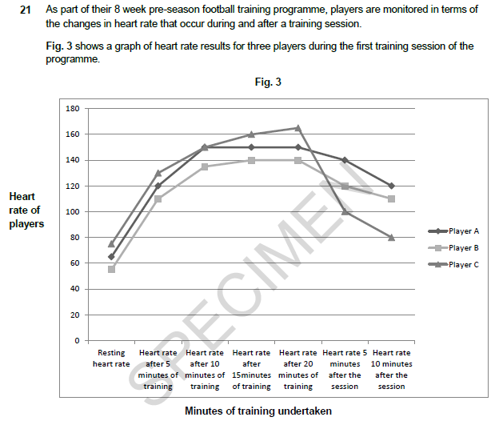

Long term effects of exercise
Task) Identify a long term effect of exercise for each system:
- Cardiovascular system
………………………………………………………………………………………………………………………………….
………………………………………………………………………………………………………………………………….
- Muscular system
………………………………………………………………………………………………………………………………….
………………………………………………………………………………………………………………………………….
- Respiratory system
………………………………………………………………………………………………………………………………….
………………………………………………………………………………………………………………………………….

Task) Complete the sentences below about the long term effects of exercise on the body by filling in the gaps:
1.2
1.2 Physical training
Learners will develop their knowledge and understanding of the components of fitness required for physical activities and sports and how each can be measured. Learners will also be able to apply their knowledge of training principles to personal exercise/training programmes to improve fitness, along with the knowledge of how to optimise training and helping to prevent injury.

The sections:
1.2.a. Components of fitness
Learners will develop their knowledge and understanding of the components of fitness, including cardiovascular endurance, muscular endurance, speed, strength, flexibility and agility. Learners will be able to define each component and be able to apply using a range of practical examples from physical activities and sports. Learners will also develop their knowledge of suitable tests for each component. Learners will be able to collect and use data related to the identified components of fitness.
Glossary of terms for 1.2 a
Agility | The ability to change direction at speed; nimbleness
Balance | The ability to stay upright or stay in control of body movement
Cardiovascular endurance | The ability to continue exertion while getting energy from the aerobic system used to supply the body with energy. Also referred to as stamina
Co-ordination | The ability to move two or more body parts under control, smoothly and efficiently
Flexibility | Range of movement available around a joint
Muscular endurance | The ability to move your body and muscles repeatedly without fatiguing
Power | The ability to exert a maximal force in as short a time as possible
Reaction time | The ability to respond quickly to a stimulus
Speed | The ability to move quickly across the ground or move limbs rapidly through movements.
Strength | The maximum force a muscle/group of muscles can apply against a resistance.

Tasks per section:

Components of fitness
Task) Create a glossary for the components of fitness (without looking at the glossary!) then include examples of activities in sports which require each component.
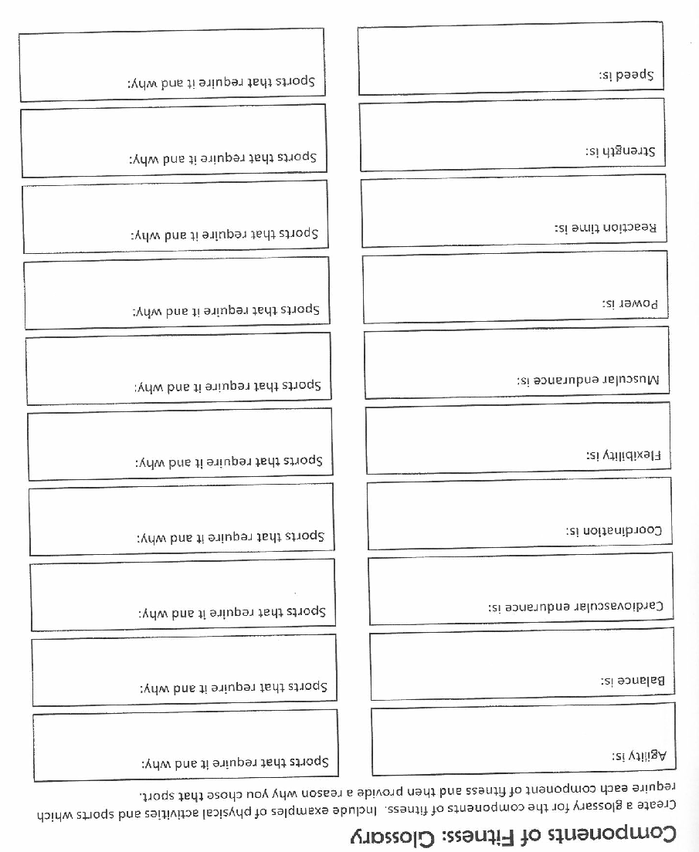

Task) Draw the route for the Illinois agility test. Then explain how it allows a person to test for agility and not just speed.
Picture:

Explanation:
………………………………………………………………………………………………………………………………….
………………………………………………………………………………………………………………………………….

Task) The test procedures have been provided for you. Fill in the rest of the table by identifying the equipment needed, the name of the test, the component of fitness it tests, and the unit of measurement.

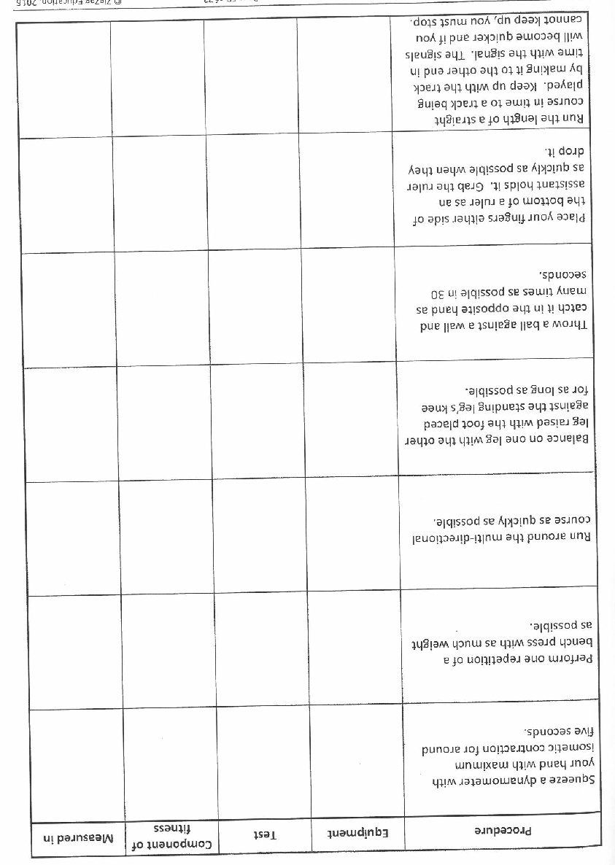
1.2.b. Applying the principles of training
Learners will develop their knowledge and understanding of the principles of training. They will be able to define each principle and be able to apply each to personal exercise/ training programmes. Learners will develop their knowledge and understanding of how to optimise training using the FITT principle and different types of training. Learners will develop their knowledge and understanding of the key components and physical benefits of the warm up and cool down applied to physical activities and sports.
Glossary of terms for 1.2 b
Specificity | The training must be matched to the needs of the sporting activity and individual
Overload | A greater than normal stress that is applied on the body for training adaptations to take place.
Progression | Gradual increases in exercise in order for the body to adapt through overload
Reversibility | Any adaptation that takes place as a result of training will be lost if you stop training
FIIT:  Frequency, Intensity, Time, Type | FITT outlines the key components of an effective exercise program:  Frequency – the number of times exercise takes place Intensity – how hard and intense the exercise is Time – how long you exercise for Type - the kind of exercise that takes place.
Circuit training | Series of alternate exercises performed at stations that focus on different muscle groups
Continuous training | Training that involves activity without rest intervals. It can be performed at any intensity
Cooldown | The act of allowing physiological activity to return to normal gradually after strenuous exercise by engaging in less strenuous exercise.  Aims to slowly decrease breathing, heart rate and muscle temperature
Fartlek | Training which varies in intensity and duration and consists of bursts of intense effort alternating with less strenuous activity
HIIT | Exercise that alternates between high intensity and periods of recovery
Interval training | Training that incorporates periods of exercise and rest
Plyometrics | Involves jumping, bounding, hopping exercise
Warm-up | Preparatory exercises to prepare the body and mind for physical activity. Aims to increase breathing heart rate and muscle temperature

Tasks per section:

Principles of training
Task) Guess the method. Read the caption then choose which method you believe it to be and place the corresponding number in the box.

Task) Using examples, define the following terms:
- Frequency
………………………………………………………………………………………………………………………………….
………………………………………………………………………………………………………………………………….
- Intensity
………………………………………………………………………………………………………………………………….
………………………………………………………………………………………………………………………………….
- Time
………………………………………………………………………………………………………………………………….
………………………………………………………………………………………………………………………………….
- Type
………………………………………………………………………………………………………………………………….
………………………………………………………………………………………………………………………………….

Optimising training
Task) Design a warm-up for your favourite sport using examples.
- Pulse raiser:
………………………………………………………………………………………………………………………………….
………………………………………………………………………………………………………………………………….
- Mobility exercises:
………………………………………………………………………………………………………………………………….
………………………………………………………………………………………………………………………………….
- Stretching:
………………………………………………………………………………………………………………………………….
………………………………………………………………………………………………………………………………….
- Dynamic movements:
………………………………………………………………………………………………………………………………….
………………………………………………………………………………………………………………………………….
- Skills practice:
………………………………………………………………………………………………………………………………….
………………………………………………………………………………………………………………………………….

1.3.c. Preventing injury in physical activity and training
Learners will develop their knowledge and understanding of how to prevent injury when participating in physical activities and sport. The potential hazards will be known in a range of physical activities and sports settings. Learners will know how risks can be minimised by using appropriate equipment, clothing, correct lifting techniques, using the warm up and cool down and an appropriate level of competition.
Glossary of terms for 1.3 c
Hazard | A hazard is an object or situation that could potentially cause harm to an individual
Hydration | Having the appropriate level of water in the body for it to function optimally. When this level of water falls below optimal levels it is referred to as dehydration.
PPE | Personal Protective Equipment. Items that are worn to protect the wearer from harm.

Tasks per section:
Prevention of injury
Task) Identify and highlight all the precautions which have been taken by the following sports team in order to limit the risk of injuries.

Task) Look at the photographs of various sporting facilities. Identify five potential hazards which you would need to be aware of if you were to use the facility.

