THEME 1 – EDEXCEL GCSE BUSINESS 9-1
INVESTIGATING SMALL BUSINESS

THEME 1 COVERS:
Topic 1.1 Enterprise & Entrepreneurship | 1.4 Making the Business Effective
Topic 1.2 Spotting a Business Opportunity | 1.5 Understanding External Influences on Business
Topic 1.3 Putting a Business Idea into Practice

TOPIC 1.3 PUTTING A BUSINESS IDEA INTO PRACTICE

1 | GIVE ME……
Five financial aims and objectives:
1
2
3
4
5
And…. Five non-financial aims and objectives:
1
2
3
4
5

Why do aims and objectives differ between businesses? Think about start-up small businesses to already established and larger businesses.

2 | DEFINE THE FOLLOWING…
Define the following key terms, giving 3 examples of each:
 | DEFINITION | EXAMPLES
FIXED COSTS |  | 1.  2.  3.
VARIABLE COSTS |  | 1.  2.  3.

3 | WHAT’S THE FORMULA…?
Write down the formula for calculating:
Revenue
Total Costs
Profit/Loss
Interest (on loans)
Break-even Output
Margin of Safety

4 | LABEL THE DIAGRAM…
Label the break-even diagram below:
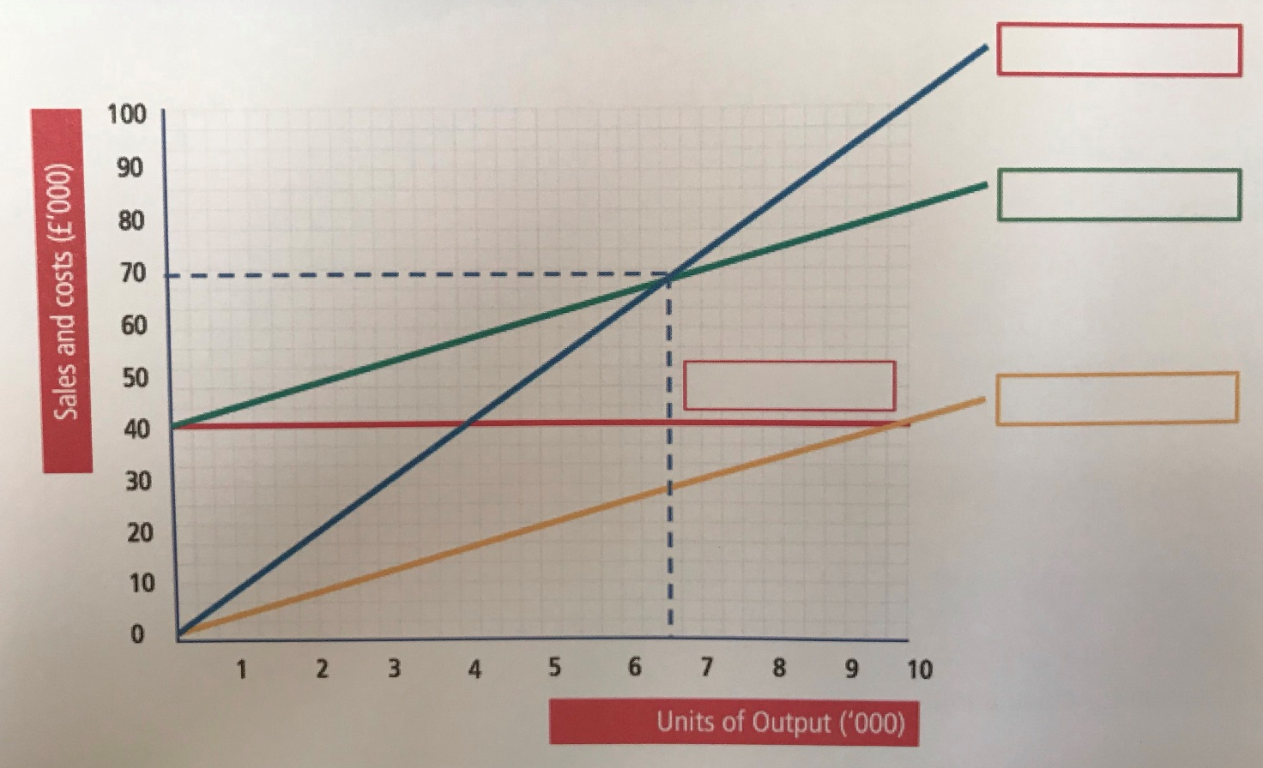

5 | TELL ME…!
How changes in revenue can impact on break-even:
How changes in costs can impact on break-even:

6 | GIVE ME THREE…
Reasons why cash is important to a business:
1

2
3

7 | WHAT’S THE DIFFERENCE…?
Write a definition for the following key terms:
CASH INFLOWS AND CASH OUTFLOWS | OPENING BALANCE AND CLOSING BALANCE

8 | WHAT’S THE FORMULA…?
Write down the formula for calculating:
Net Cash Flow
Opening Balance
Closing Balance

9 | THE BENEFITS & DRAWBACKS…
Write down the definition of the following sources of finance and then identify one benefit and one drawback of each.
 | DEFINITION | BENEFIT | DRAWBACK
Overdraft
Trade Credit
Personal Savings
Venture Capital
Share Capital
Loans
Retained Profit
Crowdfunding

10 | EXTENSION TASK…
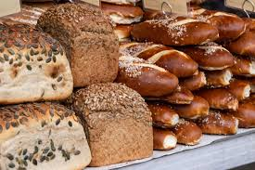
Have a go at answering the following questions. You will need a calculator for this – remember you always need to show your workings!
A bakery sells 150 bread rolls and 200 loaves of bread every day. The price of the bread rolls is 25p per roll and the price of the bread is £1.35 per loaf.
How much revenue is made for the bread rolls per day?

What is the total revenue per day?

What is the total revenue per week if the bakery works a 6-day week?

11 | CASE STUDY TASK…
Read the case study below and answer the questions in detail, using the information from the case study to help you.
CASE STUDY – Pompy’s Cycles
Pompy’s Cycles is a cycle shop in Somerset, founded by Grant Portsmouth in 1992. From the very beginning, the business’s aim was to be family run, supplying the local community and tourists in the area. The business stocks a variety of bicycles, cycling clothing and bicycle related equipment. Pompy’s is the local official dealer for a number of leading bicycle brands. It also advertises cycling events, cycle groups and routes around the local area.

What do you think a business objective is?

What do you think the business objectives of Pompy’s Cycles are?

How might these objectives relate to the success of the business?

Can you think of any other objectives that the business could adopt in order to meet its aim?

12 | EXTENSION TASK 2…
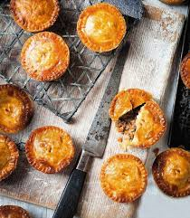
Read the following mini case study and answer the questions below:
Ajay is starting a new business making savoury pies and needs to work out how many pies (units) he needs to sell in order to meet his break-even point. Ajay is planning to sell his pies at £1.25. The ingredients and packing for each pie costs 50p and his fixed costs are £1524 per month.
How many units would Ajay need to sell per month to meet his break-even point?

After 6 months, Ajay’s business has grown and he is considering buying new equipment and employing additional staff. Before he does this, he needs to work out his margin of safety. The business has sold a total of 18,000 pies in its first 6 months. The business’s fixed and variable costs have remained the same as in the previous activity and so Ajay has kept the selling price per pie the same.
Calculate Ajay’s margin of safety.

