THEME 2 – EDEXCEL GCSE BUSINESS 9-1
GROWING THE BUSINESS

THEME 2 COVERS:
Topic 2.1 Growing the business | 2.4 Making financial decisions
Topic 2.2 Making marketing decisions | 2.5 Making human resource decisions
Topic 2.3 Making operational decisions

TOPIC 2.2 MAKING MARKETING DECISIONS

1 | CASE STUDY – THE SNOWDONIA CHEESE COMPANY
Read the case study below and use it to answer the questions. This will help you write in context (in relation to the case study)!
CASE STUDY 1 – THE SNOWDONIA CHEESE COMPANY
Page 175- Edexcel Book
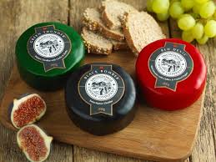
The Snowdonia Cheese Company was founded in 2001. The business’s aim was to create a new variety of premium cheeses using local Welsh ingredients. The Snowdia Cheese Company offers a range of different types and flavours of cheese, including an Extra Mature Cheddar (Black Bomber), Red Leicester (Red Devil), Smoked Cheddar (Beechwood) and Cheddar with cranberries (Bouncing Berry). The business experiments with new recipes and unusual flavours to broaden its range.

A 200g truckle (a small barrel-shaped cheese) of any variety costs £4.50. Most of the cheeses are also available as a 400g truckle or a 3kg wheel. The cheeses are encased in wax to preserve them. Each type of cheese has its own distinctive coloured and is labelled with the company’s black and white label to ensure that the product is instantly recognisable on any deli counter.

The Snowdonia Cheese Company’s cheeses are only sold through luxury grocers and delicatessens, but they have also become the cheese of choice in the number of upmarket restaurants. The business’s cheeses can also be bought, either on their own or in the speciality packs, through the company’s online store.

Amongst other prizes, the Snowdonia Cheese have won World Cheese awards, British Cheese awards and Great Taste awards. The Snowdonia Cheese Company shares news about its awards and success on social media, including Facebook and Twitter. After it emerged that HRH Prince William’s favourite Welsh meal was a lamb burger topped with the business’s Black Bomber cheese, the Snowdonia Cheese Company published the recipe on its website.

The Snowdonia Cheese Company’s products are now stocked in more than 2,000 UK outlets, as well as shops in the USA, Canada and France.

Why might the Snowdonia Cheese Company offer a wide range of products?

How might the Snowdonia Cheese Company decide on their prices?

Who are the Snowdonia Cheese Company’s main competitors?

Why are awards important to a company like the Snowdonia Cheese Company.

2 | GIVE ME THREE…
Elements of the design mix:
1
2
3
Now fill in the blanks on the design mix. After you have finished that, add in some well-known brands/businesses/products. Which element do they focus on the most?

3 | WHAT IS MEANT BY…?
Write down a definition of the key terms listed below:
PRODUCT LIFECYCLE
EXTENSION STRATEGIES

4 | THE PRODUCT LIFECYCLE – LABEL THE DIAGRAM…
Fill in the blank spaces on the product lifecycle below:
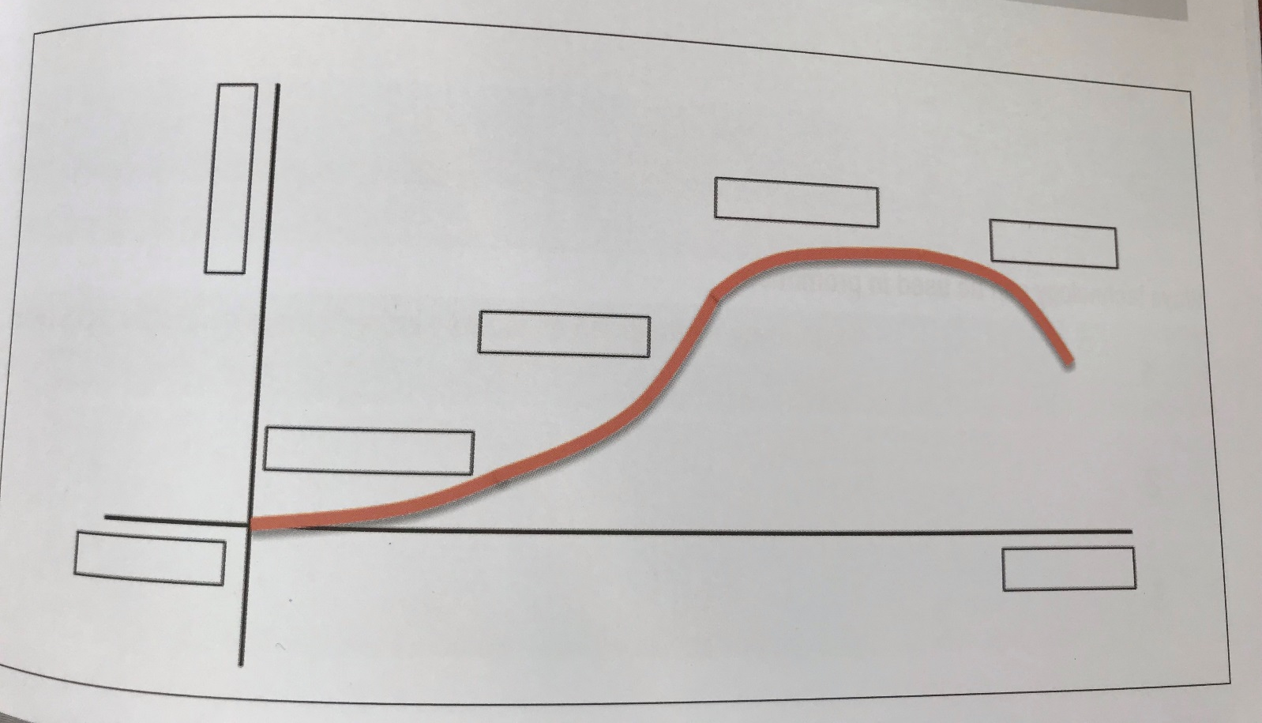
5 | TELL ME…
The importance of a business differentiating a product or service:

6 | GIVE ME THREE…
Write down three ways in which a business can extend the lifecycle of a product/service:
1
2
3

7 | TELL ME THREE…
Write down three influences on pricing strategies:
1
2
3
Write down three promotional strategies:
1
2
3
Write down three ways technology can be used in promotion:
1
2
3

8 | WHAT IS THE DIFFERENCE BETWEEN…?
Tell what the difference is between the two key terms below:
RETAILERS & E-TAILERS

9 | HOW CAN…?
Write down how each element of the marketing mix can influence the other elements?
How can the marketing mix build competitive advantage?
How can an integrated marketing mix influence competitive advantage?

10 | EXTENSION TASK 1 – CASE STUDY (LOUNGE)…
Read the case study below on LOUNGE and answer the following questions:
CASE STUDY - LOUNGE
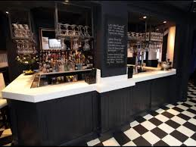
Page 182 – Edexcel Book
Lounge is a fashionable coffee shop in Sheffield. It is located on a major high street, next to other bars and restaurants. The shop’s décor gives it a relaxed and modern vibe.

The business prides itself on the quality of its coffee, which is made from a blend supplied by an independent coffee company. The average price of a cup of coffee at Lounge is £4.25

- What factors do you think will determine Lounge’s decision to charge £4.25 for a cup of coffee?
- What factors do you think determine how many cups of coffee are sold at Lounge?

11 | EXTENSION TASK 2 – CONSIDER THE STATEMENTS
With the person next to you, consider the following statements, then think of an example of one product or service that could apply to each statement. You will then need to justify your choice.
Statement | Product/service | Justification
The business is happy to sell the product at a lower price than the amount that it costs to make.
The customers will accept a high price, even when they do not believe that the product or service is worth the price.
The business gives the product away for free for a limited time.
The business chooses to make and sell a product at a low margin.
The customer pays a low price for the product that they perceive to be worth more.
The business is happy to sell smaller amounts of its product.
For each of the above statements, think of your own experiences when buying products and services from businesses you know.

12 | EXTENSION TASK 3 – CASE STUDY (SportsShoes.com)…
Read the case study below on SportsShoes.com and answer the following question:
SportsShoes.com
SportsShoes.com is an online retailer that specialises in sporting equipment, particularly in sports shoes.

It offers more than 12,000 products, including running shoes, clothing and hiking equipment.

SportsShoes.com stocks leading brands and features lots of expert advice on its website. Customers can talk to an expert via Live Chat, as well as reading articles and interacting with other runners through the site’s MyRunspiration Community.

Discuss with the person next to you, and answer the below question:
- Why do you think SportsShoes.com might have decided to sell products via a website?
- Why do you think SportsShoes.com offers a live chat facility and posts articles about running and related topics on their website?

13 | ACTIVITY 1 – HIGH-STREET BUSINESSES
List as many high-street businesses as you can think of. Put the names of the business that you have identified into a table like the one below. For each business, find out whether it has a website and whether its website supports e-commerce (that is, whether it allows customers to buy products and services online).
BUSINESS | WEBSITE? | E-COMMERCE?

13 | ACTIVITY 2 – GLOBAL BUSINESSES
Consider the following examples of global businesses. For each business, consider how the elements of the marketing mix interact with each other and answer the question that follows…
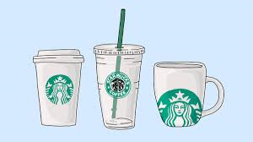
STARBUCKS
Starbucks is a global coffee chain that prides itself on providing excellent quality coffee and a laid-back, relaxing atmosphere in its stores. Starbucks aims to be a socially responsible business and it only buys its coffee from sustainable growers.

How might other elements of the marketing mix influence Starbuck’s decisions about place?

ORLA KIELY

Orla Kiely is an Irish designer who produces retro prints for use in her own range of products. Her brand covers products such as clothing, furniture and homeware goods.
Famous for its distinctive patterns, the brand targets women between the ages of 20 and 40.

How might other elements of the marketing mix influence Orla Kiely’s decisions about promotion?

