THEME 2 – EDEXCEL GCSE BUSINESS 9-1
GROWING THE BUSINESS

THEME 2 COVERS:
Topic 2.1 Growing the business | 2.4 Making financial decisions
Topic 2.2 Making marketing decisions | 2.5 Making human resource decisions
Topic 2.3 Making operational decisions

TOPIC 2.3 MAKING OPERATIONAL DECISIONS

1 | CASE STUDY – PHOTOBOX
Read the case study below and use it to answer the questions. This will help you write in context (in relation to the case study)!
CASE STUDY 1 – PHOTOBOX
Page 207- Edexcel Book
PhotoBox is an online photograph printing business. Customers can upload their photographs onto the business’s platform in order to edit them and have them printed in a variety of different sizes or into an album, as well as on a range of customisable products such as mugs and phone cases. As customers order customised products in a variety of sizes and quantity, each order fulfilled by PhotoBox is specifically tailored to each customer.

PhotoBox makes it easy for customers to upload their photos from their computers, smartphones or social media profiles. Customers can store their favourite photos in their account on the PhotoBox website, which also allows them to track the status of their order. For some of its products, Photobox also offers its customers a range of delivery options, including next day delivery for orders placed before midday.

The PhotoBox website automatically checks the resolution of each image before confirming the order. If an image is too small or the quality is too bad to be printed, the customer is informed of this. This ensures that customers will understand why a photo cannot be printed and only receive products that they will be totally satisfied with. The business prides itself on the quality of its products because ‘every memory deserves to be cherished.’

The Photobox website also allows customers to leave feedback and review PhotoBox’s products on a platform called Trust Pilot. In December 2016, the average customer satisfaction rating for Photobox was 8.5 out of 10. PhotoBox has also won a number of internet retailing awards.

What issues do you think PhotoBox could face when fulfilling orders specifically tailored to each customer?

How important is technology to Photobox’s business operations?

Why is a very good customer satisfaction rating important for a business like PhotoBox?

2 | TELL ME…
The overall purpose of business operations:

3 | DEFINE AND IDENTIFY…
Write a definition for each of the following production processes and identify one benefit and one drawback of each:
JOB PRODUCTION
DEFINITION:

BENEFIT | DRAWBACK

BATCH PRODUCTION
DEFINITION:

BENEFIT | DRAWBACK

FLOW PRODUCTION
DEFINITION:

BENEFIT | DRAWBACK

4 | GIVE ME THREE…
Write down three ways technology has impacted on production:
1
2
3

5 | LABEL THE DIAGRAM…
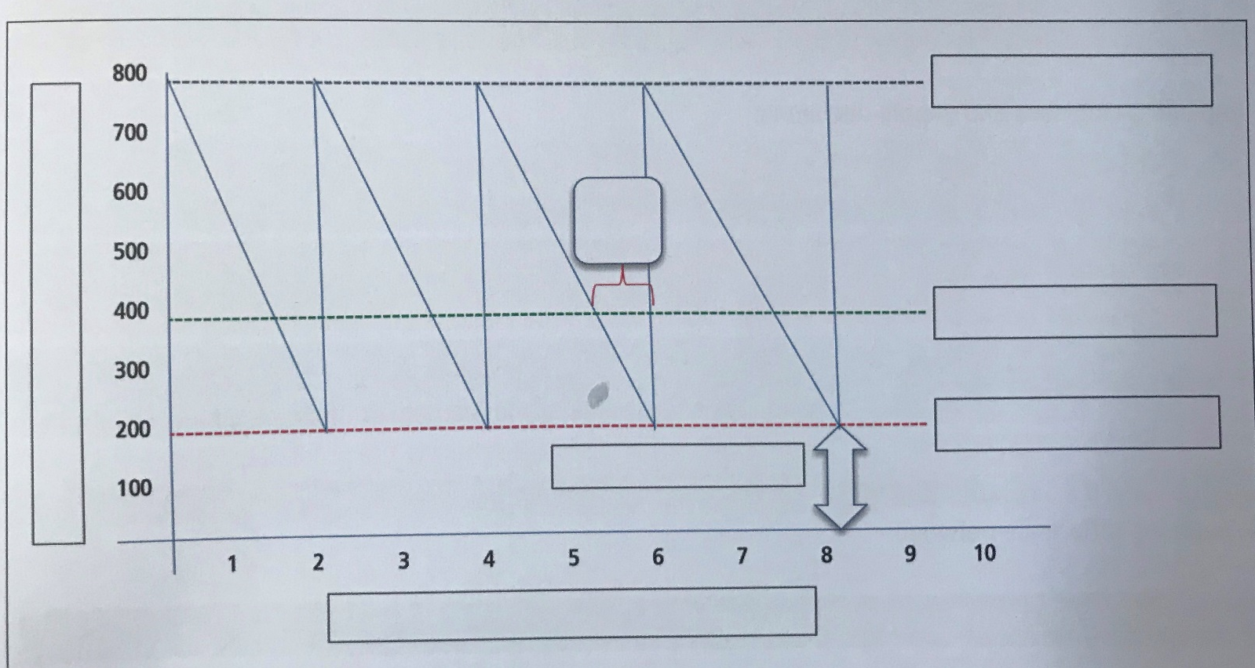
Look at the bar gate stock graph below and label the blank boxes:

6 | WHAT IS MEANT BY…?
Write down a definition for the following key terms:
Just In Time
JIT

Procurement

7 | GIVE ME THREE…
Write down three factors that lead to the efficient procurement of raw materials.
1
2
3

Write down three impacts on logistics and supply decisions:
1
2
3

8 | WHAT IS THE DIFFERENCE BETWEEN…?
Write down as many differences between the following:
QUALITY CONROL | QUALITY ASSURANCE

9 | TELL ME WHY…
Tell me why quality is important to a business:

10 | FIVE STAGES…
Identify and write down all of the five stages of the sales process.
1
2
3
4
5

11 | TELL ME THE IMPACT…
Write down the impact on a business if an element of the sales process is poor. Perhaps you have experienced your own negative customer service? Write down what happened using as much key terminology as possible:
Now write down the importance of good customer service to a business:

12 | EXTENSION TASK 1 – CASE STUDY (A Suit That Fits)…
Read the case study below on A Suit That Fits and answer the following questions:
CASE STUDY – A SUIT THAT FITS
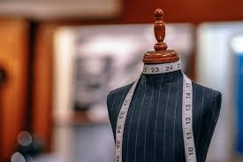
Page 208 – Edexcel Book
A Suit That Fits is a business that makes made-to-measure suits for individual customers. The business assigns each customer their own tailor, who takes measurements and helps the customer to design their own suit from a range of materials.

Choices can include collar and cuff styles and embroided initials. The suit is handmade and the service includes free fittings and adjustments before the customer collects their finished suit.

What level of skill does A Suit That Fits require its employees to have?
How do you think the way in which the business operates might have an impact on the number of suits that it can make?
How could a business like A Suit That Fits ensure it can provide customers with a lot of flexibility and customisation?

13 | EXTENSION TASK 2 – CASE STUDY (Spoilt for Choice)
Read the case study below on Spoilt for Choice and answer the following questions – AO2!
CASE STUDY – SPOILT FOR CHOICE
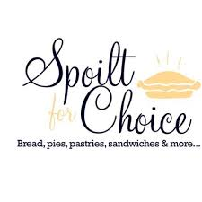
Page 215 – Edexcel Book
Spoilt for Choice is a sandwich shop in Lincoln that specialises in sandwiches and snacks made from local Lincolnshire produce. All the ingredients used in the sandwiches are organic and come from local growers and farms.
Spoilt for Choice purchases its ingredients from 12 different suppliers, even though it could easily order similar ingredients from one or two large suppliers that sell ingredients source from all over the UK.

Why do you think using local Lincolnshire produce might be important to Spoilt for Choice?

Why might it be necessary for the business to use 12 different suppliers?

What issues do you think Spoilt for Choice might face when ordering ingredients from so many different suppliers?

14 | EXTENSION TASK 3 – CASE STUDY (INDIGO FURNITURE)…
Read the case study below on INDIGO FURNITURE and answer the following question:
CASE STUDY – INDIGO FURNITURE
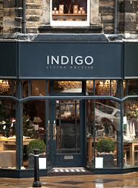
Page 223 Edexcel - Book
Indigo Furniture makes its furniture from European oak, Quebec pine and English leather that is tanned in Italy.
The business stills uses a water-powered mill that dates back to 1850 as its main workshop. Indigo’s unusual chunky furniture is designed and handmade by a team of master craftsmen and every piece of furniture has a 15-year guarantee.

Discuss with the person next to you, and answer the below question:
What factors suggest that Indigo Furniture make high-quality products?
What do you think this level of quality allows Indigo Furniture to do with its prices?
How do you think this level of quality affects Indigo Furniture’s ability to compete?

15 | EXTENSION TASK 4 – CASE STUDY (HSBC)
Read the case study below on HSBC relating to the sales process and answer the following questions…
Edexcel Pages 226-227

The bank HSBC invests heavily in its UK-based customer service team. The call-centre process is designed to minimise waiting time, with employees aiming to answer calls within seconds.
Employees are trained to deliver excellent service and all calls are monitored. After a call, customers receive a text message asking them for feedback about whether HSBC met their needs and expectations.

Why do you think HSBC invests so much in its call centre and customer service team?

Why is it important for a business to gather feedback from its customers?

Do you think that delivering excellent service always improves a business’s profits?

16 | EXTENSION TASK 4 – CASE STUDY (HSBC)
Below are examples of two services you could buy. Reads through the instructions and answer the questions in the box below:
ACTIVITY 1 - SERVICES
SERVICE 1 – A train journey to London
SERVICE 2 – An eye test at an opticians

- For each service, make a list of five or more things that you think would contribute to good customer service.
- Rank the items of both lists in order of importance. Are the things in the same order for both services?

