THEME 2 – EDEXCEL GCSE BUSINESS 9-1
GROWING THE BUSINESS

THEME 2 COVERS:
Topic 2.1 Growing the business | 2.4 Making financial decisions
Topic 2.2 Making marketing decisions | 2.5 Making human resource decisions
Topic 2.3 Making operational decisions

TOPIC 2.4 MAKING FINANCIAL DECISIONS

1 | CASE STUDY – WHITBREAD
Read the case study below and use it to answer the questions. This will help you write in context (in relation to the case study)!
CASE STUDY 1 – WHITBREAD
Page 235- Edexcel Book
Whitbread is a large hospitality company that’s owns a range of well-known restaurant, hotel and coffee shop chains including Premier Inn and Costa Coffee. In 2016, Whitbread announced that its sales and profits has risen thanks to increased sales at Costa Coffee and Premier Inn. Its sales increased by 19%, while its pre-tax profit rose by 5.4% to £307 million.

The business believes that Costa Coffee still has potential to expand. However, exchange rates mean that the cost of coffee will rise. The business buys its coffee in US Dollars, meaning that the weak pound will have an impact on the business’s costs, although Whitbread is prepared for this.

Whitbread’s Chief Executive, Alison Brittain, said that Costa Coffee’s success is based on the fact that its products are service offer great value for money, and that the business would continue focus on that in the future.

Both Costa Coffee and Premier Inn were affected by the introduction of the National Living Wage. This is a new minimum wage for employees over the age of 25, which was introduced nationwide in 2016. At its launch, the National Living Wage was £7.20 per hour. This had a considerable impact on Whitbread’s labour costs, particularly as Whitbread chose to introduce the new higher wage before it needed to, in October 2015.

By April 2017, the business plans to open another 230-250 Costa Coffee shops internationally and 3700 new Premier Inn rooms in the UK.

Which is more important to Whitbread: its sales or pre-tax profit?

What strategies could Whitbread use to maximise its profits?

How might a business like Whitbread reinvest its profits?

2 | WHAT IS THE DIFFERENCE BETWEEN…?
Write down as many differences as you can:
GROSS PROFIT & NET PROFIT

3 | WHAT IS THE FORMULA…?
Write down the formula for calculating the following:
GROSS PROFIT
GROSS PROFIT MARGIN
NET PROFIT
NET PROFIT MARGIN
AVERAGE RATE OF RETURN

4 | GIVE ME THREE…
Write down three types of QUANTITATIVE business data that can be used to support, inform and justify business decisions.
1
2
3

5 | TELL ME…!
Write down the use and limitations of financial information in understanding business performance and making business decisions.
USE OF FINANCIAL INFORMATION

LIMITATIONS OF FINANCIAL INFORMATION

6 | EXTENSION TASK 1 – APPLE
With the person next to you, read through the Apple case study, read the below three questions and answer in as much detail as possible.
CASE STUDY – APPLE
Page 236 – Edexcel Book
In 206, Apple’s iPhone sales started to decline. In October 2016, the business forecast that its profit margin would be smaller than previously expected, even though Christmas was approaching.

It announced that it expected sales in China to improve, even htough its revenue in China fell almost 30% in the previous three months. Despite the launch of the improved iPhone 7, some people began to suggest that Apple has lost technological advantage over its competitors.

What is the relationship between sales and profit?
How might Apple respond to the financial information in this case study?
What other information might Apple use to understand its overall business performance?

7 | EXTENSION TASK 2 – FINANCE ACTIVITY
With the person next to you, read the instructions below and answer the questions:
FINANCE ACTIVITY
Page 241 – Edexcel Book
Identify two large public limited companies that operate in the same industry and use their websites to find their most recent sets of financial accounts. This information may be in their annual report.

PUBLIC LIMITED COMPANY 1 _____________________

PUBLIC LIMITED COMPANY 2 _____________________

- Using these accounts, find out the business’s:
 | PLC 1 | PLC 2
SALES REVENUE/TURNOVER
GROSS PROFIT
NET PROFIT (MAY BE SHOWN AS OEPRATING PROFIT, PRE-TAX PROFIT OR PROFIT AFTER TAX)

- Using This information, calculate the gross profit margin and net profit margin for each business
PLC 1
GROSS PROFIT MARGIN
NET PROFIT MARGIN
PLC 2
GROSS PROFIT MARGIN
NET PROFIT MARGIN

- Based on this information, decide which of the two companies performed best over the past year.

- Are you surprised by the results? Can you think of any reasons why one business might have performed better than the other?

- What other information might you need in order to make a judgement on the success of these two businesses?

8 | EXTENSION TASK 3 – DATA ACTIVITY
Pages 248 and 249 Edexcel Book
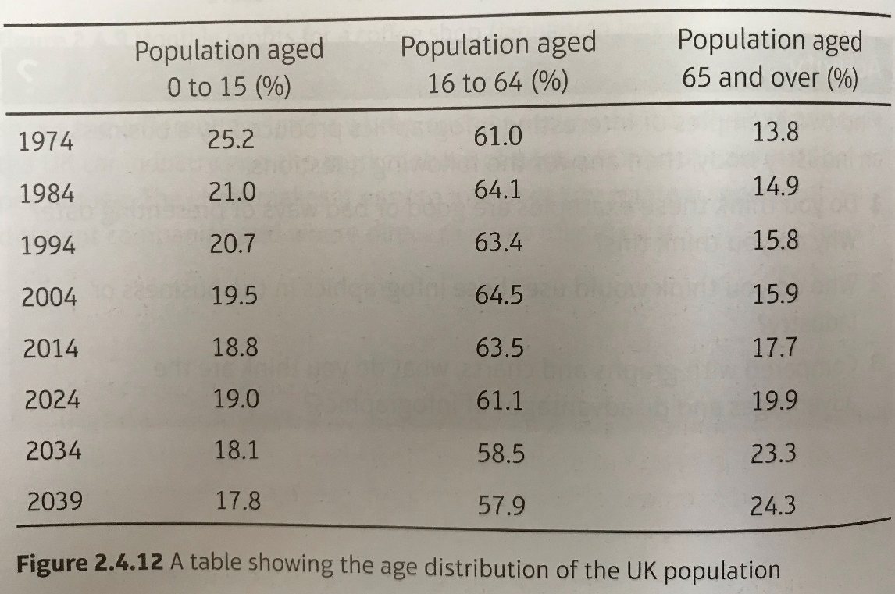
Look at the information presented in Figures 2.4.12 and 2.4.13, then answer the following questions. Figure 2.4.12 is a chart that represents the proportion of the population across different age groups, forecasting up to the year 2039. Figure 2.4.13 is a graph that represents the average weekly earnings growth rates for workers across the UK.

Discuss with the person next to you, and answer the below question:
List three facts that could be interpreted from the chart and three facts from the graph.
How could a business use the market data contained in these charts?
Explain one decision that a hotel chain might make based on the information presented in Figures 2.4.12 and 2.4.13.

