Own Learning questions
Unit 1 – The Business Environment

These questions are designed for you to complete in your Study Periods. The aim is for you to consolidate your learning and identify any knowledge gaps. The outcome is a complete set of revision notes.

You can use the following resources to help you:

- Tutor2U website (google the topic area and Tutor2u as the site is difficult to navigate around!)
- Tutor2u Youtube channel
- Your class notes
- The Cambridge Technicals Level 3 Business Book

When you have completed each section of Own Learning Questions, why don’t you print them out and file them in the appropriate section of your folder? We’ll be checking them!

An electronic copy of these questions is on XXXXXXXXX

LO1 – Understand the Different Types of Businesses and Their Objectives

- What are the three different types of business activity?

- What are the three different sectors of operation?

- Create a table like the one below and complete the columns and rows about business ownership types.

Ownership Type | Description | Pros | Cons
Sole Trader

Partnership

Private Limited (Ltd)

Public Limited (Plc)

State/government owned

Charity/not for profit

Community interest companies (CIC)

- What are the main factors that inform business ownership?

- What are the different types of business objectives?

- What are the most important factors for businesses to consider when setting objectives?

LO2 Key Functional Areas of a Business

- What are the main functional areas of a business?

- What does each functional area do?

- Demonstrate how and why the functional areas work together by completing the table below (first one is completed for you).

Functional Area | Other functional areas they could liaise with | Reasons why good communication is important between these functional areas
Finance | Finance will need to liaise with the sales function to gain accurate sales figures. | Accurate sales figures are vital if the finance function is to produce accurate financial accounts.

LO3 Understand the Effect that Different Organisational Structure have on how Businesses Operate

- What are the different organisational structure types?

- What factors influence an organisations structure?

Type of Structure (description and diagram) | Advantages of structure | Disadvantages of structure | Type of business best suited to structure

- Why are organisational structures useful?

- Explain the status and role of the following jobs in an organisation?

Job | Description of job role | Status of job within the organisation
Chief Executive

Director

Managers

Supervisors

Assistant/Operative

LO4 Be able to use Financial Information to Check the Financial Health of a Business

- Give definitions, examples (and formulas where appropriate) of the following terms:

Terms | Definition
Opportunity Cost

Fixed Cost

Variable Cost

Revenue

Profit

Break even

Margin of Safety

- What is a cash flow forecast?

- What is the deference between a cash flow forecast and a statement?

- Give three examples of cash inflows and outflows.

- What is net cash flow and how is it calculated?

- What is more important, cash or profit? Why?

- Using the information on the table below calculate for each business:
- Break-even point/output
- Profit/loss per unit
- Total profit/loss
- Margin of safety
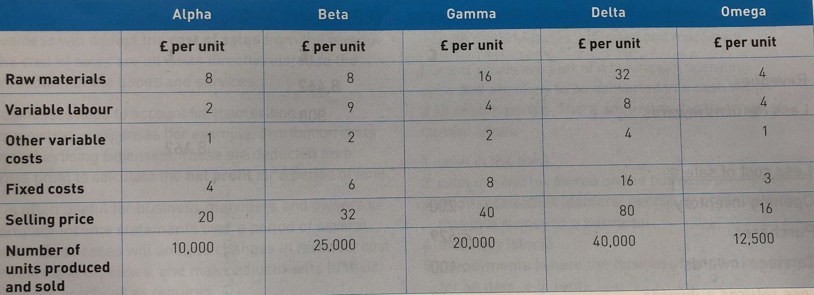

- What is an income statement and how would it be laid out?

- What is a cash flow forecast and how would it be laid out?

- How can businesses resolve cash flow problems?

- What is a statement of financial position and how would it be laid out?

LO5 Understand the Relationship Between Businesses and Stakeholders

- What is a stakeholder?

- What is the difference between an internal and external stakeholder?

- Complete the table below about the different types of stakeholder:

Stakeholder | Type  (internal/external) | Example Objectives | Why this stakeholder is important
Employee (staff and managers)
Owner/Founder

Customer

Suppliers

Financial Businesses

Local residents/communities
Local and central government
Trade unions

Shareholders

Pressure groups

- How do stakeholders attempt to alter business behaviour?

- How do businesses respond to the different/conflicting objectives of different stakeholders?

- What is a stakeholder analysis and what should it contain?

- What are the benefits and drawbacks of stakeholder analysis?

Benefits | Drawbacks

- What are the consequences to business of not listening to its stakeholders?

LO6 Understand the External Influences on Businesses

- Conduct a PESTLE analysis of McDonalds making sure you cover the following areas:

Factors - Political | Impact on McDonalds
Political Instability

Change of government

Government Initiatives

Factors – Environmental | Impact on McDonalds
Energy Management

Carbon Emissions

Waste Reductions

Recycling

Pollution

Factors - Social | Impact on McDonalds
Demographic Issues

Attitudes to Work

Disposable Income

Social Trends

Factors – Technological | Impact on McDonalds
Automation

Communication

Purchasing/sales

Mobile

Factor – Legal | Impact on McDonalds
Business Framework

Consumer Protection

Employee Protection

Data Protection Act

Copyright, Design and Patent Act

Planning Permission

Factors – Ethical | Impact on McDonalds
Workforce

CSR

Environmentally Friendly

Welfare Schemes

- Conduct a competitor analysis for McDonalds.

LO7 Understand Why Businesses Plan

- Explain three reasons why businesses plan.

- You know that planning reduces the chance of business failure. Explain two reasons why businesses fail.

- Outline why a business may need to seek additional funds.

- Complete the table below about sources of finance?

Source of Finance | Definition | Advantages | Disadvantages
Savings

Retained profit and reserves

Overdraft

Loan

Mortgage

Credit Card

Hire Purchase

Trade Credit

Venture Capital

Share Issues

Crowdfunding

- What is a business plan and when is it used?

- Explain what information is included in each of the following areas on a business plan:

Headings | Contents
Executive Summary

General
Business Description

Products and Services

Financial Plan

Resource Requirements

Marketing

Operational Plan

Management and Organisation

LO8 Be able to Assess the Performance of a Business to Inform Future Activities

- As you are aware there are both financial and non-financial reasons that will contribute to how a business performs. Using your knowledge compete the table below:

Financial factors | Non-financial factors | Short-term factors | Long-term factors

- What is a SWOT analysis and what is it used for?

- What is a KPI and why is it important for businesses to use them?

- Complete the assessment practice questions below:

