R064
Enterprise & Marketing

Everything you need to know for your January exam!

The need for customer segmentation
- Customers require different benefits from a product
- Different customers have different budgets
- Different incomes
- Expect different quality of goods
- Want to buy larger amounts
- Want to be able to purchase online or in store

Types of market segmentation
- Age
- Occupation
- Income
- Geographic
- Lifestyle
- Gender

Benefits of marketing segmentation
- Ensuring customer needs are matched and met
- Increased profit
- Increased customer retention
- Targeted marketing
- Increase in market share

Purpose of market research
- Aid decision making (like price, colour)
- Reduce risk
- Understand the market (competitors)
- Promote the organisation
- Gain customers’ views and needs
- Inform product development
Primary research
- Questionnaire
- Survey
- Consumer trial
- Observations
- Focus groups

Benefits of primary research
- Research can be tailored to your specific product so more relevant
- Results are more likely to be up-to-date
- Results not available to competitors
- Helps make less risky decisions

Secondary research
- Internal data
- Books/newspapers
- Trade magazines
- Competitors’ data
- Government publications and statistics
- Mintel reports
Benefits of secondary research
- Cost of accessing information usually low
- Relatively quick to obtain

Customer feedback
- Customer comment card
- Social media reviews and comments
- Online surveys
- Comments made to staff
- Telephone or email surveys
- Email contact forms

Costs
Variable costs - costs that changes with output
- Ink cartridges for cash till
- Stock
- Packaging like boxes for a shoe shop or carrier bags
- Components like engines for a plane
- Raw materials like milk for a coffee shop

Fixed costs - costs that do not vary with output
- Insurance for the shop premises
- Loan repayments
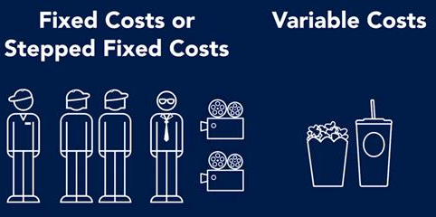
- Advertising
- Rent
- Salaries
- Utilities

Total costs
Fixed costs + Variable costs
Revenue
- Money received by the business
- Selling price x quantity sold

Break-even point
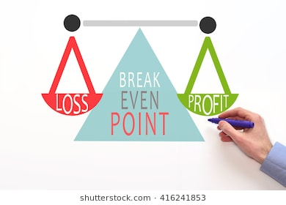
- Total revenue = total cost

Break-even formula
- Fixed costs/selling price - variable costs

Break-even
- VC, FC, TC, Revenue lines on graph
- Show how long before start-up becomes profitable
- Help understand the viability of an idea
- Calculate the margin of safety
- Assess the level of risk introducing product
- Assess the impact of changing the price charged

Profit
- Revenue per unit - total costs per unit

Product life cycle
Stages
- Development
- Introduction
- Growth
- Maturity
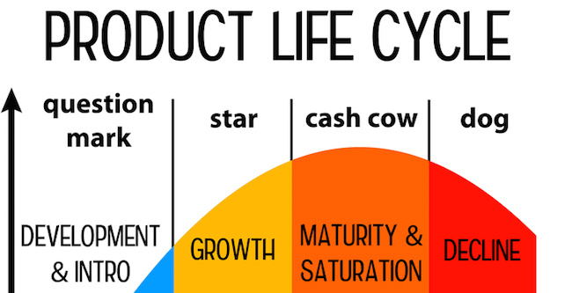
- Decline

Development stage
- No sales, product not on sale
- Loss made due to development costs

Introduction stage
- Product is launched
- Sales may be low initially
- Losses likely to continue
Growth stage
- Profit margins improve
- Sales grow quickly

Maturity stage
- Sales volumes peak
- Profits start to fall as competition increases

Decline stage
- Sales drop
- Profit decreases
Extension strategies
Adding value
- Improve specification of product

New packaging
- Redesign video game box

Expanding into new markets
- Targeting a new age group
- Targeting a new country

Price changes
- Price is often reduced due to increased competition at this stage

Advertising
- New advertising campaigns can attract new customers
- Or remind previous customers
- Or encourage customers to buy more

Product differentiation
Moving to an area with no other similar shops
Personalising products
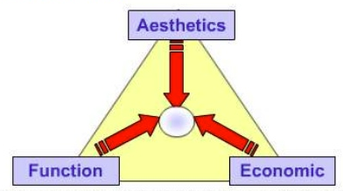
Design mix model
- Function
- Cost
- Appearance

USP
- Unique selling point
- a feature that makes a product different to its competitors
- Could be location, design, function, appearance, selling price or actual product

External factors
Technological developments
- Launch of new production machinery
- Digital developments
- Increased automation brings price down
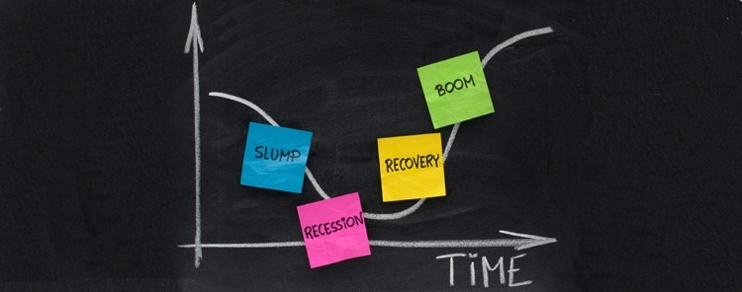
Economic
- Recession
- Recover
- Boom
- Slump
- Taxation

Effects of recession
- Customers looking for cheaper products
- Interest rates may go down
- Fewer sales so less money for product development

Legal
- New product safety standards
- Patenting new products
- Copyright challenge

Factors affecting pricing
- Income levels of target customers
- Price of competitor products
- Cost of production
- Local factors (unemployment)

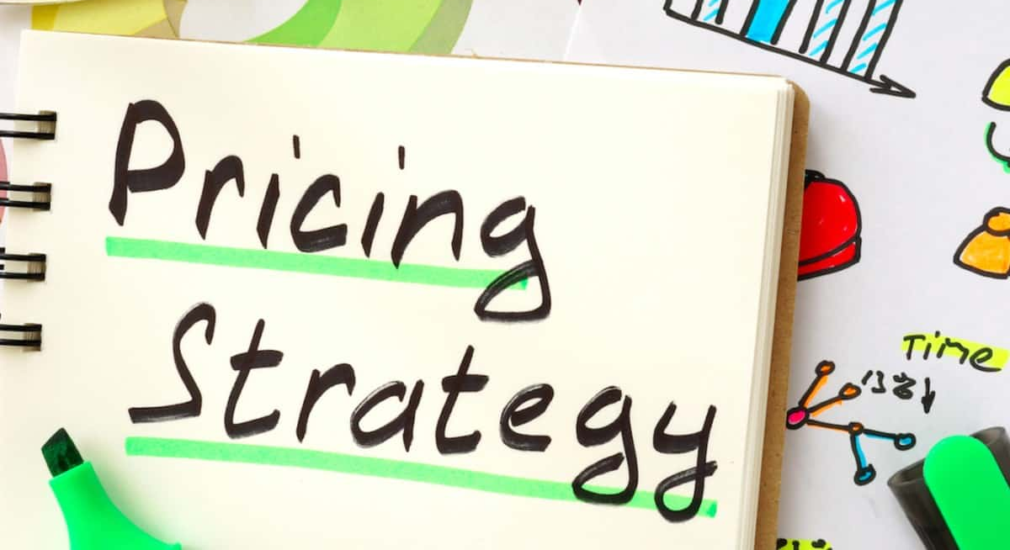

Pricing strategies
Psychological pricing
- All prices end in 99p
- Perceived in the mind of the customer as cheaper even only by a penny

Price skimming
- Setting the price high at first and lowering it over time
- High price indicates superiority or newness
- Helps maximise revenues when first launched
- High price may put some customers off
- Can only be used for a short time

Penetration pricing
- Low price to generate sales quickly
- Helps you break into a market
- Low price may encourage customers to try it and switch from competitors
- Can gradually increase prices
- Revenue and profit will be reduced while price is low
- Low price could stimulate a price war
- Customers may return to original brand when price is gradually increased

Competitive pricing
- Pricing in line with other businesses
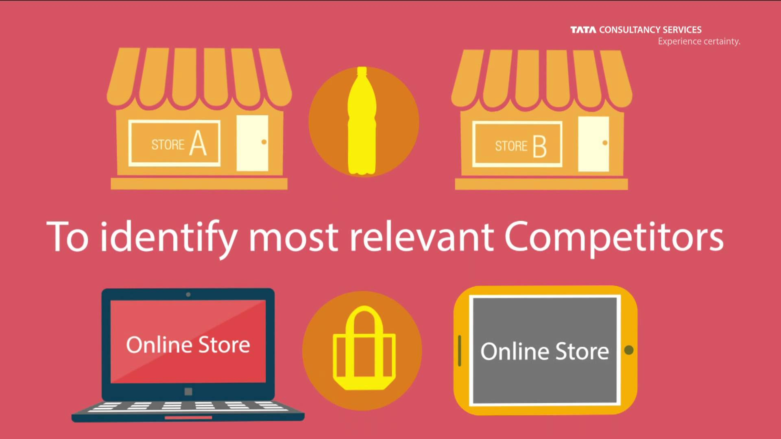
Advertising methods
Leaflets
- Easy to distribute to lots of people
- Can be kept for reference
- Can be colourful
- Might be perceived as junk mail

Local newspaper
- Low cost as only printed once
- Repeat advertising can be more
- Not everyone reads newspapers

Magazines
- Country wide
- Detailed information can be given
- Cover a particular interest
- Needs to be prepared well in advance

Websites
- Allow small businesses to access large audience

Radio
- Growing number of stations
- Can use audience profile to target specific group
- Non-visual

Social media
- Low cost to keep details up-to-date

Sales promotion techniques

Point of sale
- Any advert displayed at the point when a customer will make a purchase (near a till)

Discounts
Advantages
- Quick boost to sales
- Encourages customer to try a new product
- May buy in bulk
- May switch brands
- May purchase other items while in store
Disadvantages
- Reduces profit
- Boost to sales only short term
- Customers will expect further deals
- Damages brand image

Competitions
- Can be used to encourage purchases

BOGOF
- Buy one get one free

Free gifts
- Small samples or offer to refund if not liked

Loyalty schemes
- Reward schemes like McDonalds coffees

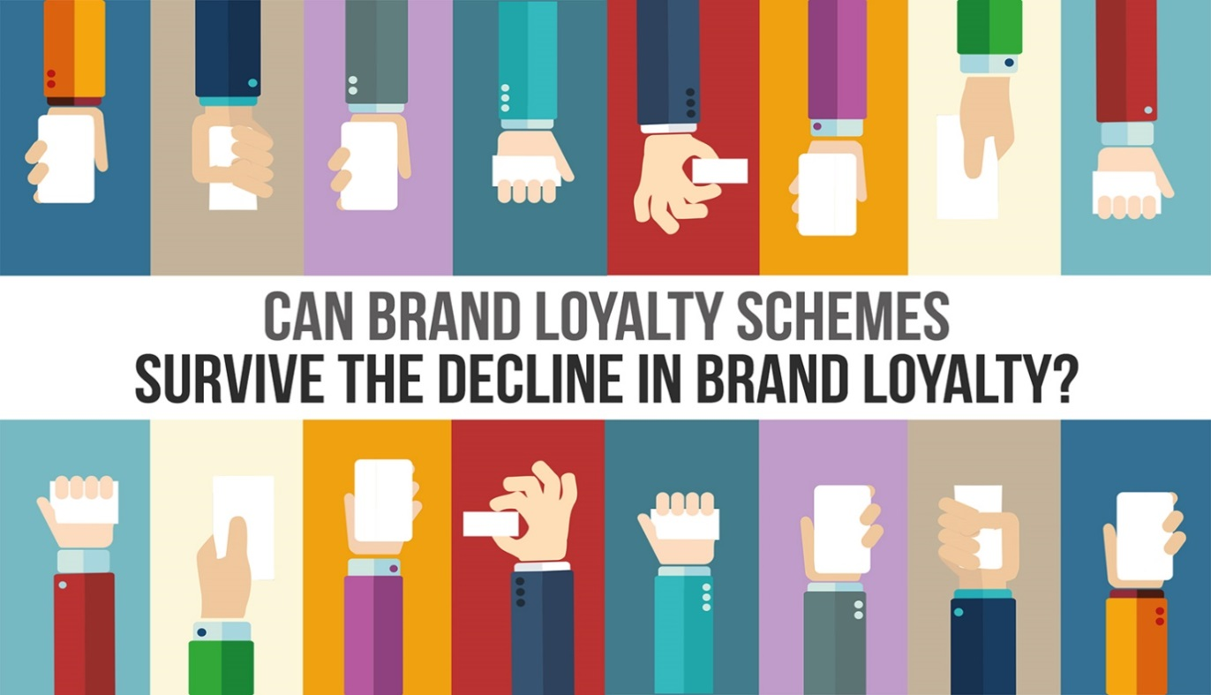

The importance of customer service
Good product knowledge
- to answer customer queries
After sales service
- An extended warranty
Customer engagement
- Being polite, good communication, presentation
Ownership types
Limited liability
- Owners do not risk losing personal possessions to repay debts of business

Unlimited liability
- Owners are liable for all debts of the business

Sole Trader
- Keep all the profit
- Make all decisions
- Easy to set up (few legal requirements)
- Not much capital needed
- Limited liability

Partnership
- Between 2 and 20 owners
- Limited liability

Limited Liability Partnership
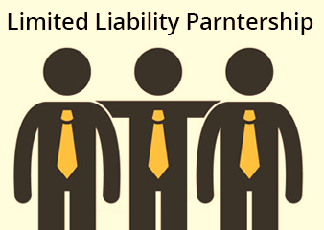
- One partner must have unlimited liability
- Other partners may be sleeping partners

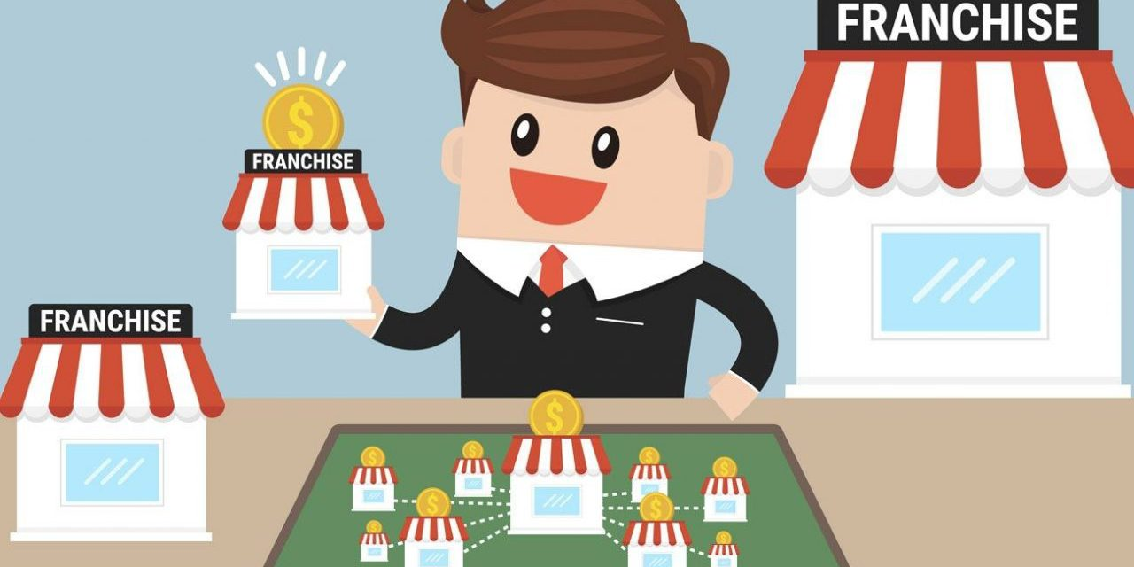
Franchise
- When a franchisee pays for the rights to use a known business’s product or service
Advantages
- Customers know brand name and products
- Support and training from franchisor
- Network with other franchisees
- National brand and promotions
- Business concept is proven to be successful
Disadvantages
- Royalty payments to the franchisor

Sources of capital
Crowdfunding
- Individuals contribute finance for equity in the business
- Advertising new business on social media asking for investment
Business angels
- Specialist lender who seeks to own part of the business
- Will often provide other expertise

Bank loan
- Money borrowed for a fixed period at an agreed rate of interest
- Must make regular payments
- Interest may be high or additional security may be required
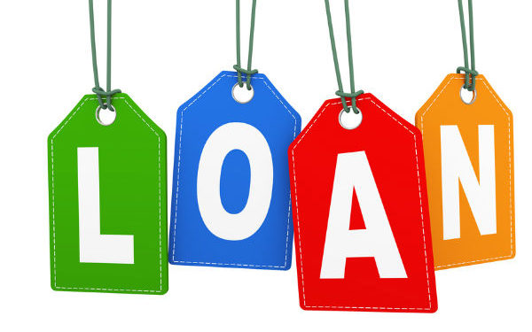
Loan from family member
Advantages
- Informal arrangement
- No forms to fill in
- Interest free
- Reduced pressure to make regular payments
Disadvantages
- May not get all money needed
- Could ask for money back at short notice
- Could lead to family disagreements

Small business grant
- Funds don’t have to be repaid
- Have to fill in application form

The importance of a business plan
- To secure funding
- communicate idea to stakeholders
- measure progress towards goals
- Help manage cash flow
- Help identify potential problems (financial shortages)

Business plans
Sections included
- Business objectives
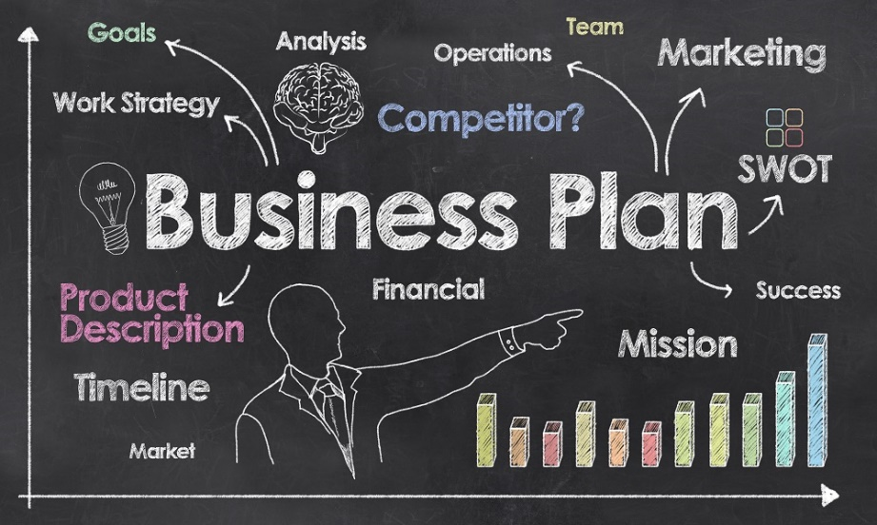
- Business strategies
- Sales plan
- Marketing plan
- Financial forecasts

Functions of functional areas
Marketing
- Finding out customer opinions through market research
- Develop new products to meet customer needs
Finance
- Monitors cash flow
- Produces budgets
- Prepares forecasts
- Prepare profit and loss account

Human Resources
- Responsible for health and safety in the workplace
- Ensure compliance with all employment legislation
- Train and develop employees
- Recruitment and selection
- Performance management of employees

Operations
- Production planning
- Producing the product or service
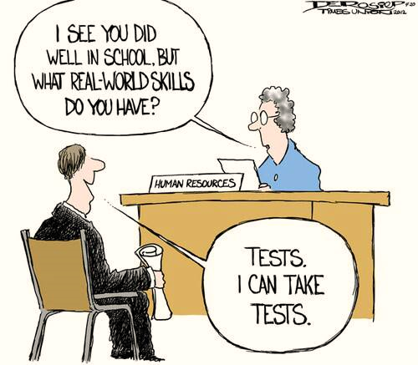
- Quality control
- Stock control
- Logistics

Activities of functional areas
Marketing
- Set the price of a product
- Design a promotional campaign
- Carry out market research

Finance
- Sets the budget for a product
- Pays invoices
- Pays staff wages

Human Resources
- Deliver induction training
- Recruit new staff
- Advertise jobs
- Organise interviews
- Carry out health and safety training

Operations
- Stock control
- Service machinery on the production line
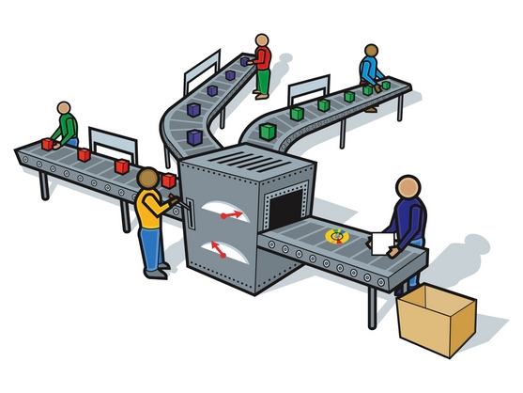
- Production
- Quality check the product
- Deliver the product

