Year 10
Sport
Learning Booklet
Name:
Tutor:
Class/teacher(s):
School:
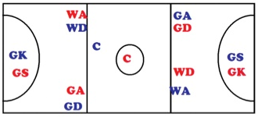
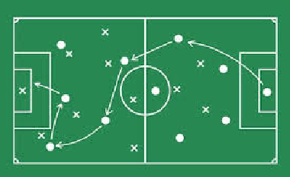
Major Key Words:
Rules | Regulations | Tactics | Positioning
Structure | Formation | Offside | Drift
Rush | Man to Man | Press | Zonal
½ court | Rotation | Pacing | Aesthetics
Officials | Umpires | Strengths | Weaknesses
Action  Plan | Key  Skills | Decision Making | Evaluation
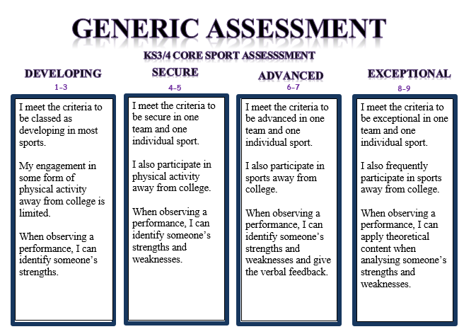

Example of key term in action:
As an evaluation of player 1’s performance I can tell that his tactical awareness is outstanding when going forward, this is because his movement off of the ball is consistent and he is always available. On the other hand, in defence he frequently goes missing and his opponents easily get free.
Invasion Games 1:
What were the key lesson objectives? …………………………………………....
…………………………………………………………………………………………………………..
…………………………………………………………………………………………………………..
Pick two key words from the table and identify how they have been used in your recent unit of work…………………………………………………………………………….
…………………………………………………………………………………………………………..
…………………………………………………………………………………………………………..
…………………………………………………………………………………………………………..
Activity Tracker.
Outside of college I have completed the following activity
(This can include clubs, teams or even walking to and from college).
…………………………………………………………………………………………………….......
…………………………………………………………………………………………………….......
…………………………………………………………………………………………………….......
Assessment information:
Date…………………... Sport…………………….
Reflect: I am working at the …………………………………………… level.
Analyse: Because………………………..……………………………………………………..
…………………………………………………………………………………………………………..
Action: In order to improve I need to…………………………………………………
………………………………………………………………………………………………………..…
…………………………………………………………………………………………………………..
Invasion games 2:
What were the key lesson objectives? …………………………………………....
…………………………………………………………………………………………………………..
…………………………………………………………………………………………………………..
Pick two key words from the table and identify how they have been used in your recent unit of work…………………………………………………………………………….
…………………………………………………………………………………………………………..
…………………………………………………………………………………………………………..
…………………………………………………………………………………………………………..
Activity Tracker.
Outside of college I have completed the following activity
(This can include clubs, teams or even walking to and from college).
…………………………………………………………………………………………………….......
…………………………………………………………………………………………………….......
…………………………………………………………………………………………………….......
Assessment information:
Date…………………... Sport…………………….
Reflect: I am working at the …………………………………………… level.
Analyse: Because………………………..……………………………………………………..
…………………………………………………………………………………………………………..
Action: In order to improve I need to…………………………………………………
………………………………………………………………………………………………………..…
…………………………………………………………………………………………………………..
Gymnastic replication:
What were the key lesson objectives? …………………………………………....
…………………………………………………………………………………………………………..
…………………………………………………………………………………………………………..
Pick two key words from the table and identify how they have been used in your recent unit of work…………………………………………………………………………….
…………………………………………………………………………………………………………..
…………………………………………………………………………………………………………..
…………………………………………………………………………………………………………..
Activity Tracker.
Outside of college I have completed the following activity
(This can include clubs, teams or even walking to and from college).
…………………………………………………………………………………………………….......
…………………………………………………………………………………………………….......
…………………………………………………………………………………………………….......
Assessment information:
Date…………………... Sport…………………….
Reflect: I am working at the …………………………………………… level.
Analyse: Because………………………..……………………………………………………..
…………………………………………………………………………………………………………..
Action: In order to improve I need to…………………………………………………
………………………………………………………………………………………………………..…
…………………………………………………………………………………………………………..
Net/Wall games:
What were the key lesson objectives? …………………………………………....
…………………………………………………………………………………………………………..
…………………………………………………………………………………………………………..
Pick two key words from the table and identify how they have been used in your recent unit of work…………………………………………………………………………….
…………………………………………………………………………………………………………..
…………………………………………………………………………………………………………..
…………………………………………………………………………………………………………..
Activity Tracker.
Outside of college I have completed the following activity
(This can include clubs, teams or even walking to and from college).
…………………………………………………………………………………………………….......
…………………………………………………………………………………………………….......
…………………………………………………………………………………………………….......
Assessment information:
Date…………………... Sport…………………….
Reflect: I am working at the …………………………………………… level.
Analyse: Because………………………..……………………………………………………..
…………………………………………………………………………………………………………..
Action: In order to improve I need to…………………………………………………
………………………………………………………………………………………………………..…
…………………………………………………………………………………………………………..
Health Related Education:
What were the key lesson objectives? …………………………………………....
…………………………………………………………………………………………………………..
…………………………………………………………………………………………………………..
Pick two key words from the table and identify how they have been used in your recent unit of work…………………………………………………………………………….
…………………………………………………………………………………………………………..
…………………………………………………………………………………………………………..
…………………………………………………………………………………………………………..
Activity Tracker.
Outside of college I have completed the following activity
(This can include clubs, teams or even walking to and from college).
…………………………………………………………………………………………………….......
…………………………………………………………………………………………………….......
…………………………………………………………………………………………………….......
Assessment information:
Date…………………... Sport…………………….
Reflect: I am working at the …………………………………………… level.
Analyse: Because………………………..……………………………………………………..
…………………………………………………………………………………………………………..
Action: In order to improve I need to…………………………………………………
………………………………………………………………………………………………………..…
…………………………………………………………………………………………………………..
Striking and Fielding:
What were the key lesson objectives? …………………………………………....
…………………………………………………………………………………………………………..
…………………………………………………………………………………………………………..
Pick two key words from the table and identify how they have been used in your recent unit of work…………………………………………………………………………….
…………………………………………………………………………………………………………..
…………………………………………………………………………………………………………..
…………………………………………………………………………………………………………..
Activity Tracker.
Outside of college I have completed the following activity
(This can include clubs, teams or even walking to and from college).
…………………………………………………………………………………………………….......
…………………………………………………………………………………………………….......
…………………………………………………………………………………………………….......
Assessment information:
Date…………………... Sport…………………….
Reflect: I am working at the …………………………………………… level.
Analyse: Because………………………..……………………………………………………..
…………………………………………………………………………………………………………..
Action: In order to improve I need to…………………………………………………
………………………………………………………………………………………………………..…
…………………………………………………………………………………………………………..

