Year 11
Sport Education
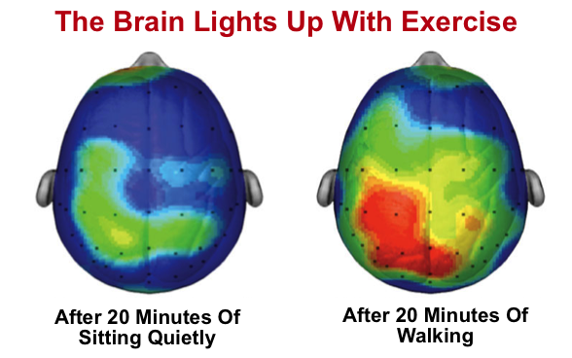
Learning Booklet
Name:
Tutor:
Class/teacher(s):

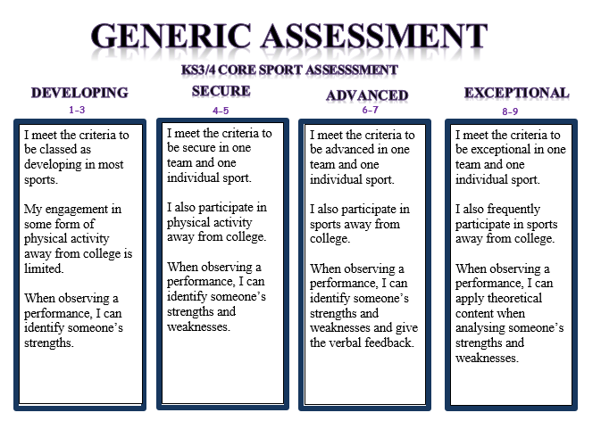
School:
Major Key Words:
Seasons | Roles | Responsibilities
Captain | Vice Captain | Manager
Referee | Player | Score Keeper
Confidence | Warm Ups | Drills
Practice | Leagues | Competition
Round Robin | Bonus | Officials

“Intensive exercise improves the academic performance of teenagers, according to new research.
The study, of about 5,000 children, found links between exercise and exam success in English, maths and science.”
“They claimed that since every 15 minutes of exercise improved performance by an average of about a quarter of a grade, it was possible children who carried out 60 minutes of exercise every day could improve their academic performance by a full grade - for example, from a C to a B, or a B to an A.”

Example of Sports Education in action:

In my role as vice-captain I was responsible for ensuring that everyone was aware of their key roles and frequently led parts of the drills sessions. I had to demonstrate a good attitude in front of my classmates and this helped me to develop good relationships with them and a sense of pride in my work.

Invasion Games 1:
What were the key lesson objectives? …………………………………………....
…………………………………………………………………………………………………………..
…………………………………………………………………………………………………………..
Identify your main role in the sport and how you have positively impacted upon your team’s progress and success…...………………………………………………….
…………………………………………………………………………………………………………..
…………………………………………………………………………………………………………..
…………………………………………………………………………………………………………..
Activity Tracker.
Outside of college I have completed the following activity
(This can include clubs, teams or even walking to and from college).
…………………………………………………………………………………………………….......
…………………………………………………………………………………………………….......
…………………………………………………………………………………………………….......
Assessment information:
Date…………………... Sport…………………….
Reflect: I am working at the …………………………………………… level.
Analyse: Because………………………..……………………………………………………..
…………………………………………………………………………………………………………..
Action: In order to improve I need to…………………………………………………
………………………………………………………………………………………………………..…
…………………………………………………………………………………………………………..
Invasion games 2:
What were the key lesson objectives? …………………………………………....
…………………………………………………………………………………………………………..
…………………………………………………………………………………………………………..
Identify your main role in the sport and how you have positively impacted upon your team’s progress and success…...………………………………………………….
…………………………………………………………………………………………………………..
…………………………………………………………………………………………………………..
…………………………………………………………………………………………………………..
Activity Tracker.
Outside of college I have completed the following activity
(This can include clubs, teams or even walking to and from college).
…………………………………………………………………………………………………….......
…………………………………………………………………………………………………….......
…………………………………………………………………………………………………….......
Assessment information:
Date…………………... Sport…………………….
Reflect: I am working at the …………………………………………… level.
Analyse: Because………………………..……………………………………………………..
…………………………………………………………………………………………………………..
Action: In order to improve I need to…………………………………………………
………………………………………………………………………………………………………..…
…………………………………………………………………………………………………………..
Gymnastic replication:
What were the key lesson objectives? …………………………………………....
…………………………………………………………………………………………………………..
…………………………………………………………………………………………………………..
Identify your main role in the sport and how you have positively impacted upon your team’s progress and success…...………………………………………………….
…………………………………………………………………………………………………………..
…………………………………………………………………………………………………………..
…………………………………………………………………………………………………………..
Activity Tracker.
Outside of college I have completed the following activity
(This can include clubs, teams or even walking to and from college).
…………………………………………………………………………………………………….......
…………………………………………………………………………………………………….......
…………………………………………………………………………………………………….......
Assessment information:
Date…………………... Sport…………………….
Reflect: I am working at the …………………………………………… level.
Analyse: Because………………………..……………………………………………………..
…………………………………………………………………………………………………………..
Action: In order to improve I need to…………………………………………………
………………………………………………………………………………………………………..…
…………………………………………………………………………………………………………..
Net/Wall games:
What were the key lesson objectives? …………………………………………....
…………………………………………………………………………………………………………..
…………………………………………………………………………………………………………..
Identify your main role in the sport and how you have positively impacted upon your team’s progress and success…...………………………………………………….
…………………………………………………………………………………………………………..
…………………………………………………………………………………………………………..
…………………………………………………………………………………………………………..
Activity Tracker.
Outside of college I have completed the following activity
(This can include clubs, teams or even walking to and from college).
…………………………………………………………………………………………………….......
…………………………………………………………………………………………………….......
…………………………………………………………………………………………………….......
Assessment information:
Date…………………... Sport…………………….
Reflect: I am working at the …………………………………………… level.
Analyse: Because………………………..……………………………………………………..
…………………………………………………………………………………………………………..
Action: In order to improve I need to…………………………………………………
………………………………………………………………………………………………………..…
…………………………………………………………………………………………………………..
Health Related Education:
What were the key lesson objectives? …………………………………………....
…………………………………………………………………………………………………………..
…………………………………………………………………………………………………………..
Identify your main role in the sport and how you have positively impacted upon your team’s progress and success…...………………………………………………….
…………………………………………………………………………………………………………..
…………………………………………………………………………………………………………..
…………………………………………………………………………………………………………..
Activity Tracker.
Outside of college I have completed the following activity
(This can include clubs, teams or even walking to and from college).
…………………………………………………………………………………………………….......
…………………………………………………………………………………………………….......
…………………………………………………………………………………………………….......
Assessment information:
Date…………………... Sport…………………….
Reflect: I am working at the …………………………………………… level.
Analyse: Because………………………..……………………………………………………..
…………………………………………………………………………………………………………..
Action: In order to improve I need to…………………………………………………
………………………………………………………………………………………………………..…
…………………………………………………………………………………………………………..
Striking and Fielding:
What were the key lesson objectives? …………………………………………....
…………………………………………………………………………………………………………..
…………………………………………………………………………………………………………..
Identify your main role in the sport and how you have positively impacted upon your team’s progress and success…...………………………………………………….
…………………………………………………………………………………………………………..
…………………………………………………………………………………………………………..
…………………………………………………………………………………………………………..
Activity Tracker.
Outside of college I have completed the following activity
(This can include clubs, teams or even walking to and from college).
…………………………………………………………………………………………………….......
…………………………………………………………………………………………………….......
…………………………………………………………………………………………………….......
Assessment information:
Date…………………... Sport…………………….
Reflect: I am working at the …………………………………………… level.
Analyse: Because………………………..……………………………………………………..
…………………………………………………………………………………………………………..
Action: In order to improve I need to…………………………………………………
………………………………………………………………………………………………………..…
…………………………………………………………………………………………………………..

