Year 7
Sport
Learning Booklet
Name:
Tutor:
Class/teacher(s):
School:
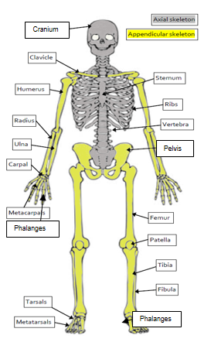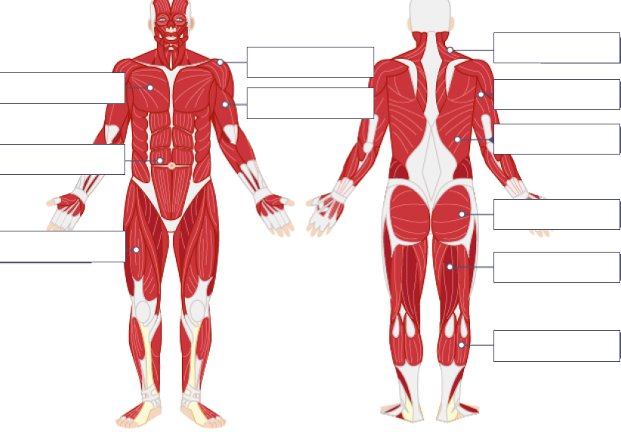
Key Information:
The Skeletal system.
The skeleton has six main functions:
Support | the skeleton keeps the body upright and provides a framework for muscle and tissue attachment.
Posture | the skeleton gives the correct shape to our body.
Protection | the bones of the skeleton protect the internal organs and reduce the risk of injury on impact. For example, the cranium protects the brain, the ribs offer protection to the heart and lungs, the vertebrae protect the spinal cord and the pelvis offers protection to the sensitive reproductive organs.
Movement | the skeleton allows movement of the body as a whole and its individual parts. The bones form joints and act as levers, allowing muscles to pull on them to produce movement. The bones of the skeleton provide surfaces for the attachment of muscles.
Blood cell production | certain bones in the skeleton contain bone marrow which produces red blood cells, white blood cells and platelets. Examples of bones that contain marrow are the pelvis, sternum, humerus and femur.
Storage of minerals | the bones store minerals such as calcium, iron, potassium and phosphorous and release them into the blood when the body needs to use them.

The Muscular System.

Here are the names, functions and examples of the major muscles in your body:
 | Function | Example in sport
Deltoid | Lifting the arm at the shoulder | Lifting the arms to block in volleyball; upward arm swing when trampolining
Trapezius | Shoulder horizontal extension (moving the arms backwards at shoulder level) | Preparation phase of an overarm throw or badminton smash
Pectorals | Adduction of the shoulder (moving the arm towards the body); Shoulder horizontal flexion (moving the arms forwards in front of the body) | Upwards phase of a press up; rugby player making a tackle
Triceps | Extension of the elbow (straightening the arm) | Shooting and chest passing in netball (execution phase)
Biceps | Flexion of the elbow (bending the arm) | Drawing a bow in archery; 'backscratch' position during tennis serve
Abdominals | Flexion of the spine (sitting upwards) | Performing a sit up or a forward roll
Latissimus dorsi | Adduction of the shoulder (moving the arm down towards the mid-line of the body) | Hitting in hockey – left shoulder during preparation, right shoulder during execution and recovery
Gluteals | Hip extension (moving the femur backwards) | Pulling leg back at the hip before kicking a ball
Quadriceps | Extension of the knee (straightening the leg) | Kicking a ball (execution and recovery phase)
Hamstrings | Flexion of the knee (bending the leg) | Performing a hamstring curl on a weights machine; preparation phase of a rebound jump in basketball
Gastrocnemius | Plantar flexion of the ankle (pointing the toes downwards) | Standing on tiptoe to mark a shot in netball or pointing the toes during a gymnastic or dance move

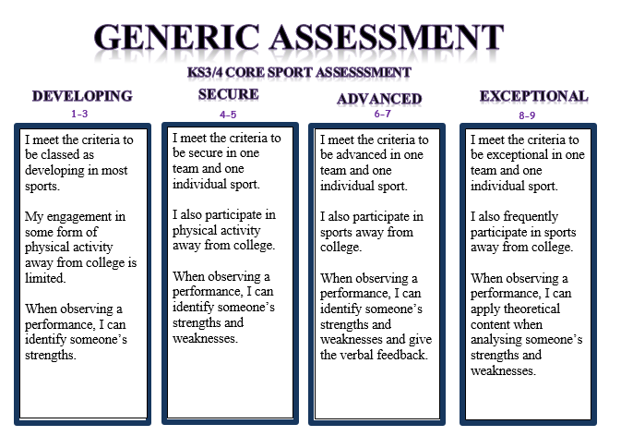

Example of muscles and bones in action:
Quadriceps- When completing a kick in football, the quadriceps contracts which allows the leg to straighten at the knee.
Rib cage – Our rib cage protects our lungs from damage when playing contact sports like rugby.

Invasion Games 1:
What were the key lesson objectives? …………………………………………....
…………………………………………………………………………………………………………..
…………………………………………………………………………………………………………..
Identify a muscle and/or a bone and how it relates to the sport……… …………………………………………………………………………………………………………..
…………………………………………………………………………………………………………..
…………………………………………………………………………………………………………..
…………………………………………………………………………………………………………..
Activity Tracker.
Outside of college I have completed the following activity
(This can include clubs, teams or even walking to and from college).
…………………………………………………………………………………………………….......
…………………………………………………………………………………………………….......
…………………………………………………………………………………………………….......
Assessment information:
Date…………………... Sport…………………….
Reflect: I am working at the …………………………………………… level.
Analyse: Because………………………..……………………………………………………..
…………………………………………………………………………………………………………..
Action: In order to improve I need to…………………………………………………
………………………………………………………………………………………………………..…
…………………………………………………………………………………………………………..
Invasion games 2:
What were the key lesson objectives? …………………………………………....
…………………………………………………………………………………………………………..
…………………………………………………………………………………………………………..
Identify a muscle and/or a bone and how it relates to the sport……… …………………………………………………………………………………………………………..
…………………………………………………………………………………………………………..
…………………………………………………………………………………………………………..
…………………………………………………………………………………………………………..
Activity Tracker.
Outside of college I have completed the following activity
(This can include clubs, teams or even walking to and from college).
…………………………………………………………………………………………………….......
…………………………………………………………………………………………………….......
…………………………………………………………………………………………………….......
Assessment information:
Date…………………... Sport…………………….
Reflect: I am working at the …………………………………………… level.
Analyse: Because………………………..……………………………………………………..
…………………………………………………………………………………………………………..
Action: In order to improve I need to…………………………………………………
………………………………………………………………………………………………………..…
…………………………………………………………………………………………………………..
Gymnastic replication:
What were the key lesson objectives? …………………………………………....
…………………………………………………………………………………………………………..
…………………………………………………………………………………………………………..
Identify a muscle and/or a bone and how it relates to the sport……… …………………………………………………………………………………………………………..
…………………………………………………………………………………………………………..
…………………………………………………………………………………………………………..
…………………………………………………………………………………………………………..
Activity Tracker.
Outside of college I have completed the following activity
(This can include clubs, teams or even walking to and from college).
…………………………………………………………………………………………………….......
…………………………………………………………………………………………………….......
…………………………………………………………………………………………………….......
Assessment information:
Date…………………... Sport…………………….
Reflect: I am working at the …………………………………………… level.
Analyse: Because………………………..……………………………………………………..
…………………………………………………………………………………………………………..
Action: In order to improve I need to…………………………………………………
………………………………………………………………………………………………………..…
…………………………………………………………………………………………………………..
Net/Wall games:
What were the key lesson objectives? …………………………………………....
…………………………………………………………………………………………………………..
…………………………………………………………………………………………………………..
Identify a muscle and/or a bone and how it relates to the sport……… …………………………………………………………………………………………………………..
…………………………………………………………………………………………………………..
…………………………………………………………………………………………………………..
…………………………………………………………………………………………………………..
Activity Tracker.
Outside of college I have completed the following activity
(This can include clubs, teams or even walking to and from college).
…………………………………………………………………………………………………….......
…………………………………………………………………………………………………….......
…………………………………………………………………………………………………….......
Assessment information:
Date…………………... Sport…………………….
Reflect: I am working at the …………………………………………… level.
Analyse: Because………………………..……………………………………………………..
…………………………………………………………………………………………………………..
Action: In order to improve I need to…………………………………………………
………………………………………………………………………………………………………..…
…………………………………………………………………………………………………………..
Health Related Education:
What were the key lesson objectives? …………………………………………....
…………………………………………………………………………………………………………..
…………………………………………………………………………………………………………..
Identify a muscle and/or a bone and how it relates to the sport……… …………………………………………………………………………………………………………..
…………………………………………………………………………………………………………..
…………………………………………………………………………………………………………..
…………………………………………………………………………………………………………..
Activity Tracker.
Outside of college I have completed the following activity
(This can include clubs, teams or even walking to and from college).
…………………………………………………………………………………………………….......
…………………………………………………………………………………………………….......
…………………………………………………………………………………………………….......
Assessment information:
Date…………………... Sport…………………….
Reflect: I am working at the …………………………………………… level.
Analyse: Because………………………..……………………………………………………..
…………………………………………………………………………………………………………..
Action: In order to improve I need to…………………………………………………
………………………………………………………………………………………………………..…
…………………………………………………………………………………………………………..
Striking and Fielding:
What were the key lesson objectives? …………………………………………....
…………………………………………………………………………………………………………..
…………………………………………………………………………………………………………..
Identify a muscle and/or a bone and how it relates to the sport……… …………………………………………………………………………………………………………..
…………………………………………………………………………………………………………..
…………………………………………………………………………………………………………..
…………………………………………………………………………………………………………..
Activity Tracker.
Outside of college I have completed the following activity
(This can include clubs, teams or even walking to and from college).
…………………………………………………………………………………………………….......
…………………………………………………………………………………………………….......
…………………………………………………………………………………………………….......
Assessment information:
Date…………………... Sport…………………….
Reflect: I am working at the …………………………………………… level.
Analyse: Because………………………..……………………………………………………..
…………………………………………………………………………………………………………..
Action: In order to improve I need to…………………………………………………
………………………………………………………………………………………………………..…
…………………………………………………………………………………………………………..

