Year 8
Sport
Learning Booklet
Name:
Tutor:
Class/teacher(s):
School:

Major Key Words:
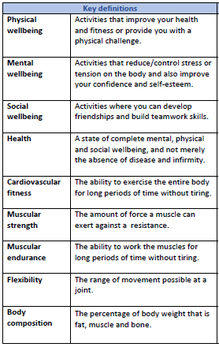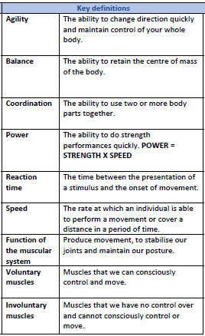

Example of component of fitness:
Agility: In basketball, agility is used when attempting to dodge around opposing players. This includes changing the shape of your body quickly whilst maintaining balance.

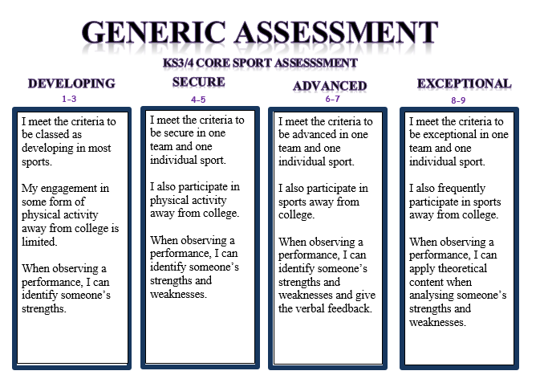

Invasion Games 1:
What were the key lesson objectives? …………………………………………....
…………………………………………………………………………………………………………..
…………………………………………………………………………………………………………..
Identify and explain a component of fitness and how it relates to the sport………………………………………………………………………………………………….
…………………………………………………………………………………………………………..
…………………………………………………………………………………………………………..
…………………………………………………………………………………………………………..
Activity Tracker.
Outside of college I have completed the following activity
(This can include clubs, teams or even walking to and from college).
…………………………………………………………………………………………………….......
…………………………………………………………………………………………………….......
…………………………………………………………………………………………………….......
Assessment information:
Date…………………... Sport…………………….
Reflect: I am working at the …………………………………………… level.
Analyse: Because………………………..……………………………………………………..
…………………………………………………………………………………………………………..
Action: In order to improve I need to…………………………………………………
………………………………………………………………………………………………………..…
…………………………………………………………………………………………………………..
Invasion games 2:
What were the key lesson objectives? …………………………………………....
…………………………………………………………………………………………………………..
…………………………………………………………………………………………………………..
Identify and explain a component of fitness and how it relates to the sport………………………………………………………………………………………………….
…………………………………………………………………………………………………………..
…………………………………………………………………………………………………………..
…………………………………………………………………………………………………………..
Activity Tracker.
Outside of college I have completed the following activity
(This can include clubs, teams or even walking to and from college).
…………………………………………………………………………………………………….......
…………………………………………………………………………………………………….......
…………………………………………………………………………………………………….......
Assessment information:
Date…………………... Sport…………………….
Reflect: I am working at the …………………………………………… level.
Analyse: Because………………………..……………………………………………………..
…………………………………………………………………………………………………………..
Action: In order to improve I need to…………………………………………………
………………………………………………………………………………………………………..…
…………………………………………………………………………………………………………..
Gymnastic replication:
What were the key lesson objectives? …………………………………………....
…………………………………………………………………………………………………………..
…………………………………………………………………………………………………………..
Identify and explain a component of fitness and how it relates to the sport………………………………………………………………………………………………….
…………………………………………………………………………………………………………..
…………………………………………………………………………………………………………..
…………………………………………………………………………………………………………..
Activity Tracker.
Outside of college I have completed the following activity
(This can include clubs, teams or even walking to and from college).
…………………………………………………………………………………………………….......
…………………………………………………………………………………………………….......
…………………………………………………………………………………………………….......
Assessment information:
Date…………………... Sport…………………….
Reflect: I am working at the …………………………………………… level.
Analyse: Because………………………..……………………………………………………..
…………………………………………………………………………………………………………..
Action: In order to improve I need to…………………………………………………
………………………………………………………………………………………………………..…
…………………………………………………………………………………………………………..
Net/Wall games:
What were the key lesson objectives? …………………………………………....
…………………………………………………………………………………………………………..
…………………………………………………………………………………………………………..
Identify and explain a component of fitness and how it relates to the sport………………………………………………………………………………………………….
…………………………………………………………………………………………………………..
…………………………………………………………………………………………………………..
…………………………………………………………………………………………………………..
Activity Tracker.
Outside of college I have completed the following activity
(This can include clubs, teams or even walking to and from college).
…………………………………………………………………………………………………….......
…………………………………………………………………………………………………….......
…………………………………………………………………………………………………….......
Assessment information:
Date…………………... Sport…………………….
Reflect: I am working at the …………………………………………… level.
Analyse: Because………………………..……………………………………………………..
…………………………………………………………………………………………………………..
Action: In order to improve I need to…………………………………………………
………………………………………………………………………………………………………..…
…………………………………………………………………………………………………………..
Health Related Education:
What were the key lesson objectives? …………………………………………....
…………………………………………………………………………………………………………..
…………………………………………………………………………………………………………..
Identify and explain a component of fitness and how it relates to the sport………………………………………………………………………………………………….
…………………………………………………………………………………………………………..
…………………………………………………………………………………………………………..
…………………………………………………………………………………………………………..
Activity Tracker.
Outside of college I have completed the following activity
(This can include clubs, teams or even walking to and from college).
…………………………………………………………………………………………………….......
…………………………………………………………………………………………………….......
…………………………………………………………………………………………………….......
Assessment information:
Date…………………... Sport…………………….
Reflect: I am working at the …………………………………………… level.
Analyse: Because………………………..……………………………………………………..
…………………………………………………………………………………………………………..
Action: In order to improve I need to…………………………………………………
………………………………………………………………………………………………………..…
…………………………………………………………………………………………………………..
Striking and Fielding:
What were the key lesson objectives? …………………………………………....
…………………………………………………………………………………………………………..
…………………………………………………………………………………………………………..
Identify and explain a component of fitness and how it relates to the sport………………………………………………………………………………………………….
…………………………………………………………………………………………………………..
…………………………………………………………………………………………………………..
…………………………………………………………………………………………………………..
Activity Tracker.
Outside of college I have completed the following activity
(This can include clubs, teams or even walking to and from college).
…………………………………………………………………………………………………….......
…………………………………………………………………………………………………….......
…………………………………………………………………………………………………….......
Assessment information:
Date…………………... Sport…………………….
Reflect: I am working at the …………………………………………… level.
Analyse: Because………………………..……………………………………………………..
…………………………………………………………………………………………………………..
Action: In order to improve I need to…………………………………………………
………………………………………………………………………………………………………..…
…………………………………………………………………………………………………………..

