Year 9
Sport
Learning Booklet
Name:
Tutor:
Class/teacher(s):
School:
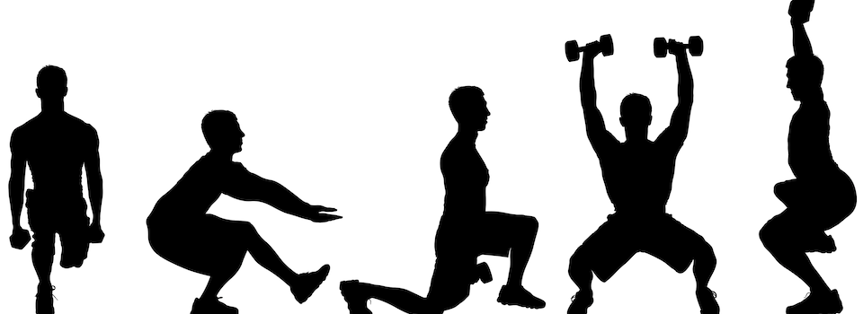

Key information:
Specificity - training must be relevant to the individual and their sport. This can be achieved by tailoring training specifically for the sport or even the position that the individual plays, the muscle groups that they use the most or the dominant energy system of the athlete. For example, a 100 m sprinter is likely to train very differently to a 10 km racer despite them both being track athletes. The sprinter will focus on speed and power while the distance runner will train for cardiovascular fitness and the ability to work at high intensity aerobically.
Overload - training needs to work the body harder than normal so there is some stress and discomfort. This makes the body systems respond by adapting to the stress placed on them. Applying the overload principle to training means that performance will improve - no overload, no improvement. Overload can be achieved by using FITT.
Progression - training should progressively become more difficult. Once the body has adapted, the performer should make further demands on the systems. However, increases must be gradual so that the athlete avoids a plateau in performance or, worse, injury.
Reversibility - if training stops, then the fitness gained will be largely lost. The body systems reverse or de-adapt and performance deteriorates if training is significantly reduced, decreases in intensity or injury prevents training from taking place for any length of time. It is essential to avoid breaks in training and to maintain the motivation of the athlete.
Rest and recovery - physical adaptations occur during the recovery and non-active period of the training cycle. Therefore, athletes and trainers must achieve the right amount of rest between sessions, good sleep patterns and the right nutrition, including the use of protein, to help repair the damage caused by intense training.

FITT principle – relates to Overload.
Frequency is how often you train, for example, three times a week. Frequency is increased by training a greater number of times each week.
Intensity is how hard you train, for example faster, heavier, less recovery. Intensity is increased by lifting a greater resistance, such as with weight training, or by training at a higher percentage of maximum heart rate (maxHR). This can be done either as continuous or interval training.
Time is how long you train for, for example a 30 minute session. Time can be manipulated by training for longer or by completing a greater number of sets or repetitions (also known as reps).
Type of training is what kind of training you do, for example interval, fartlek or continuous. Type is manipulated by offering a variety of training types and experiences to the athlete by combining training methods.

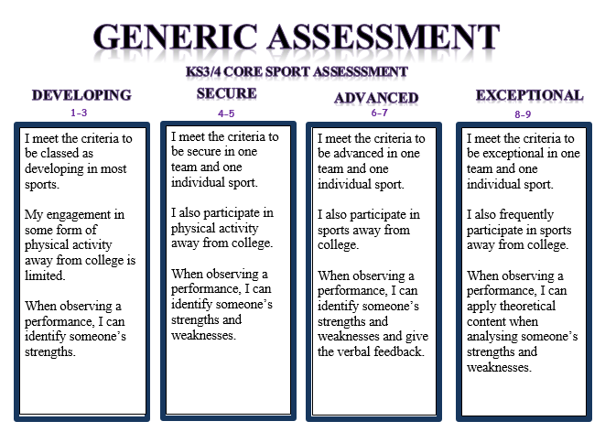

Example of principles of training:

Specificity is ensuring training is accurate and meets the requirements of the activity the perform participates in. An example of this is a footballer ensuring they focus on short sharp sprints with medium levels of intensity at times in their training program so it matches the requirements of a game.

Invasion Games 1:
What were the key lesson objectives? …………………………………………....
…………………………………………………………………………………………………………..
…………………………………………………………………………………………………………..
Pick a principle of training and identify how it is relevant to the sport you have completed………………………………………………………………………………………….
…………………………………………………………………………………………………………..
…………………………………………………………………………………………………………..
…………………………………………………………………………………………………………..
Activity Tracker.
Outside of college I have completed the following activity
(This can include clubs, teams or even walking to and from college).
…………………………………………………………………………………………………….......
…………………………………………………………………………………………………….......
…………………………………………………………………………………………………….......
Assessment information:
Date…………………... Sport…………………….
Reflect: I am working at the …………………………………………… level.
Analyse: Because………………………..……………………………………………………..
…………………………………………………………………………………………………………..
Action: In order to improve I need to…………………………………………………
………………………………………………………………………………………………………..…
…………………………………………………………………………………………………………..
Invasion games 2:
What were the key lesson objectives? …………………………………………....
…………………………………………………………………………………………………………..
…………………………………………………………………………………………………………..
Pick a principle of training and identify how it is relevant to the sport you have completed………………………………………………………………………………………….
…………………………………………………………………………………………………………..
…………………………………………………………………………………………………………..
…………………………………………………………………………………………………………..
Activity Tracker.
Outside of college I have completed the following activity
(This can include clubs, teams or even walking to and from college).
…………………………………………………………………………………………………….......
…………………………………………………………………………………………………….......
…………………………………………………………………………………………………….......
Assessment information:
Date…………………... Sport…………………….
Reflect: I am working at the …………………………………………… level.
Analyse: Because………………………..……………………………………………………..
…………………………………………………………………………………………………………..
Action: In order to improve I need to…………………………………………………
………………………………………………………………………………………………………..…
…………………………………………………………………………………………………………..
Gymnastic replication:
What were the key lesson objectives? …………………………………………....
…………………………………………………………………………………………………………..
…………………………………………………………………………………………………………..
Pick a principle of training and identify how it is relevant to the sport you have completed………………………………………………………………………………………….
…………………………………………………………………………………………………………..
…………………………………………………………………………………………………………..
…………………………………………………………………………………………………………..
Activity Tracker.
Outside of college I have completed the following activity
(This can include clubs, teams or even walking to and from college).
…………………………………………………………………………………………………….......
…………………………………………………………………………………………………….......
…………………………………………………………………………………………………….......
Assessment information:
Date…………………... Sport…………………….
Reflect: I am working at the …………………………………………… level.
Analyse: Because………………………..……………………………………………………..
…………………………………………………………………………………………………………..
Action: In order to improve I need to…………………………………………………
………………………………………………………………………………………………………..…
…………………………………………………………………………………………………………..
Net/Wall games:
What were the key lesson objectives? …………………………………………....
…………………………………………………………………………………………………………..
…………………………………………………………………………………………………………..
Pick a principle of training and identify how it is relevant to the sport you have completed………………………………………………………………………………………….
…………………………………………………………………………………………………………..
…………………………………………………………………………………………………………..
…………………………………………………………………………………………………………..
Activity Tracker.
Outside of college I have completed the following activity
(This can include clubs, teams or even walking to and from college).
…………………………………………………………………………………………………….......
…………………………………………………………………………………………………….......
…………………………………………………………………………………………………….......
Assessment information:
Date…………………... Sport…………………….
Reflect: I am working at the …………………………………………… level.
Analyse: Because………………………..……………………………………………………..
…………………………………………………………………………………………………………..
Action: In order to improve I need to…………………………………………………
………………………………………………………………………………………………………..…
…………………………………………………………………………………………………………..
Health Related Education:
What were the key lesson objectives? …………………………………………....
…………………………………………………………………………………………………………..
…………………………………………………………………………………………………………..
Pick a principle of training and identify how it is relevant to the sport you have completed………………………………………………………………………………………….
…………………………………………………………………………………………………………..
…………………………………………………………………………………………………………..
…………………………………………………………………………………………………………..
Activity Tracker.
Outside of college I have completed the following activity
(This can include clubs, teams or even walking to and from college).
…………………………………………………………………………………………………….......
…………………………………………………………………………………………………….......
…………………………………………………………………………………………………….......
Assessment information:
Date…………………... Sport…………………….
Reflect: I am working at the …………………………………………… level.
Analyse: Because………………………..……………………………………………………..
…………………………………………………………………………………………………………..
Action: In order to improve I need to…………………………………………………
………………………………………………………………………………………………………..…
…………………………………………………………………………………………………………..
Striking and Fielding:
What were the key lesson objectives? …………………………………………....
…………………………………………………………………………………………………………..
…………………………………………………………………………………………………………..
Pick a principle of training and identify how it is relevant to the sport you have completed………………………………………………………………………………………….
…………………………………………………………………………………………………………..
…………………………………………………………………………………………………………..
…………………………………………………………………………………………………………..
Activity Tracker.
Outside of college I have completed the following activity
(This can include clubs, teams or even walking to and from college).
…………………………………………………………………………………………………….......
…………………………………………………………………………………………………….......
…………………………………………………………………………………………………….......
Assessment information:
Date…………………... Sport…………………….
Reflect: I am working at the …………………………………………… level.
Analyse: Because………………………..……………………………………………………..
…………………………………………………………………………………………………………..
Action: In order to improve I need to…………………………………………………
………………………………………………………………………………………………………..…
…………………………………………………………………………………………………………..

