Q1.
Study the graph showing sources used to generate electricity in the UK (1985–2015).
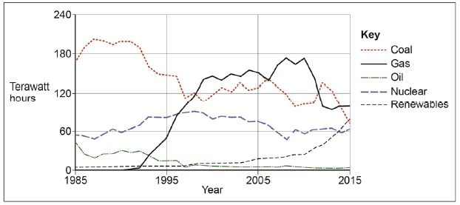
(a) Use the graph to complete the paragraph below.
Choose the correct answers from this list.

fluctuated | coal | 1992
remained steady | oil | 1989
The supply of electricity ____________________ between 1985 and 2015.
In 1985 ____________________ was the main source used to generate
electricity, supplying over 60%. By 2015 gas had become the number one source
used to generate electricity, the rapid increase in the use of gas having started in
________________________________________ .
(3)
(b) Give two reasons why the use of coal decreased between 1985–2015.
(2)
(Total 5 marks)

Mark schemes
Q1.
(a) fluctuated coal 1992
3 × 1 marks
AO4 = 3
(b) Any two reasonable points (2 × 1) or a single developed point (2 marks)
Indicative content
• The relative price.
• Ease of use / flexibility of use or transportation of resource.
• Concerns about the environment.
• Government policy.
• Response to public opinion.
• Increasing drive towards renewables.
• Coal running out / decline, in the UK.
• International carbon agreements.
AO2 = 2
[5]

