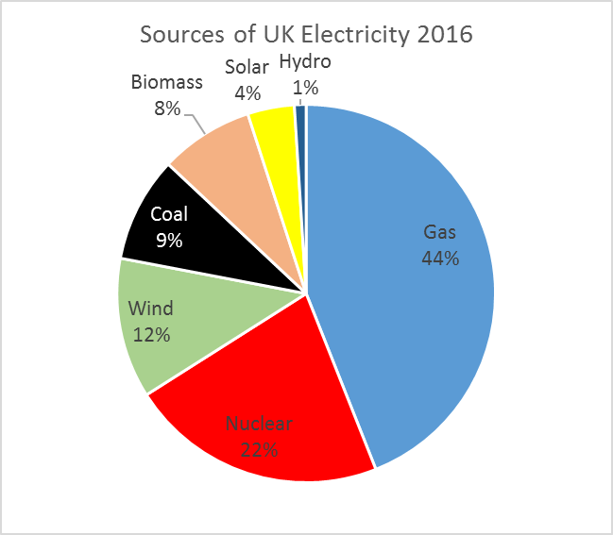
Q2.
(a) Give two causes of energy insecurity.
(2)
(b) Explain how energy security can be improved.
(6)
(Total 8 marks)

Mark Scheme
(a) Unequal distribution of fossil fuel sources (1); depletion of coal and oil reserves (1); volatile oil and gas prices (1); potential for political instability between various countries and oil-producing states (1); global warming and renewable energy concerns (1); restrictions on over-use of coal for energy (1); concerns over nuclear safety and waste, plus cost of building nuclear plants (1); energy consumption rising – in developing world expected to double by 2050 (1).
AO1 = 2
(b)
Level | Marks | Description
3  (Detailed) | 5–6 | AO2 Shows thorough understanding of the interrelationships between environments and processes in the context of energy security issues.  AO2 Demonstrates in detail how improvements can help to provide a secure source of energy.
2  (Clear) | 3–4 | AO1 Demonstrates specific and accurate knowledge of ways of improving energy security at different scales.  AO2 Shows sound understanding of the interrelationships between environments and processes in the context of energy security issues.
1  (Basic) | 1–2 | AO1 Demonstrates limited knowledge of ways of improving energy security at different scales.  AO2 Shows simple understanding of the interrelationships between environments and processes in the context of energy security issues.
Indicative content
• Energy security is defined as the extent to which an affordable, reliable and stable energy supply can be achieved.
• A number of improvements to security may be explained, including the fact that renewable energy is sustainable and so will never run out. Renewable energy facilities generally require less maintenance than traditional generators. They produce little or no waste products such as carbon dioxide or other chemical pollutants, so have minimal impact on the environment. Credit other ways of improving security, e.g. in Canada and USA oil sands and shale gas provide an alternative source of oil when other conventional sources are unavailable for political or access reasons. They help to reduce dependence on overseas imports.
• Expect some development of at least one strategy to improve energy security.
• Wind farms and solar farms in the UK make a contribution to electricity supplies and help to reduce greenhouse gas emissions. The UK has possibilities for large tidal barrages which could meet a small percentage of the UK’s need for electricity. Renewable energy can be cost-effective and efficient, although in itself will not solve energy insecurity.
• Industry and domestic users of energy should use it more efficiently (i.e. stop wasting it). Being efficient with energy will reduce household and business energy bills, reduce the amount of energy needed to be generated and cut energy related greenhouse gas pollution.

