Q1.
Study the map showing the percentage of electricity from hydroelectric power in Africa.
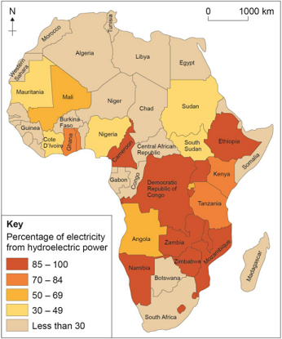
(a) What is the percentage of electricity from hydroelectric power in Mauritania?
Shade one circle only.

A | 30-49%
B | 50-69%
C | 70-84%
D | 85-100%
(1)
(b) Using the map, describe the distribution of countries in Africa where the percentage of electricity from hydroelectric power is 85% or more.
(2)
(Total 3 marks)

Mark schemes
Q1.
(a) One mark for the correct answer:
A 30–49%.
No credit if two or more answers are shaded.
AO4 = 1
(b) The question focuses on distribution of areas where the percentage of electricity from hydroelectric sources is 85% or more.
One mark for basic description relating to the distribution shown on the map, e.g.
• the majority of countries with over 85% electricity from hydroelectric power are situated in Central and East Africa (1)
• a group of countries on either side of the equator have a high percentage of electricity produced from hydroelectricity (1)
• two countries in the western part of the continent have figures over 85% (1).
Second mark for developed point using detail from the map, e.g.
• the majority of countries with over 85% electricity from hydroelectric power are situated in Central and East Africa, such as Democratic Republic of Congo and Zimbabwe (2)
• a group of countries on either side of the equator have a high percentage of electricity produced from hydroelectricity extending from Ethiopia southwards to Mozambique (2)
• two countries in the western part of the continent have figures over 85%, Namibia and Cameroon (2).
No credit for listing names of countries or for describing the areas with low hydroelectric power generation.
AO4 = 2
[3]

