Q1.
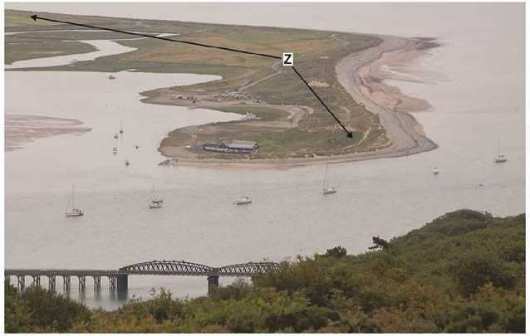
Feature Z labelled on the photograph above is a spit.
Explain the formation of a spit.
(Total 4 marks)

Mark schemes
Level | Marks | Description
2  (Clear) | 3 – 4 | AO1 Demonstrates accurate knowledge about coastal transport and depositional processes and coastal spit formation.  AO2 Shows a clear geographical understanding of the interrelationships between coastal environments and processes. Explanations are developed.
1  (Basic) | 1 – 2 | AO1 Demonstrates some knowledge of coastal transport and depositional processes and coastal spit formation.  AO2 Shows limited geographical understanding of the interrelationships between coastal environments and processes. Explanations are partial and limited in scope.
 | 0 | No relevant content.
Indicative content
.
• The command is “explain”, so responses should provide a reasoned account of how and why a spit forms.
• The question implies knowledge of the processes of transportation and deposition as well as a landform of coastal deposition. Emphasis is on explanation, so processes should be outlined as well as the sequence of formation.
• The formation of a spit usually begins due to a change in the direction of a coastline. One source of material building up a spit is from longshore drift which brings material from further down the coast. Material is carried along the shore in a zigzag fashion by waves as they swash material up the beach at an angle and backwash material down the beach at a right angle. The material initially deposited is the largest material, dropped due to the reduction in energy.
• Some material may also be derived from offshore sources and, more importantly, river-borne sediments. Credit processes of transportation such as traction, saltation and suspension.
• Credit relevant labelled / annotated diagrams as part of the explanation of processes and the sequence of spit formation.
• Where there is a break in the coastline and a slight drop in energy, longshore drift will deposit material at a faster rate than it can be removed and gradually a ridge is built up, projecting outwards into the sea - this continues to grow by the process of longshore drift and the deposition of material. A change in prevailing wind direction, or wave refraction, often causes the end of spits to become hooked (also known as a recurved lateral). Water is trapped behind the spit, creating a low energy zone, as the water begins to stagnate, mud and marshland begins to develop behind the spit.
• Spits may continue to grow until deposition can no longer occur, for example due to increased depth, or the spit begins to cross the mouth of a river and the water removes the material faster than it can deposited – preventing further build-up.
• Credit reference to Figures 1 and 2 if linked to formation of spit. There is an area of relatively shallow and sheltered water where there is a change in the direction of the coast. Material derived from the cliffs to the south may have been transported northwards by longshore drift. As the spit grows across the river estuary, the length of the spit has been restricted by the river outlet washing sediment away. At various times, a short term change in wind direction may have resulted in a change in the direction of the spit, forming a curved end. A salt marsh has formed in the sheltered, low energy zone behind the spit.
• Sequence of spit formation and some reference to processes involved required to access Level 2.
AO1 = 2
AO2 = 2

