Q1.
Study the photograph showing soft engineering.
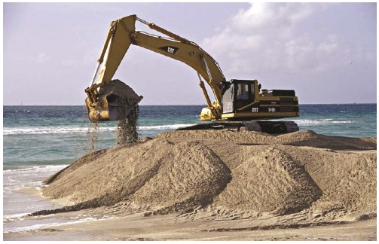
With the help of the photograph, explain how soft engineering is used to protect coastlines from the effects of physical processes.
(Total 6 marks)

Mark schemes
Q1.

Level | Marks | Description
3  (Clear) | 5 – 6 | AO3 Demonstrates thorough application of knowledge and understanding to analyse geographical information, giving detailed explanation of how soft coastal engineering techniques protect environments from the effects of physical processes.  AO3 Makes full analysis of the resource, using evidence to support the response.
2  (Clear) | 3 – 4 | AO1 Demonstrates clear knowledge of soft engineering with some indication of particular soft coastal engineering techniques.  AO2 Demonstrates clear understanding of how soft coastal engineering techniques protect the coastline.
1  (Basic) | 1 – 2 | AO1 Demonstrates limited knowledge of soft engineering other than an indication of using the beach material as shown in the photograph.  AO2 Shows limited understanding of how soft coastal engineering techniques protect the coastline.
 | 0 | No relevant content.
Indicative content
• Students might use an example (place) or discussion of soft engineering techniques.
• Soft engineering could include beach replenishment; beach recycling; beach re-profiling, all are suggested by the photograph.
• Accept points that may not be clearly identified on the picture (Question states ‘With the help of …..’) as long as they are relevant.
• Accept observations about sand dune regeneration and planting vegetation, etc.
• Students who simply describe methods of soft engineering will be restricted to lower levels. For higher level marks the emphasis needs to move towards considering how soft engineering methods work in order to protect coastal areas from physical processes.
AO1 = 2
AO2 = 2
AO3 = 2
[6]

