Q1.
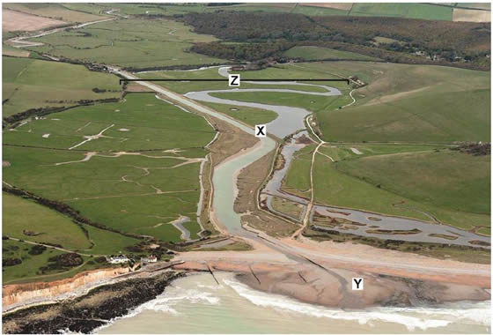
Feature Z labelled on the photograph above is a floodplain.
Explain the formation of a floodplain.
(Total 4 marks)

Mark schemes
Q1.

Level | Marks | Description
2  (Clear) | 3 – 4 | AO1 Demonstrates accurate knowledge about fluvial transport and depositional processes and floodplain formation.  AO2 Shows a clear geographical understanding of the interrelationships between fluvial environments and processes. Explanations are developed.
1  (Basic) | 1 – 2 | AO1 Demonstrates some knowledge of fluvial transport and depositional processes and floodplain formation.  AO2 Shows limited geographical understanding of the interrelationships between fluvial environments and processes. Explanations are partial and limited in scope.
• Level 2 answers will contain linked statements showing some understanding of the processes involved and the correct sequence of formation. Appropriate geographical terminology. It is not necessary to explain both erosion and depositional processes to be awarded top marks.
• Level 1 will comprise simple ideas with limited or partial sequence and little reference to the processes involved. Geographical terminology will be limited.
Indicative content
• The command is “explain”, so responses should provide a reasoned account of how and why a floodplain forms.
• Floodplains are large, flat expanses of land that form on either side of a river. The floodplain is the area that a river floods onto when water level rises above the height of the channel.
• By the time it reaches the middle / lower course the river is wider and deeper and may contain a large amount of suspended sediment.
• As the river breaks its banks friction causes sediment to be deposited, the largest material first. This requires the most energy to be transported and therefore build up around the sides of the river forming raised banks or levées. Finer material such as silt and fine clays continue to flow further over the floodplain before they are deposited.
• When floods have receded, the flood plain is slightly higher due to the deposits of silt / alluvium caused by the river flooding. A flood plain is built up over hundreds of years. Each flood makes the flood plain higher.
• Lateral (sideways) erosion widens the river channel. The river channel is also deepened. A larger river channel means there is less friction, so the water flows faster. The force of the water erodes and undercuts the river bank on the outside of the bend where water flow has most energy due to decreased friction. On the inside of the bend, where the river flow is slower, material is deposited, as there is more friction. Gradually meanders gradually migrate downstream, creating a floodplain. The edge of a flood plain is quite often marked by a clear slope or bluff line, which is the extent of lateral erosion by the river.
• Credit relevant labelled diagrams as part of the explanation of processes and the sequence of floodplain formation.
• Credit reference to the figures if linked to formation of a floodplain. The flat land next to the Cuckmere River consists of silt transported downstream. Every time the river floods further material is deposited, causing the floodplain to rise a little. The river meanders a great deal, cutting into the outer bank where the water flows fastest. This widens the floodplain. On the inside bend deposition occurs and gradually the meanders migrate across the whole floodplain.

