Q1.
Study the photograph showing urban flooding.
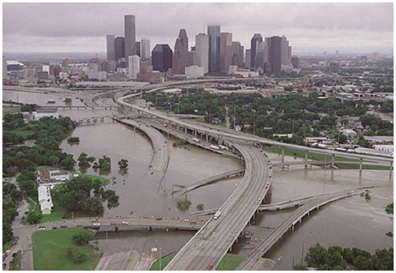
With the help of the photograph, explain how physical and human factors can increase the risk of river flooding.
(Total 6 marks)

Mark schemes
Q1.

Level | Marks | Description
3  (Detailed) | 5 – 6 | AO3 Demonstrates thorough application of knowledge and understanding and thorough analysis of the geographical information, offers detailed explanation of how physical and human factors can increase the risk of flooding.  AO3 Makes full analysis of the resource, using evidence to support the response
2  (Clear) | 3 – 4 | AO1 Demonstrates clear knowledge of the physical and human factors that can increase the risk of flooding  AO2 Demonstrates clear understanding of how physical and human factors can increase the risk of flooding
1  (Basic) | 1 – 2 | AO1 Shows limited knowledge of the physical and human factors that can increase the risk of flooding.  AO2 Shows limited understanding of how physical and human factors increase the risk of flooding.
Indicative content
• Students might use an example (place) or discussion about the different physical and human factors that might increase the flood risk.
• The figure shows an urban area and ideas generated from the photograph might include wide flood plain, flat terrain and observations about the creation of hard surfaces; drainage which might reduce lag times; changing river channels.
• Accept points about building on flood plains.
• Accept points that may not be clearly identified on the figure (Question states ‘With the help of …..’) as long as they are relevant. This might include points about deforestation etc.
• Students who simply describe flood events / effects will be restricted to lower levels. For higher level marks the emphasis needs to move towards considering the link between physical / human factors and flood risk.
AO1 = 2
AO2 = 2
AO3 = 2
[6]

