Q1.
Study the graph, showing the effects on people’s health of some pollutants in a Nigerian water supply.
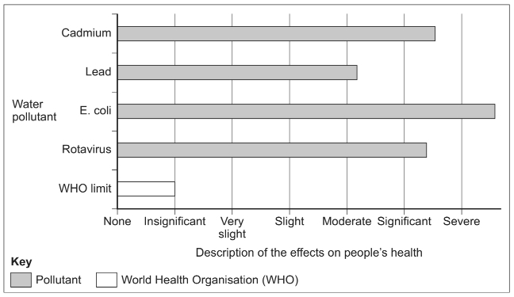
Use the graph above and your own knowledge to explain the effects of water pollution in urban areas in poorer countries.
(4)
Outline how rapid urbanisation in a poorer part of the world can increase air pollution.
(3)
(Total 7 marks)

Mark schemes
Q1.
This mark scheme is from a question paper that assessed a previous specification and has not been edited.
Click [here] to access a document explaining the differences that might apply to it.
Needs to show reference to the graph through something discernible on the graph, though this may be slight such as mentioning one of the contaminants, equally own knowledge may be evidenced through terminology and elaboration and need not be place or exemplar based. Expect comment on how the pollutants named are likely to be toxic and that there are also specific diseases and infections named which are clearly bad for people’s health; mention of other diseases such as typhoid and cholera which result from polluted water; the distressing effects of the smell and possibly harm to aquatic life. Credit fuller elaboration or interpretation of the graph in terms of the relative impacts and severity of the effect.
AO1 = 1
AO2 = 2
AO3 = 1

Level | Marks | Description
2  (Clear) | 3 – 4 | Use of figure and own knowledge, though balance not required. More than one effect needed for L2 access. In addition points will be expanded and developed to show links and explanation.
1  (Basic) | 1 – 2 | Simple statements or listed points with no development. Use of figure or own knowledge only. Likely to be assertions and / or direct lifts from the figure without demonstrating understanding. Limited or no concept of the severity or nature of the effects.
[4]
Q2.
(b) 1 × 3, or (1+1) + 1
A wide range of factors might be outlined and at least one should be elaborated for full marks. Expect comment on: the link with between urbanisation and industrialisation so that factory growth will add to air pollution; the reliance of poorer countries on fossil fuels which clearly have higher emissions; older more polluting technology in the vehicles on the roads; the use of fuelwood for heating / cooking in many squatter settlements which will create smoke; irregular electricity supply means many will rely on diesel generators which add particulates.
AO1 = 3
[5]

