Q1.
Study the information about urban change.
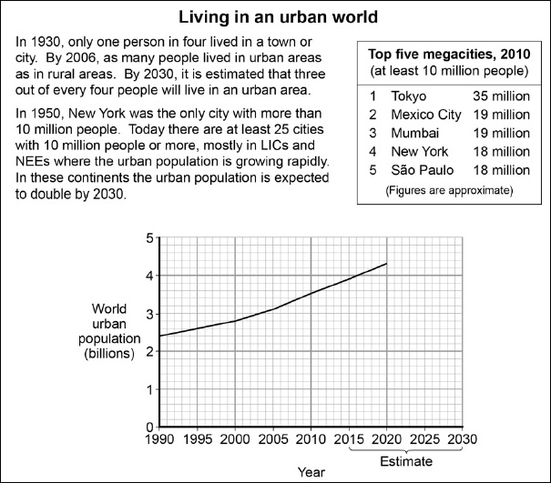
(a) How many people lived in urban areas in 2000?
(1)
(b) Suggest why an increasing number of megacities are located in lower income countries (LICs) or newly emerging economies (NEEs).
(2)
(Total 3 marks)

Mark schemes
Q1.
(a) 2.8 billion (must have billion)
AO4 = 1
(b) Individual points – 1 mark (2 × 1) OR
developed point – 2 marks.
Ideas might include:
• many cities in LICs / NEEs are growing rapidly because of high levels of migration from the countryside to the cities (rural-urban migration) (1). This is mainly due to the opportunities for a higher standard of living / food security / health / education in urban areas (pull factors)(1)
• many megacities are major centres of economic activity, including manufacturing industries and services (1), so they attract large numbers of people looking for work often from rural areas, causing the city to grow faster (1)
• push factors such as rural unemployment and poor access to services drives people into larger cities in LICs and NEEs (1)
• people who migrate to towns and cities tend to be young and so have higher birth rates in that age range (1)
• no credit for description of pattern of megacities.
AO3 = 2
[3]

