Q1.
Study the topological map showing variation in life expectancy along two train lines in Birmingham.
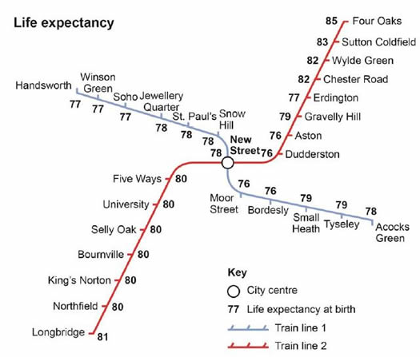
(a) Calculate the range in life expectancy shown in the map.
(1)
(b) Using the map and your own understanding, suggest why there are inequalities in health in urban areas.
(4)
(Total 5 marks)

Mark schemes
Q1.
(a) One mark for the correct answer
9 years
AO4 = 1
(b)
Level | Marks | Description
2  (Clear) | 3 – 4 | AO2 – Shows clear understanding of urban areas and processes and the concept of inequality  AO3 – Uses the figure effectively and offers development to evaluate the links between urban areas and processes and increased inequality
1  (Basic) | 1 – 2 | AO2 – Shows limited understanding of urban areas and processes and the concept of inequality  AO3 – use the figure OR own knowledge to begin to interpret the links between urban areas and processes and increased inequality
Indicative content
• Level 2 responses will apply geographical explanation in combination with the figure to present a reasoned explanation.
• Level 1 responses will be simplistic or simply assert a cause/effect link.
• Answers should make use of the figure which may be inferred through reference to inner city / rural-urban fringe differences in health indicators. Development need not be through named places but use of a case study is likely to add clarity. Development may also be found in explanation of processes of change and widening gaps in cities.
Students may refer to a range of processes of change and may achieve full marks through full development of one:
• De-industrialisation leading to inner city decline and subsequent deprivation leading to poorer health in inner areas, e.g. Aston amongst the most deprived areas in the UK. They may also comment that unhealthy behaviours such as smoking and drinking are more common in deprived areas so that life expectancies are lower.
• Urban sprawl and the growth of commuter settlements has gone hand in hand with this so that those on higher incomes are able to move out of the centre; accessing better housing, employment and healthcare; leaving behind a more elderly and disadvantaged population, exacerbating the situation above.
• It would also be possible for students to argue that redevelopment and regeneration programmes in inner city areas e.g. Aston Pride in Birmingham have improved the situation so that health in many deprived areas is not as poor as it once was.
No credit for description of the inequalities in health in isolation.
AO2 = 2
AO3 = 2
[5]

