Q1.
Study the information about a ‘Sustainable Urban Living’ project.

Sustainable Urban Living – The Greenhouse Development – Leeds
Greenhouse is part of an urban regeneration scheme, located a 10-minute walk from Leeds city centre and close to the main railway station. It was the first carbon-zero, mixed-use development in the UK that produces more energy than it uses. It has 172 eco-homes, all set around communal landscaped grounds.
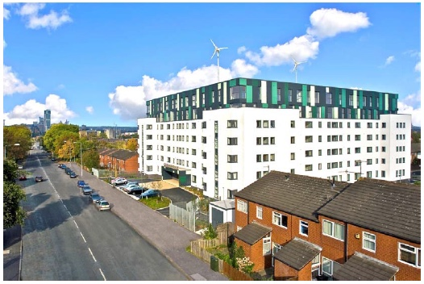
The Greenhouse development includes:
• renewable energy generation methods
• cycle links to the city centre and railway station
• a car sharing scheme
• recycling facilities
• local shops and cafés
• a medical centre and nursery
• parks with children’s playgrounds
• a sports centre, with a swimming pool
• allotments where people can grow fruit and vegetables.
Using the information and your own knowledge, discuss how the features of the Greenhouse development will make for more sustainable urban living.
(Total 6 marks)

Mark schemes
Q1.

Level | Marks | Description
3  (Detailed) | 5 – 6 | AO3 Demonstrates thorough application of knowledge and understanding in interpreting geographical information and giving detailed explanation of how the features of the Greenhouse Development make for sustainable urban living.  AO3 Makes full analysis of the resource, using evidence to support the response.
2  (Clear) | 3 – 4 | AO1 Demonstrates clear knowledge of the features that make for sustainable urban living.  AO2 Shows some geographical understanding of how particular features of urban development will make for sustainable urban living.
1  (Basic) | 1 – 2 | AO1 Demonstrates limited knowledge of the features that make for sustainable urban living.  AO2 Shows limited geographical understanding of how particular features of urban development will make for sustainable urban living.
 | 0 | No relevant content.
Indicative content
• There are a number of factors identified in the picture which could be considered as important to the sustainable development of urban areas.
• The picture highlights socio-economic and environmental aspects of sustainability.
• Students can show evidence of their own knowledge by introducing other aspects of sustainable urban management or by developing the ideas expressed in the picture.
• At the higher levels it is expected that students will show an increasing awareness of why the identified factors are important in creating sustainable urban areas, consequently, an understanding of “sustainable” in the context of urban areas is important.
• At Level 3 an appreciation of ‘sustainable’ which goes beyond environmental factors should be expected.
AO1 = 2
AO2 = 2
AO3 = 2
[6]

