Q1.
Study the figure, a satellite image of Hurricane Katrina shortly before it crossed New Orleans in the USA.
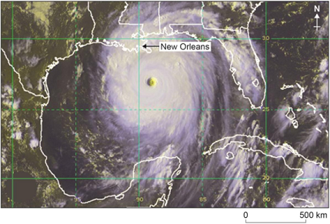
Using the image only, forecast the weather conditions in New Orleans over the next 24 hours.
(Total 4 marks)
Q2.
Give two reasons why tropical storms eventually lose their energy.
Reason 1:______________________________________________________________
_______________________________________________________________________
Reason 2:______________________________________________________________
_______________________________________________________________________
(Total 2 marks)

Mark schemes
Level | Marks | Description
2  (Clear) | 3–4 | AO3 Demonstrates accurate interpretation of weather conditions through the application of relevant knowledge and understanding to the resource.  AO4 Makes clear and effective use of the satellite image to support the forecast of weather conditions.
1  (Basic) | 1–2 | AO3 Demonstrates some interpretation of weather conditions through the application of limited relevant knowledge and understanding to the resource.  AO4 Makes limited and piecemeal use of the satellite image to support the forecast of weather conditions.
Indicative content
• The weather forecast should relate to the satellite image, so expect reference to the typical sequence of weather conditions associated with the passage of a tropical storm.
• Credit any aspects of weather that might realistically occur in the next 24 hours, e.g. cloud cover, precipitation, wind speed and direction, air pressure, humidity, general weather conditions.
• Cloud cover will increase over the next few hours and wind speed will pick up dramatically as the outer part of the vortex approaches. Winds, which will be blowing from the east, may be damaging and there will be torrential downpours of rainfall from dark cumulonimbus clouds. There is a possibility of tornadoes and thunderstorms with lightning. A storm surge combined with the heavy rain may cause dangerous flooding in low-lying coastal areas. Air pressure will drop rapidly.
• This will be followed by the centre of the storm or ‘eye’, which will only last for a short time. The weather is likely to be fairly calm with only light winds and fair weather.
• The winds will again increase suddenly as the second part of the vortex approaches. This will be accompanied by powerful winds blowing from the west, with further heavy rain. Air pressure will rise as the storm continues northwards, and cloud cover will then become thinner, with more moderate winds. Eventually the rain will cease, although further belts of showers will occur as the storm moves away.
The focus is on weather conditions. No credit for describing the structure of the storm, its causes or responses.
As the forecast is for 24-hours, allow differing interpretations about how far the tropical storm may move. Credit partial sequence to the top of Level 2 if clear and valid forecast is produced.
No credit for descriptions unrelated to the image.
Answers must apply understanding of the features of tropical storms to interpret the resource.
AO3 = 2
AO4 = 2
[4]
One mark for each reason showing understanding of the frictional effect of moving over the land, e.g. they pass over land which slows their movement due to friction, or of loss of energy due to cooling effect of passing over water (or land) at higher latitudes, e.g. they move into areas of cooler water, where there is less energy.
No credit for vague statements such as ‘mountains stop them’ or ‘they pass over the sea’.
AO2 = 2

