Q1.
Study the graph showing the area of Arctic sea ice each September between 1979 and 2016.
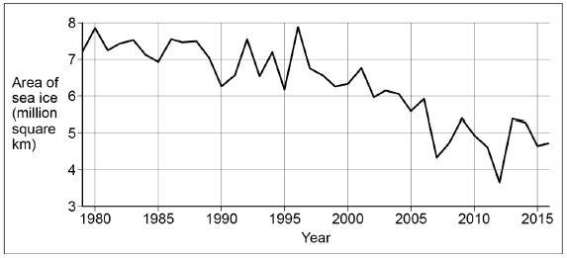
(a) Using the graph, describe how the area of Arctic sea ice has changed.
___________________________________________________________________
___________________________________________________________________
___________________________________________________________________
___________________________________________________________________
(2)
(b) Give two ways that human activity may have contributed to the changes shown in the graph.
1. _________________________________________________________________
___________________________________________________________________
2. _________________________________________________________________
___________________________________________________________________
(2)
(Total 4 marks)

Mark schemes
Q1.
(a) There has been an overall decrease in extent of Arctic Sea ice (1).
The changes in Arctic sea ice have fluctuated considerably (1)
There was limited change from 1979-1996 (1) followed by rapid decrease 1996 onwards (d) (1).
Credit use of data shown on graph or for data manipulation.
e.g. a decrease in extent from almost 8 million km to approx. 4 million at lowest point.(1)
A loss of almost 50% (in 36 years). (1)
A decrease from 7.2 million sq km to 4.8 million sq km between 1979-2016. (1)
Considerable fluctuations from year to year-rapid decrease 2006-2007, followed by rapid increase 2007-2009.(1)
No credit for stating that there has been a steady or consistent decrease.
No credit for explanations of change.
AO4 = 2
(b) Two separate ways are required. Credit relevant human activities that link to rising temperatures / enhanced greenhouse effect and diminishing sea ice. The links with extent of Arctic sea ice do not have to be explicit.
E.g. Increased burning of fossil fuels (1)
Increased manufacturing of products (1)
Rapid rates of deforestation (1)
Increased methane emission from agriculture / mining (1)
Carbon emissions from transport using oil and gas. (1)
Greater use of fertilisers / sewage farms (1)
Use of halocarbons (‘man made’ powerful greenhouse gas used by industry to make solvents and for equipment cooling). (1)
AO1 = 2
[4]

