Budmouth Academy

Year 9 German
Unit 4 Freizeit 2: Freetime activities
(Food and Sport)

Name ………………………………………….
Class ……………………………………………

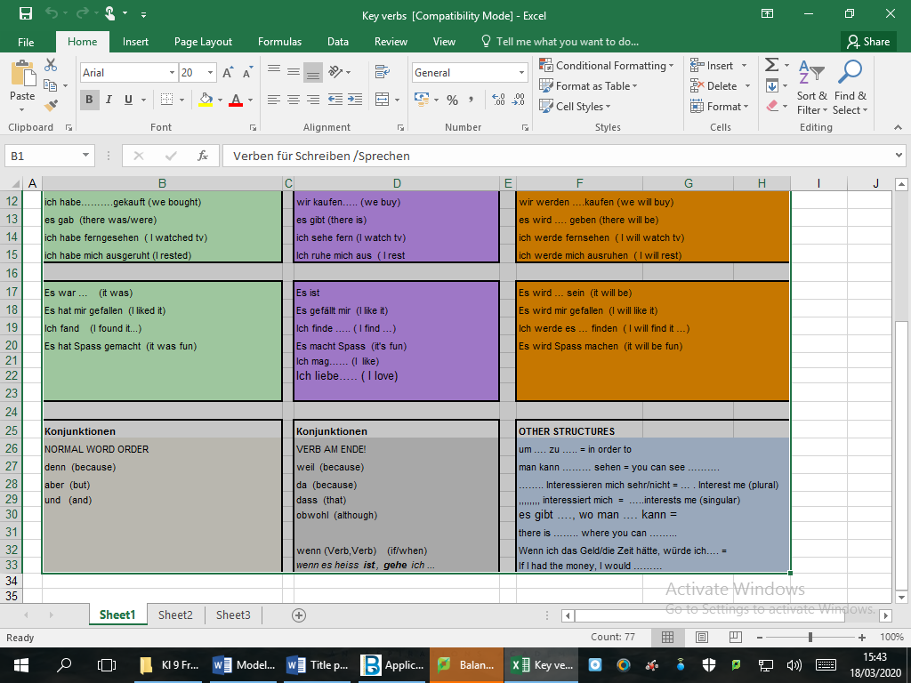

 | 3.1 G Freizeit macht Spaß Fernsehen
der | Abenteuerfilm (-e) |  | youth club
 | sich ausruhen |  | weather forecast
das | Autorennen |  | TV series
 | blöd |  | to watch TV
der | Dokumentarfilm (-e) |  | to shop
 | einkaufen |  | to rest
die | Eintrittskarte (-n) |  | to practise, to rehearse
die | Eisdiele (-n) |  | to miss
 | fernsehen |  | to improve
die | Fernsehserie (-n) |  | to happen
die | Freizeit |  | to cook
die | Handlung (-en) |  | to be interested in
 | sich interessieren für |  | ticket (to get in)
der | Jugendklub (-s) |  | team
 | kochen |  | stupid
der | Krimi (-s) |  | soap (opera)
 | langweilig |  | romantic film
der | Liebesfilm (-e) |  | programme
die | Mannschaft (-en) |  | plot, storyline
die | Nachrichten |  | news (pl)
 | passieren |  | motor racing
die | Seifenoper (-n) |  | ice cream parlour / cafe
die | Sendung (-en) |  | free time
 | spannend |  | exciting
 | täglich |  | every day, daily
 | üben |  | documentary
 | verbessern |  | detective drama
 | verpassen |  | boring
die | Werbung (-en) |  | advertisement
die | Wettervorhersage (-en) |  | adventure movie
der | Fernsehapparat |  | I watch
der | Fernseher |  | one watches
 | ich sehe |  | we watch
 | man sieht |  | TV set
 | wir sehen |  | you watch
 | du siehst |  | TV set

MFL Curriculum Overview (Knowledge) |  |  | German
Term | 1 | 2 | 3 | 4 | 5 | 6
Assess | L,W, Tr into Eng | R,S,Tr into TL | L,W, Tr into Eng | R,S,Tr into TL | L,W, Tr into Eng | R,S,Tr into TL
Year 7
Year 8 | Home Life (Fut) | My area | Travel | Holidays | Lost property | Health
 | Zu Hause | Stadt & Land | Transport | Urlaub | Verlorenes | Topfit
Year 9 | Family & friends | Local area | School subjects | Free time 1 | Free time 2 | Festivals
 | Familie, Freunde | Wohnort | Schulfaecher | Freizeit | Freizeit | Feste
 |  |  |  | (TV,Musik) | (Essen, Sport)
Year 10 | School problems | Holiday | Future studies | Health | Marriage | Technology
 | Schule | Urlaub | Studien | Gesundheit | Ehe | Technologie
 | (Probleme)
Year11 | Global issues | Social Issues | Work and careers | Revision | Revision
 | Umwelt (eco) | Wie helfen | Arbeit, Karriere

Model Tasks and Deliberate Practice
The tasks here will give you a good model of typical GCSE assessments and help you to develop skills. Keep each booklet safe and use for revision for end of unit tests and the final GCSE exam.

Einheit 3 Freizeit 1– Foundation
Your sister has received this email from her German friend. She asks you to translate it into English for her.
Mein Bruder heiβt Johannes. Er spielt in einer Band und hört jeden Tag Musik! Abends sieht er gern fern, aber das finde ich sehr langweilig. Am Wochenende geht er gern mit seinen Freunden ins Kino. Letzte Woche ist er zweimal gegangen!

_____________________________________________________________________________________
_____________________________________________________________________________________
_____________________________________________________________________________________
_____________________________________________________________________________________
_____________________________________________________________________________________
(9 marks)
Translate the following sentences into good German:-

1. I like music programmes.

……………………………………………………………………………………………………………………………………………………………
……………………………………………………………………………………………………………………………………………………………

2. I watch tv every day.

……………………………………………………………………………………………………………………………………………………………
……………………………………………………………………………………………………………………………………………………………

3. On Saturday afternoon we see a film.

……………………………………………………………………………………………………………………………………………………………
……………………………………………………………………………………………………………………………………………………………

4. I listen to music in my bedroom.

……………………………………………………………………………………………………………………………………………………………
……………………………………………………………………………………………………………………………………………………………

5. On Friday we went to the cinema.
……………………………………………………………………………………………………………………………………………………………
……………………………………………………………………………………………………………………………………………………………

Einheit 3 Freizeit 1 Typical speaking conversation questions (F & H)
Use the “useful phrases tables” below to help you. The vocab page 62 will also help.
- Was machst du in deiner Freizeit? = ………………………………………………………………….……………………………………………

…………………………………………………………………………………………………………………………………………………………………………

…………………………………………………………………………………………………………………………………………………………………………

- Siehst du gern fern? = ……………………………………………………………………………………………………………………………………..

…………………………………………………………………………………………………………………………………………………………………………

…………………………………………………………………………………………………………………………………………………………………………

- Hast du eine Lieblingssendung? = …………………………………………………………………………………………………………………..

…………………………………………………………………………………………………………………………………………………………………………

…………………………………………………………………………………………………………………………………………………………………………

- Magst du Musik? = ………………………………………………………………………………………………………………………………………….

…………………………………………………………………………………………………………………………………………………………………………

…………………………………………………………………………………………………………………………………………………………………………

- Was ist besser… Filme im Kino oder Zuhause? = …………………….....................................……………………………………

…………………………………………………………………………………………………………………………………………………………………………

…………………………………………………………………………………………………………………………………………………………………………

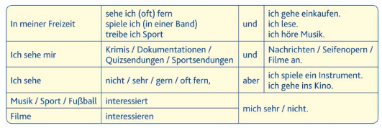

Freizeit 1 Writing Foundation
Du gehst mit Freunden ins Kino und schickst dieses Foto an deine Freundin in Österreich. Schreib vier Sätze auf Deutsch über das Foto.
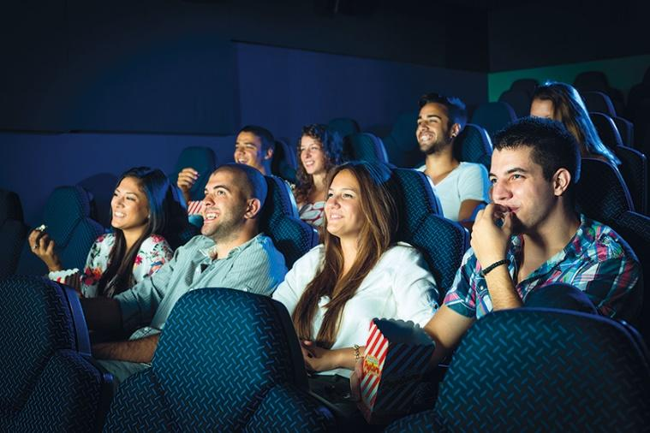

- _____________________________________________________________________________________
(2 marks)

2 _____________________________________________________________________________________
(2 marks)

3 _____________________________________________________________________________________
(2 marks)

4 _____________________________________________________________________________________
(2 marks)
40 word piece
Du schreibst eine Email über deine Freizeit. Schreib etwas über :
1 deine Freizeit
2 dein Lieblingshobby
3 Musik
4 Was du im Kino gesehen hast
_____________________________________________________________________________________
_____________________________________________________________________________________
_____________________________________________________________________________________
_____________________________________________________________________________________
_____________________________________________________________________________________
_____________________________________________________________________________________
_____________________________________________________________________________________

90 word piece
Dein Freund Markus hat dich etwas zum Thema Freizeit gefragt. Du schreibst Markus eine E-Mail.
Schreib:
- etwas über deine Freizeitaktivitäten
- etwas über deine Lieblingssendung
- was für Musik du magst
- was du neulich im Kino gesehen hast
Du musst ungefähr 90 Wörter auf Deutsch schreiben. Schreib etwas über alle Punkte der Aufgabe.
____________________________________________________________________________________
_____________________________________________________________________________________
_____________________________________________________________________________________
_____________________________________________________________________________________
_____________________________________________________________________________________
_____________________________________________________________________________________
_____________________________________________________________________________________
_____________________________________________________________________________________
_____________________________________________________________________________________
_____________________________________________________________________________________
______________________________________________________________________________________
_____________________________________________________________________________________
_____________________________________________________________________________________
_____________________________________________________________________________________
____________________________________________________________________________________
_____________________________________________________________________________________
-------------------------------------------------------------------------------------------------------------------------- (16 marks)

Foundation Speaking
Photo card
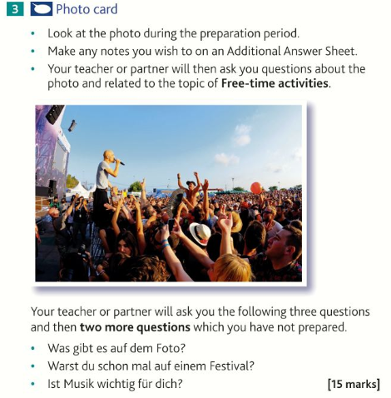

Foundation Role play
2 Your teacher or partner will play the part of your German friend and will speak first.
You should address your friend as du.
When you see this – ! – you will have to respond to something you have not prepared.
When you see this – ? – you will have to ask a question.

Du sprichst mit deinem deutschen Freund / deiner deutschen Freundin über Fernsehen und Filme.
- Gern fernsehen (ein Detail).
- Deine Meinung über Liebesfilme.
- !
- Filme zu Hause – wie oft.
- ? Lieblingsfilm.
(15 marks)

Einheit 3 Freizeit 1 – Higher Tier
Your brother’s exchange partner is coming to stay. He has sent this email about his interests and your brother asks you to translate it into English for him.
Ich gehe sehr gern ins Kino oder sehe mir zu Hause DVDs an. Musik ist für mich das Wichtigste im Leben, weil sie mich total entspannt. Mein Lieblingsessen war früher Wurst mit Pommes, aber ich habe mich jetzt entschieden, gesünder zu essen. Ich treibe viel Sport, aber in Zukunft werde ich auf jeden Fall Extremsportarten ausprobieren.
______________________________________________________________________________________
______________________________________________________________________________________
______________________________________________________________________________________
______________________________________________________________________________________
______________________________________________________________________________________
______________________________________________________________________________________
______________________________________________________________________________________
______________________________________________________________________________________
(9 marks)
Translate the following passage into German.
I really like watching television in my room, but yesterday my friends and I went to the cinema. We watched a comedy and ate lots of snacks. Next week I will try a new sport. When I am older, I would like to be a famous singer because I love music.
_____________________________________________________________________________________
_____________________________________________________________________________________
_____________________________________________________________________________________
_____________________________________________________________________________________
_____________________________________________________________________________________
_____________________________________________________________________________________
_____________________________________________________________________________________
_____________________________________________________________________________________
_____________________________________________________________________________________
(12 marks)

