Budmouth Academy

Year 9 German
Unit 1 Identity and Culture: Me, my family and friends

Name ………………………………………….
Class ……………………………………………
Tutor Group ………………………………..

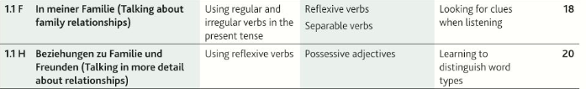

 |  | Assessment Bands in MFL
Exceptional  Advanced  Secure  Developing | = Nearly always …  = Mostly …  = Occasionally …  = Rarely … | Takes an active part in lessons and accepts challenge  Goes “above and beyond” in independent learning  Recognises and uses vocab from current topic and previous topics  Recognises and uses structures from current topic and previous topics  Remains focused when listening and uses context to understand new language  Uses varied strategies and resilience to read and understand written texts  Writing:-  communicates in appropriate detail, with varied pronouns  uses resourcefulness and creativity when writing (including HW)  uses varied connectives with accurate word order and grammar  uses model texts to produce own written pieces with at least two tenses (sentences / paragraphs / 40 / 90 /150 words)  checks own written work, aiming for accuracy and quality  Speaking:-  develops ideas clearly and accurately in at least two tenses (photo card/ topics)  talks spontaneously and deals with unpredictable elements.  makes an effort to speak with accurate pronunciation  willingly responds to teacher feedback  asks thoughtful Qs about grammar  pays attention to detail when translating
The length and complexity of what students understand and produce is expected to increase as each year progresses.
Progress is made as students develop the frequency in which they apply the skills outlined above.

Useful verbs and structures
VERGANGENHEIT |  | PRASENS |  | FUTUR
ich bin …. gefahren ( I went / travelled) |  | ich fahre (I go / travel) |  | ich werde …. fahren (I will go / travel)
ich bin …. aufgestanden (I got up) |  | ich stehe …. auf (I get up) |  | ich werde …. aufstehen (I will get up)
ich bin …..gegangen |  | ich gehe |  | ich möchte …. gehen (I would like to go)
ich habe gelesen (I read) |  | ich lese (I read) |  | ich werde..... lesen (I will read)
ich habe …. gegessen / getrunken (I ate/drank) |  | ich esse / ich trinke (I eat/drink) |  | ich will …. essen / trinken (I want to eat / drink)
ich habe …. gesehen (I saw/watched) |  | ich sehe (I see/watch) |  | ich werde …. sehen (I will see/watch)
wir haben…… getanzt (we danced) |  | wir tanzen (we dance) |  | wir werden ... tanzen (we will dance)
wir haben ….. gesprochen (we spoke) |  | wir sprechen (we speak) |  | wir werden …. sprechen (we will speak)
es gab (there was/were) |  | es gibt (there is) |  | es wird …. geben (there will be)
 |  | Ich komme gut mit …. aus (I get on well with)
Es war … (it was) |  | Es ist |  | Es wird … sein (it will be)
Es hat mir gefallen (I liked it) |  | Es gefällt mir (I like it) |  | Es wird mir gefallen (I will like it)
Ich fand (I found it...) |  | Ich finde ….. ( I find …) |  | Ich werde es … finden ( I will find it …)
Es hat Spass gemacht (it was fun) |  | Es macht Spass (it's fun) |  | Es wird Spass machen (it will be fun)
Konjunktionen |  | Konjunktionen |  | OTHER STRUCTURES
NORMAL WORD ORDER |  | VERB AM ENDE! |  | um …. zu ….. = in order to
denn (because) |  | weil (because)
aber (but) |  | da (because) |  | mit ... auskommen = to get on with .....
und (and) |  | dass (that)
 |  | obwohl (although)
 |  | wenn (Verb,Verb) (if/when)
 |  | wenn es heiss ist, gehe ich ...

Meine Familie und Haustiere |  | AQA, S. 18/19
der Bruder |  | at home
das Einzelkind |  | bird
der Freund |  | brother
die Geschwister |  | budgie
getrennt |  | called, named
der Goldfisch |  | cat
die Halbschwester |  | dog
zu Hause |  | friend
das Haustier |  | goldfish
heiraten |  | guinea pig
heißen |  | half-sister
der Hund |  | horse
jetzt |  | nice
das Kaninchen |  | now
die Katze |  | only
klein |  | only child
leider |  | pet
das Meerschweinchen |  | rabbit
namens |  | separated
nett |  | siblings
nur |  | sister
das Pferd |  | small
die Schwester |  | to be called
der Vogel |  | to marry
der Wellensittich |  | twins
die Zwillinge |  | unfortunately

Seite 20 In meiner Familie
auskommen | to go out / to get on with
aussehen | to look like / to see out
beide | both / bees
beschreiben | to describe / to write
bestimmt | certainly / always
der Cousin (-s) | uncle / cousin (m)
die Cousine ( -n) | cousin (f) / cauliflower
die Frau (-en) | man / woman
die Freundin (-nen) | male friend / female friend
geben (es gibt) | to give (there is) / to buy (it buys)
gefallen | to fall / to please
die Gemeinschaft(-en) | community, group / football club
das Geschenk (-e) | chicken / present
geschieden | married / divorced
Glück haben | to be lucky / to be sad
glücklich | happy / sad
die Grosseltern | parents / grandparents
jeder / jede / jeder | each, every / leather
ledig | single / loud
liebevoll | loving / aggressive
der Morgen | evening / morning
auf die Nerven gehen | to be kind /to get on one's nerves
der Partner (-) | male partner / female partner
die Stiefschwester (-n) | step mum / step sister
das Taschengeld | handkerchief / pocket money
das Verhältnis (-se) | train / relationship
verheiratet | married / separated
verlobt | engaged / to lob a ball
sich verstehen | to understand / to get on with
vorbeikommen | to sail / to call in
die Witwe | bird / widow
zu dritt | three (of us) / four (of us)
zusammen | separately / together
Model Tasks and Deliberate Practice
The tasks here will give you a good model of typical GCSE assessments and help you to develop skills. Keep each booklet safe and use for revision for end of unit tests and the final GCSE exam.
Einheit 1 Familie und Freunde Foundation
Your brother has received an email from a German friend. He asks you to translate it into English for him.

Ich habe eine sympathische Freundin. Sie hat drei Brüder und ein altes Kaninchen. Sie wohnt mit ihrer Mutter und ihrem Stiefvater im Dorfzentrum. Meine Freundin kommt nicht so gut mit ihren Eltern aus. Letzte Woche war sie traurig, denn es gab Streit.

………………………………………………………………………………………………………………
………………………………………………………………………………………………………………
………………………………………………………………………………………………………………
………………………………………………………………………………………………………………
………………………………………………………………………………………………………………

Translate the following sentences into good German:-

1. I have a sister and she is ten.
……………………………………………………………………………………………………………………….

…………………………………………………………………………………………………………………………

2. My grandma is quite old but she is sporty.
……………………………………………………………………………………………………………………….

…………………………………………………………………………………………………………………………

3. We have an aunt who is funny.
……………………………………………………………………………………………………………………….

…………………………………………………………………………………………………………………………

4. I get on well with my sister.
……………………………………………………………………………………………………………………….

…………………………………………………………………………………………………………………………

5. Yesterday there was an argument.
……………………………………………………………………………………………………………………….

…………………………………………………………………………………………………………………………

Einheit 1 Familie und Freunde Typical speaking conversation questions
Use the “useful phrases tables” below to help you. The vocab pages 28 & 29 will also help.
- Hast du Geschwister? = ……………………………………………………………………………………..

……………………………………………………………………………………………………………………….

……………………………………………………………………………………………………………………….
- Beschreib deine Mutter. = …………………………………………………………………………………..

……………………………………………………………………………………………………………………….

……………………………………………………………………………………………………………………….

- Kommst du gut mit deiner Mutter aus? = ……………………………………………………………………

……………………………………………………………………………………………………………………….

……………………………………………………………………………………………………………………….

- Wie viele Haustiere hast du? = ……………………………………………………………………………...

……………………………………………………………………………………………………………………….

……………………………………………………………………………………………………………………….

- Was für eine Person bist du? = ……………………………………………………………………………....

……………………………………………………………………………………………………………………….

……………………………………………………………………………………………………………………….

Foundation Writing

40 word piece

Du schreibst eine E-mail an deinen deutschen Austauschpartner, Klaus. Schreib etwas über:
  - Deine Familie
  - Deine Großeltern
  - Freunde
  - Haustiere
Du musst ungefähr 40 Wörter auf Deutsch schreiben. (16 Marks)

Top Tips! 10 marks are for communication - so make sure you write in some detail (approximately 10 words) about EACH bullet point. For the 6 marks for Language, use varied vocab, verbs, opinions and some justifications.
………………………………………………………………………………………………………...
…………………………………………………………………………………………………………
………………………………………………………………………………………………………...
…………………………………………………………………………………………………………
………………………………………………………………………………………………………...
…………………………………………………………………………………………………………
………………………………………………………………………………………………………...
…………………………………………………………………………………………………………
…………………………………………………………………………………………………………
…………………………………………………………………………………………………………
…………………………………………………………………………………………… [16 marks]

Foundation Writing 90 word piece

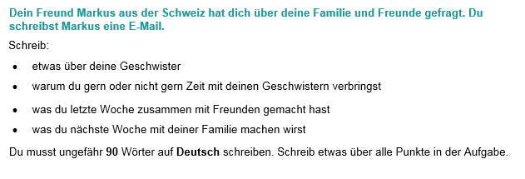
Top Tips! 10 marks are for communication - so make sure you write in some detail (approximately 23 words) about EACH bullet point. For the 6 marks for Language, use varied vocab, verbs, opinions and some justifications.
………………………………………………………………………………………………………...
…………………………………………………………………………………………………………
………………………………………………………………………………………………………...
…………………………………………………………………………………………………………
………………………………………………………………………………………………………...
…………………………………………………………………………………………………………
………………………………………………………………………………………………………...
…………………………………………………………………………………………………………
…………………………………………………………………………………………………………
…………………………………………………………………………………………………………
…………………………………………………………………………………………………………
………………………………………………………………………………………………………...
…………………………………………………………………………………………………………
…………………………………………………………………………………………………………
…………………………………………………………………………………………………………
………………………………………………………………………………………………[16 marks]

Foundation Speaking Role Play

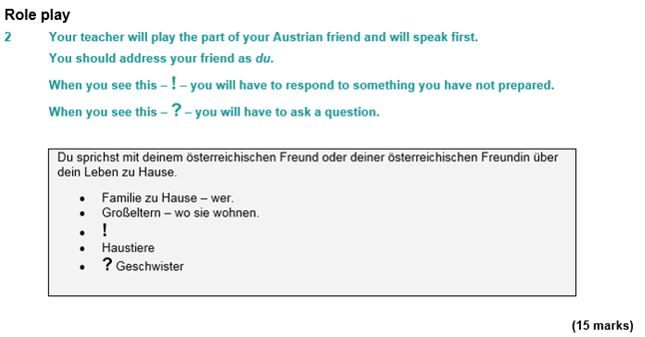
………………………………………………………………………………………………………...
…………………………………………………………………………………………………………
…………………………………………………………………………………………………………
…………………………………………………………………………………………………………
………………………………………………………………………………………………………...
…………………………………………………………………………………………………………
………………………………………………………………………………………………………...
…………………………………………………………………………………………………………
…………………………………………………………………………………………………………
……………………………………………………………………………………… [15 marks]

Foundation Speaking Photo Card

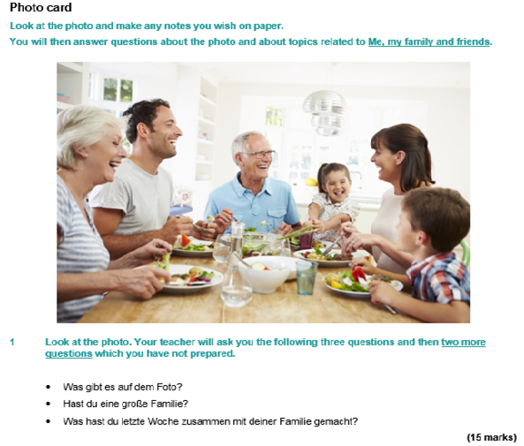

It’s wise to use the Verb Table found near the start of this Learning Booklet so you VARY verbs/opinions/structures. Remember: We need a minimum of THREE “ideas” for each question.
....……………………………………………………………………………………………………...
…………………………………………………………………………………………………………
…………………………………………………………………………………………………………
…………………………………………………………………………………………………………
………………………………………………………………………………………………………...
…………………………………………………………………………………………………………
…………………………………………………………………………………………………………
…………………………………………………………………………………………………………
………………………………………………………………………………………………………...
…………………………………………………………………………………………………………
………………………………………………………………………………………………………...
…………………………………………………………………………………………………………
………………………………………………………………………………………………………...
…………………………………………………………………………………………………………
………………………………………………………………………………………………[15 marks]
Unit 1 Die Familie – Higher Tier Translate the paragraph into English.

....……………………………………………………………………………………………………...
…………………………………………………………………………………………………………
…………………………………………………………………………………………………………
…………………………………………………………………………………………………………
………………………………………………………………………………………………………....
………………………………………………………………………………………………………….
………………………………………………………………………………………………………….
………………………………………………………………………………………………………….
…………………………………………………………………………………………………………..

....……………………………………………………………………………………………………...
…………………………………………………………………………………………………………
…………………………………………………………………………………………………………
…………………………………………………………………………………………………………
………………………………………………………………………………………………………....
………………………………………………………………………………………………………….
………………………………………………………………………………………………………….
………………………………………………………………………………………………………….
…………………………………………………………………………………………………………..
Extended Writing Deliberate Practice
150 word piece Higher
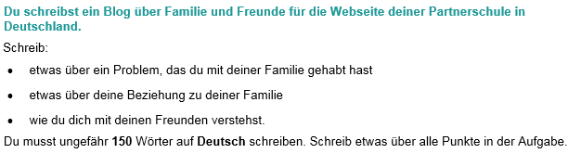

Top Tip: You don’t HAVE to use all three tenses in this 150-word piece of writing, but it’s a good idea to include all three, so that you show the examiner that you can use them well. Remember to include lots of varied, complex structures! Keep it clear and relevant.

.…………………………………………………………………………………………………………
………………………………………………………………………………………………………...
…………………………………………………………………………………………………………
…………………………………………………………………………………………………………
………………………………………………………………………………………………………...
…………………………………………………………………………………………………………
………………………………………………………………………………………………………...
…………………………………………………………………………………………………………
…………………………………………………………………………………………………………
…………………………………………………………………………………………………………
…………………………………………………………………………………………………………
…………………………………………………………………………………………………………
…………………………………………………………………………………………………………
………………………………………………………………………………………………………...
…………………………………………………………………………………………………………
…………………………………………………………………………………………………………
………………………………………………………………………………………………………...
…………………………………………………………………………………………………………
………………………………………………………………………………………………………...
…………………………………………………………………………………………………………
…………………………………………………………………………………………………………
…………………………………………………………………………………………………………
…………………………………………………………………………………………………………
…………………………………………………………………………………………………………
…………………………………………………………………………………………………………
…………………………………………………………………………………………………………
…………………………………………………………………………………………………………
…………………………………………………………………………………………………………
…………………………………………………………………………………………… [32 marks]

Higher Speaking Role Play

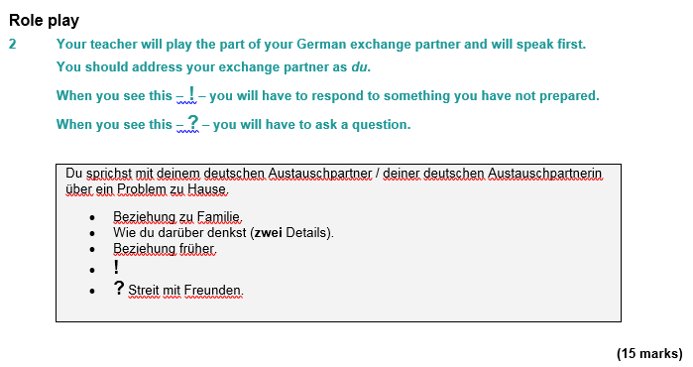
………………………………………………………………………………………………………...
…………………………………………………………………………………………………………
…………………………………………………………………………………………………………
…………………………………………………………………………………………………………
………………………………………………………………………………………………………...
…………………………………………………………………………………………………………
………………………………………………………………………………………………………...
…………………………………………………………………………………………………………
…………………………………………………………………………………………………………
……………………………………………………………………………………… [15 marks]

Some Higher Tier Reading Practice

Useful websites for independent learning

www.kerboodle.com (your teacher will provide your individual log-in details.

www.quizlet.com

www.languagesonline.org.uk

www.linguascope.com (username: budmouth password provided by your teacher)

www.memrise.com

https://www.dw.com/de/deutsch-lernen/nachrichten/s-8030 (slowly spoken German news)

