Budmouth Academy

Year 9 Spanish
Unit 1 Mi Familia y amigos

Name ………………………………………….
Class ……………………………………………
Tutor Group ………………………………..

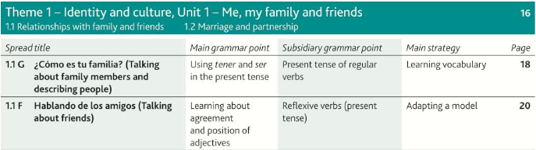

 |  | Assessment Bands in MFL
Exceptional  Advanced  Secure  Developing | = Nearly always …  = Mostly …  = Occasionally …  = Rarely … | Takes an active part in lessons and accepts challenge  Goes “above and beyond” in independent learning  Recognises and uses vocab from current topic and previous topics  Recognises and uses structures from current topic and previous topics  Remains focused when listening and uses context to understand new language  Uses varied strategies and resilience to read and understand written texts  Writing:-  communicates in appropriate detail, with varied pronouns  uses resourcefulness and creativity when writing (including HW)  uses varied connectives with accurate word order and grammar  uses model texts to produce own written pieces with at least two tenses (sentences / paragraphs / 40 / 90 /150 words)  checks own written work, aiming for accuracy and quality  Speaking:-  develops ideas clearly and accurately in at least two tenses (photo card/ topics)  talks spontaneously and deals with unpredictable elements.  makes an effort to speak with accurate pronunciation  willingly responds to teacher feedback  asks thoughtful Qs about grammar  pays attention to detail when translating
The length and complexity of what students understand and produce is expected to increase as each year progresses.
Progress is made as students develop the frequency in which they apply the skills outlined above.

1.1G ¿Cómo es tu familia?
la abuela |  | old
el abuelo |  | beard
los abuelos |  | tall
alegre |  | brown hair colour
alto/a |  | thin
amable |  | grandmother
anciano/a |  | glasses
la barba |  | good looking, handsome
calvo/a |  | grandfather
cariñoso/a |  | sister
casi nearly, |  | grandparents
castaño/a |  | daughter
corto/a |  | kind
delgado/a |  | happy
las gafas |  | long
gracioso/a |  | straight
guapo/a |  | bald
la hermana |  | eyes
el hermano |  | short
la hija |  | affectionate, tender
el hijo |  | funny
joven |  | almost
largo/a |  | brother
liso/a |  | freckles
la madrastra |  | stepfather
los ojos |  | stepmother
el padrastro |  | son
las pecas |  | young
pelirrojo/a |  | old
el pelo |  | curly
rizado/a |  | aunt
la tía |  | uncle
el tío |  | hair
viejo/a |  | red-haired

1.1F Hablando de los amigos
a menudo |  | advice
alegrarse de |  | to look after
comprensivo/a |  | argument
conocer |  | team
el consejo |  | good fun
la cosa |  | often
cuidar |  | strong
la discusión |  | thing
la disputa |  | talkative
divertido/a |  | understanding
egoísta |  | mature
el equipo |  | to be happy about
escribir |  | dangerous
fastidiar |  | to know a person or place
fuerte |  | sense of humour
hablador/a |  | certain, sure
honrado/a |  | selfish
maduro/a |  | naughty
mismo/a |  | honest
peligroso/a |  | to write
reírse |  | summer
seguro/a |  | to annoy, to bother
el sentido del humor |  | life
travieso/a |  | same
triste |  | sad
el verano |  | to laugh
la vida |  | argument

1.1H Relaciones con la familia
abierto/a |  | affection
aconsejar |  | blame, fault
actualmente |  | fed up
aguantar |  | home
arreglar |  | unfairly
la barrera generacional |  | to advise
el cariño |  | even
celoso/a |  | to tidy
la culpa |  | generation gap
los demás |  | freedom
harto/a |  | open
el hogar |  | together
hoy en día |  | others
incluso |  | nowadays
injustamente |  | to bother
juntos |  | to bear, to put up with
la libertad |  | nowadays
manera |  | jealous
molestar |  | proud
oír hablar de |  | lazy
olvidar |  | to cause
orgulloso/a |  | to tend to
parecido/a |  | way
la pelea |  | to hear about
perezoso/a |  | nephew, niece
provocar |  | still
el sobrino / la sobrina |  | similar
tender a |  | to forget
todavía |  | fight
tratar |  | sad
triste |  | to treat

Verbos para hablar / escribir |  |  |  | Name:……………………………………………..
PASADO |  | PRESENTE |  | FUTURO
Fui a ( I went to) |  | Voy a (I go to) |  | Voy a ir / iré (I am going to / I will go)
Discutí (I argued) |  | Discuto / discutimos (I / we argue) |  | Me gustaría ir ( I would like to go)
Me llevaba bien con… (I used to get on well with) |  | Me llevo bien con … I get on well with
Paseamos … ( We went for a walk) |  | Paseo / paseamos ( I / we go for a walk) |  | Voy a pasear/ pasearé ( I am going to / I will go for a walk/ )
Salí (I went out) |  | Salgo (I go out) |  | Voy a salir/ saldré (I am going to / I will go out)
Comí / bebí (I ate/drank) |  | Como / bebo (I eat/drink) |  | Quiero comer / beber (I want to eat / drink)
Vi (I saw/watched) |  | Veo (I see/watch) |  | Voy a ver/ veré (I am going to / I will see/watch)
Bailamos (we danced) |  | Bailamos (we dance) |  | Vamos a bailar / bailaremos (we are going to / We will dance)
Hablamos (we spoke) |  | Hablamos (we speak) |  | Vamos a hablar / hablaremos (we are going to / We will speak)
Había (there was/were) |  | Hay (there is) |  | Habrá (there will be)
Tenía (I / he / she had) |  | Me cuida … He / she looks after me
Fue … (it was) |  | Es ( It is) |  | Será (it will be)
Me gustó (I liked it) |  | Me gusta (I like it) |  | Me gustará (I will like it)
Me pareció (I found it...) |  | Me parece ….. ( I find …) |  | Me paracerá ( I will find it …)
Fue divertido (it was fun) |  | Es divertido ( It's fun) |  | Será divertido (it will be fun)
Conectores |  | Connectores |  | OTHER STRUCTURES
 |  | Cuando - when |  | desde hace … años - For … years
porque (because) |  | asi como (as well as)
ya que (because / since) |  | si (if)
y (and) |  | que (which / that)
también (also) |  | aunque (although)
sin embargo (however)
pero (but)

Model Tasks and Deliberate Practice
The tasks here will give you a good model of typical GCSE assessments and help you to develop skills. Keep each booklet safe and use for revision for end of unit tests and the final GCSE exam.
Tema 1 Familia y amigos Foundation

Your brother has received an email from a Spanish friend. He asks you to translate it into English for him.

Me llevo bien con mi hermana porque es amable y alegre. Vamos al centro del pueblo los sábados y compramos muchas cosas. Mi hermana tiene novio. Tiene el pelo moreno y los ojos azules, también tiene buen sentido del humor.

…………………………………………………………………………………………………………………………
…………………………………………………………………………………………………………………………
…………………………………………………………………………………………………………………………
…………………………………………………………………………………………………………………………

Translate the following sentences into good Spanish:-

1. My brother is tall and thin.

…………………………………………………………………………………………………………………………
…………………………………………………………………………………………………………………………

2. I am going to the cinema with my friend.

…………………………………………………………………………………………………………………………
…………………………………………………………………………………………………………………………

3. My cousins don’t get on because they are similar.

…………………………………………………………………………………………………………………………
…………………………………………………………………………………………………………………………

4. My dog is called Taco. He plays football.

…………………………………………………………………………………………………………………………
…………………………………………………………………………………………………………………………

5. We have been friends for five years.

…………………………………………………………………………………………………………………………
…………………………………………………………………………………………………………………………

Tema 1 Familia y amigos Typical speaking conversation questions
Use the “useful phrases tables” below to help you. The vocab on page 28 will also help.
- ¿Cuales son las ventajas de tener una familia numerosa? = ……………………………………………………

…………………………………………………………………………………………………………………………
…………………………………………………………………………………………………………………………

- Describe a tu mejor amigo. = ………………………………………………………………………………….

…………………………………………………………………………………………………………………………
…………………………………………………………………………………………………………………………

- ¿Te llevas bien con tu familia? = ……………………………………………………………………………….

…………………………………………………………………………………………………………………………
…………………………………………………………………………………………………………………………

- ¿Qué es más importante para ti: los amigos o la familia? = ……………………………………………………

…………………………………………………………………………………………………………………………
………………………………………………………………………………………………………………………....

- ¿Qué vas a hacer con tu amigos el fin de semana? = …………………………………………………………

…………………………………………………………………………………………………………………………
…………………………………………………………………………………………………………………………

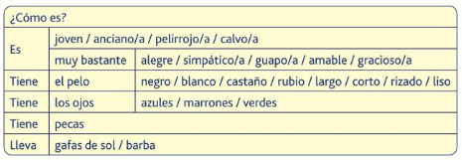
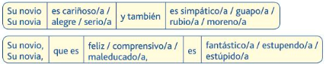
Writing Practice 90 word piece [16 marks]

Top Tips! 10 marks are for communication - so make sure you write in some detail (approximately 23 words) about EACH bullet point. For the 6 marks for Language, use varied vocab, verbs, opinions and some justifications.

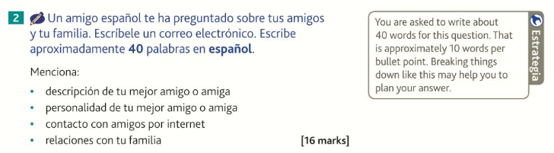

…………………………………………………………………………………………………………………………
…………………………………………………………………………………………………………………………
…………………………………………………………………………………………………………………………
…………………………………………………………………………………………………………………………
…………………………………………………………………………………………………………………………
…………………………………………………………………………………………………………………………
…………………………………………………………………………………………………………………………
…………………………………………………………………………………………………………………………
…………………………………………………………………………………………………………………………
…………………………………………………………………………………………………………………………
…………………………………………………………………………………………………………………………
…………………………………………………………………………………………………………………………
…………………………………………………………………………………………………………………………
…………………………………………………………………………………………………………………………
…………………………………………………………………………………………………………………………
…………………………………………………………………………………………………………………………
…………………………………………………………………………………………………………………………
…………………………………………………………………………………………………………………………
…………………………………………………………………………………………………………………………
………………………………………………………………………………………………………………………...

Writing Practice 90 word piece [16 marks]

Top Tips! 10 marks are for communication - so make sure you write in some detail (approximately 23 words) about EACH bullet point. For the 6 marks for Language, use varied vocab, verbs, opinions and some justifications

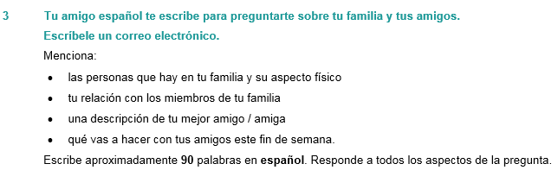
…………………………………………………………………………………………………………………………
…………………………………………………………………………………………………………………………
…………………………………………………………………………………………………………………………
…………………………………………………………………………………………………………………………
…………………………………………………………………………………………………………………………
…………………………………………………………………………………………………………………………
…………………………………………………………………………………………………………………………
…………………………………………………………………………………………………………………………
…………………………………………………………………………………………………………………………
…………………………………………………………………………………………………………………………
…………………………………………………………………………………………………………………………
…………………………………………………………………………………………………………………………
…………………………………………………………………………………………………………………………
…………………………………………………………………………………………………………………………
…………………………………………………………………………………………………………………………
…………………………………………………………………………………………………………………………
…………………………………………………………………………………………………………………………
…………………………………………………………………………………………………………………………
…………………………………………………………………………………………………………………………
…………………………………………………………………………………………………………………………

Foundation Speaking

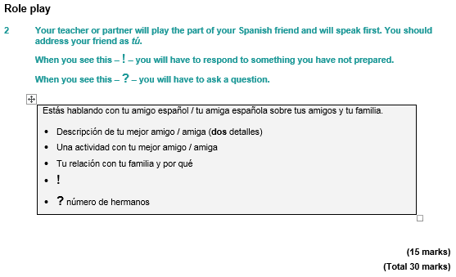
…………………………………………………………………………………………………………………………
…………………………………………………………………………………………………………………………
…………………………………………………………………………………………………………………………
…………………………………………………………………………………………………………………………
…………………………………………………………………………………………………………………………
…………………………………………………………………………………………………………………………
…………………………………………………………………………………………………………………………
…………………………………………………………………………………………………………………………
…………………………………………………………………………………………………………………………
…………………………………………………………………………………………………………………………
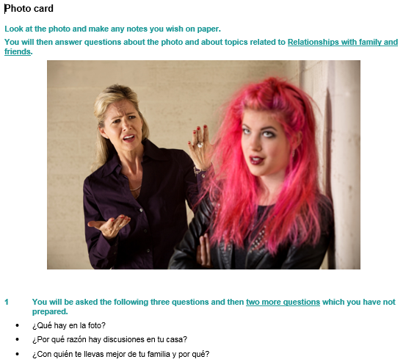

…………………………………………………………………………………………………………………………
…………………………………………………………………………………………………………………………
…………………………………………………………………………………………………………………………
…………………………………………………………………………………………………………………………
…………………………………………………………………………………………………………………………
…………………………………………………………………………………………………………………………
…………………………………………………………………………………………………………………………
…………………………………………………………………………………………………………………………
…………………………………………………………………………………………………………………………
…………………………………………………………………………………………………………………………
…………………………………………………………………………………………………………………………
…………………………………………………………………………………………………………………………
…………………………………………………………………………………………………………………………
…………………………………………………………………………………………………………………………
……………………………………………………………………………………………………………[15 marks]

Useful websites for independent learning

www.kerboodle.com (your teacher will provide your individual log-in details.

www.quizlet.com

www.languagesonline.org.uk

www.linguascope.com (username: budmouth password provided by your teacher)

www.atantot.com (username: Budmouth password provided by your teacher)

www.memrise.com

