Budmouth Academy

Year 9 French
Unit 3: Mon temps libre 2

Name ………………………………………….
Class ……………………………………………
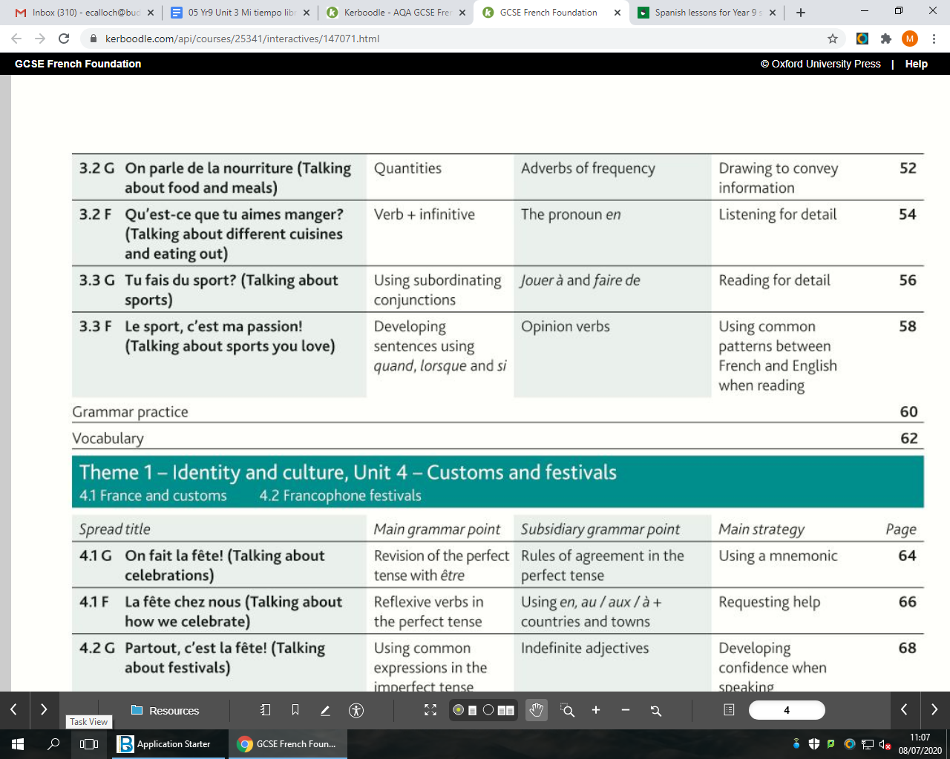
Tutor Group ………………………………..

MFL Curriculum Overview of Topics (Knowledge)

 |  |  | French
Term | 1 | 2 | 3 | 4 | 5 | 6
Assess | L,W, Tr into Eng | R,S,Tr into TL | L,W, Tr into Eng | R,S,Tr into TL | L,W, Tr into Eng | R,S,Tr into TL
Year 7 | Meeting people | School life | Family | My home | Free time | Food & Drink
Year 8 | Life at home | My area | Health | Travel | Lost property | Holidays
Year 9 | Family & friends | Local area | School subjects | Free time 1 | Free time 2 | Festivals
 | Ma famille et mes amis | Ma ville et ma maison | L'école et les matières | Les loisirs 1 | Les loisirs 2 | Les fêtes et traditions
Year 10 | School problems | Holiday | Future studies | Health | Marriage | Technology
 | La vie scolaire | Les vacances | Les études (l'avenir) | La santé/mon mode de vie | Le marriage | La technologie
Year11 | Global issues | Social Issues | Work and careers | Revision | Revision
 | L'environnement | Les problèmes sociaux | Le travail | les révisions | les révisions

 |  | Assessment Bands in MFL
Exceptional  Advanced  Secure  Developing | = Nearly always …  = Mostly …  = Occasionally …  = Rarely … | Takes an active part in lessons and accepts challenge  Goes “above and beyond” in independent learning  Recognises and uses vocab from current topic and previous topics  Recognises and uses structures from current topic and previous topics  Remains focused when listening and uses context to understand new language  Uses varied strategies and resilience to read and understand written texts  Writing:-  communicates in appropriate detail, with varied pronouns  uses resourcefulness and creativity when writing (including HW)  uses varied connectives with accurate word order and grammar  uses model texts to produce own written pieces with at least two tenses (sentences / paragraphs / 40 / 90 /150 words)  checks own written work, aiming for accuracy and quality  Speaking:-  develops ideas clearly and accurately in at least two tenses (photo card/ topics)  talks spontaneously and deals with unpredictable elements.  makes an effort to speak with accurate pronunciation  willingly responds to teacher feedback  asks thoughtful Qs about grammar  pays attention to detail when translating
The length and complexity of what students understand and produce is expected to increase as each year progresses.
Progress is made as students develop the frequency in which they apply the skills outlined above.

3.2G On parle de la nourriture
acheter to buy
le biscuit biscuit
la boîte can, tin, box, jar
la bouteille bottle
ça m’énerve it gets on my nerves
les chips (f) crisps
l’eau (f) water
l’entrée (f) starter
les frites (f) chips
les haricots verts (m) green beans
le jambon ham
le lait milk
l’oeuf (m) egg
oublier to forget
le paquet packet
les pâtes (f) pasta
la pomme apple
la pomme de terre potato
le pot pot
le repas meal
retourner to go back, to return
le riz rice
la tablette bar
la tranche slice
le verre glass
le yaourt yoghurt

3.2F Qu’est-ce que tu aimes manger?
l’addition (f) the bill
l’agneau (m) lamb
le bifteck beef steak
le boeuf beef
la boisson drink
le champignon mushroom
chinois(e) Chinese
la crêpe pancake
cuit(e) cooked
épicé(e) spicy
évidemment obviously
immangeable uneatable, inedible
indien(ne) Indian
les légumes (m) vegetables
musulman(e) Muslim
les nouilles (f) noodles
la nourriture food
le plat dish
le porc pork
le poulet chicken
Quel cauchemar! What a nightmare!
râpé(e) grated
salé(e) salty
le serveur waiter
la serveuse waitress
sucré(e) sweet / sugary
végétarien(ne) vegetarian
la viande meat

3.3G Tu fais du sport?
le centre de loisirs leisure centre
courir to run
l’entraînement (m) training
s’entraîner to train
l’équipe (f) team
l’équitation (f) horse riding
gagner to win
le gymnase the sports hall
le jogging running
le lac lake
la médaille the medal
la musculation weight training
la natation swimming
la piscine swimming pool
la plongée sous-marine scuba diving
le saut en longueur long jump
le stade stadium
le terrain de sport sports ground
le tournoi tournament
la voile sailing

3.3F Le sport, c’est ma passion!
aquatique water (adjective)
la balade walk, ride
depuis since, for
l’escalade (f) rock climbing
être passionné(e) de to be passionate about
le joueur player
la joueuse player
le mur wall
nettoyer to clean
rêver to dream
le sport de combat combat sport
le sport de défense defensive sport
le stage course
Model Tasks and Deliberate Practice
The tasks here will give you a good model of typical GCSE assessments and help you to develop skills. Keep each booklet safe and use for revision for end of unit tests and the final GCSE exam.
Thème 3 Mon temps libre 2 Foundation

Your French friend has texted about his holiday plans. Translate it into English for your friend.
Je fais beaucoup de sports, mais je n’ai jamais pratiqué le ski. Par chance, le mois prochain, nous allons voyager dans les montagnes de Suisse pour pratiquer les sports d’hiver. Je vais aussi faire un peu d’alpinisme. Ce sera génial de manger des plats typiques suisses.

………………………………………………………………………………………………………………………………………………………….………
………………………………………………………………………………………………………………………………………………………….………
………………………………………………………………………………………………………………………………………………………….………
………………………………………………………………………………………………………………………………………………………….………
………………………………………………………………………………………………………………………………………………………….………

Translate the following sentences into French.
1 I prefer individual sports such as skating and swimming.

_____________________________________________________________________________________
_____________________________________________________________________________________
2 I love going canoeing with my friends during the holidays.
_____________________________________________________________________________________
_____________________________________________________________________________________

3 On Fridays, I do yoga as it keeps me fit and removes stress.

_____________________________________________________________________________________
_____________________________________________________________________________________
4 I like team sports; my favourite sport is basketball.

_____________________________________________________________________________________
_____________________________________________________________________________________
5 I don’t like rock-climbing; I prefer water sports such as water polo.
_____________________________________________________________________________________
_____________________________________________________________________________________

Thème 3 Mon temps libre 2
Typical speaking conversation questions
Use the “useful phrases tables” below to help you. The vocab on page 74 will also help.

- Quels sports pratiquais-tu quand tu étais petit? = …….………………………………………………………………………………………………………………….……………………………………………………………………………………………………………………….…….………………………………………………………………………………………………………………….……………………………………………………………………………………………………………………….........................................................................................................................

- Quels sports aimerais-tu pratiquer dans le futur? = …….………………………………………………………………………………………………………………….………………………………………………………………………………………………………………………..…….………………………………………………………………………………………………………………….…………………………………………………………………………………………………………………………………………………………………………………………………………………………………………..

- Quels sports tu n’as jamais pratiqué et pourquoi? = …….………………………………………………………………………………………………………………….………………………………………………………………………………………………………………………..…….………………………………………………………………………………………………………………….…………………………………………………………………………………………………………………………………………………………………………………………………………………………………………..

Writing Foundation Tier Photo
Ecris quatre phrases sur la photo. [Write four sentences about the photo]
(eg There is a beach. / There is a wedding. / The sun is shining. / They are wearing elegant clothes. / etc)
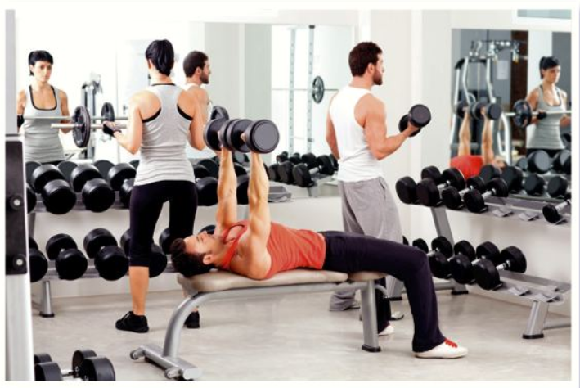

- _____________________________________________________________________________
(2 marks)

2 _____________________________________________________________________________
(2 marks)

3 _____________________________________________________________________________
(2 marks)

4 _____________________________________________________________________________
(2 marks)

Writing Practice 40 word piece [16 marks]

Top Tips! 10 marks are for communication - so make sure you write something about EACH bullet point. For the 6 marks for Language, use varied vocab, verbs, opinions and a few justifications.

Ton ami français t’a demandé de parler de ton temps libre.
Ecris un e-mail.
Mencionne:

- What sports you like/don’t like and why
- What sports you do in school or outside school
- What sports you would like to practise in the future

…………………………………………………………………………………………………………………………………
…………………………………………………………………………………………………………………………………
…………………………………………………………………………………………………………………………………
…………………………………………………………………………………………………………………………………
…………………………………………………………………………………………………………………………………
…………………………………………………………………………………………………………………………………
…………………………………………………………………………………………………………………………………
…………………………………………………………………………………………………………………………………
…………………………………………………………………………………………………………………………………
…………………………………………………………………………………………………………………………………
…………………………………………………………………………………………………………………………………
…………………………………………………………………………………………………………………………………

Writing Practice 90 word piece

Top Tips! 10 marks are for communication - so make sure you write in some detail (approximately 23 words) about EACH bullet point. For the 6 marks for Language, use varied vocab, verbs, opinions and some justifications.
Ton ami belge t’a demandé de parler de ton temps libre.
Ecris un e-mail
Mencionne:

- Les sports que tu pratiques pendant la semaine.
- Un sport que tu as pratiqué le weekend dernier avec tes amis.
- Si tu préfères les sports individuels ou les sports d’équipe.
- Ton opinion au sujet des sports à risque.

…………………………………………………………………………………………………………………………………
…………………………………………………………………………………………………………………………………
…………………………………………………………………………………………………………………………………
…………………………………………………………………………………………………………………………………
…………………………………………………………………………………………………………………………………
…………………………………………………………………………………………………………………………………
…………………………………………………………………………………………………………………………………
…………………………………………………………………………………………………………………………………
…………………………………………………………………………………………………………………………………
…………………………………………………………………………………………………………………………………
…………………………………………………………………………………………………………………………………
…………………………………………………………………………………………………………………………………
…………………………………………………………………………………………………………………………………
…………………………………………………………………………………………………………………………………
…………………………………………………………………………………………………………………………………
…………………………………………………………………………………………………………………………………
…………………………………………………………………………………………………………………………………
…………………………………………………………………………………………………………………………………
…………………………………………………………………………………………………………………………………
…………………………………………………………………………………………………………………………………
…………………………………………………………………………………………………………………………………
…………………………………………………………………………………………………………………………………
…………………………………………………………………………………………………………………………………

Foundation Speaking Role Play [15 marks]

Your teacher or partner will play the part of your French friend and will speak first. You should address your friend as “tu”
When you see “!” you will have to respond to something you have not prepared.
When you see this “?” you will have to ask a question
- Sport préféré (deux détails)
- Un sport que tu as pratiqué le weekend dernier avec tes copains (deux détails)
- Un sport que tu n’aimes pas et pourquoi.
- !
- ? Ton opinion sur les sports à risque.

…………………………………………………………………………………………………………………………………
…………………………………………………………………………………………………………………………………
…………………………………………………………………………………………………………………………………
…………………………………………………………………………………………………………………………………
…………………………………………………………………………………………………………………………………
…………………………………………………………………………………………………………………………………
…………………………………………………………………………………………………………………………………
…………………………………………………………………………………………………………………………………
…………………………………………………………………………………………………………………………………
…………………………………………………………………………………………………………………………………
…………………………………………………………………………………………………………………………………
…………………………………………………………………………………………………………………………………
…………………………………………………………………………………………………………………………………
…………………………………………………………………………………………………………………………………
…………………………………………………………………………………………………………………………………

Foundation Tier Speaking Photo Card [15 marks]

Top Tips!
- It’s wise to use the Verb Table found near the start of this Learning Booklet so you VARY
verbs/opinions/structures.
- Remember: We need a minimum of THREE “ideas” for each question, so that we develop each answer.

…………………………………………………………………………………………………………………………………
…………………………………………………………………………………………………………………………………
…………………………………………………………………………………………………………………………………
…………………………………………………………………………………………………………………………………
…………………………………………………………………………………………………………………………………
…………………………………………………………………………………………………………………………………
…………………………………………………………………………………………………………………………………
…………………………………………………………………………………………………………………………………
…………………………………………………………………………………………………………………………………
…………………………………………………………………………………………………………………………………
…………………………………………………………………………………………………………………………………
…………………………………………………………………………………………………………………………………
…………………………………………………………………………………………………………………………………
…………………………………………………………………………………………………………………………………
…………………………………………………………………………………………………………………………………

Thème 3 Mon temps libre 2 – Higher Tier
- Your PE teacher has shown you an article about Olympic sports. Translate it into English for your
friend.
Une étude médicale révèle que certains sports olympiques peuvent avoir des effets positifs sur le mental en plus du corps. L’étude explique les avantages de l’athlétisme et de la natation, des exercices d’aérobic qui ont des effets positifs sur le cerveau et améliorent le sentiment de bien être. D’autres sports recommandés sont le football, le hand ball et le cyclisme.

…………………………………………………………………………………………………………………………………
…………………………………………………………………………………………………………………………………
…………………………………………………………………………………………………………………………………
…………………………………………………………………………………………………………………………………
…………………………………………………………………………………………………………………………………
…………………………………………………………………………………………………………………………………
…………………………………………………………………………………………………………………………………
…………………………………………………………………………………………………………………………………
…………………………………………………………………………………………………………………………………[12 marks]

Translate the following sentences into French:-

Practising sports help teenagers learn the importance of discipline and effort. Sports also promote competitiveness, which developed in moderation can be very beneficial for their life. Boys and girls learn to enjoy the victories and get stronger with defeats. In the case of team sports, they learn the importance of counting on others, which develops their social skills. They also learn the importance of respecting authority, the need to obey the rules and respecting their opponents.
…………………………………………………………………………………………………………………………………
…………………………………………………………………………………………………………………………………
…………………………………………………………………………………………………………………………………
…………………………………………………………………………………………………………………………………
…………………………………………………………………………………………………………………………………
…………………………………………………………………………………………………………………………………
…………………………………………………………………………………………………………………………………
…………………………………………………………………………………………………………………………………
…………………………………………………………………………………………………………………………………[12 marks]

HIGHER Speaking practice Higher Tier PHOTO CARD [15 marks]

- It’s wise to use the Verb Table found near the start of this Learning Booklet so you VARY
verbs/opinions/structures.
- Remember: We need a minimum of THREE “ideas” for each question so that we develop each response.

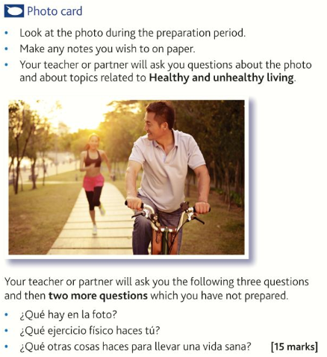

- Qu’est-ce-qu’il y a sur la photo?
- Quels sports fais-tu?
- Quelles autres choses fais-tu pour vivre une vie saine?
(15 marks)
…………………………………………………………………………………………………………………………………
…………………………………………………………………………………………………………………………………
…………………………………………………………………………………………………………………………………
…………………………………………………………………………………………………………………………………
…………………………………………………………………………………………………………………………………
…………………………………………………………………………………………………………………………………
…………………………………………………………………………………………………………………………………
…………………………………………………………………………………………………………………………………
…………………………………………………………………………………………………………………………………
…………………………………………………………………………………………………………………………………
…………………………………………………………………………………………………………………………………
…………………………………………………………………………………………………………………………………
…………………………………………………………………………………………………………………………………

Extended Writing Deliberate Practice
90 word writing piece
- Ton ami français veut savoir ce que font les jeunes pendant leur temps libre dans ton pays.
Ecris-lui une carte.
Mencionne:
- Ce que tu fais le soir pendant la semaine
- les activités que tu as fait le weekend dernier
- les sports préférés de tes amis
- la mauvaise manière pour les jeunes de passer leur temps libre

Ecris approximativement 90 mots en français Réponds à tous les aspects de la question.

…………………………………………………………………………………………………………………………………
…………………………………………………………………………………………………………………………………
…………………………………………………………………………………………………………………………………
…………………………………………………………………………………………………………………………………
…………………………………………………………………………………………………………………………………
…………………………………………………………………………………………………………………………………
…………………………………………………………………………………………………………………………………
…………………………………………………………………………………………………………………………………
…………………………………………………………………………………………………………………………………
…………………………………………………………………………………………………………………………………
…………………………………………………………………………………………………………………………………
…………………………………………………………………………………………………………………………………
…………………………………………………………………………………………………………………………………
…………………………………………………………………………………………………………………………………
…………………………………………………………………………………………………………………………………
…………………………………………………………………………………………………………………………………
…………………………………………………………………………………………………………………………………
…………………………………………………………………………………………………………………………………
…………………………………………………………………………………………………………………………………
…………………………………………………………………………………………………………………………………
…………………………………………………………………………………………………………………………………

150 word writing piece

Tip: You don’t HAVE to to include all three tenses in this piece, however it’s a good idea to do so. This enables you to show that you know the three different tenses.
…………………………………………………………………………………………………………………………………
…………………………………………………………………………………………………………………………………
…………………………………………………………………………………………………………………………………
…………………………………………………………………………………………………………………………………
…………………………………………………………………………………………………………………………………
…………………………………………………………………………………………………………………………………
…………………………………………………………………………………………………………………………………
…………………………………………………………………………………………………………………………………
…………………………………………………………………………………………………………………………………
…………………………………………………………………………………………………………………………………
…………………………………………………………………………………………………………………………………
…………………………………………………………………………………………………………………………………
…………………………………………………………………………………………………………………………………
…………………………………………………………………………………………………………………………………
…………………………………………………………………………………………………………………………………
…………………………………………………………………………………………………………………………………
…………………………………………………………………………………………………………………………………
…………………………………………………………………………………………………………………………………
…………………………………………………………………………………………………………………………………
…………………………………………………………………………………………………………………………………
…………………………………………………………………………………………………………………………………
…………………………………………………………………………………………………………………………………
…………………………………………………………………………………………………………………………………
…………………………………………………………………………………………………………………………………
…………………………………………………………………………………………………………………………………
…………………………………………………………………………………………………………………………………
…………………………………………………………………………………………………………………………………
…………………………………………………………………………………………………………………………………
…………………………………………………………………………………………………………………………………
…………………………………………………………………………………………………………………………………
…………………………………………………………………………………………………………………………………
…………………………………………………………………………………………………………………………………
…………………………………………………………………………………………………………………………………
…………………………………………………………………………………………………………………………………
…………………………………………………………………………………………………………………………………
…………………………………………………………………………………………………………………………………
…………………………………………………………………………………………………………………………………
…………………………………………………………………………………………………………………………………
…………………………………………………………………………………………………………………………………
…………………………………………………………………………………………………………………………………
…………………………………………………………………………………………………………………………………
…………………………………………………………………………………………………………………………………

Useful websites for independent learning

www.kerboodle.com (your teacher will provide your individual log-in details.

www.quizlet.com

www.languagesonline.org.uk

www.linguascope.com (username: budmouth password: flags)

www.atantot.com (username: Budmouth password: 8034)

www.memrise.com

