Budmouth Academy
Year 9 German
Unit 5: Wohnort
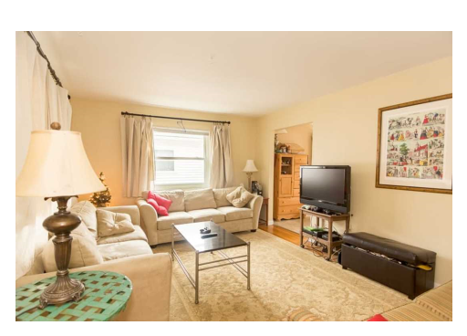
Name ………………………………………….
Class ……………………………………………
Tutor Group ………………………………..
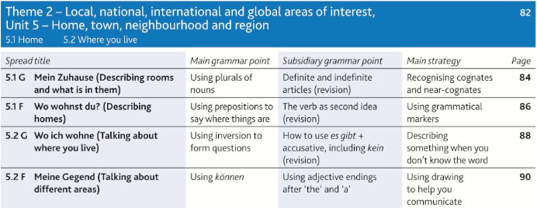
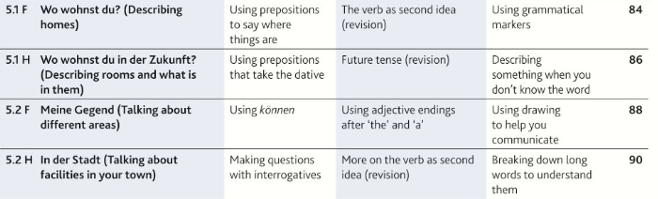

 |  | Assessment Bands in MFL
Exceptional  Advanced  Secure  Developing | = Nearly always …  = Mostly …  = Occasionally …  = Rarely … | Takes an active part in lessons and accepts challenge  Goes “above and beyond” in independent learning  Recognises and uses vocab from current topic and previous topics  Recognises and uses structures from current topic and previous topics  Remains focused when listening and uses context to understand new language  Uses varied strategies and resilience to read and understand written texts  Writing:-  communicates in appropriate detail, with varied pronouns  uses resourcefulness and creativity when writing (including HW)  uses varied connectives with accurate word order and grammar  uses model texts to produce own written pieces with at least two tenses (sentences / paragraphs / 40 / 90 /150 words)  checks own written work, aiming for accuracy and quality  Speaking:-  develops ideas clearly and accurately in at least two tenses (photo card/ topics)  talks spontaneously and deals with unpredictable elements.  makes an effort to speak with accurate pronunciation  willingly responds to teacher feedback  asks thoughtful Qs about grammar  pays attention to detail when translating
The length and complexity of what students understand and produce is expected to increase as each year progresses.
Progress is made as students develop the frequency in which they apply the skills outlined above.

Useful verbs and structures

VERGANGENHEIT |  | PRASENS |  | FUTUR
ich bin …. gefahren ( I went / travelled) |  | ich fahre (I go / travel) |  | ich werde …. fahren (I will go / travel)
ich bin …. umgezogen (I moved house) |  | ich ziehe ….um (I am moving house) |  | ich werde …. umziehen (I will move house)
ich bin …..gegangen (I went) |  | ich gehe (I go) |  | ich möchte …. gehen (I would like to go)
ich bin…….gespielt (I played) |  | ich spiele (I play) |  | ich werde………..spielen (I will play)
ich habe……. gewohnt (I lived) |  | ich wohne (I live) |  | ich werde…….wohnen (I will live)
ich habe …. geschlafen (I slept) |  | ich schlafe (I sleep) |  | ich will …. schlafen (I want to sleep)
ich habe …. gesehen (I saw/watched) |  | ich sehe (I see/watch) |  | ich werde …. sehen (I will see/watch)
wir haben…… besucht (we visited) |  | wir besuchen (we visit) |  | wir werden ... besuchen (we will visit
wir haben ….. besichtigt (we visited) |  | wir besichtigen (we visit) |  | wir wollen …. besichtigen (we want to visit)
es gab (there was/were) |  | es gibt (there is/ there are) |  | es wird …. geben (there will be)
Es war … (it was) |  | Es ist |  | Es wird … sein (it will be)
Es hat mir gefallen (I liked it) |  | Es gefällt mir (I like it) |  | Es wird mir gefallen (I will like it)
Ich fand (I found it...) |  | Ich finde ….. ( I find …) |  | Ich werde es … finden ( I will find it …)
Es hat Spass gemacht (it was fun) |  | Es macht Spass (it's fun) |  | Es wird Spass machen (it will be fun)
Ich hatte (I had) |  |  |  | Es wäre - it would be
Konjunktionen |  | Konjunktionen |  | OTHER STRUCTURES
NORMAL WORD ORDER |  | VERB AM ENDE! |  | um …. zu ….. = in order to
denn (because) |  | weil (because) |  | man kann ……… sehen = you can see ……….
aber (but) |  | da (because) |  | Touristen können … gehen = tourists can go …….
und (and) |  | dass (that)
 |  | obwohl (although) |  | es gibt …., wo man …. kann =
 |  |  |  | there is …….. where you can ……...
 |  | wenn (Verb,Verb) (if/when) |  | Wenn ich das Geld/die Zeit hätte, würde ich…. =
 |  | wenn es heiss ist, gehe ich ... |  | If I had the money, I would ………

5.1G Mein Zuhause
altmodisch |  | above, upstairs
das Arbeitszimmer |  | armchair
das Badezimmer |  | bathroom
das Bett |  | bed
das Esszimmer |  | bedroom
der Fernseher |  | below/downstairs
der Flur |  | chest of drawers
der Herd |  | cooker/stove
die Kommode |  | cupboard
die Küche |  | curtain
neben |  | dining room
oben |  | floor/storey
das Schlafzimmer |  | hall, corridor
der Schrank |  | kitchen
der Sessel |  | living room
das Sofa |  | mirror
der Spiegel |  | next to
der Stock |  | old-fashioned
der Tisch |  | sofa
die Toilette |  | study
unten |  | table
der Vorhang |  | toilet
das Wohnzimmer |  | tv

5.2F meine Gegend
die Ampel |  | a little, a bit
die Apotheke |  | art gallery
die Auswahl |  | bakery
die Bäckerei |  | bank
ein bisschen |  | butcher's shop
das Dach |  | cake shop
das Denkmal |  | capital city
der Einwohner |  | cheap, value for money
das Elektrogeschäft |  | choice, selection
die Fabrik |  | clothes shop
der Friseur |  | crossroads
die Friseurin |  | department store
die Fußgängerzone |  | department store
die Gegend |  | dry-cleaner's
das Geschäft |  | even
der Hafen |  | factory
der Hauptbahnhof |  | hairdresser (m)
die Hauptstadt |  | hairdresser (f)
das Juweliergeschäft |  | harbour, port
das Kaufhaus |  | inhabitant
das Kleidergeschäft |  | jeweller's shop
die Konditorei |  | main railway station
die Kreuzung |  | monument
die Kunstgalerie |  | pedestrian precinct
der Laden |  | pharmacy
leiden |  | price
die Mauer |  | public transport
die Metzgerei |  | region, area
öffentliche Verkehrsmittel |  | roof
der Preis |  | shop
preiswert |  | shop
die Reinigung |  | shop electrical goods
sogar |  | suburb
die Sparkasse |  | to suffer, to stand, bear
der Vorort |  | traffic light
das Warenhaus |  | wall (outside)
Model Tasks and Deliberate Practice
The tasks here will give you a good model of typical GCSE assessments and help you to develop skills. Keep each booklet safe and use for revision for end of unit tests and the final GCSE exam.
Einheit 1 Familie und Freunde Foundation
You are going to stay with a family in Switzerland. They have sent this message about their house. Translate the message into English for your parents.
Ich wohne in einem Einfamilienhaus in der Nähe von einem See. Die Gegend gefällt mir, denn es ist nicht laut hier. Wenn das Wetter gut ist, gibt es viel zu machen. Hinter dem Haus kann man einen Fluss sehen.

…………………………………………………………………………………………………………………………………………………………………………….
…………………………………………………………………………………………………………………………………………………………………………….
…………………………………………………………………………………………………………………………………………………………………………….
…………………………………………………………………………………………………………………………………………………………………………….
…………………………………………………………………………………………………………………………………………………………………………….

Translate the following sentences into good German:-

1. I live in a terraced house with no garden.
…………………………………………………………………………………………………………………………………………………………………………….
…………………………………………………………………………………………………………………………………………………………………………….

2. It is in the town but very quiet.
…………………………………………………………………………………………………………………………………………………………………………….
…………………………………………………………………………………………………………………………………………………………………………….

3. My bedroom is very small.
…………………………………………………………………………………………………………………………………………………………………………….
…………………………………………………………………………………………………………………………………………………………………………….

4. I do my homework in the kitchen.
…………………………………………………………………………………………………………………………………………………………………………….
…………………………………………………………………………………………………………………………………………………………………………….

5. Yesterday I listened to music.
…………………………………………………………………………………………………………………………………………………………………………….
…………………………………………………………………………………………………………………………………………………………………………….

Einheit 1 Familie und Freunde Typical speaking conversation questions
Use the “useful phrases tables” below to help you. The vocab pages 94 & 95 will also help.
- Beschreib dein Haus = ……………………………………………………………………………………..

…………………………………………………………………………………………………………………………………………………………………………….
…………………………………………………………………………………………………………………………………………………………………………….
- Hast du ein eigenes Schlafzimmer? = ………………………………………………………………………

…………………………………………………………………………………………………………………………………………………………………………….
…………………………………………………………………………………………………………………………………………………………………………….

- Was kann man in Weymouth machen? = ……………………………………………………………………

…………………………………………………………………………………………………………………………………………………………………………….
…………………………………………………………………………………………………………………………………………………………………………….

- Gefällt dir deine Region? = ………………………………………………………………………………….

…………………………………………………………………………………………………………………………………………………………………………….
…………………………………………………………………………………………………………………………………………………………………………….

- Würdest du lieber in einer Stadt oder auf dem Land wohnen? =
………………………………………………………………………….………………………………………………

…………………………………………………………………………………………………………………………………………………………………………….
…………………………………………………………………………………………………………………………………………………………………………….
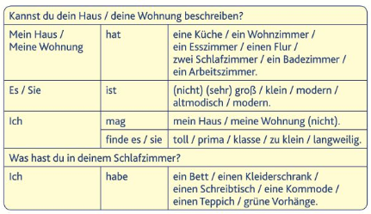

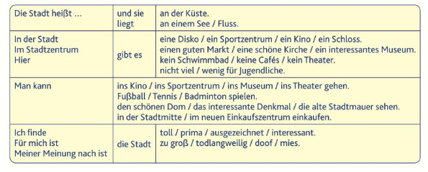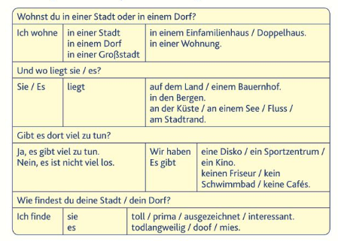

Foundation Writing

40 word piece

Du schreibst eine E-Mail über dein Haus an deinen deutschen Freund.
Schreib etwas über:

- was für eine Art Haus es ist
- wo es liegt
- das Wohnzimmer
- dein Schlafzimmer.
Du musst ungefähr 40 Wörter auf Deutsch schreiben. (16 Marks)

Top Tips! 10 marks are for communication - so make sure you write in some detail (approximately 10 words) about EACH bullet point. For the 6 marks for Language, use varied vocab, verbs, opinions and some justifications.
………………………………………………………………………………………………………………………………………………………………………………..
………………………………………………………………………………………………………………………………………………………………………………..
………………………………………………………………………………………………………………………………………………………………………………..
………………………………………………………………………………………………………………………………………………………………………………..
………………………………………………………………………………………………………………………………………………………………………………..
……………………………………………………………………………………………………………………………………………………………………………….
……………………………………………………………………………………………………………………………………………………………………………...
……………………………………………………………………………………………………………………………………………………………………………...
……………………………………………………………………………………………………………………………………………………………………………...
……………………………………………………………………………………………………………………………………………………………………………...
……………………………………………………………………………………………………………………………………………………………….[16 marks]

Foundation Writing 90 word piece

Dein österreichischer Freund möchte etwas über dein Haus und deinen Wohnort wissen. Du schickst ihm eine E-Mail.
Schreib:
- etwas über dein Haus / deine Wohnung
- warum du gern oder nicht gern da wohnst
- wo du früher gewohnt hast
- was du morgen in der Stadt machen wirst.
Du musst ungefähr 90 Wörter auf Deutsch schreiben. Schreib etwas über alle Punkte der Aufgabe.
Top Tips! 10 marks are for communication - so make sure you write in some detail (approximately 23 words) about EACH bullet point. For the 6 marks for Language, use varied vocab, verbs, opinions and some justifications.
………………………………………………………………………………………………………………………………………………………………………………..
………………………………………………………………………………………………………………………………………………………………………………..
………………………………………………………………………………………………………………………………………………………………………………..
………………………………………………………………………………………………………………………………………………………………………………..
………………………………………………………………………………………………………………………………………………………………………………..
……………………………………………………………………………………………………………………………………………………………………………….
……………………………………………………………………………………………………………………………………………………………………………...
……………………………………………………………………………………………………………………………………………………………………………...
……………………………………………………………………………………………………………………………………………………………………………...
……………………………………………………………………………………………………………………………………………………………………………...
………………………………………………………………………………………………………………………………………………………………………………..
………………………………………………………………………………………………………………………………………………………………………………..
………………………………………………………………………………………………………………………………………………………………………………..
………………………………………………………………………………………………………………………………………………………………………………..
………………………………………………………………………………………………………………………………………………………………………………..
……………………………………………………………………………………………………………………………………………………………………………….
……………………………………………………………………………………………………………………………………………………………………………...
……………………………………………………………………………………………………………………………………………………………………………...
……………………………………………………………………………………………………………………………………………………………………………...
………………………………………………………………………………………………[16 marks]

Foundation Speaking Role Play

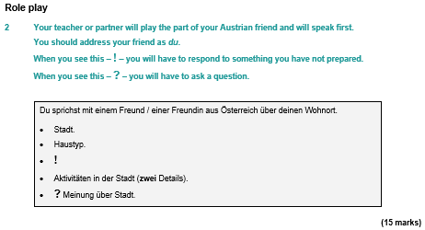
………………………………………………………………………………………………………………………………………………………………………………..
………………………………………………………………………………………………………………………………………………………………………………..
………………………………………………………………………………………………………………………………………………………………………………..
………………………………………………………………………………………………………………………………………………………………………………..
………………………………………………………………………………………………………………………………………………………………………………..
……………………………………………………………………………………………………………………………………………………………………………….
……………………………………………………………………………………………………………………………………………………………………………...
……………………………………………………………………………………………………………………………………………………………………………...
……………………………………………………………………………………………………………………………………………………………………………...
……………………………………………………………………………………………………………………………………………………………………………...
……………………………………………………………………………………… [15 marks]

Foundation Speaking Photo Card

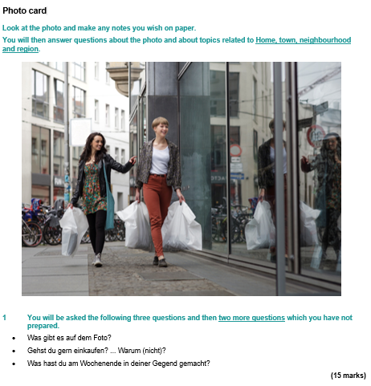

It’s wise to use the Verb Table found near the start of this Learning Booklet so you VARY verbs/opinions/structures. Remember: We need a minimum of THREE “ideas” for each question.
………………………………………………………………………………………………………………………………………………………………………………..
………………………………………………………………………………………………………………………………………………………………………………..
………………………………………………………………………………………………………………………………………………………………………………..
………………………………………………………………………………………………………………………………………………………………………………..
………………………………………………………………………………………………………………………………………………………………………………..
……………………………………………………………………………………………………………………………………………………………………………….
……………………………………………………………………………………………………………………………………………………………………………...
……………………………………………………………………………………………………………………………………………………………………………...
……………………………………………………………………………………………………………………………………………………………………………...
……………………………………………………………………………………………………………………………………………………………………………...
……………………………………………………………………………………[15 marks]

Unit 1 Die Familie – Higher Tier Translate the paragraph into English.

Your Austrian exchange partner has sent you a text about what to expect when you visit her in Vienna. Your parents would like to know too, so translate the message into English.
Wir haben ein Einfamilienhaus in einem kleinen Vorort der Stadt. Du kannst dein eigenes Schlafzimmer haben, während du nächste Woche bei uns bist. Wien ist eine sehr kulturelle Stadt, da es so viel zu machen gibt. Wenn du dich für Sehenswürdigkeiten und Geschichte interessierst, wird dir die Stadt sehr gut gefallen.

………………………………………………………………………………………………………………………………………………………………………………..
………………………………………………………………………………………………………………………………………………………………………………..
………………………………………………………………………………………………………………………………………………………………………………..
………………………………………………………………………………………………………………………………………………………………………………..
………………………………………………………………………………………………………………………………………………………………………………..
……………………………………………………………………………………………………………………………………………………………………………….
……………………………………………………………………………………………………………………………………………………………………………...
……………………………………………………………………………………………………………………………………………………………………………...
……………………………………………………………………………………………………………………………………………………………………………...
…………………………………………………………………………………………………………………………………………………[9 marks]

Translate the following sentences into good German:-

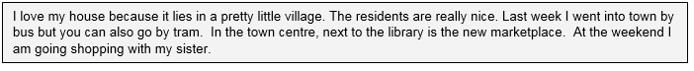
………………………………………………………………………………………………………………………………………………………………………………..
………………………………………………………………………………………………………………………………………………………………………………..
………………………………………………………………………………………………………………………………………………………………………………..
………………………………………………………………………………………………………………………………………………………………………………..
………………………………………………………………………………………………………………………………………………………………………………..
……………………………………………………………………………………………………………………………………………………………………………….
……………………………………………………………………………………………………………………………………………………………………………...
……………………………………………………………………………………………………………………………………………………………………………...
……………………………………………………………………………………………………………………………………………………………………………...
……………………………………………………………………………………………………………………………………[12 marks]
Extended Writing Deliberate Practice
90 word piece
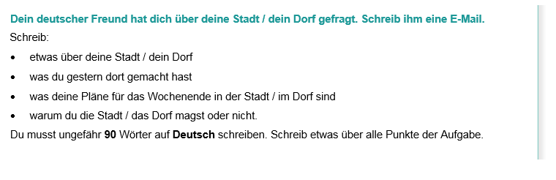
Top Tips! 10 marks are for communication - so make sure you write in some detail (approximately 23 words) about EACH bullet point. For the 6 marks for Language, use varied vocab, verbs, opinions and some justifications.
………………………………………………………………………………………………………………………………………………………………………………..
………………………………………………………………………………………………………………………………………………………………………………..
………………………………………………………………………………………………………………………………………………………………………………..
………………………………………………………………………………………………………………………………………………………………………………..
………………………………………………………………………………………………………………………………………………………………………………..
……………………………………………………………………………………………………………………………………………………………………………….
……………………………………………………………………………………………………………………………………………………………………………...
……………………………………………………………………………………………………………………………………………………………………………...
……………………………………………………………………………………………………………………………………………………………………………...
………………………………………………………………………………………………………………………………………………………………………………
………………………………………………………………………………………………………………………………………………………………………………..
………………………………………………………………………………………………………………………………………………………………………………..
………………………………………………………………………………………………………………………………………………………………………………..
………………………………………………………………………………………………………………………………………………………………………………..
………………………………………………………………………………………………………………………………………………………………………………..
……………………………………………………………………………………………………………………………………………………………………………….
……………………………………………………………………………………………………………………………………………………………………………...
……………………………………………………………………………………………………………………………………………………………………………...
……………………………………………………………………………………………………………………………………………………………………………...
[16 marks]

150 word piece Higher
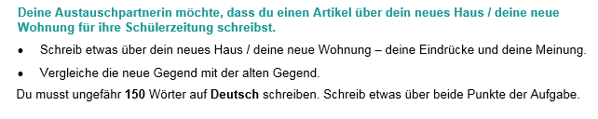

Top Tip: You don’t HAVE to use all three tenses in this 150-word piece of writing, but it’s a good idea to include all three, so that you show the examiner that you can use them well. Remember to include lots of varied, complex structures! Keep it clear and relevant.

………………………………………………………………………………………………………………………………………………………………………………..
………………………………………………………………………………………………………………………………………………………………………………..
………………………………………………………………………………………………………………………………………………………………………………..
………………………………………………………………………………………………………………………………………………………………………………..
………………………………………………………………………………………………………………………………………………………………………………..
……………………………………………………………………………………………………………………………………………………………………………….
……………………………………………………………………………………………………………………………………………………………………………...
……………………………………………………………………………………………………………………………………………………………………………...
……………………………………………………………………………………………………………………………………………………………………………...
……………………………………………………………………………………………………………………………………………………………………………...
………………………………………………………………………………………………………………………………………………………………………………..
………………………………………………………………………………………………………………………………………………………………………………..
………………………………………………………………………………………………………………………………………………………………………………..
………………………………………………………………………………………………………………………………………………………………………………..
………………………………………………………………………………………………………………………………………………………………………………..
……………………………………………………………………………………………………………………………………………………………………………….
……………………………………………………………………………………………………………………………………………………………………………...
……………………………………………………………………………………………………………………………………………………………………………...
……………………………………………………………………………………………………………………………………………………………………………...
……………………………………………………………………………………………………………………………………………………………………………...
…………………………………………………………………………………………… [32 marks]

Higher Speaking Role Play
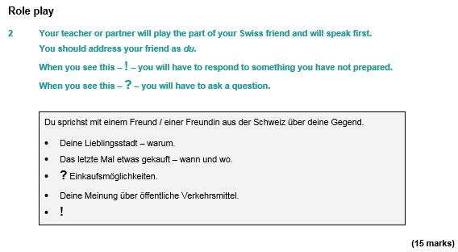
………………………………………………………………………………………………………………………………………………………………………………..
………………………………………………………………………………………………………………………………………………………………………………..
………………………………………………………………………………………………………………………………………………………………………………..
………………………………………………………………………………………………………………………………………………………………………………..
………………………………………………………………………………………………………………………………………………………………………………..
……………………………………………………………………………………………………………………………………………………………………………….
……………………………………………………………………………………………………………………………………………………………………………...
……………………………………………………………………………………………………………………………………………………………………………...
……………………………………………………………………………………………………………………………………………………………………………...
……………………………………………………………………………………………………………………………………………………………………………...
……………………………………………………………………………………… [15 marks]

Photo Card (Higher)
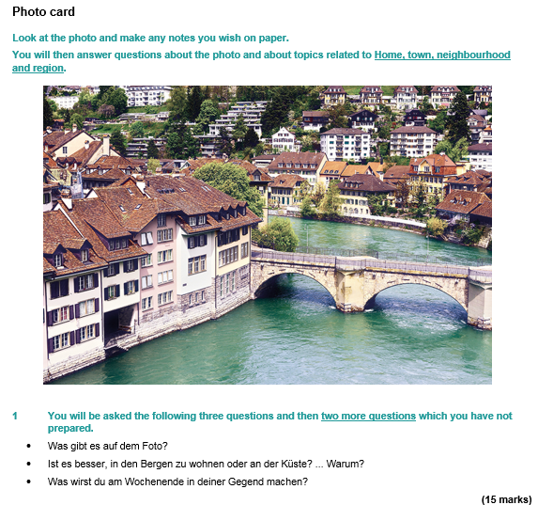

………………………………………………………………………………………………………………………………………………………………………………..
………………………………………………………………………………………………………………………………………………………………………………..
………………………………………………………………………………………………………………………………………………………………………………..
………………………………………………………………………………………………………………………………………………………………………………..
………………………………………………………………………………………………………………………………………………………………………………..
……………………………………………………………………………………………………………………………………………………………………………….
……………………………………………………………………………………………………………………………………………………………………………...
……………………………………………………………………………………………………………………………………………………………………………...
……………………………………………………………………………………………………………………………………………………………………………...
……………………………………………………………………………………………………………………………………………………………………………...
……………………………………………………………………………………… [15 marks]

Some Higher Tier Reading Practice

Useful websites for independent learning
www.kerboodle.com (your teacher will provide your individual log-in details.

www.quizlet.com

www.languagesonline.org.uk
www.linguascope.com (username: budmouth password provided by your teacher)
www.memrise.com

https://www.dw.com/de/deutsch-lernen/nachrichten/s-8030 (slowly spoken German news)

