Budmouth Academy
Year 9 Spanish
Unit 5: Mi casa y donde vivo
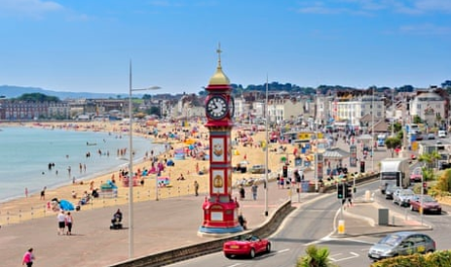
Name ………………………………………….
Class ……………………………………………
Tutor Group ………………………………..

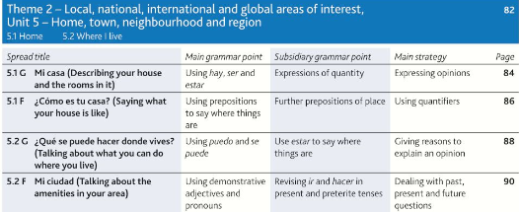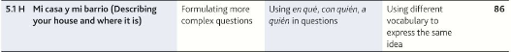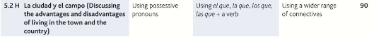

 |  | Assessment Bands in MFL
Exceptional  Advanced  Secure  Developing | = Nearly always …  = Mostly …  = Occasionally …  = Rarely … | Takes an active part in lessons and accepts challenge  Goes “above and beyond” in independent learning  Recognises and uses vocab from current topic and previous topics  Recognises and uses structures from current topic and previous topics  Remains focused when listening and uses context to understand new language  Uses varied strategies and resilience to read and understand written texts  Writing:-  communicates in appropriate detail, with varied pronouns  uses resourcefulness and creativity when writing (including HW)  uses varied connectives with accurate word order and grammar  uses model texts to produce own written pieces with at least two tenses (sentences / paragraphs / 40 / 90 /150 words)  checks own written work, aiming for accuracy and quality  Speaking:-  develops ideas clearly and accurately in at least two tenses (photo card/ topics)  talks spontaneously and deals with unpredictable elements.  makes an effort to speak with accurate pronunciation  willingly responds to teacher feedback  asks thoughtful Qs about grammar  pays attention to detail when translating
The length and complexity of what students understand and produce is expected to increase as each year progresses.
Progress is made as students develop the frequency in which they apply the skills outlined above.

5.1G Mi casa
la alfombra |  | cupboard, wardrobe
el armario |  | shelves, shelving unit
el ascensor |  | microwave oven
la butaca |  | comfortable, convenient, handy
la cocina |  | wall
cómodo |  | armchair
compartir |  | lift
el cuarto de baño |  | bathroom
el dormitorio |  | ground, floor
los electrodomésticos |  | (electrical) appliances
la escalera |  | armchair
el espejo |  | kitchen sink
la estantería |  | terrace
el fregadero |  | carpet, rug
la habitación |  | washing machine
el lavabo |  | stairs
la lavadora |  | mirror
el lavaplatos |  | bedroom
el microondas |  | room
la nevera |  | to share
la pared |  | dishwasher
el salón |  | washbasin
el sillón |  | fridge
el suelo |  | lounge, living room
la terraza |  | kitchen, cooker, cuisine
5.1F ¿Cómo es tu casa?
las afueras |  | to find
antiguo |  | bungalow, detached house, villa
el árbol |  | piece of furniture
el campo |  | tree
el chalet / chalé |  | bookcase, bookshop
la costa |  | shelf
el estante |  | old
encontrar |  | furniture
encontrarse |  | coast
encontrarse con |  | to keep, to put away,to save
la granja |  | outskirts
guardar |  | countryside, field,sports ground
la librería |  | to be situated
la montaña |  | to meet up with
el mueble |  | flat, floor (of a building)
los muebles |  | worse, worst
peor |  | farm
el piso |  | mountain
5.2G ¿Qué se puede hacer donde vives?
el barrio |  | necklace
la biblioteca |  | to enjoy oneself, to have a good time
la bolera |  | doll
el bolso |  | department stores
la carnicería |  | baker’s
el césped |  | jeweller’s
el collar |  | money
descansar |  | (designer) clothes
el dinero |  | market
divertirse |  | handbag
el estanco |  | museum
los grandes almacenes |  | neighbourhood, area
la joyería |  | lawn
la juguetería |  | grocery store, food shop
el mercado |  | bowling alley
la muñeca |  | toy shop
el museo |  | tobacconist’s (also sells stamps)
la panadería |  | earrings
el parque |  | butcher’s
la pastelería |  | to rest
los pendientes |  | cake shop
la plaza de toros |  | library
la ropa (de marca) |  | infantil park, playground
la tienda de comestibles |  | shoe shop
la zapatería |  | bull ring
5.2F Mi ciudad
la avenida |  | bridge
el ayuntamiento |  | to go shopping
bienvenido/a |  | Post Office
el centro comercial |  | square (in a town)
la ciudad |  | avenue
el club de jóvenes |  | factory
Correos |  | Town Hall
construir |  | country
convertirse en (+ noun) |  | shopping centre
los espacios verdes |  | city, large town
la fábrica |  | to build
fundar |  | theatre
el/la habitante |  | youth club
la iglesia |  | sports centre
ir de compras |  | welcome
el país |  | church
la plaza |  | to found
el polideportivo |  | port, harbour
el pueblo (small) |  | to become
el puente |  | inhabitant
el puerto |  | open spaces
el siglo |  | century
el teatro |  | town, village. People
5.1H Mi casa y mi barrio
abajo |  | pet
amplio/a |  | lower
arriba |  | business, shop
el balcón |  | dining room
la calefacción |  | upper, higher
la cocina amueblada |  | essential, indispensable
el comedor |  | shop
el comercio |  | floor (of a building), plant
imprescindible |  | heating
inferior |  | under, downstairs
el jardín |  | spacious, roomy
lujoso/a |  | balcony
la mascota |  | tower, tower block
la piscina |  | above, upstairs, up
la planta |  | garden
la planta baja |  | fitted kitchen
superior |  | luxurious
la tienda |  | swimming pool
la torre |  | view, sight
la vista |  | ground floor
5.2H La ciudad y el campo
aislado/a |  | pollution
amistoso/a |  | to look after, to take care of
animado/a |  | oil industry
el bosque |  | damaging
la contaminación |  | flower
cuidar |  | ago
en paro |  | lake
la finca |  | disadvantage, inconvenience
la flor |  | poverty, hardship
la flora y fauna |  | to move house
hace (+ exp. of time) |  | estate, (large) farm
la industria petrolera |  | therefore
el inconveniente |  | nightclub
el lago |  | poverty
el lugar |  | place, spot
la miseria |  | friendly
mudarse (de casa) |  | unemployed
la pobreza |  | lively
por lo tanto |  | mountain range
perjudicial |  | wildlife
la sala de fiestas |  | place, site
la sierra |  | isolated
el sitio |  | woods, forest

Useful verbs and structures

PASADO |  | PRESENTE |  | FUTURO
Hubo/Había - there was/used to be |  | Hay - There is/are |  | Habrá/Va a haber - there will be
Fue/era - it was/used to be |  | Es - it is (description) |  | Será/va a ser - it will be
Estuvo/estaba - it was used to be |  | Está - it is (location) |  | Estará/va a ser - it will be
Paseamos/paseabamos - We went/used to go for a walk |  | Paseo / paseamos - I / we go for a walk |  | Pasearé/Voy a pasear - I am going to go for a walk
Salí/salía - I went/used to go out |  | Salgo - I go out |  | Saldré/Voy a salir - I am going to go out
Comí/comía bebí/bebía - I ate/used to eat drank/used to drink |  | Como / bebo - I eat/drink |  | Quiero comer / beber - I want to eat / drink
Vi/veía - I saw/watched/used to see/watch |  | Veo - I see/watch |  | Veré/Voy a ver - I will see/watch
Se podía - you could/one could |  | Se puede - you/one can |  | Se podrá - you/one will be able to
Podía - I used to be able to |  | Puedo - I can |  | Podré/voy a poder
Trabajé/trabajaba - I worked/used to work |  | Trabajo - I work |  | Trabajaré/voy a trabajar
Visité/visitaba - I visited/used to visit |  | Visito - I visit |  | Visitaré/voy a visitar
Fue … (it was) |  | Es ( It is) |  | Será (it will be)
Me gustó (I liked it) |  | Me gusta (I like it) |  | Me gustará (I will like it)
Me pareció (I found it...) |  | Me parece ….. ( I find …) |  | Me parecerá ( I will find it …)
Fue divertido (it was fun) |  | Es divertido ( It's fun) |  | Será divertido (it will be fun)
Conectores |  | Connectores |  | OTHER STRUCTURES
por lo tanto - therefore |  | Cuando - when |  | desde hace … años - For … years
porque (because) |  | asi como (as well as) |  | ¿dónde está?
ya que (because / since) |  | si (if) |  | ¿Cómo es?
y (and) |  | que (which / that) |  | ¿Qué tipo de..?
también (also) |  | aunque (although) |  | Al lado de
sin embargo (however) |  | por eso - for that reason |  | Cerca de
pero (but) |  | a causa de - because of |  | prepositions p93

Model Tasks and Deliberate Practice
The tasks here will give you a good model of typical GCSE assessments and help you to develop skills. Keep each booklet safe and use for revision for end of unit tests and the final GCSE exam.
Tema 5 Donde vivo Foundation

Your Spanish friend has sent you a description of his house before you visit. Translate it into English for your family.

Mi casa es pequeña pero muy bien arreglada. La casa está en las afueras, el barrio es tranquilo pero un poco sucio. Hay unas tiendas cerca de la casa y una plaza histórica donde hay el ayuntamiento y la biblioteca.
…………………………………………………………………………………………………………………………………………………………………………….
…………………………………………………………………………………………………………………………………………………………………………….
…………………………………………………………………………………………………………………………………………………………………………….
…………………………………………………………………………………………………………………………………………………………………………….
…………………………………………………………………………………………………………………………………………………………….... [9 marks]

Translate the following sentences into good Spanish:-

1. The lamp is on the table.

…………………………………………………………………………………………………………………………………………………………………………….
…………………………………………………………………………………………………………………………………………………………………………….

2. The shelves are to the right of the window.

…………………………………………………………………………………………………………………………………………………………………………….
…………………………………………………………………………………………………………………………………………………………………………….

3. My shoes are under the bed.

…………………………………………………………………………………………………………………………………………………………………………….
…………………………………………………………………………………………………………………………………………………………………………….

4. The garden is behind the house.

…………………………………………………………………………………………………………………………………………………………………………….
…………………………………………………………………………………………………………………………………………………………………………….

5. The sports center is near the church.

…………………………………………………………………………………………………………………………………………………………………………….
…………………………………………………………………………………………………………………………………………………………………………….
Tema 1 Familia y amigos Typical speaking conversation questions
Use the “useful phrases tables” below to help you. The vocab on page 94 will also help.
- ¿Dónde vives? ¿Cómo es tu casa? = ………………………………………………………………………….

…………………………………………………………………………………………………………………………………………………………………………….
…………………………………………………………………………………………………………………………………………………………………………….

- ¿te gusta tu barrio? = ………………………………………………………………………………….

…………………………………………………………………………………………………………………………………………………………………………….
…………………………………………………………………………………………………………………………………………………………………………….

- ¿Es mejor vivir en la cuidad o el campo? = ……………………………………………………………………

…………………………………………………………………………………………………………………………………………………………………………….
…………………………………………………………………………………………………………………………………………………………………………….

- ¿Qué sitio de interés has visitado en tu cuidad/región? = ……………………………………………………

…………………………………………………………………………………………………………………………………………………………………………….
…………………………………………………………………………………………………………………………………………………………………………….

- ¿Cómo sería la casa de tus sueños? = ………………………………………………………………………...

…………………………………………………………………………………………………………………………………………………………………………….
…………………………………………………………………………………………………………………………………………………………………………….

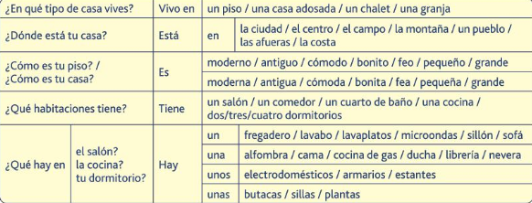

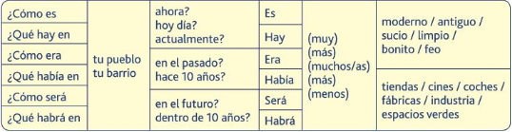

Writing Practice 40 word piece

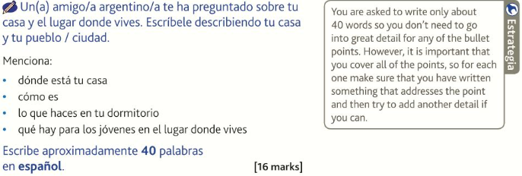

…………………………………………………………………………………………………………………………………………………………………………….
…………………………………………………………………………………………………………………………………………………………………………….
…………………………………………………………………………………………………………………………………………………………………………….
…………………………………………………………………………………………………………………………………………………………………………….
…………………………………………………………………………………………………………………………………………………………………………….
…………………………………………………………………………………………………………………………………………………………………………….
…………………………………………………………………………………………………………………………………………………………………………….
…………………………………………………………………………………………………………………………………………………………………………….
……………………………………………………………………………………………………………… …………………………………………… [16 marks]

Writing Practice 90 word piece [16 marks]

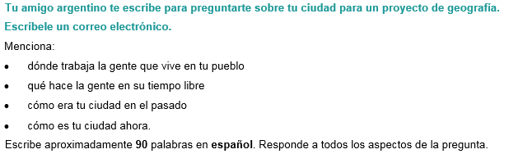
Top Tips! 10 marks are for communication - so make sure you write in some detail (approximately 23 words) about EACH bullet point. For the 6 marks for Language, use varied vocab, verbs, opinions and some justifications.

…………………………………………………………………………………………………………………………………………………………………………….
…………………………………………………………………………………………………………………………………………………………………………….
…………………………………………………………………………………………………………………………………………………………………………….
…………………………………………………………………………………………………………………………………………………………………………….
…………………………………………………………………………………………………………………………………………………………………………….
…………………………………………………………………………………………………………………………………………………………………………….
…………………………………………………………………………………………………………………………………………………………………………….
…………………………………………………………………………………………………………………………………………………………………………….
…………………………………………………………………………………………………………………………………………………………………………….
…………………………………………………………………………………………………………………………………………………………………………….
…………………………………………………………………………………………………………………………………………………………………………….
…………………………………………………………………………………………………………………………………………………………………………….
…………………………………………………………………………………………………………………………………………………………………………….
…………………………………………………………………………………………………………………………………………………………………………….
…………………………………………………………………………………………………………………………………………………………………………….
…………………………………………………………………………………………………………………………………………………………………………….
…………………………………………………………………………………………………………………………………………………………….[16 marks]

Foundation Speaking

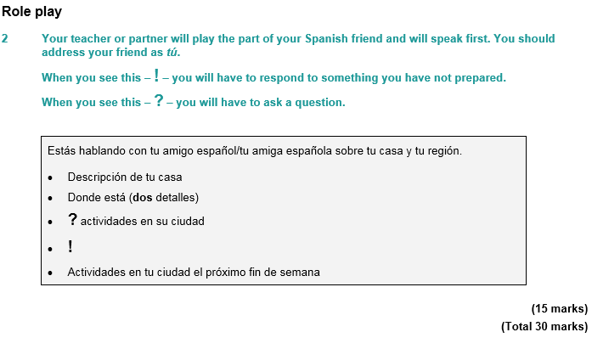
…………………………………………………………………………………………………………………………………………………………………………….
…………………………………………………………………………………………………………………………………………………………………………….
…………………………………………………………………………………………………………………………………………………………………………….
…………………………………………………………………………………………………………………………………………………………………………….
…………………………………………………………………………………………………………………………………………………………………………….
…………………………………………………………………………………………………………………………………………………………………………….
…………………………………………………………………………………………………………………………………………………………………………….
………………………………………………………………………………………………………………………………………………………… [15 marks]

Photo Card (Foundation)
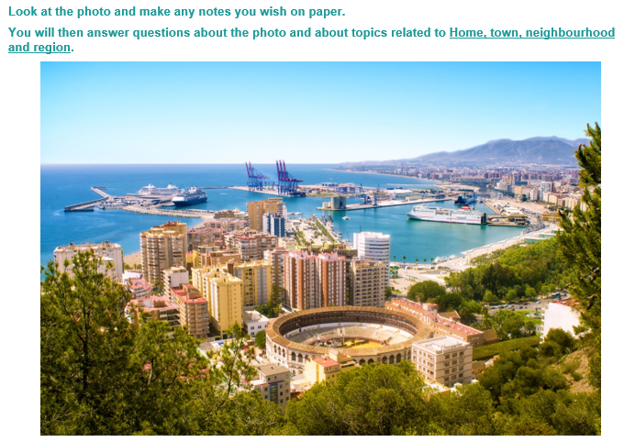

…………………………………………………………………………………………………………………………………………………………………………….
…………………………………………………………………………………………………………………………………………………………………………….
…………………………………………………………………………………………………………………………………………………………………………….
…………………………………………………………………………………………………………………………………………………………………………….
…………………………………………………………………………………………………………………………………………………………………………….
…………………………………………………………………………………………………………………………………………………………………………….
…………………………………………………………………………………………………………………………………………………………………………….
…………………………………………………………………………………………………………………………………………………………………………….
…………………………………………………………………………………………………………………………………………………………………………….
…………………………………………………………………………………………………………………………………………………………………………….
…………………………………………………………………………………………………………………………………………………………………………….
…………………………………………………………………………………………………………………………………………………………………………….
…………………………………………………………………………………………………………………………………………………………………………….
…………………………………………………………………………………………………………………………………………………………………………….
………………………………………………………………………………………………………………………………………………………… [15 marks]

Tema 5 Donde vivo– Higher Tier
Your Spanish friend emails you about where his holiday home in the mountains. Translate the message into English for your family .

Cuando era pequeño, teníamos una casa donde y pasábamos nuestras vacaciones de verano. Era una casa de carácter con grandes terrazas en las afueras de un pueblo en las montañas. El pueblo era antiguo y era fácil esconderse o perderse. En verano, nos gustaba cenar en la terraza o nadar en el rio detrás de la casa, pero en invierno solía nevar mucho y practicábamos esquí.
…………………………………………………………………………………………………………………………………………………………………………….
…………………………………………………………………………………………………………………………………………………………………………….
…………………………………………………………………………………………………………………………………………………………………………….
…………………………………………………………………………………………………………………………………………………………………………….
…………………………………………………………………………………………………………………………………………………………………………….
…………………………………………………………………………………………………………………………………………………………………………….
……………………………………………………………………………………………………………………………………………………………… [9 marks]

Translate the following sentences into good Spanish:-

My town is very modern but there are also many historical monuments that are popular with the tourists. The cathedral is very famous and there is a big lake with a beautiful park where we like to go for a walk. Although the town is very picturesque, a lot of young people get bored.
…………………………………………………………………………………………………………………………………………………………………………….
…………………………………………………………………………………………………………………………………………………………………………….
…………………………………………………………………………………………………………………………………………………………………………….
…………………………………………………………………………………………………………………………………………………………………………….
…………………………………………………………………………………………………………………………………………………………………………….
…………………………………………………………………………………………………………………………………………………………………………….
……………………………………………………………………………………………………………………………………………………………[12 marks]

Extended Writing Deliberate Practice Higher Tier
90 word piece
- Tu amigo español quiere saber cómo es tu casa. Escríbele un correo electrónico.
Menciona:
- las habitaciones que hay
- una descripción de tu dormitorio
- cómo es el jardín
- cómo es tu calle.
Escribe aproximadamente 90 palabras en español. Responde a todos los aspectos de la pregunta.
Top Tips! 10 marks are for communication - so make sure you write in some detail (approximately 23 words) about EACH bullet point. For the 6 marks for Language, use varied vocab, verbs, opinions and some justifications.

…………………………………………………………………………………………………………………………………………………………………………….
…………………………………………………………………………………………………………………………………………………………………………….
…………………………………………………………………………………………………………………………………………………………………………….
…………………………………………………………………………………………………………………………………………………………………………….
…………………………………………………………………………………………………………………………………………………………………………….
…………………………………………………………………………………………………………………………………………………………………………….
…………………………………………………………………………………………………………………………………………………………………………….
…………………………………………………………………………………………………………………………………………………………………………….
…………………………………………………………………………………………………………………………………………………………………………….
…………………………………………………………………………………………………………………………………………………………………………….
…………………………………………………………………………………………………………………………………………………………………………….
…………………………………………………………………………………………………………………………………………………………………………….
…………………………………………………………………………………………………………………………………………………………………………….
…………………………………………………………………………………………………………………………………………………………………………….
………………………………………………………………………………………………………………………………………………………… [16 marks]

150 word piece (Higher Tier)

- Tu amigo español está haciendo un proyecto sobre Gran Bretaña y quiere saber cómo es vivir en el campo allí. Escríbele dando tus opiniones.
Menciona:
- las ventajas y desventajas de vivir en el campo
- algunos aspectos negativos de vivir en la ciudad.
Escribe aproximadamente 150 palabras en español. Responde a los dos aspectos de la pregunta.

…………………………………………………………………………………………………………………………………………………………………………….
…………………………………………………………………………………………………………………………………………………………………………….
…………………………………………………………………………………………………………………………………………………………………………….
…………………………………………………………………………………………………………………………………………………………………………….
…………………………………………………………………………………………………………………………………………………………………………….
…………………………………………………………………………………………………………………………………………………………………………….
…………………………………………………………………………………………………………………………………………………………………………….
…………………………………………………………………………………………………………………………………………………………………………….
…………………………………………………………………………………………………………………………………………………………………………….
…………………………………………………………………………………………………………………………………………………………………………….
…………………………………………………………………………………………………………………………………………………………………………….
………………………………………………………………………………………………………………………………………………………………………………
…………………………………………………………………………………………………………………………………………………………………………...
…………………………………………………………………………………………………………………………………………………………………………….
…………………………………………………………………………………………………………………………………………………………………………….
…………………………………………………………………………………………………………………………………………………………………………….
…………………………………………………………………………………………………………………………………………………………………………….
…………………………………………………………………………………………………………………………………………………………………………….
…………………………………………………………………………………………………………………………………………………………………………….
…………………………………………………………………………………………………………………………………………………………………………….
…………………………………………………………………………………………………………………………………………………………………………….
…………………………………………………………………………………………………………………………………………………………………………….
…………………………………………………………………………………………………………………………………………………………………………….
……………………………………………………………………………………………………………………………………………………………[32 marks]

Higher Speaking Role Play

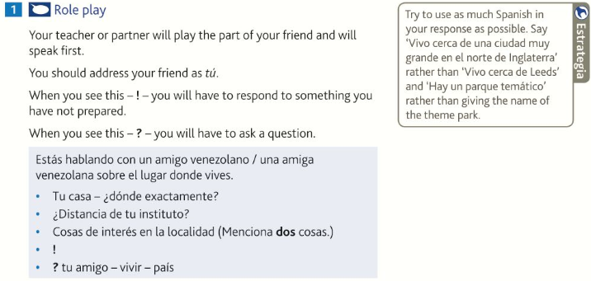
…………………………………………………………………………………………………………………………………………………………………………….
…………………………………………………………………………………………………………………………………………………………………………….
…………………………………………………………………………………………………………………………………………………………………………….
…………………………………………………………………………………………………………………………………………………………………………….
…………………………………………………………………………………………………………………………………………………………………………….
…………………………………………………………………………………………………………………………………………………………………………….
…………………………………………………………………………………………………………………………………………………………………………….
…………………………………………………………………………………………………………………………………………………………….[15 marks]

Higher Photo Card
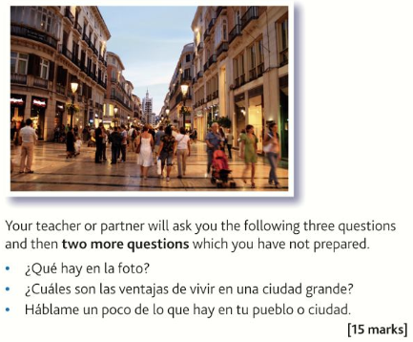
…………………………………………………………………………………………………………………………………………………………………………….
…………………………………………………………………………………………………………………………………………………………………………….
…………………………………………………………………………………………………………………………………………………………………………….
…………………………………………………………………………………………………………………………………………………………………………….
…………………………………………………………………………………………………………………………………………………………………………….
…………………………………………………………………………………………………………………………………………………………………………….
…………………………………………………………………………………………………………………………………………………………………………….
…………………………………………………………………………………………………………………………………………………………………………….
…………………………………………………………………………………………………………………………………………………………………………….
…………………………………………………………………………………………………………………………………………………………………………….
…………………………………………………………………………………………………………………………………………………………………………….
…………………………………………………………………………………………………………………………………………………………………………….
…………………………………………………………………………………………………………………………………………………………………………….
…………………………………………………………………………………………………………………………………………………………….[15 marks]

Some Higher Reading Practice

Useful websites for independent learning

www.kerboodle.com (your teacher will provide your individual log-in details.

www.quizlet.com

www.languagesonline.org.uk

www.linguascope.com (username: budmouth password provided by your teacher)

www.atantot.com (username: Budmouth password provided by your teacher)

www.memrise.com

