Budmouth Academy
Year 9 French
Unité 5 Ma ville et ma maison
Unit 5 Identity and Culture: Home, town and neighbourhood
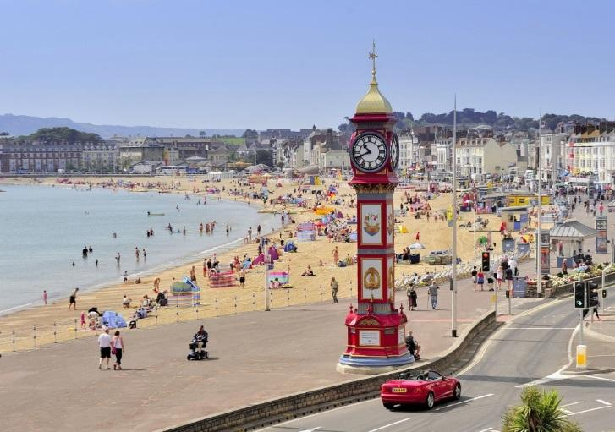
Name ………………………………………….
Class ……………………………………………
Tutor Group ………………………………..

 |  | Assessment Bands in MFL
Exceptional  Advanced  Secure  Developing | = Nearly always …  = Mostly …  = Occasionally …  = Rarely … | Takes an active part in lessons and accepts challenge  Goes “above and beyond” in independent learning  Recognises and uses vocab from current topic and previous topics  Recognises and uses structures from current topic and previous topics  Remains focused when listening and uses context to understand new language  Uses varied strategies and resilience to read and understand written texts  Writing:-  communicates in appropriate detail, with varied pronouns  uses resourcefulness and creativity when writing (including HW)  uses varied connectives with accurate word order and grammar  uses model texts to produce own written pieces with at least two tenses (sentences / paragraphs / 40 / 90 /150 words)  checks own written work, aiming for accuracy and quality  Speaking:-  develops ideas clearly and accurately in at least two tenses (photo card/ topics)  talks spontaneously and deals with unpredictable elements.  makes an effort to speak with accurate pronunciation  willingly responds to teacher feedback  asks thoughtful Qs about grammar  pays attention to detail when translating
The length and complexity of what students understand and produce is expected to increase as each year progresses.
Progress is made as students develop the frequency in which they apply the skills outlined above.

MFL Curriculum Overview of Topics (Knowledge)

 |  |  | French
Term | 1 | 2 | 3 | 4 | 5 | 6
Assess | L,W, Tr into Eng | R,S,Tr into TL | L,W, Tr into Eng | R,S,Tr into TL | L,W, Tr into Eng | R,S,Tr into TL
Year 7 | Meeting people | School life | Family | My home | Free time | Food & Drink
Year 8 | Life at home | My area | Health | Travel | Lost property | Holidays
Year 9 | Family & friends | Local area | School subjects | Free time 1 | Free time 2 | Festivals
 | Ma famille et mes amis | Ma ville et ma maison | L'école et les matières | Les loisirs 1 | Les loisirs 2 | Les fêtes et traditions
Year 10 | School problems | Holiday | Future studies | Health | Marriage | Technology
 | La vie scolaire | Les vacances | Les études (l'avenir) | La santé/mon mode de vie | Le marriage | La technologie
Year11 | Global issues | Social Issues | Work and careers | Revision | Revision
 | L'environnement | Les problèmes sociaux | Le travail | les révisions | les révisions

5.1G À la maison
to help |  | rose
wardrobe |  | la porte
book case / library |  | nettoyer
white |  | cuisiner
made of wood |  | noir(e)
desk |  | le canapé
sofa |  | aider
chair |  | violet(te)
chest of drawers |  | en métal
to cook |  | le bureau
hard |  | les meubles (m)
shelf |  | l’étagère (f)
to cook |  | propre
to do the gardening |  | laver la voiture
armchair |  | blanc(he)
window |  | faire le jardinage
grey |  | faire la cuisine
yellow |  | la commode
to wash the car |  | la chaise
bed |  | le miroir the
made of metal |  | la fenêtre
furniture |  | ranger
mirror |  | gris(e)
wall |  | la peinture
to clean |  | dur(e)
black |  | en bois
paint / painting |  | rouge
door |  | jaune
clean / own |  | le mur
to tidy |  | vert(e)
pink |  | le fauteuil
red |  | en velours
rug |  | le tapis
made of fabric |  | en tissu
to work |  | l’armoire (f)
made of velvet |  | la bibliothèque
green |  | le lit
purple |  | travailler

5.1F Des maisons différentes
annoying |  | agaçant(e)
office / study |  | l’étage (m)
cellar |  | le grenier
bedroom |  | la cuisine
kitchen |  | la chambre
to move house |  | les toilettes (f)
cosy |  | déménager
staircase |  | le séjour
floor, storey |  | sombre
window |  | la fenêtre
attic |  | la salle d’eau
garden |  | le salon lounge,
(detached / semi‑detached / terraced) house |  | le bureau
room |  | douillet(te)
ground floor |  | le rez-de-chaussée
dining room |  | la maison (individuelle / jumelée / mitoyenne)
bathroom |  | le jardin
wet room |  | la cave
living room |  | le sous-sol
lounge, living room |  | la salle à manger
dark |  | la pièce
basement |  | la salle de bains
WC, toilet |  | l’escalier (m)

5.2F Trouver ta ville jumelée idéale
to welcome |  | voir
hand‑made |  | trop de
to attract |  | tôt
to need |  | tard
cheap |  | surtout
shopping centre |  | pratique
castle |  | pas grand-chose
expensive |  | ouvert(e)
choice |  | loin (de)
outside |  | le quartier
to try (on) |  | le choix
student |  | le château
closed |  | le centre commercial
free of charge |  | le / la voisin(e)
far (from) |  | la zone piétonne
open |  | la ville jumelée
not much |  | l’usine (f)
practical |  | l’étudiant(e)
area, part of town |  | gratuit(e)
especially |  | fermé(e)
medium‑sized |  | essayer
late |  | dehors
early |  | de taille moyenne
too many |  | cher / chère
twin city / town |  | bon marché
to see |  | avoir besoin de
neighbour |  | attirer
factory |  | artisanal(e)
pedestrian zone |  | accueillir

5.2G Là où j’habite
lively |  | vivre
beautiful |  | à la campagne
by the seaside |  | au bord de la mer
quiet |  | où
in the countryside |  | beau / belle
city centre |  | historique
the suburbs |  | petit(e)
east |  | animé(e)
big |  | touristique
to live |  | le village
historic |  | vieux / vieille
attractive |  | le centre-ville
in the mountains |  | à la montagne
dead |  | nouveau / nouvelle
north |  | le sud
new |  | l’ouest (m)
where |  | joli(e)
west |  | habiter
small |  | mort(e)
south |  | la banlieue
touristic |  | l’est (m)
old |  | le nord
village |  | grand(e)
to live |  | calme

Useful verbs and structures

PAST |  | PRESENT |  | FUTURE
j’ai habité I lived |  | je suis I am |  | je vais aller I’m going to go
j’ai fait I did |  | j’ai I have |  | je vais jouer I’m going to play
j’ai regardé I watched |  | je fais I do |  | je vais regarder I’m going to watch
j’ai vu I saw |  | je joue I play |  | je vais faire I’m going to do
j'ai bu I drank |  | j’habite I live |  | je vais manger I’m going to eat
j’ai mangé I ate |  | je reste I stay |  | je vais boire I’m going to drink
j’ai visité I visited |  | je vais I go |  | je vais habiter I'm going to live
je suis allé(e) I went |  | je m'entends bien avec (I get on well with)
je suis resté(e) I stayed |  | je me sers de (I use) |  | POSH FUTURE
 |  | j'utilise (I use) |  | j’irai I’ll go
C'était … (it was) |  |  |  | je jouerai I’ll play
J'ai aimé (I liked) |  | il y a (there is/there are) |  | je regarderai I’ll watch
Il me semblait (I found it) |  | C'est (it is) |  | je ferai I’ll do
 |  |  |  | je mangerai I’ll eat
TIME PHRASES PAST |  | TIME PHRASES FUTURE |  | je boirai I’ll drink
le weekend dernier last weekend |  | le weekend prochain next weekend |  | J’aurai I’ll have
la semaine dernière last week |  | la semaine prochaine next week |  | je serai I’ll be
l’année dernière last year |  | l’année prochaine next year |  | ce sera it will be
il y a trois ans 3 years ago |  | demain tomorrow |  | il y aura there will be
hier yesterday |  | Dans deux ans in two years
LINKING WORDS |  | GIVING OPINIONS |  | ADJECTIVES
parce que because |  | Starting the sentence |  | intéressant interesting | mauvais - bad
car because |  | à mon avis in my opinion |  | ennuyeux boring | casse-pieds - pain in the neck
mais but |  | je pense que I think that |  | barbant boring | nul - rubbish
cependant however |  | je trouve que I think that |  | douillet/douillette cosy | marrant - funny
aussi also |  | je ne pense pas que I don’t think that |  | confortable comfortable | rigolo - funny
en outre in addition |  | par contre on the other hand |  | génial great | amusant - fun
etant donné que given that |  | il me semble que it seems to me that |  | merveilleux marvellous | facile - easy
premièrement firstly |  | je suis persuadé que I’m convinced that |  | passionant fascinating | affreux - awful
deuxiémement secondly |  | je dirais que I would say that |  | super great | ridicule ridiculous
finalement lastly |  | Pour moi for me |  | fantastique great | je ne l’ai pas aimé - I didn’t like it.
 |  | Je crois que I believe that |  | cool cool un gaspillage de temps (a waste of time)
HOW IT USED TO BE |  | HOW I'D LIKE IT TO BE |  | INTENSIFIERS
avant, je faisais before, I used to do |  | je voudrais I’d like |  | assez - quite
avant, j’habitais before, I used to live |  | j’aurais I would have |  | très - very
il y avait there was /used to be |  | je serais I would be |  | un peu - a bit
c’était it was |  | je porterais I would wear |  | trop - too
 |  | il y aurait there would be |  | vraiment - really
 |  | ce serait it would be |  | tout à fait - totally
 |  |  |  | extrêmement
 |  |  |  | absolument
 |  |  |  | complètement

Model Tasks and Deliberate Practice
The tasks here will give you a good model of typical GCSE assessments and help you to develop skills. Keep each booklet safe and use for revision for end of unit tests and the final GCSE exam.
Unité 5 Ma ville et ma maison

Translate the following passage into English.

J’habite un petit village au bord de la mer. J’aime bien habiter ici mais je pense qu’en été, il y a trop de touristes. À la plage, on peut bronzer, se baigner ou pêcher. J’aime toutes ces activités.
……………………………………………………………………………………………………………………………………………………………
……………………………………………………………………………………………………………………………………………………………
…………………………………………………………………………………………………………………………………………………………...
……………………………………………………………………………………………………………………………………………[9 marks]

Translate the following sentences into good French:-

1. In my bedroom, there is a desk, a wardrobe and a bed.
……………………………………………………………………………………………………………………………………………………………
……………………………………………………………………………………………………………………………………………………………

2. I do the washing up twice a week.
……………………………………………………………………………………………………………………………………………………………
……………………………………………………………………………………………………………………………………………………………

3. I live in a flat on the second floor.
……………………………………………………………………………………………………………………………………………………………
……………………………………………………………………………………………………………………………………………………………

4. We do not have a garden.
……………………………………………………………………………………………………………………………………………………………
……………………………………………………………………………………………………………………………………………………………

5. I live in a flat on the second floor.
……………………………………………………………………………………………………………………………………………………………
……………………………………………………………………………………………………………………………………………………………

Unité 5 Ma ville et ma maison Typical speaking conversation questions
- Use the “useful phrases tables” below to help you. The vocab pages will also help.
- Qu’est-ce que tu fais pour aider à la maison? =……………………………………………….
……………………………………………………………………………………………………………………………………………………………
……………………………………………………………………………………………………………………………………………………………

- Où est votre maison? = ……………………………………………………………………...

……………………………………………………………………………………………………………………………………………………………
……………………………………………………………………………………………………………………………………………………………

- Qu’est-ce qu’il y a au rez-de-chaussée? = …………………………………………………………...

……………………………………………………………………………………………………………………………………………………………
……………………………………………………………………………………………………………………………………………………………

- Qu’est-ce qu’il y a au premier étage? = ………………………………………………………

……………………………………………………………………………………………………………………………………………………………
……………………………………………………………………………………………………………………………………………………………

- Quels sont les avantages/les inconvénients de votre maison? =
……………………………………………………………………………………………….

……………………………………………………………………………………………………………………………………………………………
……………………………………………………………………………………………………………………………………………………………

Foundation Writing 40 word piece

Vous écrivez à votre ami(e) français(e) pour lui dire où vous habitez.
Mentionnez:
- la région où vous habitez
- votre ville / village
- votre maison / appartement
- votre chambre.
Écrivez environ 40 mots en français.

Top Tips! 10 marks are for communication - so make sure you write something about EACH bullet point. For the 6 marks for Language, use varied vocab, verbs, opinions and a few justifications.
__________________________________________________________________________________________________________________________________________________________________________________________________________________________________________________________________________________________________________________________________________________________________________________________________________________________________________________________________________________________________________________________________________________________________________________________
(16 marks)

Writing Practice 90 word piece

Vous décrivez votre ville sur votre blog.
Décrivez:
- sa taille
- ce qu’il y a à voir
- ce qu’il y a pour les jeunes
- ce que vous allez y faire ce weekend.
Écrivez environ 90 mots en français. Répondez à chaque aspect de la question.

Top Tips! 10 marks are for communication - so make sure you write in some detail (approximately 23 words) about EACH bullet point. For the 6 marks for Language, use varied vocab, verbs, opinions and some justifications.

……………………………………………………………………………………………………………………………………………………………
……………………………………………………………………………………………………………………………………………………………
……………………………………………………………………………………………………………………………………………………………
……………………………………………………………………………………………………………………………………………………………
……………………………………………………………………………………………………………………………………………………………
……………………………………………………………………………………………………………………………………………………………
……………………………………………………………………………………………………………………………………………………………
……………………………………………………………………………………………………………………………………………………………
……………………………………………………………………………………………………………………………………………………………
……………………………………………………………………………………………………………………………………………………………
……………………………………………………………………………………………………………………………………………………………
……………………………………………………………………………………………………………………………………………………………
……………………………………………………………………………………………………………………………………………………………
……………………………………………………………………………………………………………………………………………………………
……………………………………………………………………………………………………………………………………………………………
……………………………………………………………………………………………………………………………………………………………
[16 marks]

Foundation Speaking
Role play
Role play
2 Your teacher or partner will play the part of the French visitor and will speak first. You should address the visitor as vous.
When you see this – ! – you will have to respond to something you have not prepared.
When you see this – ? – you will have to ask a question.

Vous parlez au téléphone à un visiteur français qui voudrait louer votre maison pendant les vacances.
- Où se trouve votre maison (deux détails)
- Les pièces
- Description de votre ville (deux détails)
- !
- ? dates du séjour
(15 marks)

……………………………………………………………………………………………………………………………………………………………
……………………………………………………………………………………………………………………………………………………………
……………………………………………………………………………………………………………………………………………………………
……………………………………………………………………………………………………………………………………………………………
……………………………………………………………………………………………………………………………………………………………
……………………………………………………………………………………………………………………………………………………………
……………………………………………………………………………………………………………………………………………………………
……………………………………………………………………………………………………………………………………………………………
……………………………………………………………………………………………………………………………………………………………
……………………………………………………………………………………………………………………………………………………………
……………………………………………………………………………………………………………………………………………………………
[15 marks]

Foundation Tier Speaking Photo Card

Look at the photo and make any notes you wish on paper.
You will then answer questions about the photo and about topics related to Home, town, neighbourhood and region.
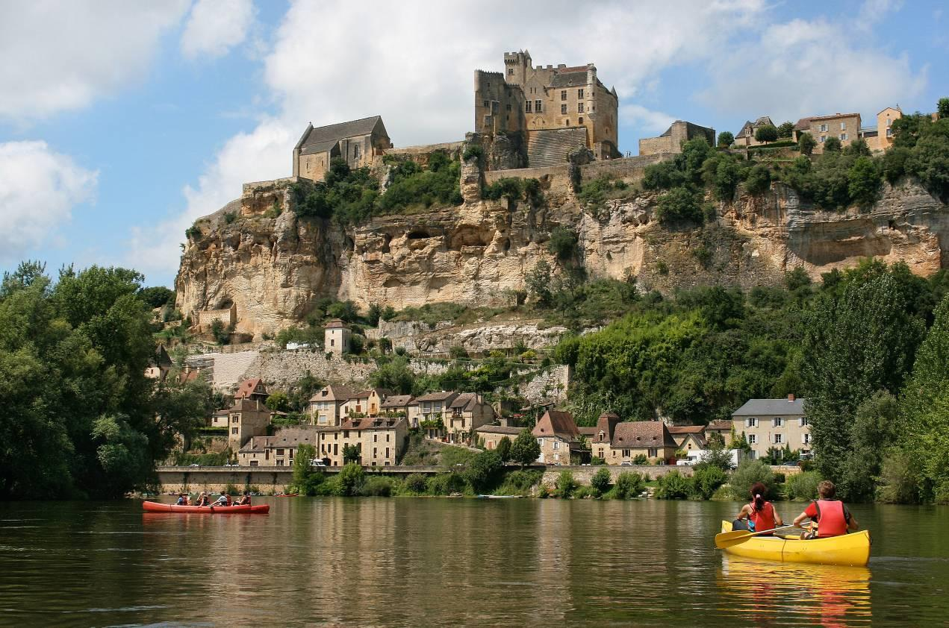
1 You will be asked the following three questions and then two more questions which you have not prepared.
- Qu’est-ce qu’il y a sur la photo?
- Tu préfères habiter dans un village ou une ville? Pourquoi?
- Comment est ta maison?

- It’s wise to use the Verb Table found near the start of this Learning Booklet so you VARY
verbs/opinions/structures.
- Remember: We need a minimum of THREE “ideas” for each question.

……………………………………………………………………………………………………………………………………………………………
……………………………………………………………………………………………………………………………………………………………
……………………………………………………………………………………………………………………………………………………………
……………………………………………………………………………………………………………………………………………………………
……………………………………………………………………………………………………………………………………………………………
……………………………………………………………………………………………………………………………………………………………
……………………………………………………………………………………………………………………………………………………………
……………………………………………………………………………………………………………………………………………………………
……………………………………………………………………………………………………………………………………………………………
……………………………………………………………………………………………………………………………………………………………
………………………………………………………………………………………………………………………………… [15 marks]
Higher Translation
Translate the following passage into French.

On Tuesday, I bought a lottery ticket. If I won, I would buy a luxury house by the sea. It would have a sea view and everyone would have their own room with a bathroom. At the moment, I have to share my room with my sister. I find her annoying.

……………………………………………………………………………………………………………………………………………………………
……………………………………………………………………………………………………………………………………………………………
……………………………………………………………………………………………………………………………………………………………
……………………………………………………………………………………………………………………………………………………………
……………………………………………………………………………………………………………………………………………………………
……………………………………………………………………………………………………………………………………………………………
……………………………………………………………………………………………………………………………………………………………
[9 marks]

Translate the following passage into English.
Your parents have seen this post on Facebook and ask you to translate it for them into English.
Nous venons de rentrer de vacances. On était en Camargue. C’était bien parce qu’on était près de la mer et il y avait beaucoup de choses à faire. Pourtant, il a fait trop chaud. L’après-midi, il a fallu rester à l’intérieur. L’année prochaine, je pense qu’on ira dans une région où il fait plus frais.

……………………………………………………………………………………………………………………………………………………………
……………………………………………………………………………………………………………………………………………………………
……………………………………………………………………………………………………………………………………………………………
……………………………………………………………………………………………………………………………………………………………
……………………………………………………………………………………………………………………………………………………………
……………………………………………………………………………………………………………………………………………………………
…………………………………………………………………………………………………………………………………………[12 marks]

Extended Writing Deliberate Practice Higher 90 word piece

Vous décrivez votre maison sur votre blog.
Décrivez:
- votre maison
- ce que vous aimez et n’aimez pas chez vous et pourquoi
- où vous aimeriez habiter et pourquoi
- votre maison idéale.
Écrivez environ 90 mots en français. Répondez à chaque aspect de la question. (16 marks)
(16 marks)

Top Tips! 10 marks are for communication - so make sure you write in some detail (approximately 23 words) about EACH bullet point. For the 6 marks for Language, use varied vocab, verbs, opinions and some justifications.
……………………………………………………………………………………………………………………………………………………………
……………………………………………………………………………………………………………………………………………………………
……………………………………………………………………………………………………………………………………………………………
……………………………………………………………………………………………………………………………………………………………
……………………………………………………………………………………………………………………………………………………………
……………………………………………………………………………………………………………………………………………………………
……………………………………………………………………………………………………………………………………………………………
……………………………………………………………………………………………………………………………………………………………
……………………………………………………………………………………………………………………………………………………………
……………………………………………………………………………………………………………………………………………………………
……………………………………………………………………………………………………………………………………………………………
……………………………………………………………………………………………………………………………………………………………
……………………………………………………………………………………………………………………………………………………………
……………………………………………………………………………………………………………………………………………………………
……………………………………………………………………………………………………………………………………………………………
……………………………………………………………………………………………………………………………………………………………
[16 marks]

Higher 150 word piece
2 Vous écrivez un article sur votre région pour un magazine français.
Décrivez:
- ce qu’elle a de particulier
- ce que vous y avez fait récemment.
Écrivez environ 150 mots en français. Répondez aux deux aspects de la question. (32 marks).
Tipp: You don’t HAVE to to include all three tenses in this piece, however it’s a good idea to do so. This enables you to show that you know the three different tenses.
……………………………………………………………………………………………………………………………………………………………
……………………………………………………………………………………………………………………………………………………………
……………………………………………………………………………………………………………………………………………………………
……………………………………………………………………………………………………………………………………………………………
……………………………………………………………………………………………………………………………………………………………
……………………………………………………………………………………………………………………………………………………………
……………………………………………………………………………………………………………………………………………………………
……………………………………………………………………………………………………………………………………………………………
……………………………………………………………………………………………………………………………………………………………
……………………………………………………………………………………………………………………………………………………………
……………………………………………………………………………………………………………………………………………………………
……………………………………………………………………………………………………………………………………………………………
……………………………………………………………………………………………………………………………………………………………
……………………………………………………………………………………………………………………………………………………………
……………………………………………………………………………………………………………………………………………………………
……………………………………………………………………………………………………………………………………………………………
……………………………………………………………………………………………………………………………………………………………
……………………………………………………………………………………………………………………………………………………………
……………………………………………………………………………………………………………………………………………………………
……………………………………………………………………………………………………………………………………………………………
……………………………………………………………………………………………………………………………………………………………
……………………………………………………………………………………………………………………………………………………………
……………………………………………………………………………………………………………………………………………………………
……………………………………………………………………………………………………………………………………………………………
…………………………………………………………………………………………………………………………………………[32 marks]
Higher Speaking Role Play

2 Your teacher or partner will play the part of the exchange student and will speak first. You should address the student as tu.
When you see this – ! – you will have to respond to something you have not prepared.
When you see this – ? – you will have to ask a question.

Ton ami(e) français(e) arrive chez toi en échange scolaire.
- Sa chambre (deux détails)
- Où est la maison exactement
- !
- Tes activités préférées en ville (deux détails)
- ? Heure du lever
(15 marks)

……………………………………………………………………………………………………………………………………………………………
……………………………………………………………………………………………………………………………………………………………
……………………………………………………………………………………………………………………………………………………………
……………………………………………………………………………………………………………………………………………………………
……………………………………………………………………………………………………………………………………………………………
……………………………………………………………………………………………………………………………………………………………
……………………………………………………………………………………………………………………………………………………………
……………………………………………………………………………………………………………………………………………………………
……………………………………………………………………………………………………………………………………………………………
……………………………………………………………………………………………………………………………………………………………
……………………………………………………………………………………… [15 marks]

Higher Photo card
Photo card
Look at the photo and make any notes you wish on paper.
You will then answer questions about the photo and about topics related to Home, town, neighbourhood and region.
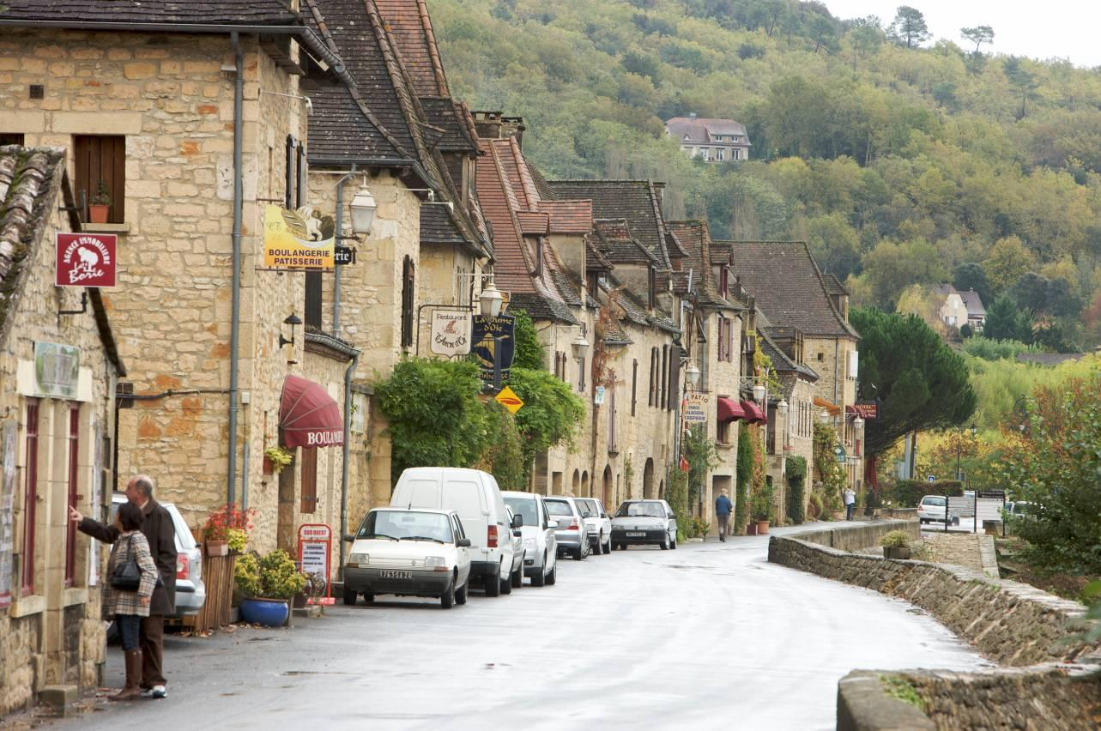
1 You will be asked the following three questions and then two more questions which you have not prepared.
- Qu’est-ce qu’il y a sur la photo?
- Aimerais-tu que ta ville/ton village soit jumelé(e) avec la ville de la photo? Pourquoi/Pourquoi pas?
- Ta ville jumelée idéale, elle serait comment exactement?
(15 marks)
It’s wise to use the Verb Table found near the start of this Learning Booklet so you VARY
verbs/opinions/structures.Remember: We need a minimum of THREE “ideas” for each question.
……………………………………………………………………………………………………………………………………………………………
……………………………………………………………………………………………………………………………………………………………
……………………………………………………………………………………………………………………………………………………………
……………………………………………………………………………………………………………………………………………………………
……………………………………………………………………………………………………………………………………………………………
……………………………………………………………………………………………………………………………………………………………
……………………………………………………………………………………………………………………………………………………………
……………………………………………………………………………………………………………………………………………………………
……………………………………………………………………………………………………………………………………………………………
……………………………………………………………………………………………………………………………………………………………
……………………………………………………………………………………………………………………………………………………………
……………………………………………………………………………………………………………………………………………………………
…………………………………………………………………………………………………………………………………………………………... [15 marks]
Some Higher Reading Practice

Useful websites for independent learning

www.kerboodle.com (your teacher will provide your individual log-in details.

www.quizlet.com

www.languagesonline.org.uk

www.linguascope.com (username: budmouth password provided by your teacher)

