Budmouth Academy

Year 9 French
Unit 3.1 Identity and Culture: Free-time activities

Name ………………………………………….
Class ……………………………………………
Tutor Group ………………………………..

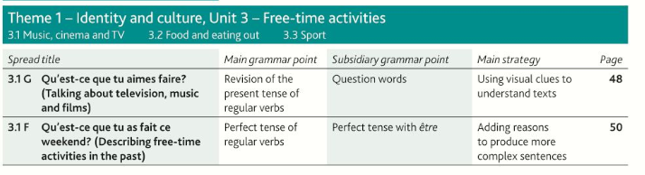

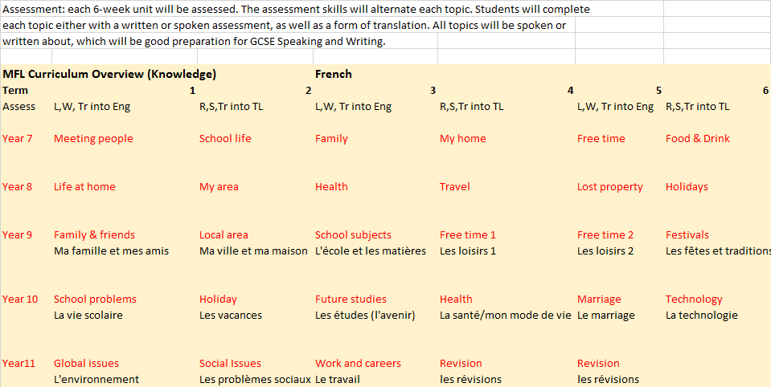

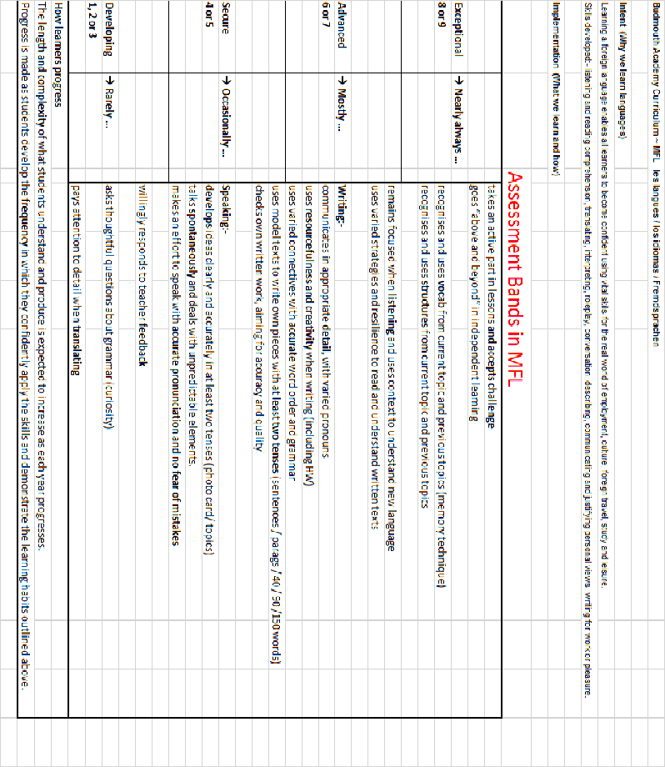

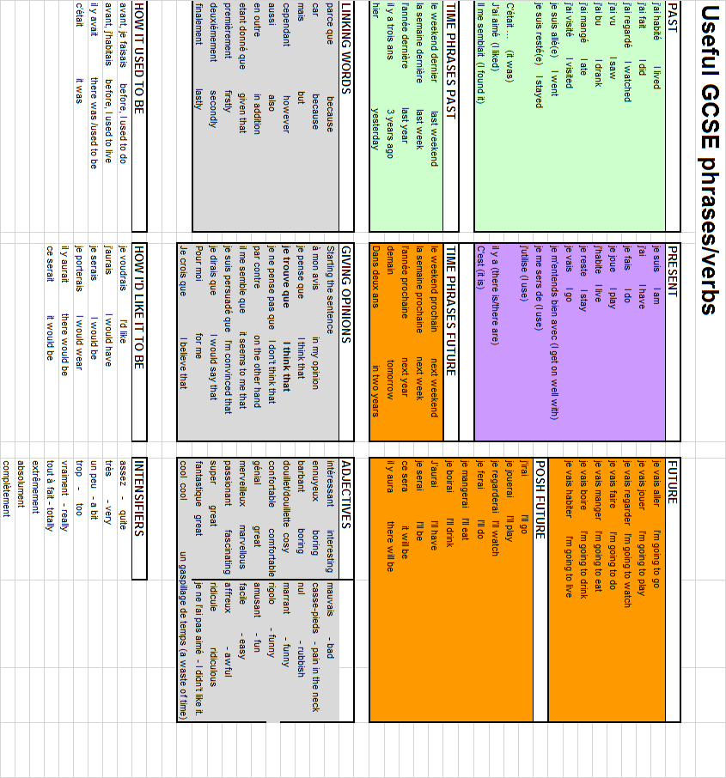
3.1G Qu’est-ce que tu aimes faire?
the news |  | les actualités (f)
to be scared |  | le documentaire
cartoon |  | le film d’amour
documentary |  | le film policier
programme |  | partager
on average |  | le téléfilm
boring |  | la télé-réalité
romantic film |  | le film d’horreur
animated film |  | avoir peur
horror film |  | l’émission (f)
detective film |  | la guerre
war |  | télécharger
game show |  | ennuyeux(-se)
to share |  | la variété française
not at all |  | le film d’animation
series |  | pas du tout
survey |  | en moyenne
to download |  | le sondage
TV drama |  | le jeu télévisé
reality television |  | la série
French easy listening music |  | le dessin animé
3.1F Qu’est-ce que tu as fait ce weekend?
MP3 player |  | le baladeur MP3
of course |  | communiquer
at the house of |  | le hockey sur glace
to choose |  | choisir
to communicate |  | génial(e)
a way to |  | la fête
to have a picnic |  | une façon de
party, festival, celebration |  | retrouver
great |  | les loisirs
ice hockey |  | incroyable
incredible |  | par contre
to get information |  | le journal
newspaper / the news |  | marrant(e)
free time (activities) |  | faire un piquenique
funny |  | chez
on the other hand |  | s’informer
ice rink |  | bien sûr
to relax |  | la patinoire
to meet |  | utiliser
to use |  | se relaxer

Model Tasks and Deliberate Practice
The tasks here will give you a good model of typical GCSE assessments and help you to develop skills. Keep each booklet safe and use for revision for end of unit tests and the final GCSE exam.

Unité 3.1G Les Loisirs

Translate the following passage into English.
J’aime regarder les documentaires et aussi j’adore regarder les films. Je suis fan des séries américaines
et quelquefois je regarde les émissions de télé-réalité.

………………………………………………………………………………………………………………………………………………………….
………………………………………………………………………………………………………………………………………………………….
………………………………………………………………………………………………………………………………………………………….
………………………………………………………………………………………………………………………………………………………….

Translate the following sentences into good French:-

1. I like to watch documentaries.

……………………………………………………………………………………………………………………………………………………………
……………………………………………………………………………………………………………………………………………………………

2. I watch American series.

……………………………………………………………………………………………………………………………………………………………
……………………………………………………………………………………………………………………………………………………………

3. I prefer to watch reality t.v shows.

……………………………………………………………………………………………………………………………………………………………
……………………………………………………………………………………………………………………………………………………………

4. I do not watch action films.

……………………………………………………………………………………………………………………………………………………………
……………………………………………………………………………………………………………………………………………………………

5. I hate watching horror films.
……………………………………………………………………………………………………………………………………………………………
……………………………………………………………………………………………………………………………………………………………
Unité 3.1G Les loisirs Typical speaking conversation questions
Use the “useful phrases tables” below to help you. The vocab pages will also help.
- Est-ce que tu regardes la télé? = …………………………………………………………………………………………………………………….

……………………...……………………………………………………………………………………………………………………………………………….

…………………………………………………………………………………………………………………………………………………………………………

- Quelle sorte de films préfères-tu? = ………………………………………………………………………………………………………………..

……………………...……………………………………………………………………………………………………………………………………………….

…………………………………………………………………………………………………………………………………………………………………………

- Qu’est-ce que tu n’aimes pas regarder? = ………………………………………………………………………………………………………..

……………………...……………………………………………………………………………………………………………………………………………….

…………………………………………………………………………………………………………………………………………………………………………

- Quelle musique écoutes-tu? = ……………………………………………………………………………………………………………………....

……………………...……………………………………………………………………………………………………………………………………………….

…………………………………………………………………………………………………………………………………………………………………………

- Combien d’heures écoutes-tu de la musique? = …………………………………………………………………………………………….

……………………...……………………………………………………………………………………………………………………………………………….

…………………………………………………………………………………………………………………………………………………………………………
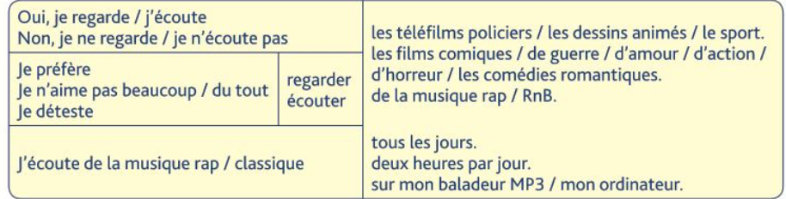The questions (muddled up) in English
Does a wedding have to cost lots of money?
Would you perhaps like to have children later on? (how many/when?)
When and where do you want to marry? (How will it be?)
What do you think of getting married?/marriage/living together?
Do you want to get married in future (why/why not?)
Do you have a girlfriend /boyfriend?

Foundation Speaking

Role play
2 Your teacher or partner will play the part of your French friend and will speak first. You should address your friend as tu.
When you see this – ! – you will have to respond to something you have not prepared.
When you see this – ? – you will have to ask a question. 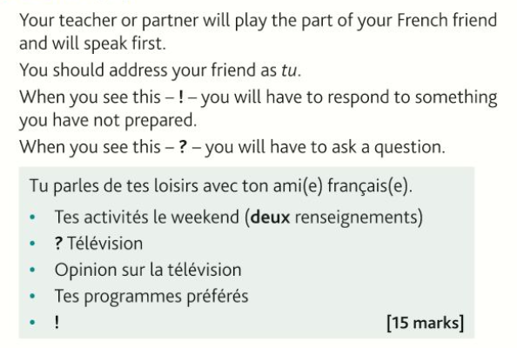
……………………...………………………………………………………………………………………………………………………………………………………………………………………………………………………………………………………………………………………………………………………………………………………………………………………………………………………………………………………………………………………………………………………………………………………………………………………………………………………………………………………………………………………………………………………………………………………………………………………………………………………………………………………………………………………………………………………………………………………………………………………………………………………………………………………………………………………………………………………………………………………………………………………………………………...……………………...……………………………………………………………………………………………………………………………………………………………………………………………………………………………………………………………………………………………………………………………………………………………………………………………………………………………………………………………………………………………………………………………………………………………………………………………………………………………………………………………………………………………………………………………………………………………………………………………………………………………………………………………………………………………………………………………………………………………………………………………………………………………………………………………...………………………………………………………………………………………………………………………………………………………………………………………………………………………………………………………………………………………………………………………………………………………………………………………………………………………………………………………………………………………………………………………………………………………………………………………………………………………………………………………………………………………………………………………………………………………………………………………………………………………………………………………………………………………………………………………………………………………………………………………………………………………………………………………………………………………………………………………………………………………………………………………………………………...……………………...………………………………………………………………………………………………………………………………………………………………………………………………………………………………………………………………………………………………………………………………………………………………………………………………………………………………………………………………………………………………………………………………………………………………………………………………………………………………………………………………………………………………………………………………………………………………………………………………………………………………………………………………………………………………………………………………………………………………………………………………………………………………………

Photo card
Look at the photo and make any notes you wish on paper.
You will then answer questions about the photo and about topics related to sport and leisure.
- Read the guidance in the “Strategie” box before preparing your responses to the 3 printed Qs. It’s wise to use the Verb Table found near the start of this Learning Booklet so you VARY verbs/opinions/structures.
- Remember: We need a minimum of THREE “ideas” for each question
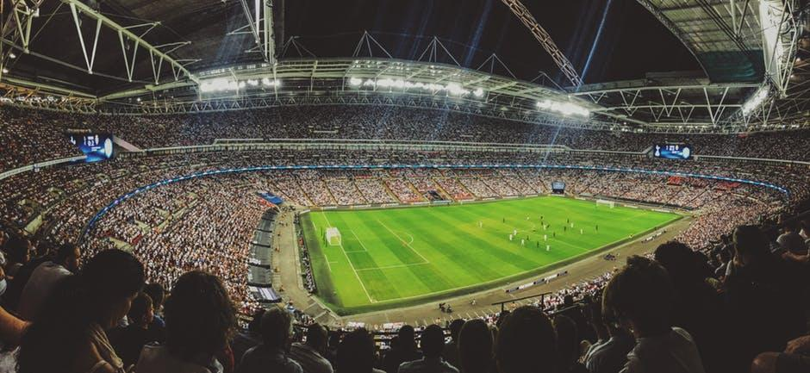
You will be asked these 3 questions and then two more questions which you have not prepared.
- Qu’est-ce qu’il y a sur la photo?
- Tu préfères quel sport?
- Est-ce que tu regardes le sport à la télé?
(15 marks)
……………………...………………………………………………………………………………………………………………………………………………………………………………………………………………………………………………………………………………………………………………………………………………………………………………………………………………………………………………………………………………………………………………………………………………………………………………………………………………………………………………………………………………………………………………………………………………………………………………………………………………………………………………………………………………………………………………………………………………………………………………………………………………………………………………………………………………………………………………………………………………………………………………………………………………...……………………...…………………………………………………………………………………………………………………………………………………………………………………………………………………………………………………………………………………………………………………………………………………………………………………………………………………………………………………………………………………………………………………………………………………………………………………………………………………………………………………………………………………………………………………………………………………………………………………………………………………………………………………………………………………………………………………………………………………………………………………………………………………………………………………………………………………………………………………………………………………………………………………………………………………………………………………………………………………………………………………………………………………………………………………………...……………………...………………………………………………………………………………………………………………………………………………………………………………………………………………………………………………………………………………………………………………………………………………………………………………………………………………………………………………………………………………………………………………………………………………………………………………………………………………………………………………………………………………………………………………………………………………………………………………………………………………………………………………………………………………………………………………………………………………………………………………………………………………………………………

Foundation Writing
40 word piece [16 marks]
Vous envoyez un mail à votre correspondant(e) francais(e) pour décrire ce que vous faites le weekend.
(You send …….)
Mentionnez:
- Une activité (one activity)
- Le samedi soir (Saturday evening)
- La télévision (TV)
- Le sport. (sport)
Écrivez environ 40 mots en français.

Top Tips! 10 marks are for communication - so make sure you write something about EACH bullet point. For the 6 marks for Language, use varied vocab, verbs, opinions and a few justifications.
…………………………………………………………………………………………………………………………………………………………………………………………………………………………………………………………………………………………………………………………………………………...……………………...…………………………………………………………………………………………………………………………………………………………………………………………………………………………………………………………………………………………………………………………………………………………………………………………………………………………………………………………………………………………………………………………………………………………………………………………………………………………………………………………………………………………………………………………………………………………………………………………………………………………………………………………………………………………………………………………………………………………………………………………………………………………………………………………………………………………………………………………………………………………………………………………………………………………………………………………………………………………………………………………………………………………………………………………...……………………...……………………………………………………………………………………………………………………………………………………………………………………………………………………………………………………………………………………………………………………………………………………………………………………………………………………………………………………………………………………………………………………………………………………………………………………………………………………………………………………………………………………………………………………………………………………………………………………………………………………………………………………………………………………………………………………………………………………………………………………………………………………………………………………………………………………………………………………………………………………………………………………… [16 marks]

90 word writing task [16 marks]
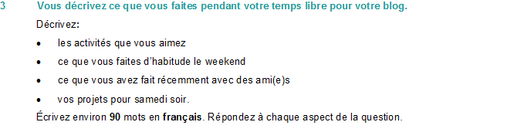Top Tips! 10 marks are for communication - so make sure you write in some detail (approximately 23 words) about EACH bullet point. For the 6 marks for Language, use varied vocab, verbs, opinions and some justifications.
…………………………………………………………………………………………………………………………………………………………………………………………………………………………………………………………………………………………………………………………………………………...……………………...…………………………………………………………………………………………………………………………………………………………………………………………………………………………………………………………………………………………………………………………………………………………………………………………………………………………………………………………………………………………………………………………………………………………………………………………………………………………………………………………………………………………………………………………………………………………………………………………………………………………………………………………………………………………………………………………………………………………………………………………………………………………………………………………………………………………………………………………………………………………………………………………………………………………………………………………………………………………………………………………………………………………………………………………...……………………...………………………………………………………………………………………………………………………………………………………………………………………………………………………………………………………………………………………………………………………………………………………………………………………………………………………………………………………………………………………………………………………………………………………………………………………………………………………………………………………………………………………………………………………………………………………………………………………………………………………………………………………………………………………………………………………………………………………………………………………………………………………………

Useful websites for independent learning

www.kerboodle.com (your teacher will provide your individual log-in details.

www.quizlet.com

www.languagesonline.org.uk

www.linguascope.com (username: budmouth password provided by your teacher)

