Budmouth Academy

Year 9 Spanish
Unit 3: Mi tiempo libre1

Name ………………………………………….
Class ……………………………………………
Tutor Group ………………………………..

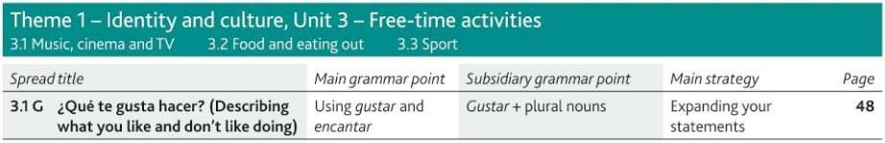

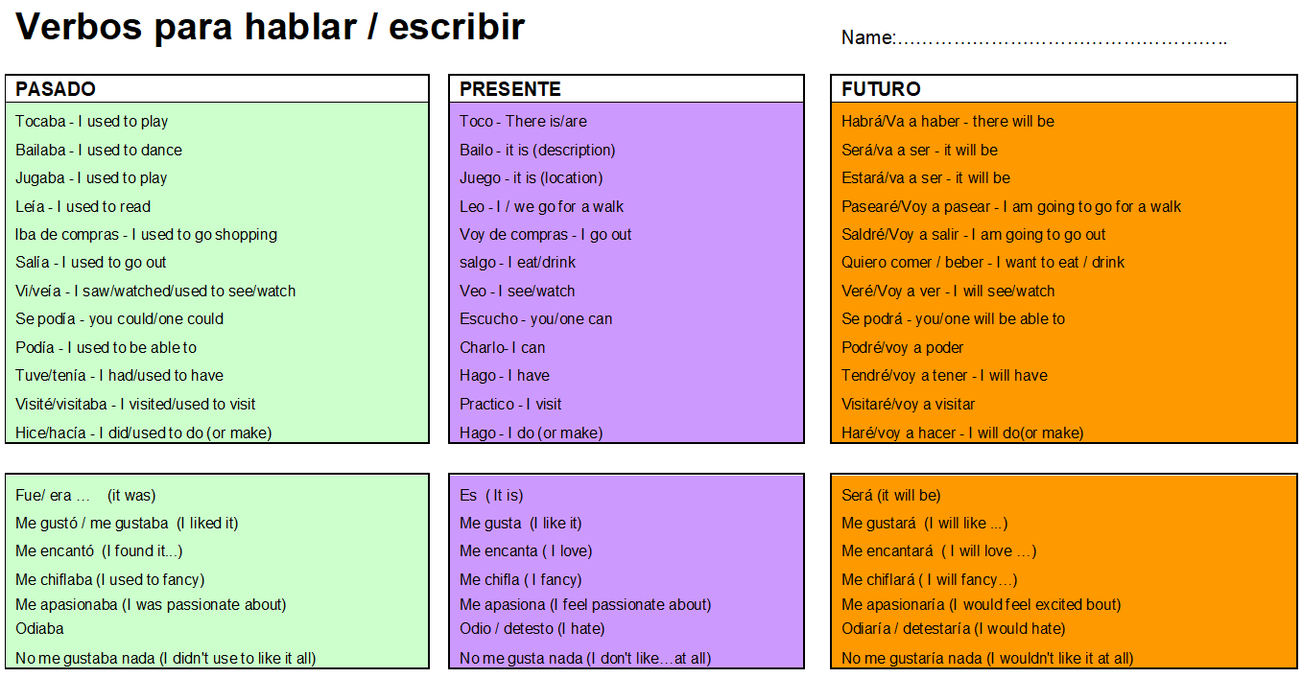
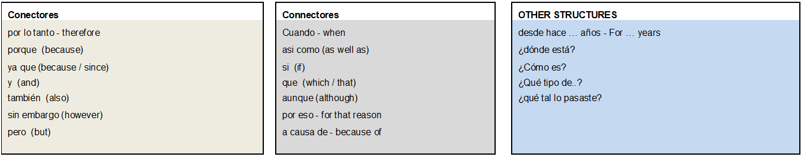

3.1G ¿Qué te gusta hacer?
aburrido/a |  | cinema
bailar |  | to read
cantar |  | boring
el cine |  | film
de vez en cuando |  | entertaining
entretenido/a |  | to practise
estimulante |  | to dance
jugar |  | to go out
leer |  | free
libre |  | to sing
odiar |  | to touch, to play(an instrument)
la película |  | from time to time, occasionally
practicar |  | to see, watch
salir |  | to hate
la tarde |  | keyboard
el teclado |  | to play (game, sport)
tocar |  | challenging
ver |  | afternoon, evening
3.1F ¿Qué haces en tu tiempo libre?
a veces |  | to chat
bastante |  | to put
cada |  | choir
cenar |  | cartoons
charlar |  | documentary
el coro |  | news
descansar |  | sometimes
los dibujos animados |  | occupied, busy
el documental |  | always
el fin de semana |  | weekend
genial |  | to have an evening meal
las noticias |  | each, every
nunca |  | soap opera
ocupado/a |  | quite
policíaco/a |  | time
poner |  | great
por lo general |  | to rest
siempre |  | never
el teatro |  | police, detective, crime (adj.)
la telenovela |  | all, every
terminar |  | time, occasion
el tiempo |  | in general
todo/a/os/as |  | theatre
tonto/a |  | to finish
la vez |  | silly, stupid
3.1H Hablando del tiempo libre y de los planes
aburrido/a |  | exciting
agradable |  | afternoon, evening
al aire libre |  | entertaining
la batería |  | challenging
la canción |  | lyrics, words
dar un paseo |  | relaxing
de vez en cuando |  | interview
desafiante |  | pleasant
divertido/a |  | routine
emocionante |  | horror
entretenido/a |  | to record
la entrevista |  | in the open air, outdoors
estar en forma |  | from time to time, occasionally
grabar |  | fun
la letra |  | song
relajante |  | drums
la rutina |  | to be fit, to be in shape
la tarde |  | boring
el terror |  | to go for a walk

Model Tasks and Deliberate Practice
The tasks here will give you a good model of typical GCSE assessments and help you to develop skills. Keep each booklet safe and use for revision for end of unit tests and the final GCSE exam.
Tema 3 Mi tiempo libre 1 Foundation

Your Spanish friend has texted about his holiday plans. Translate it into English for your friend.
Los que más me gusta hacer en mi tiempo libre es ver la tele. Podría pasarme el día viendo series de televisión y películas. Mi serie de televisión favorita se llama ‘Friends’ porque es muy divertida. También me encantan las películas de ciencia ficción y policiacas pero detesto las películas románticas porque son un rollo.

………………………………………………………………………………………………………………………………………………………….…………………………
………………………………………………………………………………………………………………………………………………………….…………………………
………………………………………………………………………………………………………………………………………………………….…………………………
………………………………………………………………………………………………………………………………………………………….…………………………
………………………………………………………………………………………………………………………………………………………….…………………………

Translate the following sentences into Spanish.
1 They are going to eat in a Mexican restaurant.

______________________________________________________________________________________
______________________________________________________________________________________
2 I love going to the shopping centre with you.
______________________________________________________________________________________
______________________________________________________________________________________

3 On Fridays, I watch a film and I go out with my friends.

______________________________________________________________________________________
______________________________________________________________________________________
4 I like peaches but I prefer pineapples.

______________________________________________________________________________________
______________________________________________________________________________________
5 I do not like horror films; I prefer comedies as they are funny.

______________________________________________________________________________________
______________________________________________________________________________________

Tema 3 Mi tiempo libre 1 Typical speaking conversation questions
Use the “useful phrases tables” below to help you.

- Describe tu rutina diaria = ………………………………………………………………………………………………………………………………

…………………………………………………………………………………………………………………………………………………………………………
…………………………………………………………………………………………………………………………………………………………………………
- ¿Qué haces en tu tiempo libre? = ……………………………………………………………………………………………………………………

…………………………………………………………………………………………………………………………………………………………………………

…………………………………………………………………………………………………………………………………………………………………………

- ¿Cuándo fue la última vez que fuiste al cine? = ..……………………………………………………………………………………………..

…………………………………………………………………………………………………………………………………………………………………………

- ¿Qué deporte te gustaría practicar en el futuro? = …..…………………………………………………………………………………….

…………………………………………………………………………………………………………………………………………………………………………

………………………………………………………………………………………………………………………………………………………………………

- ¿Qué planes tienes para el próximo fin de semana? = …………….……………………………………………………………………

………………………………………………………………………………………………………………………………………………………………………

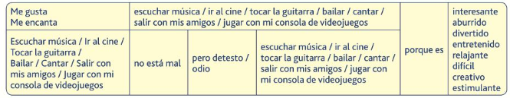

Foundation Speaking
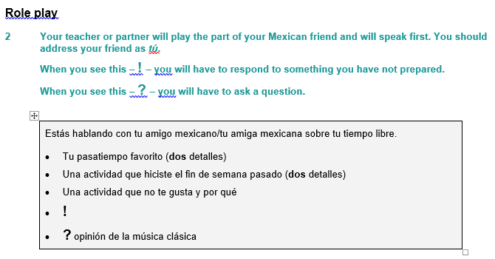

……………………………………………………………………………………………………………………………………………………………………………………
……………………………………………………………………………………………………………………………………………………………………………………
……………………………………………………………………………………………………………………………………………………………………………………
……………………………………………………………………………………………………………………………………………………………………………………
……………………………………………………………………………………………………………………………………………………………………………………
……………………………………………………………………………………………………………………………………………………………………………………
……………………………………………………………………………………………………………………………………………………………………………………
……………………………………………………………………………………………………………………………………………………………………………………
……………………………………………………………………………………………………………………………………………………………………………………
……………………………………………………………………………………………………………………………………………………………………………………
……………………………………………………………………………………………………………………………………………………………………………………
…………………………………………………………………………………………………………………………………………………………………… 15 marks

Foundation Tier Speaking Photo Card

- It’s wise to use the Verb Table found near the start of this Learning Booklet so you VARY
verbs/opinions/structures.
- Remember: We need a minimum of THREE “ideas” for each question.

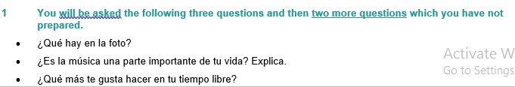
……………………………………………………………………………………………………………………………………………………………………………………
……………………………………………………………………………………………………………………………………………………………………………………
……………………………………………………………………………………………………………………………………………………………………………………
……………………………………………………………………………………………………………………………………………………………………………………
……………………………………………………………………………………………………………………………………………………………………………………
……………………………………………………………………………………………………………………………………………………………………………………
……………………………………………………………………………………………………………………………………………………………………………………
……………………………………………………………………………………………………………………………………………………………………………………
……………………………………………………………………………………………………………………………………………………………………………………
……………………………………………………………………………………………………………………………………………………………………………………
……………………………………………………………………………………………………………………………………………………………………………………
…………………………………………………………………………………………………………………………………………………………………… 15 marks

Writing Practice 40 word piece

Top Tips! 10 marks are for communication - so make sure you write something about EACH bullet point. For the 6 marks for Language, use varied vocab, verbs, opinions and a few justifications.

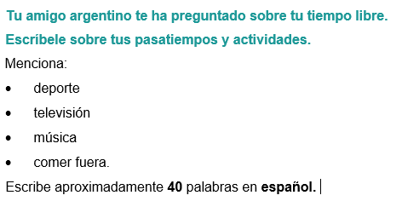

……………………………………………………………………………………………………………………………………………………………………………………
……………………………………………………………………………………………………………………………………………………………………………………
……………………………………………………………………………………………………………………………………………………………………………………
……………………………………………………………………………………………………………………………………………………………………………………
……………………………………………………………………………………………………………………………………………………………………………………
……………………………………………………………………………………………………………………………………………………………………………………
……………………………………………………………………………………………………………………………………………………………………………………
……………………………………………………………………………………………………………………………………………………………………………………
……………………………………………………………………………………………………………………………………………………………………………………
……………………………………………………………………………………………………………………………………………………………………………………
……………………………………………………………………………………………………………………………………………………………………………………
…………………………………………………………………………………………………………………………………………………………………… 16 marks

Writing Practice 90 word piece

Top Tips! 10 marks are for communication - so make sure you write in some detail (approximately 23 words) about EACH bullet point. For the 6 marks for Language, use varied vocab, verbs, opinions and some justifications.

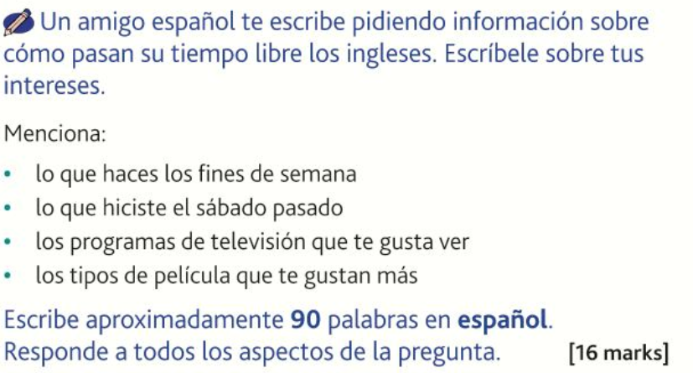

……………………………………………………………………………………………………………………………………………………………………………………
……………………………………………………………………………………………………………………………………………………………………………………
……………………………………………………………………………………………………………………………………………………………………………………
……………………………………………………………………………………………………………………………………………………………………………………
……………………………………………………………………………………………………………………………………………………………………………………
……………………………………………………………………………………………………………………………………………………………………………………
……………………………………………………………………………………………………………………………………………………………………………………
……………………………………………………………………………………………………………………………………………………………………………………
……………………………………………………………………………………………………………………………………………………………………………………
……………………………………………………………………………………………………………………………………………………………………………………
……………………………………………………………………………………………………………………………………………………………………………………
……………………………………………………………………………………………………………………………………………………………………………………
……………………………………………………………………………………………………………………………………………………………………………………
……………………………………………………………………………………………………………………………………………………………………………………
……………………………………………………………………………………………………………………………………………………………………………………
……………………………………………………………………………………………………………………………………………………………………………………
……………………………………………………………………………………………………………………………………………………………………………………
……………………………………………………………………………………………………………………………………………………………………………………
………………………………………………………………………………………………………………………………………………………… 16 marks

Tema 3 Mi tiempo libre 1 – Higher Tier
No tengo mucho tiempo libre, pero cuando puedo me gusta salir a dar un paseo con mis perros a la playa. Es muy relajante y me gusta estar al aire libre. Otras veces me gusta ir al parque con un libro, normalmente me tumbo en el césped y leo durante alrededor de una hora. También salgo con mis amigos a menudo. Nos gusta ir al cine los sábados siempre compramos palomitas y refrescos. Este sábado vamos a ver una película de terror.

……………………………………………………………………………………………………………………………………………………………………………………
…………………………………………………………………………………………………………………………………………………………………………………
……………………………………………………………………………………………………………………………………………………………………………………
……………………………………………………………………………………………………………………………………………………………………………………
……………………………………………………………………………………………………………………………………………………………………………………
……………………………………………………………………………………………………………………………………………………………………………………
……………………………………………………………………………………………………………………………………………………………………………………
……………………………………………………………………………………………………………………………………………………………………………………
……………………………………………………………………………………………………………………………………………………………………………………
……………………………………………………………………………………………………………………………………………………………………………………
…………………………………………………………………………………………………………………………………………………… 9 marks

Translate the following sentences into Spanish:-

Many people think that reading is boring but I love it. Especially when I am on holiday, I like to relax on the beach with a big novel. I also

……………………………………………………………………………………………………………………………………………………………………………………
……………………………………………………………………………………………………………………………………………………………………………………
……………………………………………………………………………………………………………………………………………………………………………………
……………………………………………………………………………………………………………………………………………………………………………………
……………………………………………………………………………………………………………………………………………………………………………………
……………………………………………………………………………………………………………………………………………………………………………………
……………………………………………………………………………………………………………………………………………………………………………………
……………………………………………………………………………………………………………………………………………………………………………………
……………………………………………………………………………………………………………………………………………………………………………………
……………………………………………………………………………………………………………………………………………………………………………………
……………………………………………………………………………………………………………………………………………………………………………………
………………………………………………………………………………………………………………………………………………… 12 marks

HIGHER Speaking practice

- It’s wise to use the Verb Table found near the start of this Learning Booklet so you VARY
verbs/opinions/structures.
- Remember: We need a minimum of THREE “ideas” for each question.

PHOTO CARD
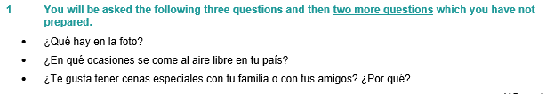

……………………………………………………………………………………………………………………………………………………………………………………
……………………………………………………………………………………………………………………………………………………………………………………
……………………………………………………………………………………………………………………………………………………………………………………
……………………………………………………………………………………………………………………………………………………………………………………
……………………………………………………………………………………………………………………………………………………………………………………
……………………………………………………………………………………………………………………………………………………………………………………
……………………………………………………………………………………………………………………………………………………………………………………
……………………………………………………………………………………………………………………………………………………………………………………
……………………………………………………………………………………………………………………………………………………………………………………
……………………………………………………………………………………………………………………………………………………………………………………
……………………………………………………………………………………………………………………………………………………………………………………
……………………………………………………………………………………………………………………………………………………………………………………
………………………………………………………………………………………………………………………………………………………… 15 marks

Extended Writing Deliberate Practice
90 word piece
- Tu amigo español quiere saber lo que hacen en su tiempo libre los jóvenes de tu país.
Escríbele una carta.
Menciona:
- qué haces por la tarde durante la semana
- las actividades que hiciste el fin de semana pasado
- los deportes favoritos entre tus amigos
- una mala manera en que algunos jóvenes pasan el tiempo.
Escribe aproximadamente 90 palabras en español. Responde a todos los aspectos de la pregunta.

……………………………………………………………………………………………………………………………………………………………………………………
……………………………………………………………………………………………………………………………………………………………………………………
……………………………………………………………………………………………………………………………………………………………………………………
……………………………………………………………………………………………………………………………………………………………………………………
……………………………………………………………………………………………………………………………………………………………………………………
……………………………………………………………………………………………………………………………………………………………………………………
……………………………………………………………………………………………………………………………………………………………………………………
……………………………………………………………………………………………………………………………………………………………………………………
…………………………………………………………………………………………………………………………………………………………………………………
……………………………………………………………………………………………………………………………………………………………………………………
……………………………………………………………………………………………………………………………………………………………………………………
……………………………………………………………………………………………………………………………………………………………………………………
……………………………………………………………………………………………………………………………………………………………………………………
……………………………………………………………………………………………………………………………………………………………………………………
……………………………………………………………………………………………………………………………………………………………………………………
………………………………………………………………………………………………………………………………………………………… 16 marks

150 word piece

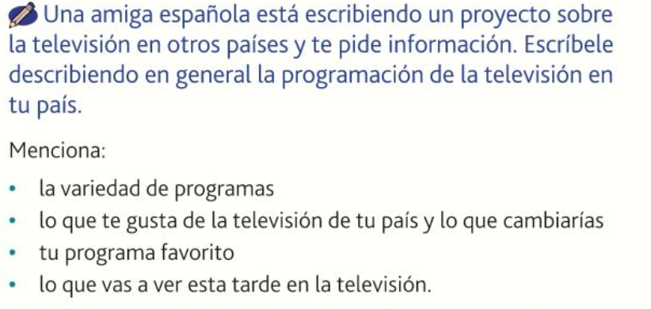

……………………………………………………………………………………………………………………………………………………………………………………
……………………………………………………………………………………………………………………………………………………………………………………
……………………………………………………………………………………………………………………………………………………………………………………
……………………………………………………………………………………………………………………………………………………………………………………
……………………………………………………………………………………………………………………………………………………………………………………
……………………………………………………………………………………………………………………………………………………………………………………
……………………………………………………………………………………………………………………………………………………………………………………
……………………………………………………………………………………………………………………………………………………………………………………
……………………………………………………………………………………………………………………………………………………………………………………
……………………………………………………………………………………………………………………………………………………………………………………
……………………………………………………………………………………………………………………………………………………………………………………
……………………………………………………………………………………………………………………………………………………………………………………
……………………………………………………………………………………………………………………………………………………………………………………
……………………………………………………………………………………………………………………………………………………………………………………
……………………………………………………………………………………………………………………………………………………………………………………
……………………………………………………………………………………………………………………………………………………………………………………
……………………………………………………………………………………………………………………………………………………………………………………
……………………………………………………………………………………………………………………………………………………………………………………
……………………………………………………………………………………………………………………………………………………………………………………
……………………………………………………………………………………………………………………………………………………………………………………
……………………………………………………………………………………………………………………………………………………………………………………
……………………………………………………………………………………………………………………………………………………………………………………
……………………………………………………………………………………………………………………………………………………………………………………
……………………………………………………………………………………………………………………………………………………………………………………
……………………………………………………………………………………………………………………………………………………………………………………
……………………………………………………………………………………………………………………………………………………………………………………
……………………………………………………………………………………………………………………………………………………………………………………
……………………………………………………………………………………………………………………………………………………………………………………
……………………………………………………………………………………………………………………………………………………………………………………
……………………………………………………………………………………………………………………………………………………………………………………
……………………………………………………………………………………………………………………………………………………………………………………
……………………………………………………………………………………………………………………………………………………………………………………
……………………………………………………………………………………………………………………………………………………………………………………
……………………………………………………………………………………………………………………………………………………………………………………
……………………………………………………………………………………………………………………………………………………………………………………
……………………………………………………………………………………………………………………………………………………………………………………
……………………………………………………………………………………………………………………………………………………………………………………
……………………………………………………………………………………………………………………………………………………………………………………
……………………………………………………………………………………………………………………………………………………………………………………
……………………………………………………………………………………………………………………………………………………………… 32 marks

Useful websites for independent learning

www.kerboodle.com (your teacher will provide your individual log-in details.

www.quizlet.com

www.languagesonline.org.uk

www.linguascope.com (username: budmouth password: flags)

www.atantot.com (username: Budmouth password: 8034)

www.memrise.com

