Budmouth Academy

Year 9 French
Unit 3: Mon temps libre 2

Name ………………………………………….
Class ……………………………………………
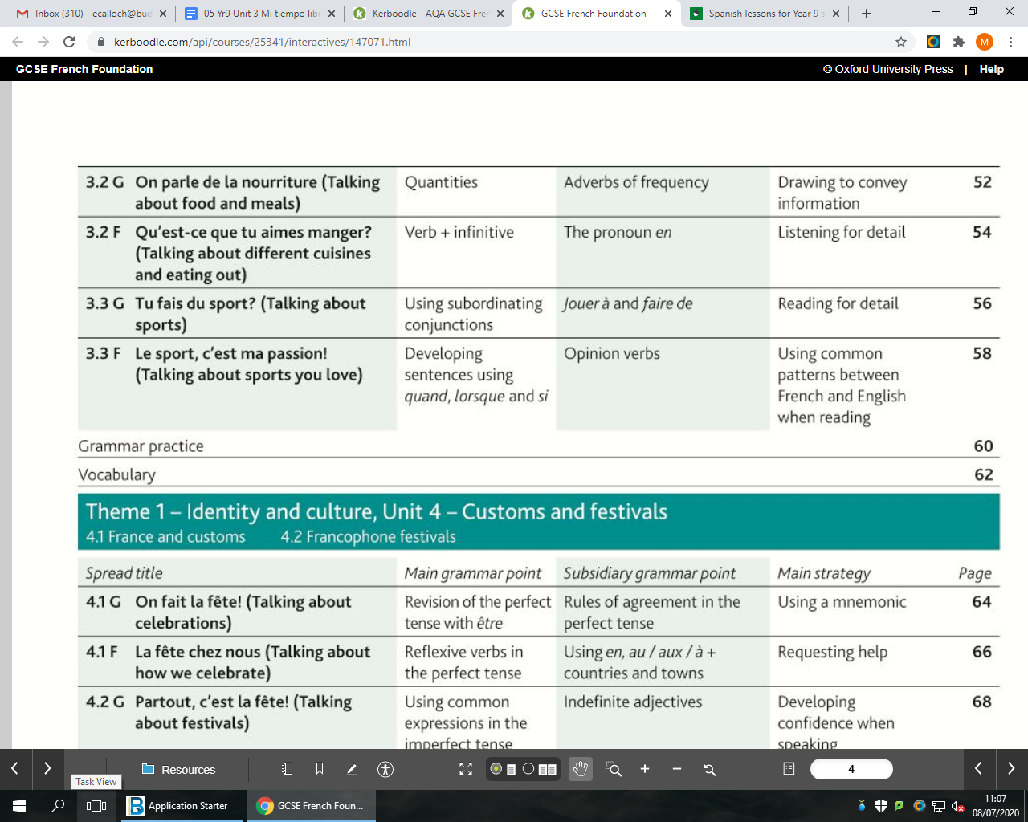
Tutor Group ………………………………..

MFL Curriculum Overview of Topics (Knowledge)

 |  |  | French
Term | 1 | 2 | 3 | 4 | 5 | 6
Assess | L,W, Tr into Eng | R,S,Tr into TL | L,W, Tr into Eng | R,S,Tr into TL | L,W, Tr into Eng | R,S,Tr into TL
Year 7 | Meeting people | School life | Family | My home | Free time | Food & Drink
Year 8 | Life at home | My area | Health | Travel | Lost property | Holidays
Year 9 | Family & friends | Local area | School subjects | Free time 1 | Free time 2 | Festivals
 | Ma famille et mes amis | Ma ville et ma maison | L'école et les matières | Les loisirs 1 | Les loisirs 2 | Les fêtes et traditions
Year 10 | School problems | Holiday | Future studies | Health | Marriage | Technology
 | La vie scolaire | Les vacances | Les études (l'avenir) | La santé/mon mode de vie | Le marriage | La technologie
Year11 | Global issues | Social Issues | Work and careers | Revision | Revision
 | L'environnement | Les problèmes sociaux | Le travail | les révisions | les révisions

 |  | Assessment Bands in MFL
Exceptional  Advanced  Secure  Developing | = Nearly always …  = Mostly …  = Occasionally …  = Rarely … | Takes an active part in lessons and accepts challenge  Goes “above and beyond” in independent learning  Recognises and uses vocab from current topic and previous topics  Recognises and uses structures from current topic and previous topics  Remains focused when listening and uses context to understand new language  Uses varied strategies and resilience to read and understand written texts  Writing:-  communicates in appropriate detail, with varied pronouns  uses resourcefulness and creativity when writing (including HW)  uses varied connectives with accurate word order and grammar  uses model texts to produce own written pieces with at least two tenses (sentences / paragraphs / 40 / 90 /150 words)  checks own written work, aiming for accuracy and quality  Speaking:-  develops ideas clearly and accurately in at least two tenses (photo card/ topics)  talks spontaneously and deals with unpredictable elements.  makes an effort to speak with accurate pronunciation  willingly responds to teacher feedback  asks thoughtful Qs about grammar  pays attention to detail when translating
The length and complexity of what students understand and produce is expected to increase as each year progresses.
Progress is made as students develop the frequency in which they apply the skills outlined above.

3.3G ¿Haces deporte?
activo/a |  | basketball
al aire libre |  | to spend time
ayudar |  | court
el baloncesto |  | active
el campo |  | horse riding
la cancha |  | ice rink
los deberes |  | swimming
la equitación |  | in the open air, outdoors
el estadio |  | stadium
montar a caballo |  | to help
montar en bicicleta |  | sports centre
la natación |  | countryside, playing field
pasar |  | to ride a bike
el patinaje |  | peaceful, quiet
la pista de hielo |  | homework
el polideportivo |  | to ride a horse
tranquilo/a |  | skating
3.3F ¿Qué deportes harás?
el alpinismo |  | skiing
cansado/a |  | to answer
la carrera |  | training
el concurso |  | to train
contestar |  | this
durante |  | race
el ejercicio |  | team
el entrenamiento |  | health
entrenar |  | rock climbing
el equipo |  | tomorrow
el esquí |  | tired
este, esta |  | competition (contest)
ganar |  | to relax
el jugador |  | during
mañana |  | exercise
el miembro |  | to try, to test
el partido |  | to win
probar |  | match
relajarse |  | member
la salud |  | player
3.3H El deporte en el mundo
al aire libre |  | to stop …ing, to quit …ing
bajar |  | defeat
el beneficio |  | the others
el/la campeón/campeona |  | to develop
caro/a |  | daily, every day
contar con |  | together with
cualquier/a |  | in the open air, outdoors
dejar de + infinitive |  | to go down
los demás |  | hard
la derrota |  | balanced
desarrollar |  | benefit
diariamente |  | effort
disfrutar |  | any
duro/a |  | expensive
empezar |  | to retire
equilibrado/a |  | champion
el esfuerzo |  | to rely on
fomentar |  | to take, to carry, to wear
jubilarse |  | ball
junto con |  | rule
llevar |  | to promote, to encourage
pasar |  | to have a good time
pasarlo bien |  | to enjoy
la pelota |  | to spend (time)
la pista |  | to break
la regla |  | to start
romper |  | healthy
sano/a |  | team, squad
seguir |  | it is worth it, it is worthwhile
la selección |  | trainers
la suerte |  | slope
tanto/a/os/as |  | temptation
la tentación |  | so much, so many
vale la pena |  | to follow
las zapatillas de deporte |  | luck

Model Tasks and Deliberate Practice
The tasks here will give you a good model of typical GCSE assessments and help you to develop skills. Keep each booklet safe and use for revision for end of unit tests and the final GCSE exam.
Tema 3 Mi tiempo libre 2 Foundation

Your Spanish friend has texted about his holiday plans. Translate it into English for your friend.
Yo hago muchos deportes, pero no he practicado el esquí jamás. Por suerte, el mes próximo, vamos a viajar a las montañas de Suiza para practicar deportes de invierno. También voy a hacer un poco de alpinismo. Va a ser genial comer unos típicos platos Suizos.

………………………………………………………………………………………………………………………………………………………….………
………………………………………………………………………………………………………………………………………………………….………
………………………………………………………………………………………………………………………………………………………….………
………………………………………………………………………………………………………………………………………………………….………
………………………………………………………………………………………………………………………………………………………….………

Translate the following sentences into Spanish.
1 I prefer individual sports such as skating and swimming.

_____________________________________________________________________________________
_____________________________________________________________________________________
2 I love going canoeing with my friends during the holidays.
_____________________________________________________________________________________
_____________________________________________________________________________________

3 On Fridays, I do yoga as it keeps me fit and removes stress.

_____________________________________________________________________________________
_____________________________________________________________________________________
4 I like team sports; my favourite sport is basketball.

_____________________________________________________________________________________
_____________________________________________________________________________________
5 I don’t like rock-climbing; I prefer water sports such as water polo.
_____________________________________________________________________________________
_____________________________________________________________________________________

Tema 3 Mi tiempo libre 1 Typical speaking conversation questions
Use the “useful phrases tables” below to help you. The vocab on page 74 will also help.

- ¿Qué deportes practicabas cuando eras pequeño? = …….………………………………………………………………………………………………………………….……………………………………………………………………………………………………………………….…….………………………………………………………………………………………………………………….……………………………………………………………………………………………………………………….........................................................................................................................

- ¿Qué deporte te gustaría practicar en el futuro? = …….………………………………………………………………………………………………………………….………………………………………………………………………………………………………………………..…….………………………………………………………………………………………………………………….…………………………………………………………………………………………………………………………………………………………………………………………………………………………………………..

- ¿Qué deportes nunca practicarías y por qué? = …….………………………………………………………………………………………………………………….………………………………………………………………………………………………………………………..…….………………………………………………………………………………………………………………….…………………………………………………………………………………………………………………………………………………………………………………………………………………………………………..

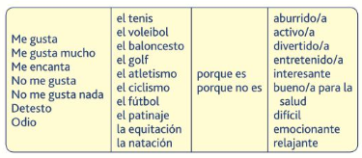

The questions (muddled up) in English
What sport would you like to practise in the future?
What sport did you use to practise when you were little?)
When and where do you want to marry? (How will it be?)
What do you think of getting married?/marriage/living together?
Do you want to get married in future (why/why not?)
Do you have a girlfriend /boyfriend?

Writing Foundation Tier Photo
Escribe cuatro frases sobre la foto. [Write four sentences about the photo]
(eg There is a beach. / There is a wedding. / The sun is shining. / They are wearing elegant clothes. / etc)
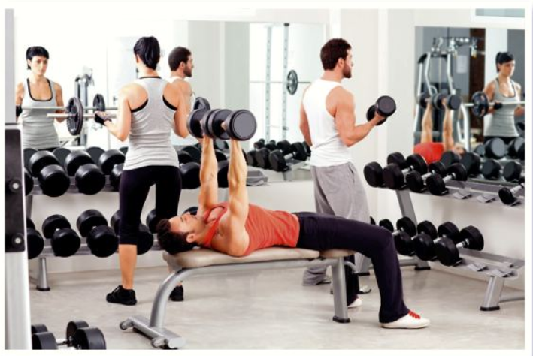

- _____________________________________________________________________________
(2 marks)

2 _____________________________________________________________________________
(2 marks)

3 _____________________________________________________________________________
(2 marks)

4 _____________________________________________________________________________
(2 marks)

Writing Practice 40 word piece [16 marks]

Top Tips! 10 marks are for communication - so make sure you write something about EACH bullet point. For the 6 marks for Language, use varied vocab, verbs, opinions and a few justifications.

Tu amigo argentino te ha preguntado sobre tu tiempo libre.
Escribe un e-mail.
Menciona:

- What sports you like/don’t like and why
- What sports you do in school or outside school
- What sports you would like to practise in the future

…………………………………………………………………………………………………………………………………
…………………………………………………………………………………………………………………………………
…………………………………………………………………………………………………………………………………
…………………………………………………………………………………………………………………………………
…………………………………………………………………………………………………………………………………
…………………………………………………………………………………………………………………………………
…………………………………………………………………………………………………………………………………
…………………………………………………………………………………………………………………………………
…………………………………………………………………………………………………………………………………
…………………………………………………………………………………………………………………………………
…………………………………………………………………………………………………………………………………
…………………………………………………………………………………………………………………………………

Writing Practice 90 word piece

Top Tips! 10 marks are for communication - so make sure you write in some detail (approximately 23 words) about EACH bullet point. For the 6 marks for Language, use varied vocab, verbs, opinions and some justifications.
Tu amigo mexicano te ha preguntado sobre tu tiempo libre.
Escribe un e-mail.
Menciona:

- Que deportes practicas durante la semana.
- Un deporte que practicaste el fin de semana pasado con tus amigos.
- Prefieres los deportes de equipo o individuales y por qué.
- Tu opinión sobre los deportes de riesgo.

…………………………………………………………………………………………………………………………………
…………………………………………………………………………………………………………………………………
…………………………………………………………………………………………………………………………………
…………………………………………………………………………………………………………………………………
…………………………………………………………………………………………………………………………………
…………………………………………………………………………………………………………………………………
…………………………………………………………………………………………………………………………………
…………………………………………………………………………………………………………………………………
…………………………………………………………………………………………………………………………………
…………………………………………………………………………………………………………………………………
…………………………………………………………………………………………………………………………………
…………………………………………………………………………………………………………………………………
…………………………………………………………………………………………………………………………………
…………………………………………………………………………………………………………………………………
…………………………………………………………………………………………………………………………………
…………………………………………………………………………………………………………………………………
…………………………………………………………………………………………………………………………………
…………………………………………………………………………………………………………………………………
…………………………………………………………………………………………………………………………………
…………………………………………………………………………………………………………………………………
…………………………………………………………………………………………………………………………………
…………………………………………………………………………………………………………………………………
…………………………………………………………………………………………………………………………………

Foundation Speaking Role Play [15 marks]

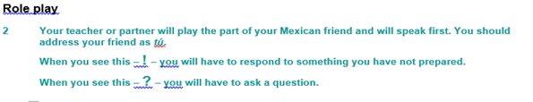
- Deporte favorito (dos detalles)
- Un deporte que practicaste el fin de semana pasado con tus amigos (dos detalles)
- Un deporte que no te gusta y Por qué.
- !
- ? Tu opinión sobre los deportes de riesgo.

…………………………………………………………………………………………………………………………………
…………………………………………………………………………………………………………………………………
…………………………………………………………………………………………………………………………………
…………………………………………………………………………………………………………………………………
…………………………………………………………………………………………………………………………………
…………………………………………………………………………………………………………………………………
…………………………………………………………………………………………………………………………………
…………………………………………………………………………………………………………………………………
…………………………………………………………………………………………………………………………………
…………………………………………………………………………………………………………………………………
…………………………………………………………………………………………………………………………………
…………………………………………………………………………………………………………………………………
…………………………………………………………………………………………………………………………………
…………………………………………………………………………………………………………………………………
…………………………………………………………………………………………………………………………………

Foundation Tier Speaking Photo Card [15 marks]

Top Tips!
- It’s wise to use the Verb Table found near the start of this Learning Booklet so you VARY
verbs/opinions/structures.
- Remember: We need a minimum of THREE “ideas” for each question, so that we develop each answer.

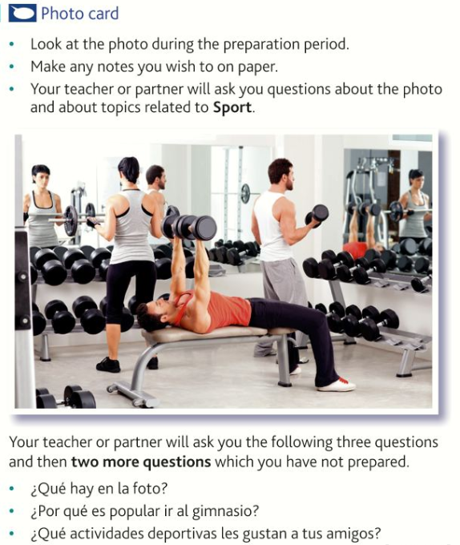

…………………………………………………………………………………………………………………………………
…………………………………………………………………………………………………………………………………
…………………………………………………………………………………………………………………………………
…………………………………………………………………………………………………………………………………
…………………………………………………………………………………………………………………………………
…………………………………………………………………………………………………………………………………
…………………………………………………………………………………………………………………………………
…………………………………………………………………………………………………………………………………
…………………………………………………………………………………………………………………………………
…………………………………………………………………………………………………………………………………
…………………………………………………………………………………………………………………………………
…………………………………………………………………………………………………………………………………
…………………………………………………………………………………………………………………………………
…………………………………………………………………………………………………………………………………
…………………………………………………………………………………………………………………………………
…………………………………………………………………………………………………………………………………
…………………………………………………………………………………………………………………………………

Tema 3 Mi tiempo libre 2 – Higher Tier
- Your PE teacher has shown you an article about Olympic sports. Translate it into English for your
friend.
Una investigación médica revela que algunos deportes olímpicos pueden tener efectos positivos en la mente además de en el cuerpo. El estudio explica las ventajas del atletismo y de la natación, dos ejercicios aeróbicos que tienen beneficios en el cerebro y mejoran el sentido de bienestar. Otros deportes recomendados son el fútbol, el balonmano, y el ciclismo.

…………………………………………………………………………………………………………………………………
…………………………………………………………………………………………………………………………………
…………………………………………………………………………………………………………………………………
…………………………………………………………………………………………………………………………………
…………………………………………………………………………………………………………………………………
…………………………………………………………………………………………………………………………………
…………………………………………………………………………………………………………………………………
…………………………………………………………………………………………………………………………………
…………………………………………………………………………………………………………………………………[12 marks]

Translate the following sentences into Spanish:-

Practising sports help teenagers learn the importance of discipline and effort. Sports also promote competitiveness, which developed in moderation can be very beneficial for their life. Boys and girls learn to enjoy the victories and get stronger with defeats. In the case of team sports, they learn the importance of counting on others, which develops their social skills. They also learn the importance of respecting the authority, the need of obeying the rules and respecting their opponents.
…………………………………………………………………………………………………………………………………
…………………………………………………………………………………………………………………………………
…………………………………………………………………………………………………………………………………
…………………………………………………………………………………………………………………………………
…………………………………………………………………………………………………………………………………
…………………………………………………………………………………………………………………………………
…………………………………………………………………………………………………………………………………
…………………………………………………………………………………………………………………………………
…………………………………………………………………………………………………………………………………[12 marks]

HIGHER Speaking practice Higher Tier PHOTO CARD [15 marks]

- It’s wise to use the Verb Table found near the start of this Learning Booklet so you VARY
verbs/opinions/structures.
- Remember: We need a minimum of THREE “ideas” for each question so that we develop each response.

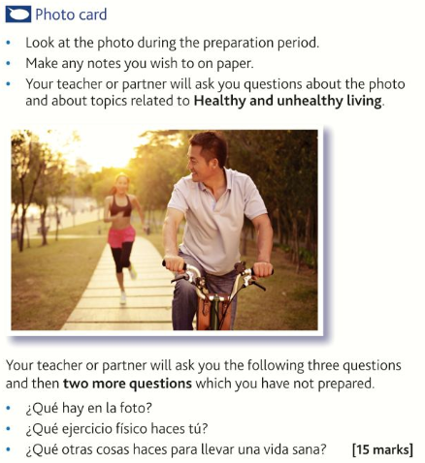

…………………………………………………………………………………………………………………………………
…………………………………………………………………………………………………………………………………
…………………………………………………………………………………………………………………………………
…………………………………………………………………………………………………………………………………
…………………………………………………………………………………………………………………………………
…………………………………………………………………………………………………………………………………
…………………………………………………………………………………………………………………………………
…………………………………………………………………………………………………………………………………
…………………………………………………………………………………………………………………………………
…………………………………………………………………………………………………………………………………
…………………………………………………………………………………………………………………………………
…………………………………………………………………………………………………………………………………
…………………………………………………………………………………………………………………………………
…………………………………………………………………………………………………………………………………
…………………………………………………………………………………………………………………………………

Extended Writing Deliberate Practice
90 word writing piece
- Tu amigo español quiere saber lo que hacen en su tiempo libre los jóvenes de tu país.
Escríbele una carta.
Menciona:
- qué haces por la tarde durante la semana
- las actividades que hiciste el fin de semana pasado
- los deportes favoritos entre tus amigos
- una mala manera en que algunos jóvenes pasan el tiempo.
Escribe aproximadamente 90 palabras en español. Responde a todos los aspectos de la pregunta.

…………………………………………………………………………………………………………………………………
…………………………………………………………………………………………………………………………………
…………………………………………………………………………………………………………………………………
…………………………………………………………………………………………………………………………………
…………………………………………………………………………………………………………………………………
…………………………………………………………………………………………………………………………………
…………………………………………………………………………………………………………………………………
…………………………………………………………………………………………………………………………………
…………………………………………………………………………………………………………………………………
…………………………………………………………………………………………………………………………………
…………………………………………………………………………………………………………………………………
…………………………………………………………………………………………………………………………………
…………………………………………………………………………………………………………………………………
…………………………………………………………………………………………………………………………………
…………………………………………………………………………………………………………………………………
…………………………………………………………………………………………………………………………………
…………………………………………………………………………………………………………………………………
…………………………………………………………………………………………………………………………………
…………………………………………………………………………………………………………………………………
…………………………………………………………………………………………………………………………………
…………………………………………………………………………………………………………………………………

150 word writing piece

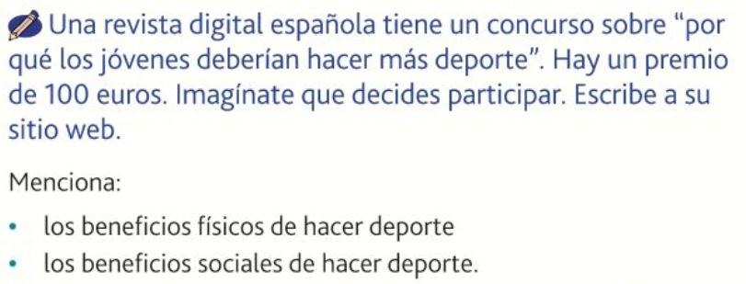

Tip: You don’t HAVE to to include all three tenses in this piece, however it’s a good idea to do so. This enables you to show that you know the three different tenses.
…………………………………………………………………………………………………………………………………
…………………………………………………………………………………………………………………………………
…………………………………………………………………………………………………………………………………
…………………………………………………………………………………………………………………………………
…………………………………………………………………………………………………………………………………
…………………………………………………………………………………………………………………………………
…………………………………………………………………………………………………………………………………
…………………………………………………………………………………………………………………………………
…………………………………………………………………………………………………………………………………
…………………………………………………………………………………………………………………………………
…………………………………………………………………………………………………………………………………
…………………………………………………………………………………………………………………………………
…………………………………………………………………………………………………………………………………
…………………………………………………………………………………………………………………………………
…………………………………………………………………………………………………………………………………
…………………………………………………………………………………………………………………………………
…………………………………………………………………………………………………………………………………
…………………………………………………………………………………………………………………………………
…………………………………………………………………………………………………………………………………
…………………………………………………………………………………………………………………………………
…………………………………………………………………………………………………………………………………
…………………………………………………………………………………………………………………………………
…………………………………………………………………………………………………………………………………
…………………………………………………………………………………………………………………………………
…………………………………………………………………………………………………………………………………
…………………………………………………………………………………………………………………………………
…………………………………………………………………………………………………………………………………
…………………………………………………………………………………………………………………………………
…………………………………………………………………………………………………………………………………
…………………………………………………………………………………………………………………………………
…………………………………………………………………………………………………………………………………
…………………………………………………………………………………………………………………………………
…………………………………………………………………………………………………………………………………
…………………………………………………………………………………………………………………………………
…………………………………………………………………………………………………………………………………
…………………………………………………………………………………………………………………………………
…………………………………………………………………………………………………………………………………
…………………………………………………………………………………………………………………………………
…………………………………………………………………………………………………………………………………
…………………………………………………………………………………………………………………………………
…………………………………………………………………………………………………………………………………
…………………………………………………………………………………………………………………………………

Useful websites for independent learning

www.kerboodle.com (your teacher will provide your individual log-in details.

www.quizlet.com

www.languagesonline.org.uk

www.linguascope.com (username: budmouth password: flags)

www.atantot.com (username: Budmouth password: 8034)

www.memrise.com

